All Color: <https://www.w3schools.com/colors/colors_names.asp>

1. **RGB** Color Values: **rgb(*red,* *green*, *blue*)**

Each parameter (red, green, and blue) defines the intensity of the color with a value between 0 and 255.

This means that there are 256 x 256 x 256 = 16777216 possible colors!

For example, rgb(255, 0, 0) is displayed as red, because red is set to its highest value (255), and the other two (green and blue) are set to 0.

Another example, rgb(0, 255, 0) is displayed as green, because green is set to its highest value (255), and the other two (red and blue) are set to 0.

To display black, set all color parameters to 0, like this: rgb(0, 0, 0).

To display white, set all color parameters to 255, like this: rgb(255, 255, 255).

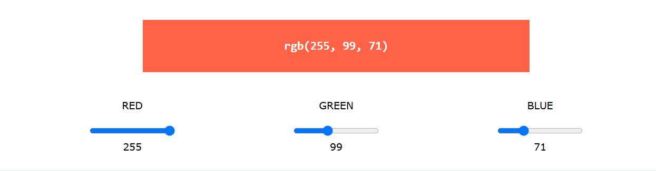

**rgba(*red,* *green*, *blue, alpha*)**

The alpha parameter is a number between 0.0 (fully transparent) and 1.0 (not transparent at all):

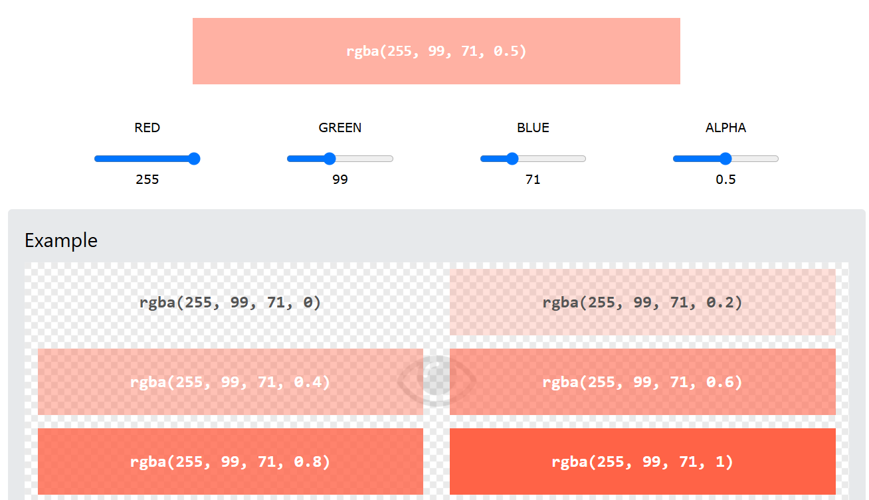

1. HEX Color Values: **#*rrggbb***

Where rr (red), gg (green) and bb (blue) are hexadecimal values between 00 and ff (same as decimal 0-255).

For example, #ff0000 is displayed as red, because red is set to its highest value (ff), and the other two (green and blue) are set to 00.

Another example, #00ff00 is displayed as green, because green is set to its highest value (ff), and the other two (red and blue) are set to 00.

To display black, set all color parameters to 00, like this: #000000.

To display white, set all color parameters to ff, like this: #ffffff.

Experiment by mixing the HEX values below:

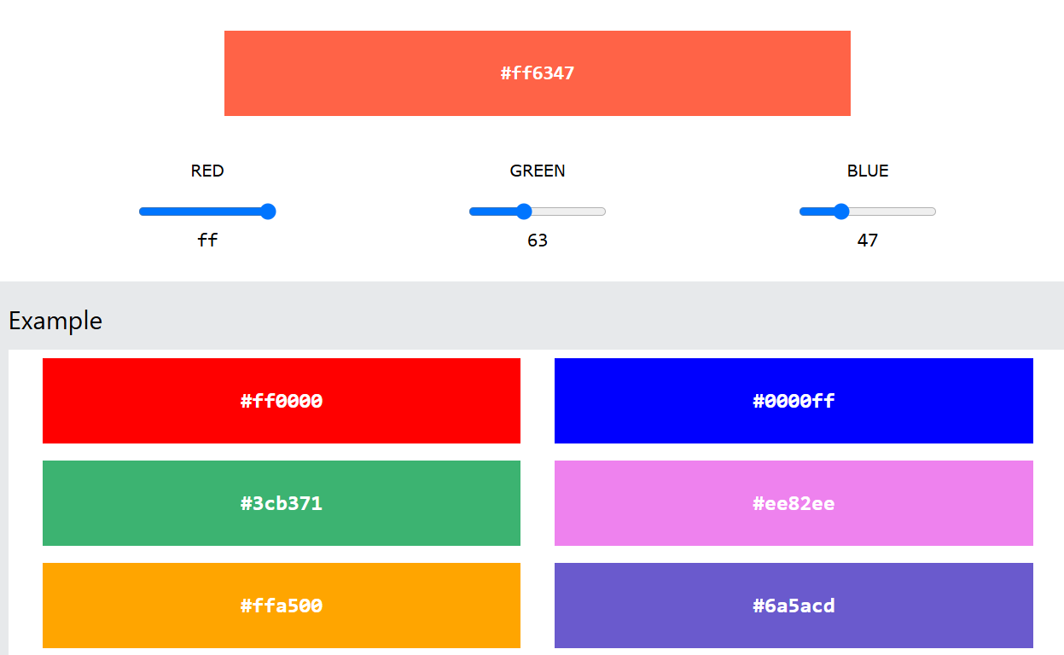

1. HSL Color Values: **hsl(*hue*, *saturation*, *lightness*)**

Hue is a degree on the color wheel from 0 to 360. 0 is red, 120 is green, and 240 is blue.

Saturation is a percentage value. 0% means a shade of gray, and 100% is the full color.

Lightness is also a percentage value. 0% is black, and 100% is white.

Experiment by mixing the HSL values below:

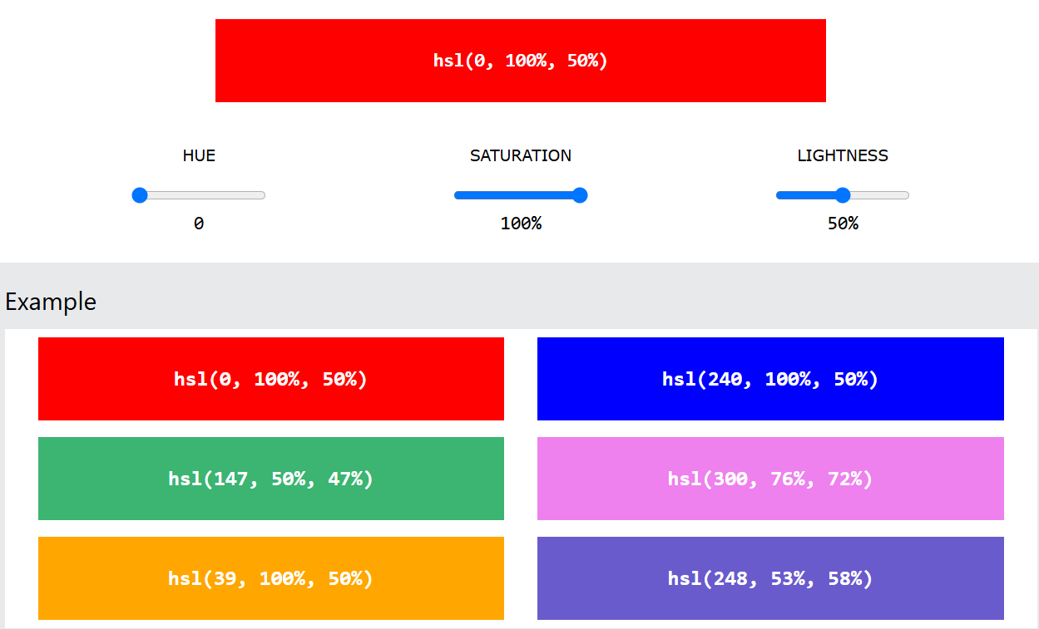

**hsla(*hue,* *saturation*, *lightness, alpha*)**

The alpha parameter is a number between 0.0 (fully transparent) and 1.0 (not transparent at all):

