Network Models

Kalyan and Stepek

# Introduction

The aim of this assignment was to compute average shortest-path as a function of the parameter p of the WS model and plot the average shortest-path length as a function of the network size of the ER model. We chose to use networkx library for our analysis.

# Implementation

We followed all the instructions as per the pdf document. The first choice we had to take was to figure out the right value for the constant z (Average degree) and p in such a way that do not get isolated vertex.

Using the folmula below, we could obtain the best value of z = 13 for graphs with nodes upto 100,000 where all nodes that give us connected graph.

$$z=(n−1)*p$$

.

### Erdos-Renyi Model

Instead of using the erdos_renyi_graph api from from networkx which has $O(n^{2})$ runtime complexity, we chose fast_gnp_random_graph api as it has $O(n+m)$ run time complexity, n is the number of nodes and m is the expected of edges. Once we obtained the values of network size between 100 and 100000 and average shortest-path length we obtain the scatter plot below.

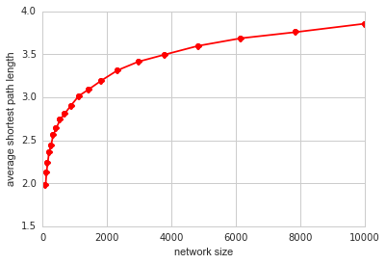

Erdos-Renyi Model

### Watts-Strogatz Model

We needed to compute clustering coefficient and average shortest-path as a function of parameter p. The constants we used were, k = 4 (Nearest neighbors in ring topology), Size of graph n = 500 (Since computaionally it did not take too much time). After obtaining these values over function of parameter p we normalized it to be within range [0, 1]. By Averaging the the cluster coefficient and shortest path over 10 different random seeds we obtained smoothed scatted plot below.The averaging was performed using a function which for every p generated k values and returned their mean value.

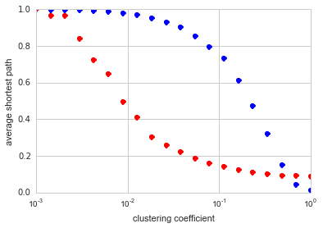

Watts-Strogatz Model

# Results

We did not have any problem simulating the results. Using python comprehensions we were optimized our code and improved readibility. The plots obtained for Watts-Strogatz model gave us better results when averaged over multiple graphs with different random seeds.