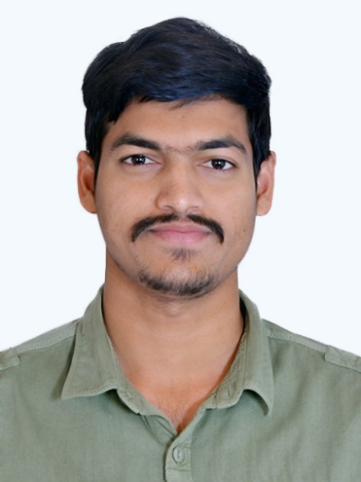

**KRISHNA KANAJAM**

**UI Developer**

**……………………………………...**

[**krishnakanajam@gmail.com**](mailto:krishnakanajam@gmail.com)

**9059911239**

**EDUCATION**

**Sep 2013 - May 2017 B.Tech EEE**

**Gudlavalleru Engineering College, Gudlavalleru.**

**Agg: 78.83%**

**Jun 2011 - Mar 2013 Intermediate**

**Sri chaitanya College, Vijayawada.**

**Agg: 96.5%**

**Jun 2010 - Apr 2011 Tenth**

**Sahayamatha High School, Mudinepalli.**

**Agg: 89.83%**

**SKILLS WORK EXPERIENCE – 2Years 10Months**

**1. HTML5 2. CSS3 DEC 2017 - FEB 2020 (2 Years 2 Months)**

**3. Java Script 4. Jquery**

**5. Bootstrap4 & 5 6. Photoshop Worked as a UI & UX Developer in EXADATA**

**7. Coraldraw 8. Illustrator CONSULTING Pvt Ltd, KPHB, HYDERABAD.**

**9. Angular 8**

**MAR 2020 – November 2020 (8 Months)**

**Working as a Ui Developer in KEKA TECHNOLOGIES,**

**MADHAPUR, HYDERABAD.**

**GUI TOOLS PROFESSIONAL STRENGTHS**

**1. Visual Studio 2019 1.** **Responsive web designs in multiple screen    2. NotePad + + sizes/devices.**

**3. XAMPP 2. Expert in Identifying and Fixing UI issues.**

**4. Sublime Text 3 3. Having Knowledge and Idea about the**

**5. Visual studio code Backend & Databases.**

**4. Knowing the Multi Layouts and snippets** **the**

**designing applications in short period of time as**

**per client requirement.**

**PROJECTS :**

**Teluguvoice :**

This Site is about the Day to Day Live online News Both in English and Telugu News.This entire Designs are done by only me and it consists of Articles, Videos, Shortflims, Polling, Live Tv, Audio player, Gallery etc...

Website URL : <https://www.teluguvoice.com/>

**Telemed Visits**:

This site for booking the docotor's appointment all over USA in online.For the your Health issues based on thier particular specialities which was already mentioned in the Website.It has Video calling chatting with the doctor and online view reports.

Website URL : <http://telemedvisit.org/>

**Keka Project** :

Keka techonologies is a product based company (Based on Hr Operations and Financial). In this my role is as a Ui Developer which I had developed the lot of web pages and also worked for the HIRO Project (for Hiring Purposes).

Website Url : <https://www.keka.com/> ( Company Website )

Keka Product Web Application Url : original.dev.kekad.com

click on keka password

email : mallika.dmc@kekad.com

password : malikA

**INTERESTS**

**My hobbies are spying, accumulation and Internet surfing**.

**ACHIEVEMNTS**

**Participated in Robotics and Matlab workshop Awarded with second prize.**

**Participated in sports such as cricket and volley ball Awarded with first prize.**

**My EMACET rank is : 9055.**

**PERSONAL DETAILS**

**Name : Kanajam Venkata Siva Rama Krishna**

**Father Name : K.Durga Rao**

**Gender : Male**

**Date of Birth : 20-11-1995**

**Contact Address : Dno: EWS 382, Ground Floor,**

**Near Samskruthi Costumes,**

**Road No:3, KPHB colony,**

**Hyderabad 500072.**

**DECLARATION**

**I hereby declare that the details that are mentioned above are true and to the**

**best of knowledge and belief.**

**Krishna Kanajam**

**NOTE : Url :** https://krishnakanajam.github.io/krishprofile/ **open this link for my Online Profile.**