**DAY2**

**THEORY OF COMPUTATION**

**PRATICAL SESSION**

**2.3) Construct an NFA for binary strings that start and end with different digits.**

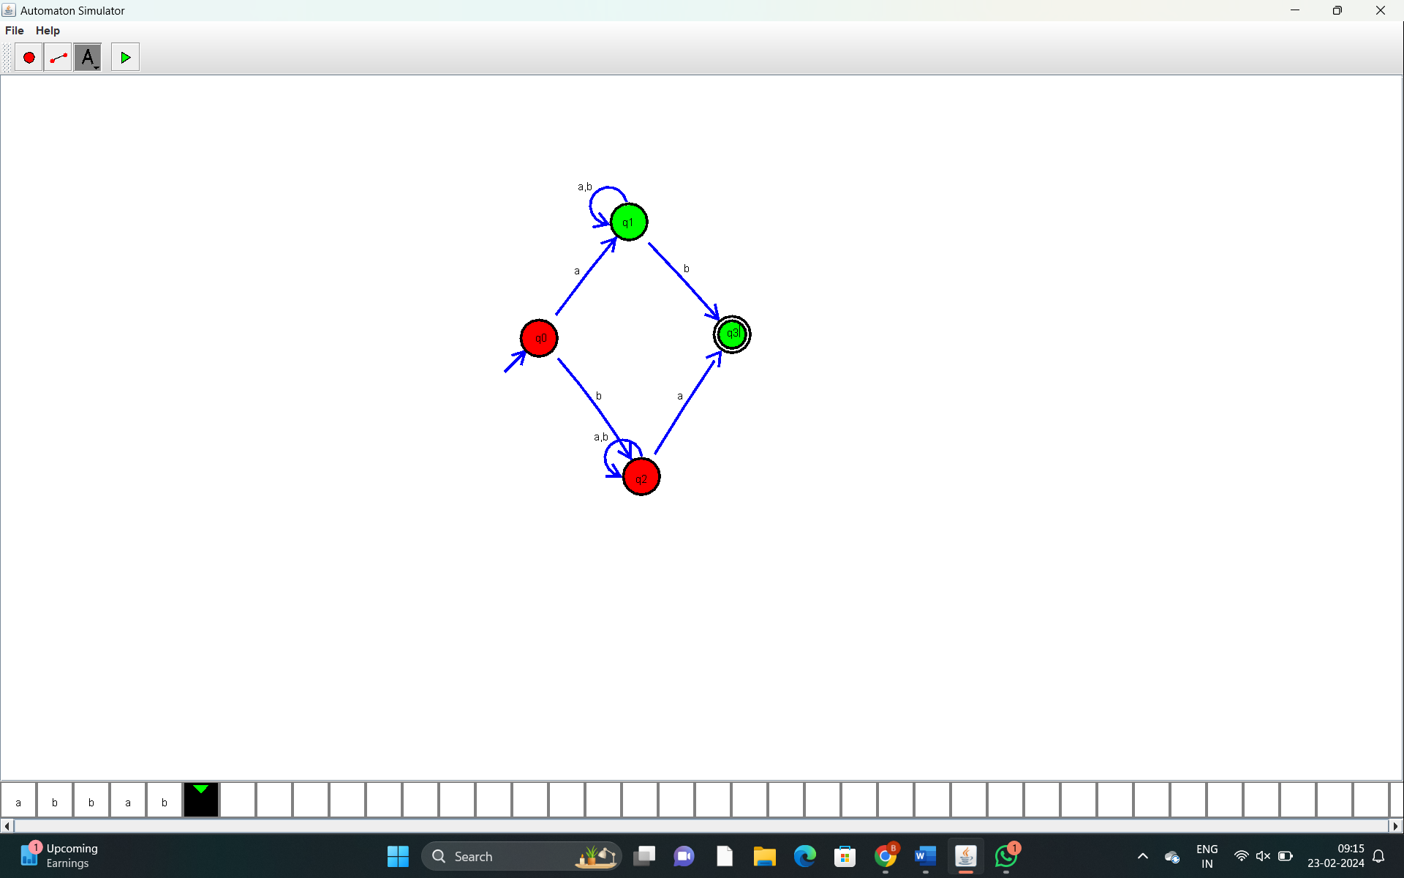

**3. Construct an NFA without ϵ-moves equivalent to the NFA with ϵ-moves given**

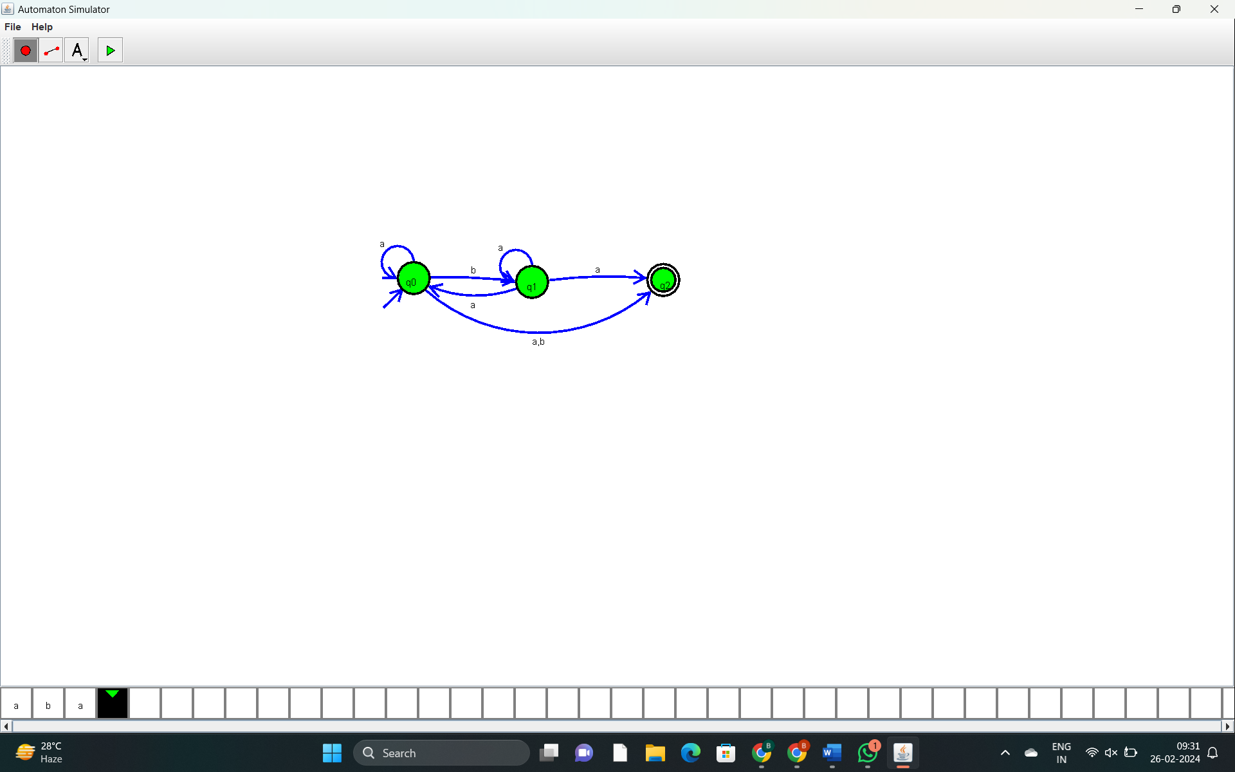

**4. Construct a DFA equivalent to the NFA with ε-moves given below**:

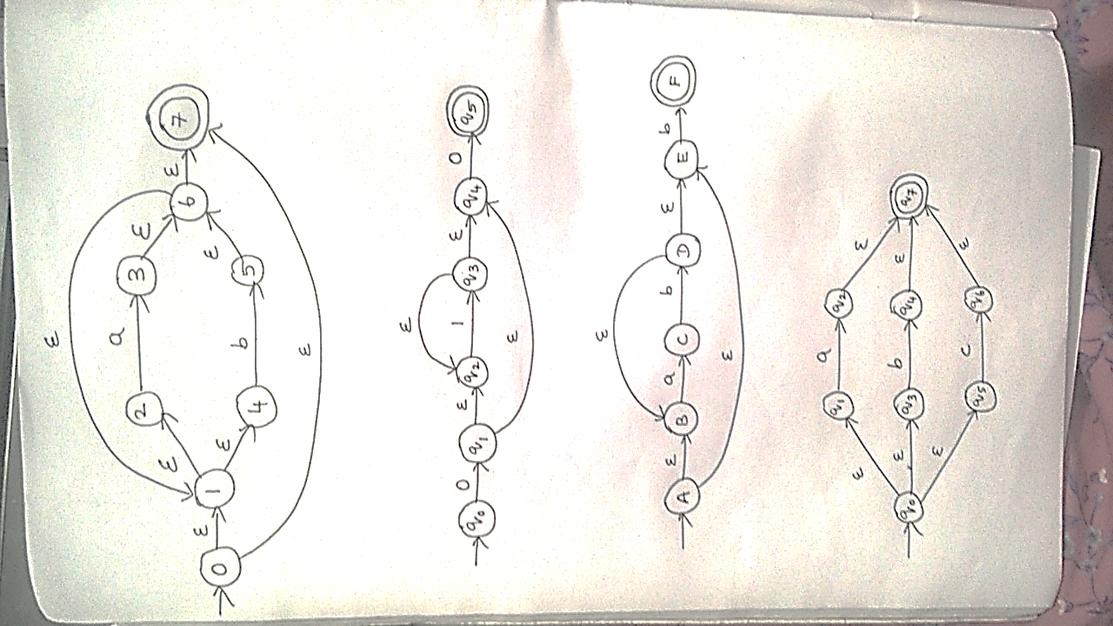

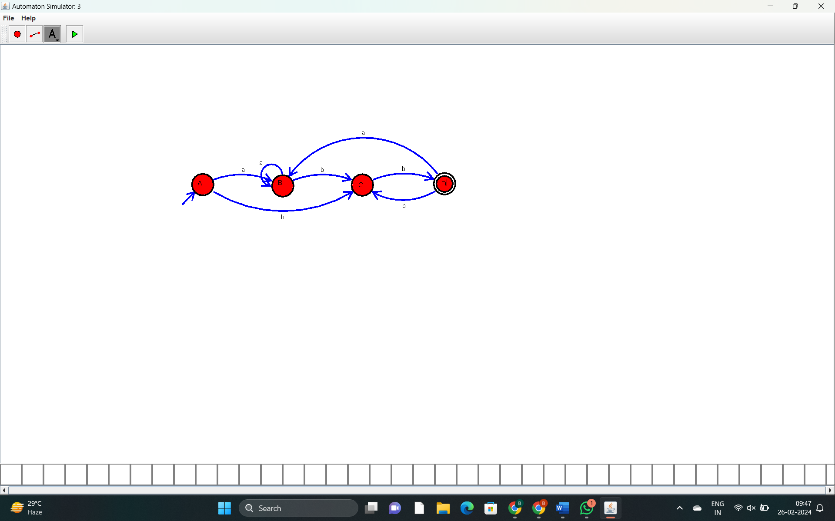

**5.Minimize the DFA given below**:

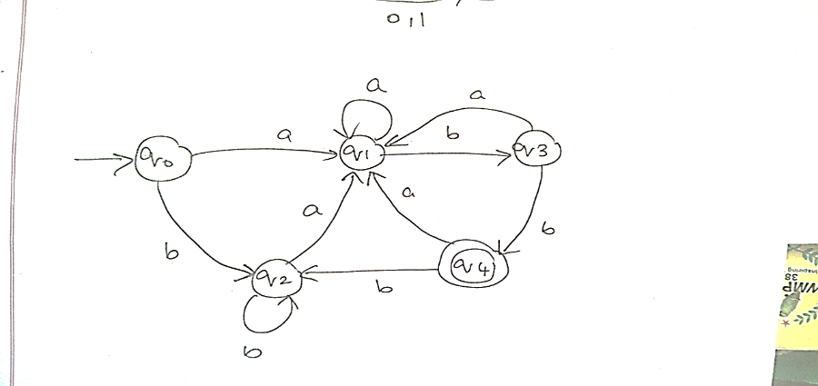

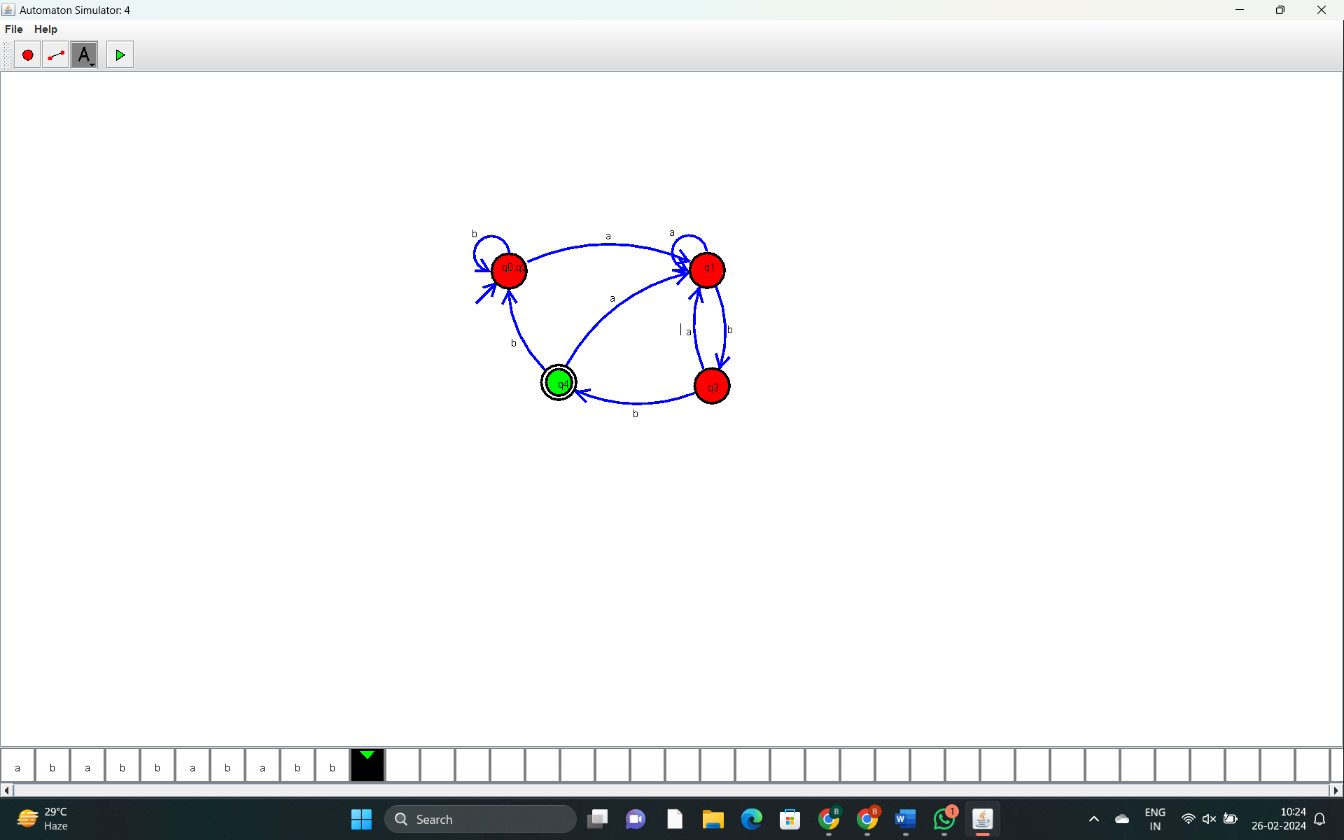

**6.Define r.e. for the following languages**:

1. Set of all strings of a’s and b’s having bb as a substring

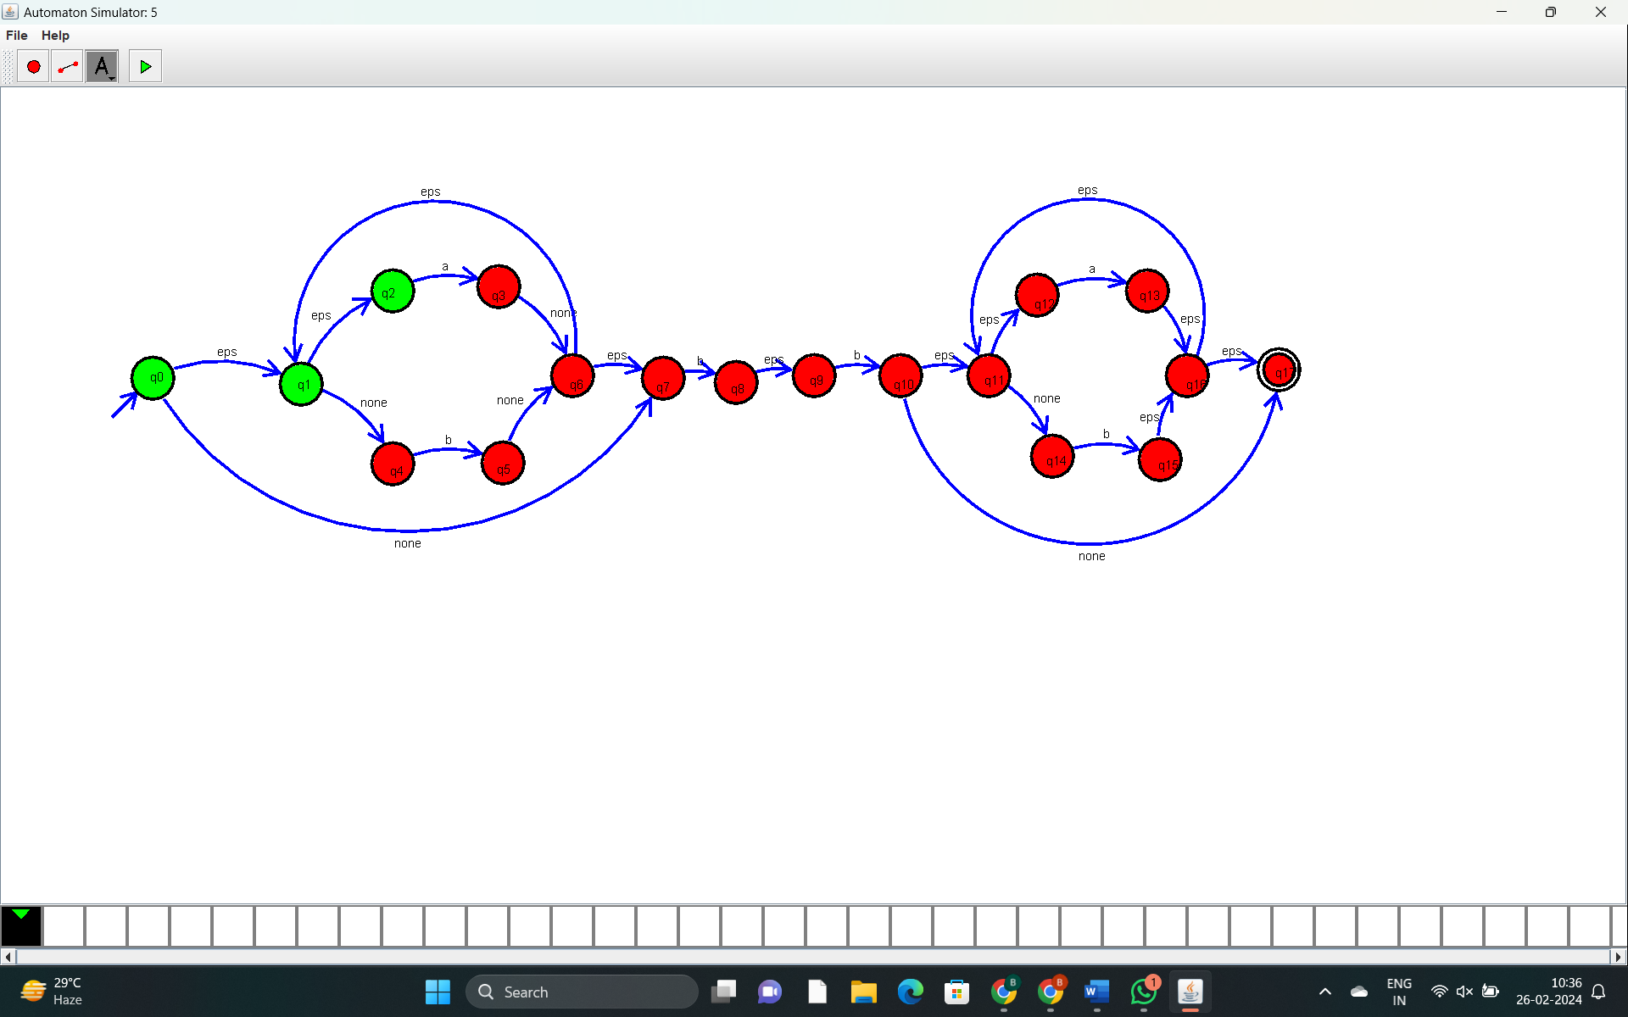

1. Set of all strings that start with a and end with b over 𝚺={a,b}

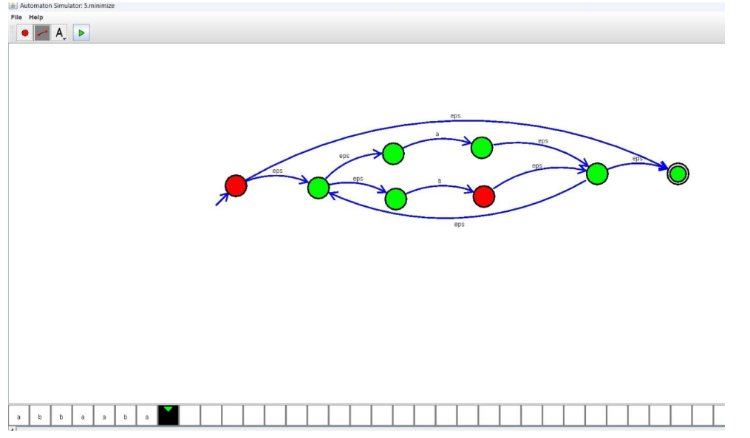

**7. Identify the language defined by the r.e**:

1. (a*+b*)*

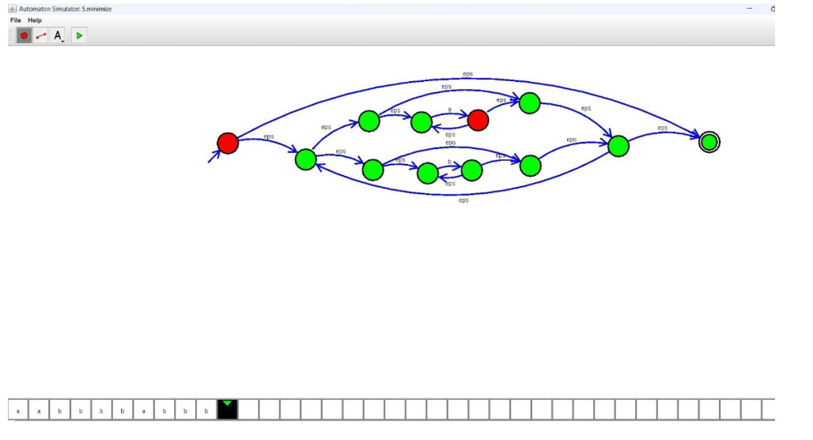

1. (01+10)*

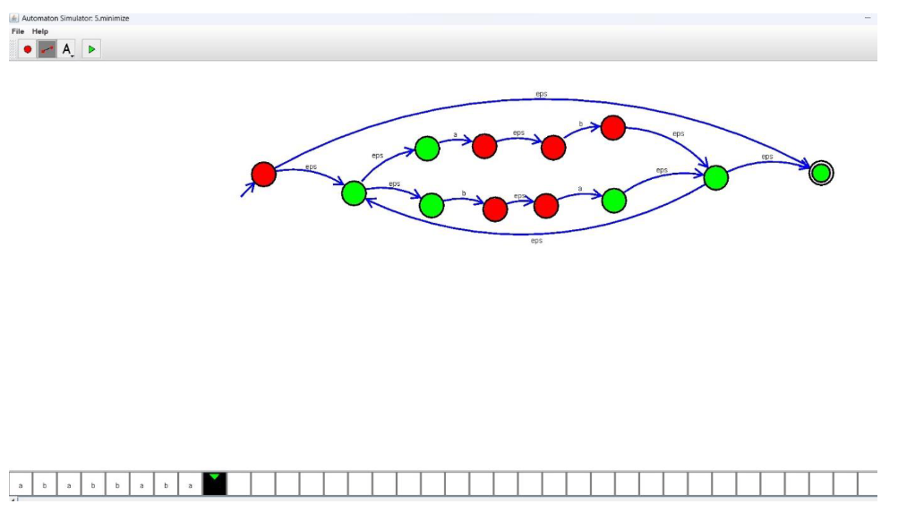

1. ab*a

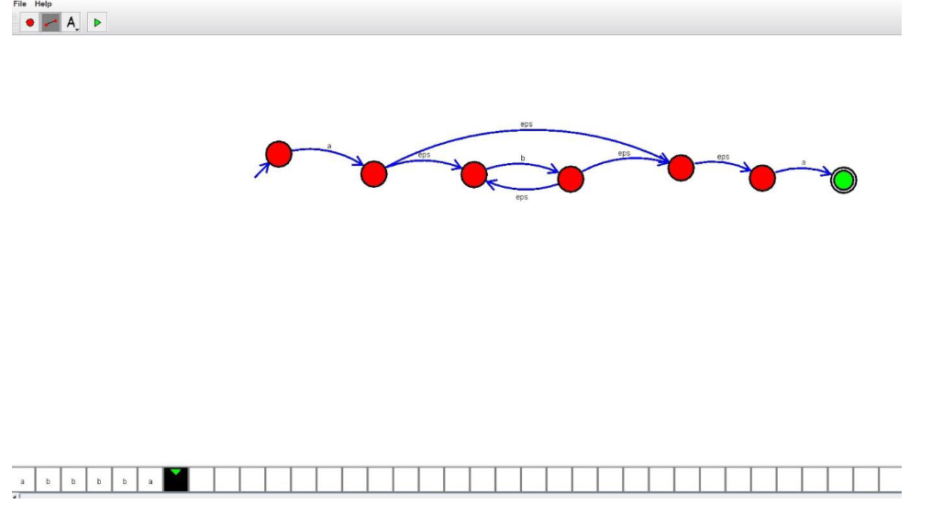

**8. Construct r.e. from the DFA given below:**

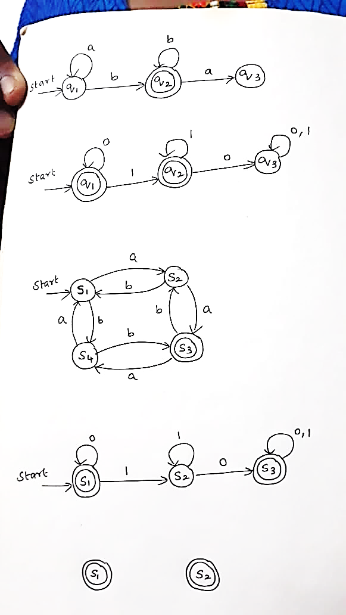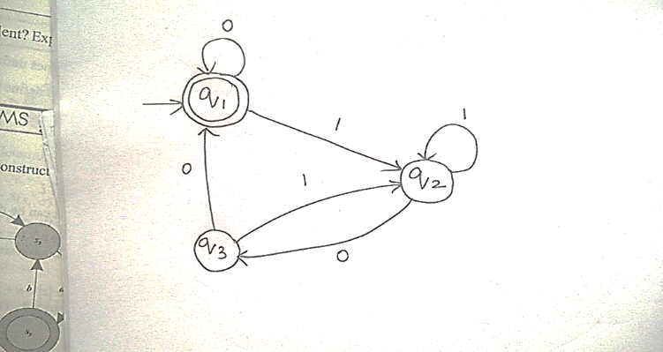

S1: a*

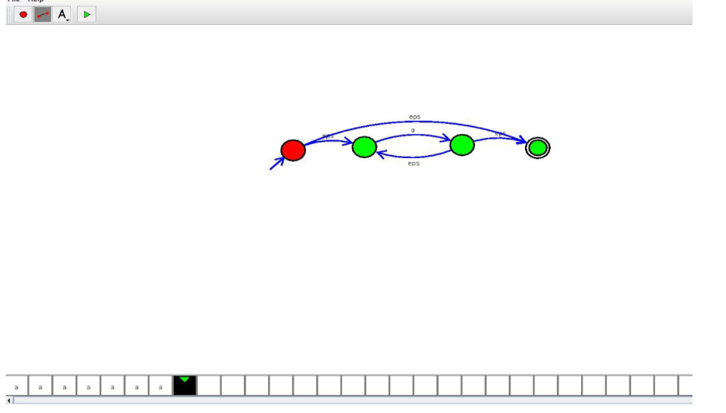

S2: a*bb*

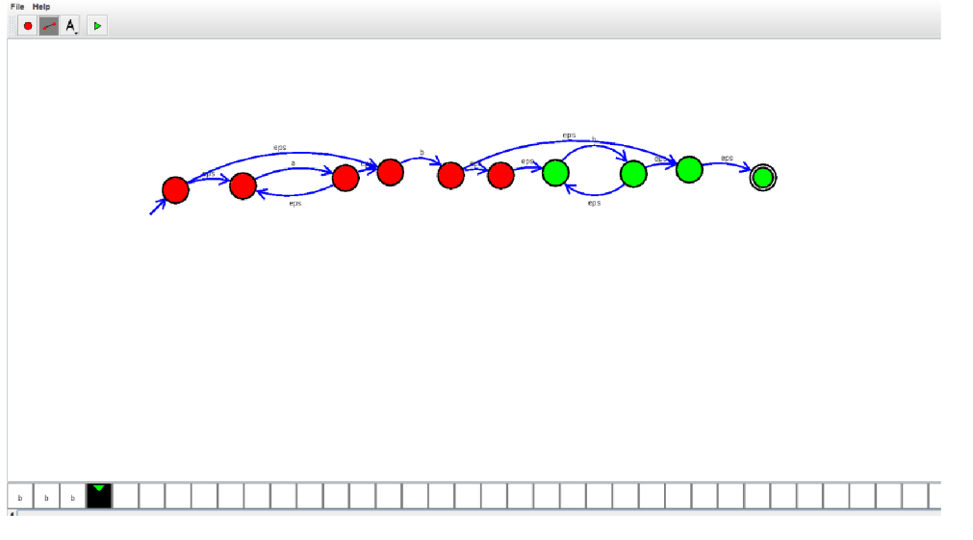

S3: a*bb*a(a+b)*

