**CSA1322**

**THEORY OF COMPUTATION**

**PRATICAL DAY1**

* 1. **Design a DFA for the Binary strings having odd no of 1’s and any number of 0’s**

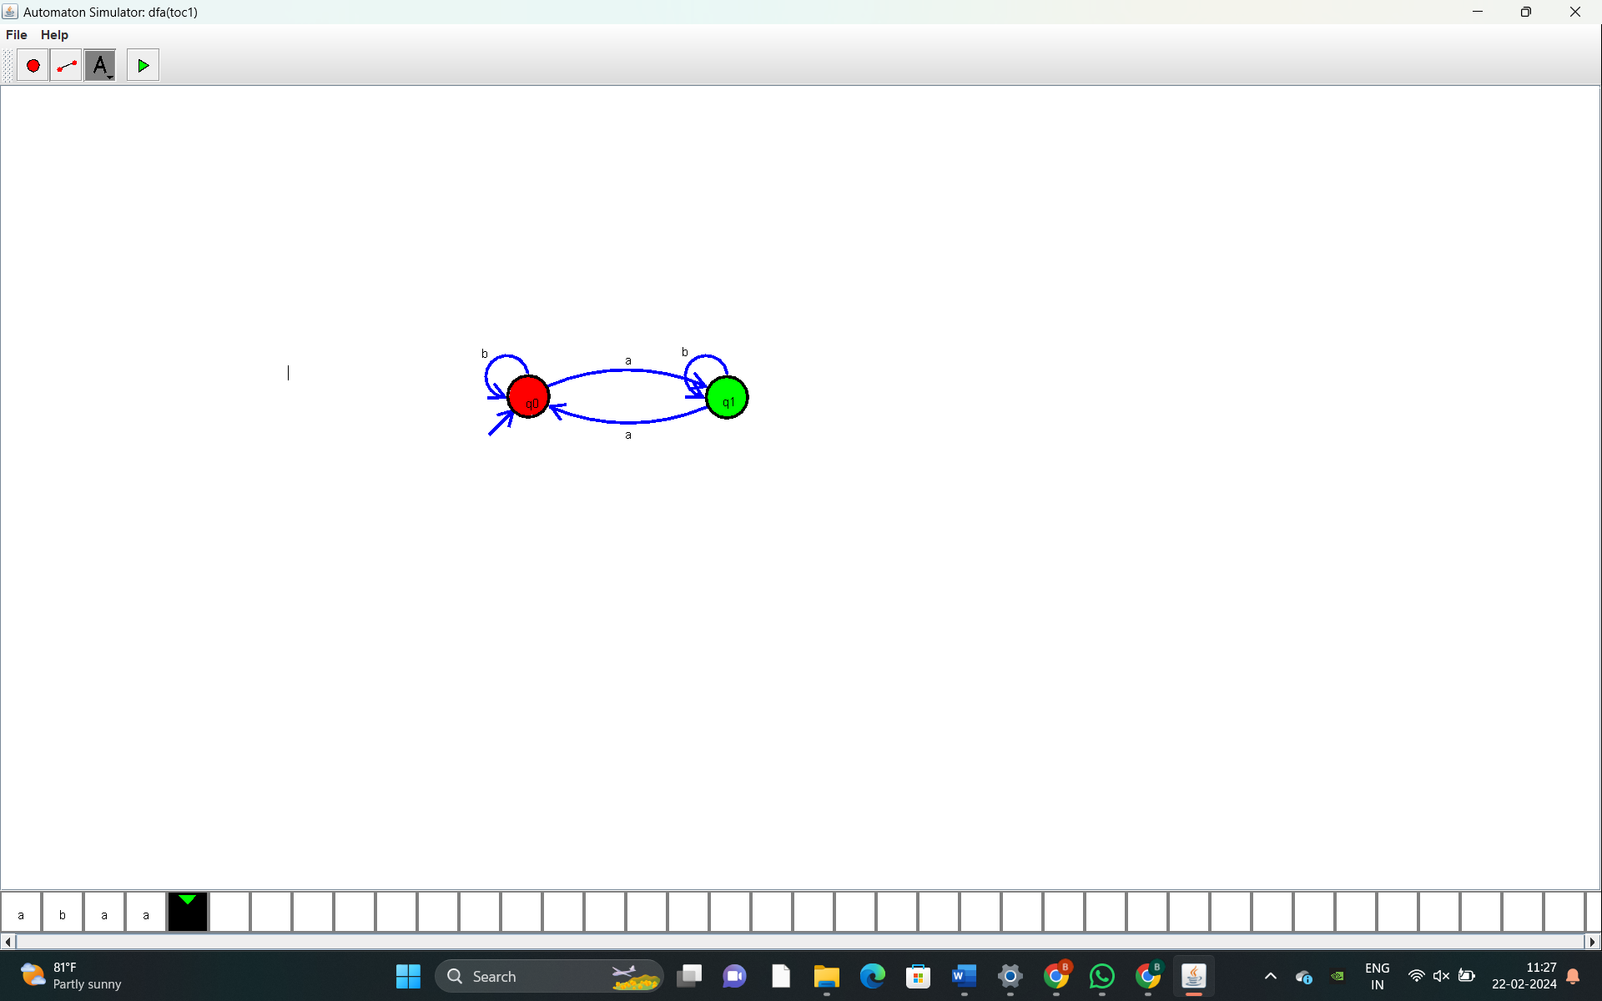

**1.2) Design a DFA for the Binary strings having even no. of 0’s and even no. of 1’s**

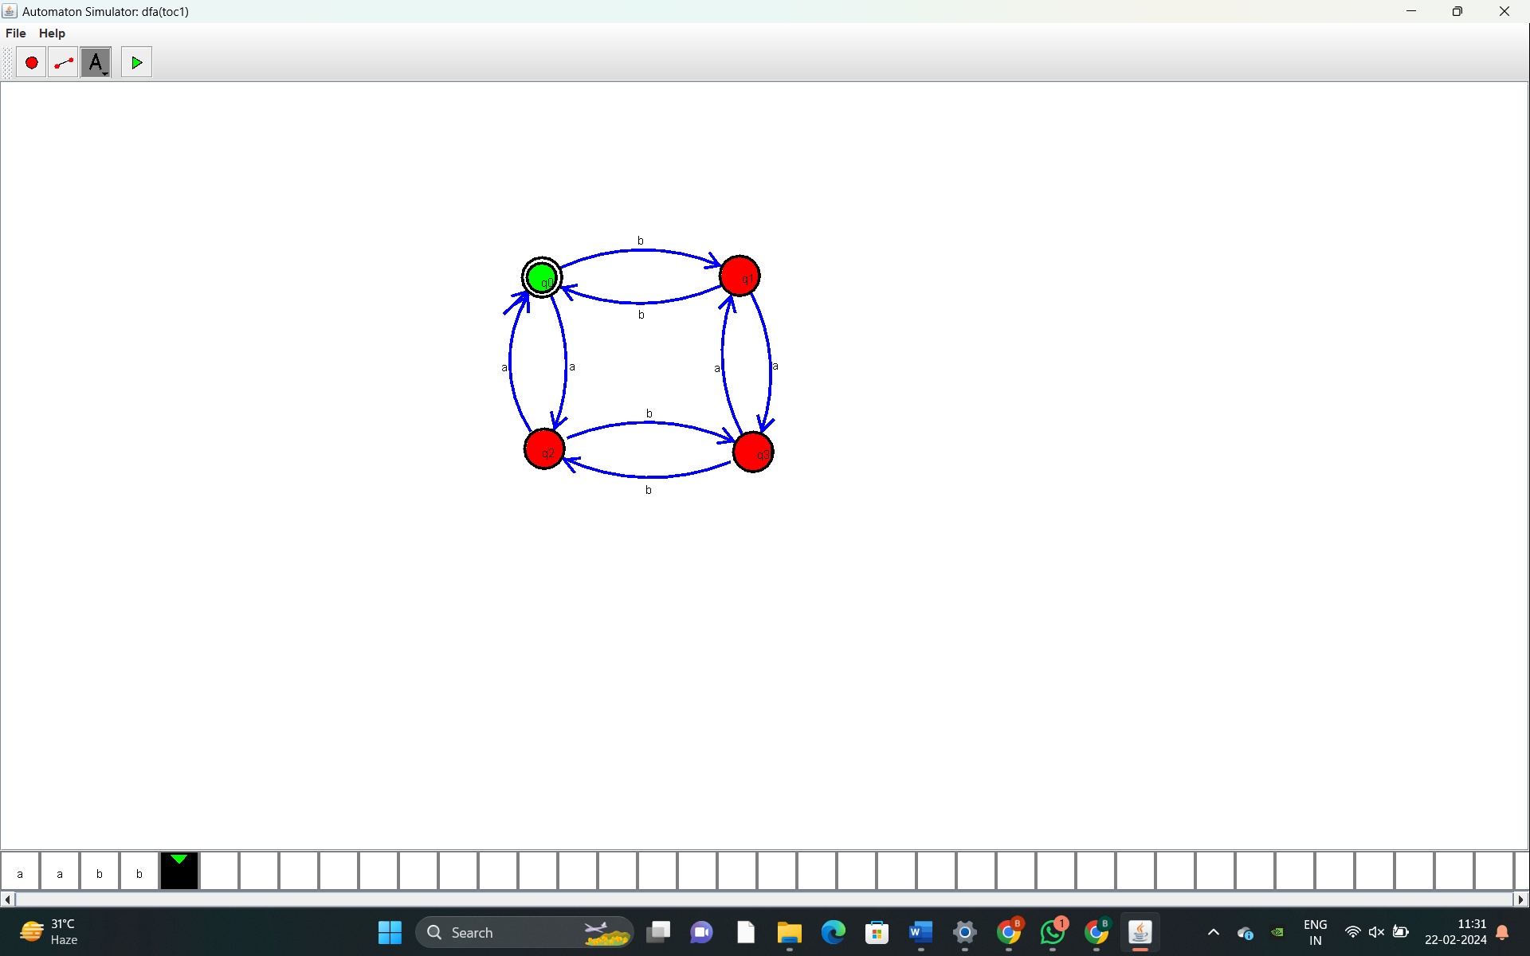

**1.3) Design a DFA for the Binary strings having the substring 101**

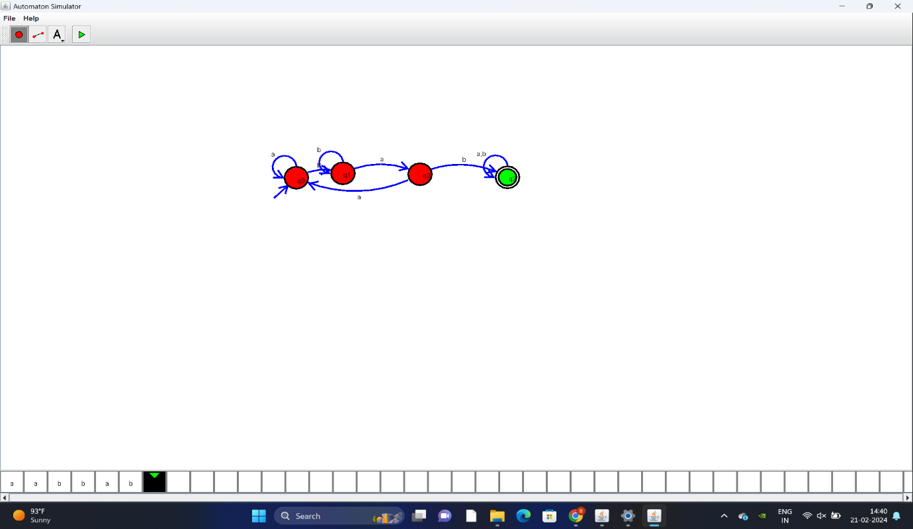

* 1. **Design a DFA for the Binary strings having no consecutive 0’s**

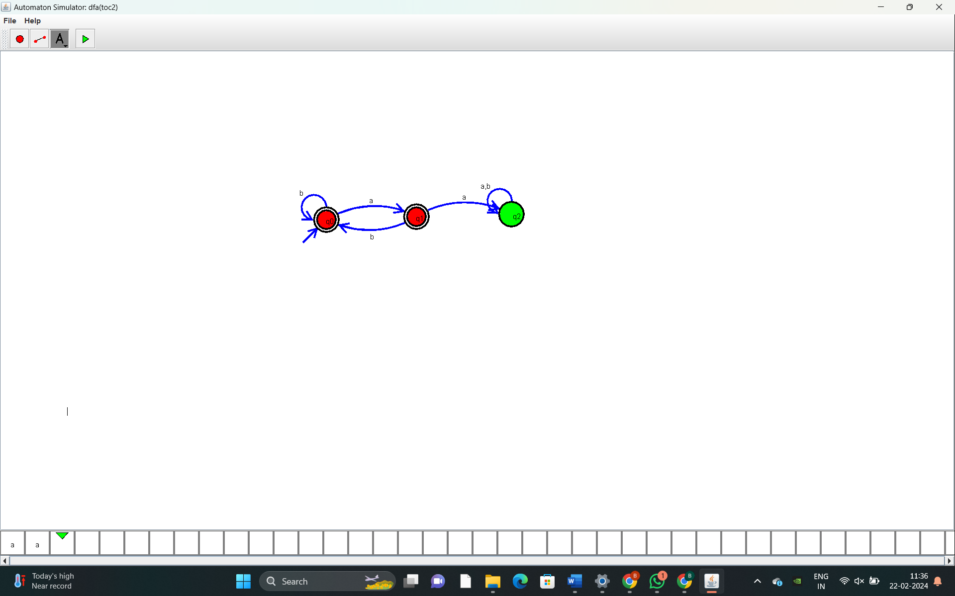

**2.1) Design NFA for the Binary strings having 00 as a substring**

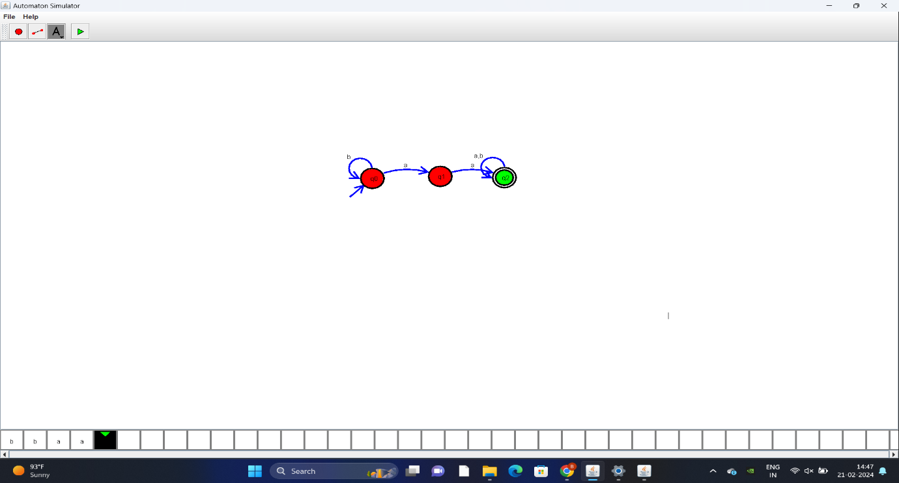

**2.2) Design NFA for the Binary strings that start and end with 0**

