Name: Krishna Karthik Reddy Jonnala

NYU ID: kj2056

Course Section Number: CSCI-GA.2433-001

**Project Part 1**

**Total in points** (100 points total): ____________________

**Professor’s Comments:**

**Business Requirements**

I chose a simpler business instead of an Insurance example as I am not well aware of terms mentioned involving Insurance. I chose a simple Electronics rental business as a case study for the project.

A **Customer** is any individual that has an account stored in the business’s database system. Each **Customer** has a unique ID, First Name, Last Name, Age (indicates account age not customer age, i.e., active since), Contact and Status (Good and Bad) which indicates the trust level of the Customer based on their previous transactions with the rental company. Customers can loan Electronics with software (**OS**) (for this project, let's consider onlyLaptop, Phone and Consoles for rental) and each has **Name** (Ex: MacBook Air M1), **Manufacturer** (Ex: Apple, Dell etc), **Year** in which the item was released, **Count** number of such items, **Cost** to rent the equipment for a month, **Rating**. An Electronic device can have multiple OS (dual boot etc).

The loaner laptops data is stored as **Loan**, which has start and due date of loan, deposit amount, status whether the laptop is returned within due date otherwise the Customer will be Penalized (Penalty). If Customer doesn’t return an item within the due date Customer’s status will be updated to Bad until the Penalty fee is paid. If a particular laptop is unavailable, the Customers can request to be notified (Notify) once the item is available.

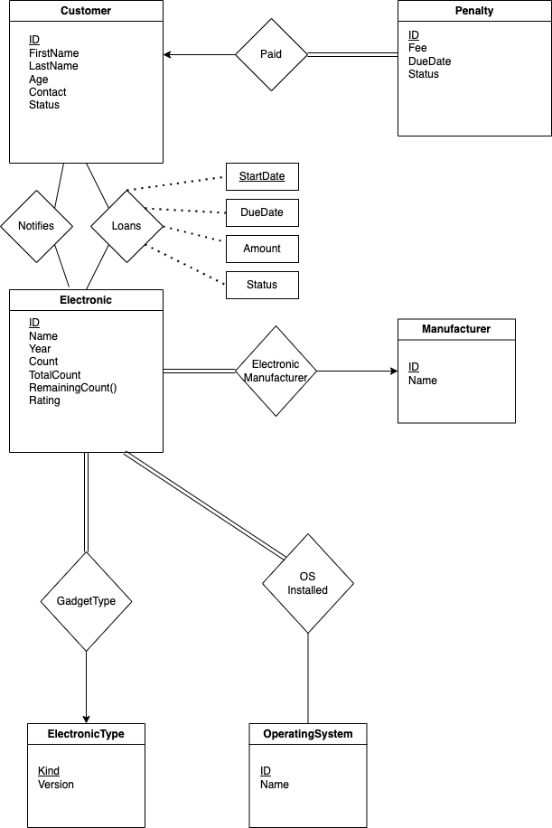

**Entity Sets**

* Entity Set **Customer** has a primary key as unique ID with attributes FirstName, LastName, Age (account active since), Contact and Status
* Entity Set **Electronic** has a primary key as a unique ID (Ex: Hardware ID) with attributes Name, release Year, TotalCount, Cost per day, Rating. RemainingCount() is a derived attribute.
* Entity Set **Manufacturer** indicates the manufacturer of the corresponding Electronic gadget. It has a primary key as a unique identifier ID with attributes Name.
* Entity set **ElectronicType** indicates the type(Laptop, Phone or console) of the gadget, it has a single attribute which is primary key Kind (Laptop, Phone or Console).
* Entity set **OperatingSystem** indicates the OS installed on the electronic device and it has primary key as unique identifier ID and other attribute Name.
* If the Customer does not return the loaned device by due date he will be penalized. This is saved in entity set **Penalty** with primary key as unique ID with attributes Fee, DueDate and Status.

**Relations**

* Relation Loans: When a Customer **Loans** an Electronic device. This is a many-to-many relation. Relationship attribute: StartDate with other attributes DueDate, Amount and Status.
* Relation Notifies: When a Customer opts to be notified if a certain Electronic device is in stock again to be loaned. This is a many-to-many relation.
* Relation Paid: When Customer finishes paying their fee due to a penalty. Each Penalty is linked to exactly one Customer and a Customer can have multiple penalties. Therefore this is a one-to-many relationship.
* Relation OSInstalled: An Electronic device should have at least one OS installed. There is no restriction on whether if every OS should have an electronic device in the catalog.
* Relation ElectronicManufacturer: Similar to OSInstalled, an electronic device should have at least one manufacturer but every manufacturer need not have a device in the catalog. Therefore this is a many-to-one relationship.
* Finally, relation GadgetType indicates the binary relation between device and the type of device.