Name: Krishna Karthik Reddy Jonnala

NYU ID: kj2056

Course Section Number: CSCI-GA.2433-001

**Project Part 2**

**Total in points** (100 points total): ____________________

**Professor’s Comments:**

**Logical Schema for ER model developed in Part 1**

Entities and Relations

* Customer (ID, FirstName, LastName, Age, Contact, Status)
* Penalty(ID, CustomerID, Fee, DueDate, Status) with foreign key CustomerID referring Customer(ID). Penalty data for corresponding deleted Customer can be removed. Cascade on delete.
* Electronic(ID, Name, Year, TotaCount, Rating, ManufacturerID, Kind) with foreign key ManufacturerID, Kind referencing to Manufacturer(ID) and ElectronicType(Kind)
* OperatingSystem(ID, Name)
* ElectronicType(Kind, Version)
* Manufacturer(ID, Name)
* Loans(CustomerID, ElectronicID, StartDate, DueDate, Amount, Status) with foreign keys (CustomerID, ElectronicID) referring to Customer(ID), Electronic(ID). Relation value can be deleted once the Customer/Electronic item is deleted. Cascade on Delete.
* Notifies(CustomerID, ElectronicID) foreign key CustomerID, ElectronicID referring to Customer(ID) and Electronic(ID)
* OSInstalled(ElectronicID, OperatingSystemID) foreign key ElectronicID, OperatingSystemID referring to Electronic(ID) and OperatingSystem(ID)

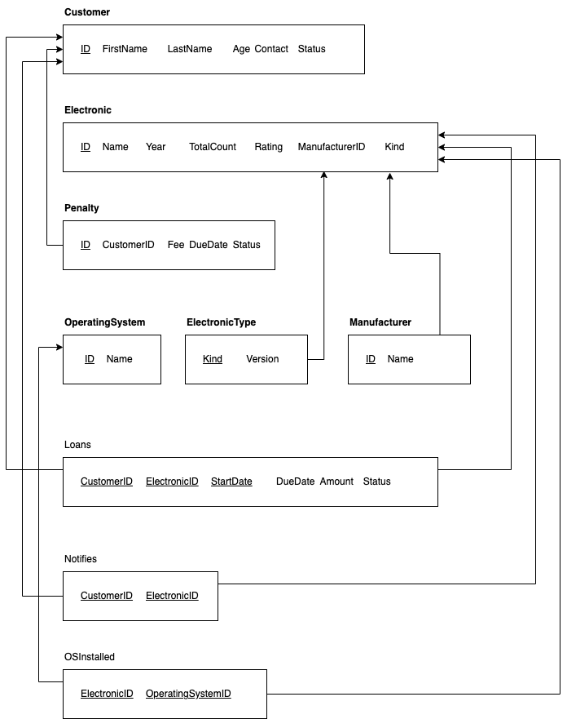

**Normalization and extensions**

At least 3NF is required for all to not suffer from update anomalies in the database.

* Customer (ID, FirstName, LastName, Age, Contact, Status)

All attributes are atomic and it has a single attribute as primary key, hence at least 2NF. As there are no transitive dependency for non-primary attributes and 2NF, therefore it satisfies 3NF

* Penalty(ID, CustomerID, Fee, DueDate, Status)

All attributes are atomic and it has a single attribute as primary key, hence at least 2NF.

Non-primary key attributes have no transitive dependency so it satisfies 3NF

* Electronic(ID, Name, Year, TotaCount, Rating, ManufacturerID, Kind)

All attributes are atomic and it has a single attribute as primary key, hence at least 2NF.

Non-primary key attributes have no transitive dependency so it satisfies 3NF

* OperatingSystem(ID, Name)

All attributes are atomic and it has a single attribute as primary key, hence at least 2NF.

Non-primary key attributes have no transitive dependency so it satisfies 3NF

* ElectronicType(Kind, Version)

All attributes are atomic and it has a single attribute as primary key, hence at least 2NF.

Non-primary key attributes have no transitive dependency so it satisfies 3NF

* Manufacturer(ID, Name)

All attributes are atomic and it has a single attribute as primary key, hence at least 2NF.

Non-primary key attributes have no transitive dependency so it satisfies 3NF

* Loans(CustomerID, ElectronicID, StartDate, DueDate, Amount, Status)

All attributes are atomic and non-primary key attributes are not partially dependent on the candidate key.

Non-primary key attributes have no transitive dependency so it satisfies 3NF

* Notifies(CustomerID, ElectronicID)

All attributes are atomic and no non-primary keys so at least 3NF.

* OSInstalled(ElectronicID, OperatingSystemID)

Similar to Notifiedz, this is at least 3NF.