Name: Krishna Karthik Reddy Jonnala

NYU ID: kj2056

Course Section Number: CSCI-GA.2433-001

**Project Part 3**

**Total in points** (100 points total): ____________________

**Professor’s Comments:**

**Implementation**

Made a few name changes like ID to CustomerID, Status to Customer Status in order to avoid using SQL default terms.

Code available at: <https://github.com/krishnakarthiknyu/databasecourseproject>

Tools used:

* Local MySQL server on Ubuntu
* Azure Data Studio as IDE for writing SQL scripts. It helped in running sql commands and queries similar to python scripts in Jupyternotebook.
* Python to convert the dataset into desired format (need numpy and pandas)
* Azure Database for MySQL flexible server

Data processing and cleaning up:

* For now, I am considering only Laptops as part of the project
* Dataset used: <https://www.kaggle.com/code/danielbethell/laptop-prices-prediction/data>
* It has various laptop information and price details. I’ve used python to clean up the data and only have the required information.
* The cleaned up data is formatted into desired format and saved as manufacturers.csv, electronics.csv, osinstalled.csv
* The above mentioned python code can be viewed here: [code](https://github.com/krishnakarthiknyu/databasecourseproject/blob/main/laptopdataprocessing.py)

**Database definitions and creation of tables**

SQL script: [DefinitionsAndInitiation.sql](https://github.com/krishnakarthiknyu/databasecourseproject/blob/main/DefinitionsAndInitiation.sql)

Database with the name *‘Rentaldb’* is created.

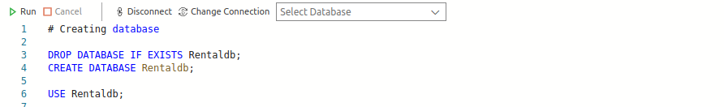

Tables are created for each of the Entities mentioned in previous parts

*Customer*

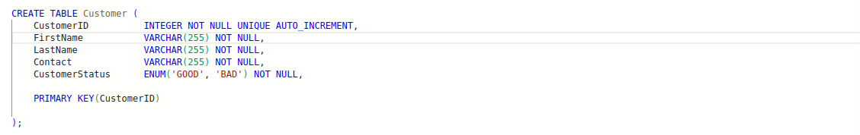

*Penalty*

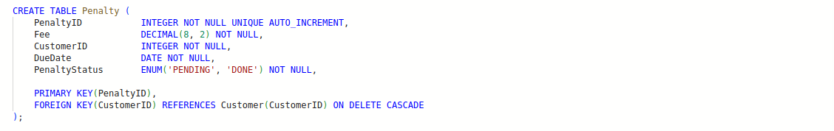

*Manufacturer*

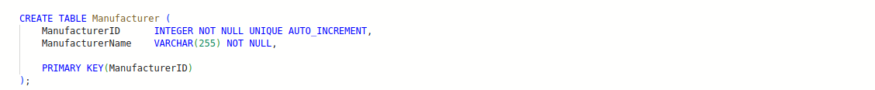

*ElectronicType*

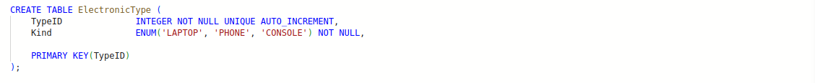

*Electronic and Operating System*

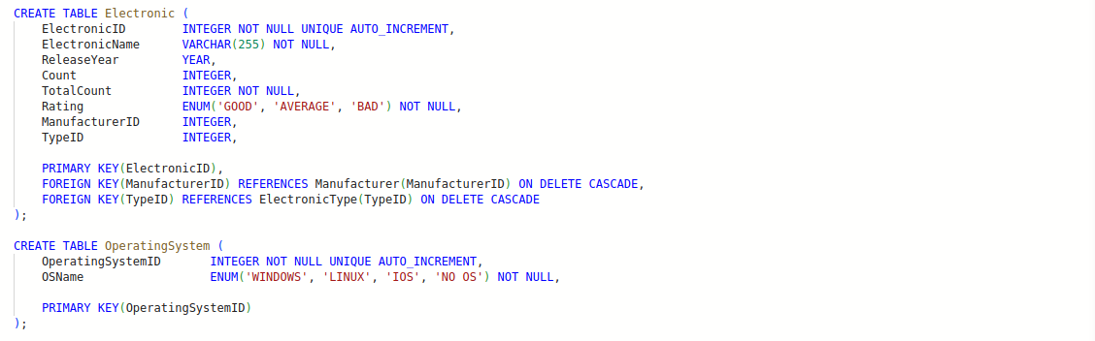

Tables are created for relations:  *Loans, Notifies, OSInstalled*

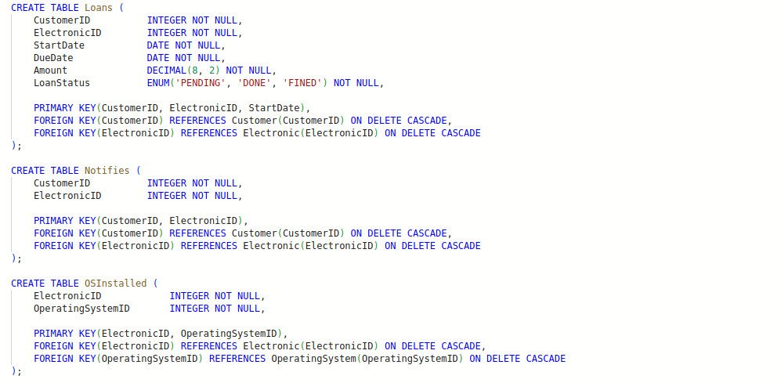

Couple of views are created for better viewing of the data: *ElectronicOSView and TotalPenaltyView*

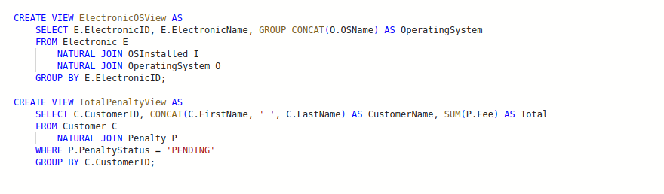

**Inserting some test data into the database**

SQL Script: [InsertData.sql](https://github.com/krishnakarthiknyu/databasecourseproject/blob/main/InsertData.sql)

Here I inserted few rows of data into *Customer, ElectronicType, OperatingSystem* tables

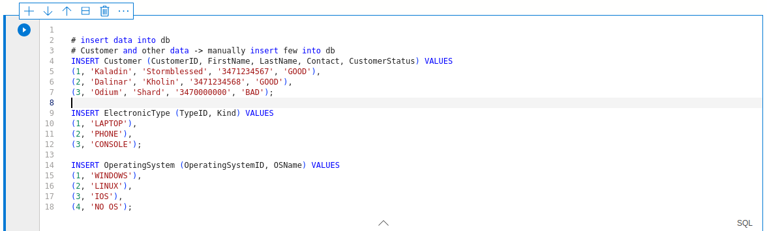

Querying the data to check

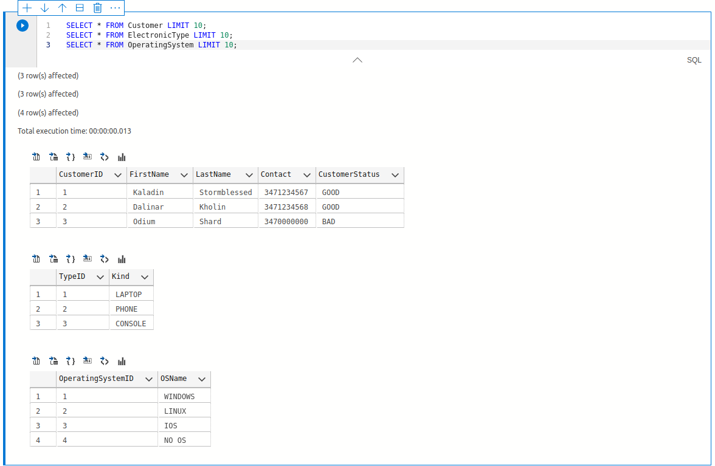

In order to upload the data from ‘manufacturers.csv’, ‘electronics.csv’ and ‘osinstalled.csv’ i used LOAD INTO command in SQL but it gave few issues as SQL only allow files inside sequre_file_priv directory which for my case is: ‘/var/lib/mysql-files/manufacturers.csv’

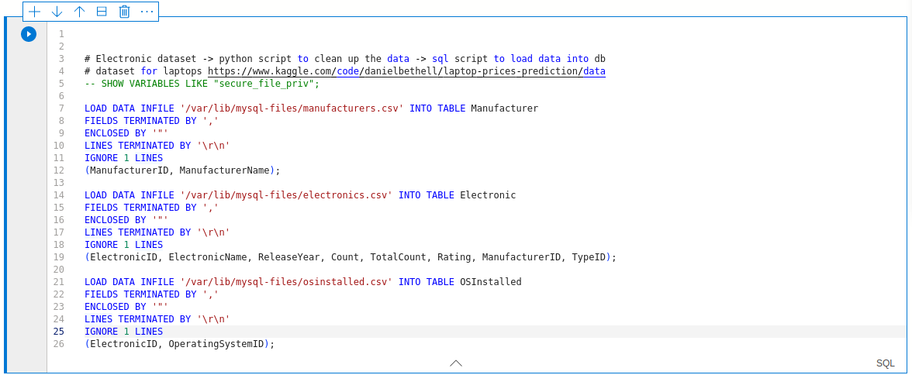

Queried the data to verify.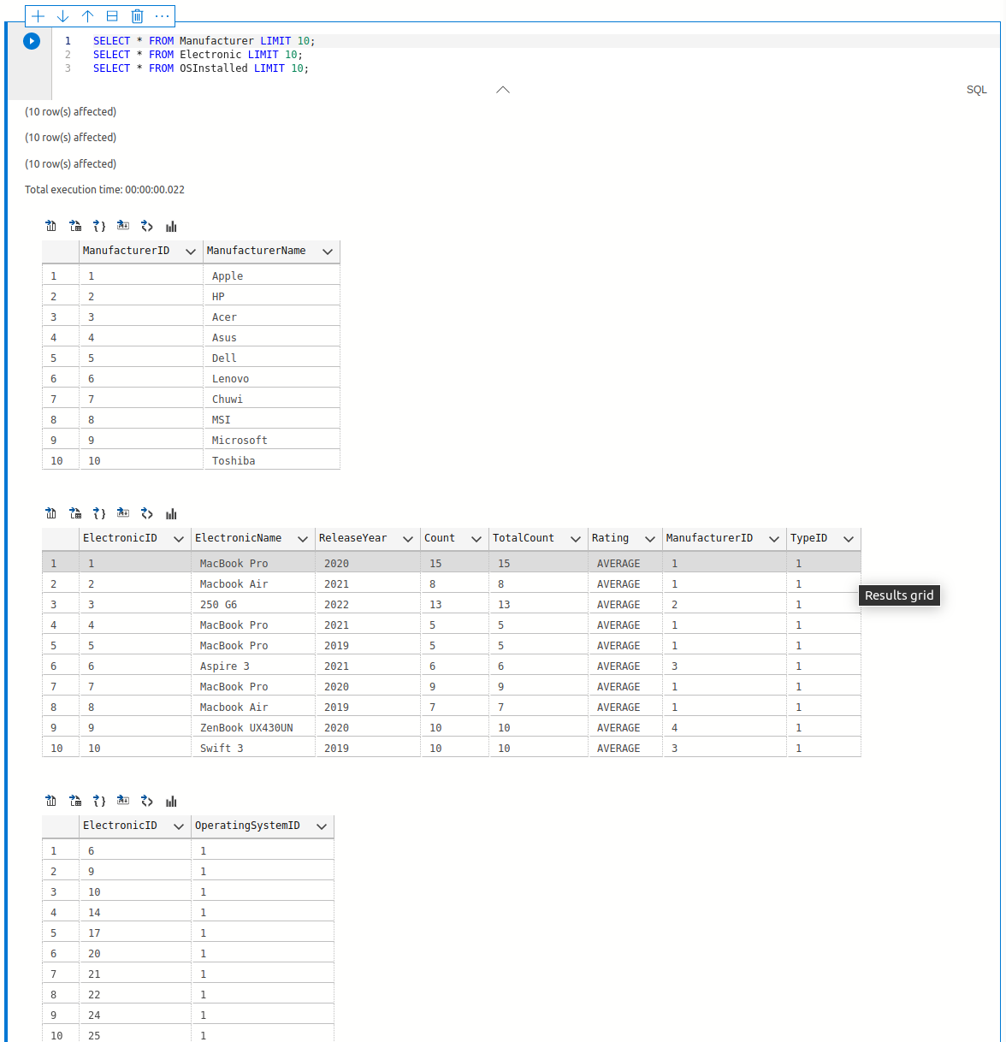

Inserted relations data

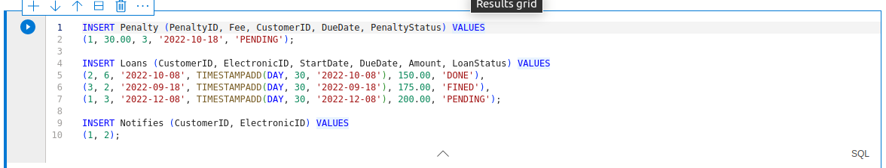

Query

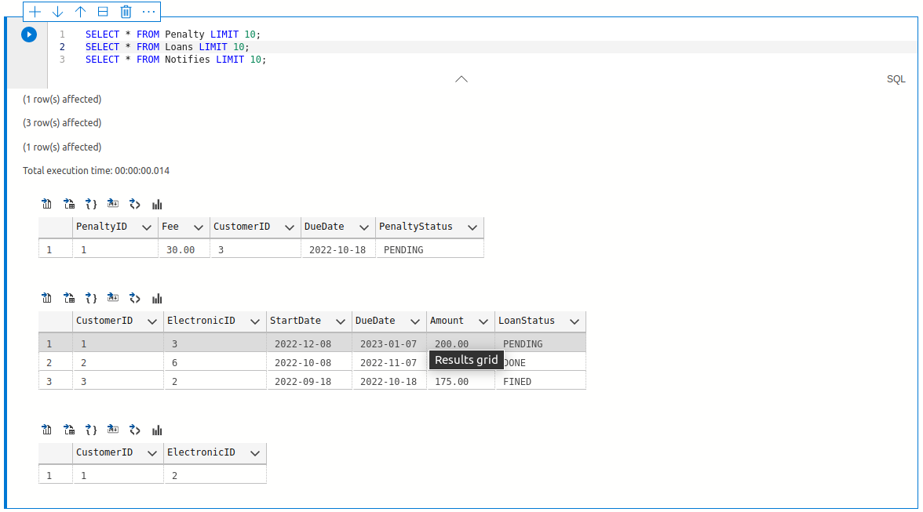

**Queries and Updates essential for the business use cases**

SQL Script: [Procedures_and_examples.sql](https://github.com/krishnakarthiknyu/databasecourseproject/blob/main/procedures_and_examples.sql)

* If we want to know what electronics are available and their operating system details

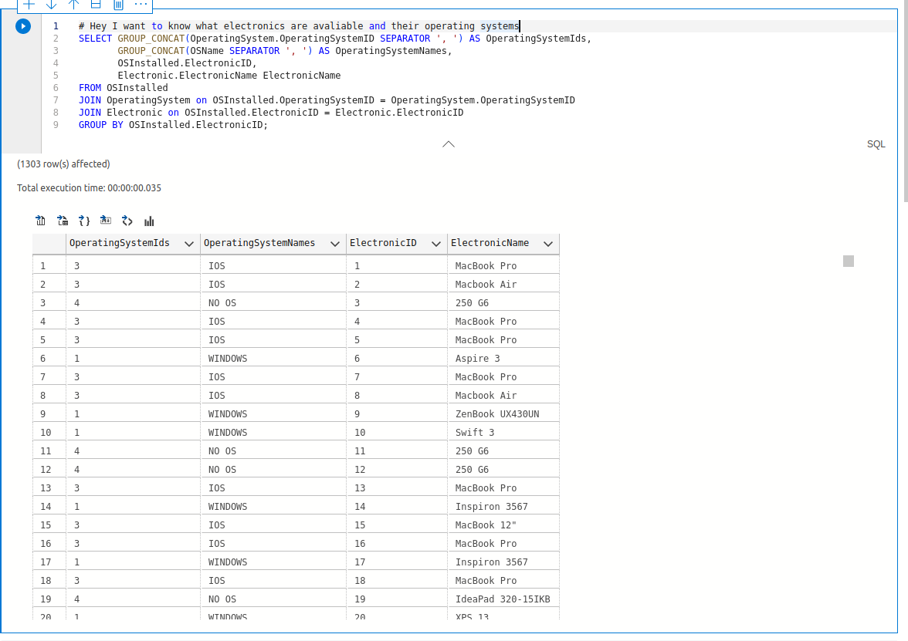

* If we want to know total penalty due by a customer

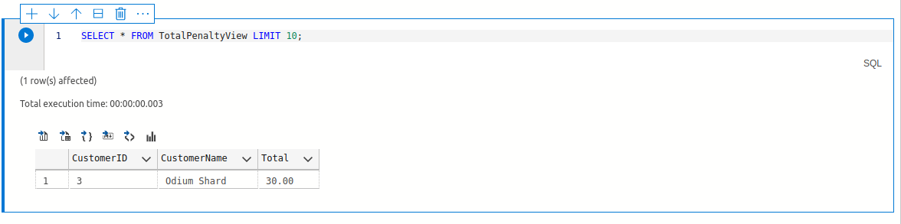

* To view total number of devices which have a particular OS installed (A device can have multiple OS installed, dual boot etc)

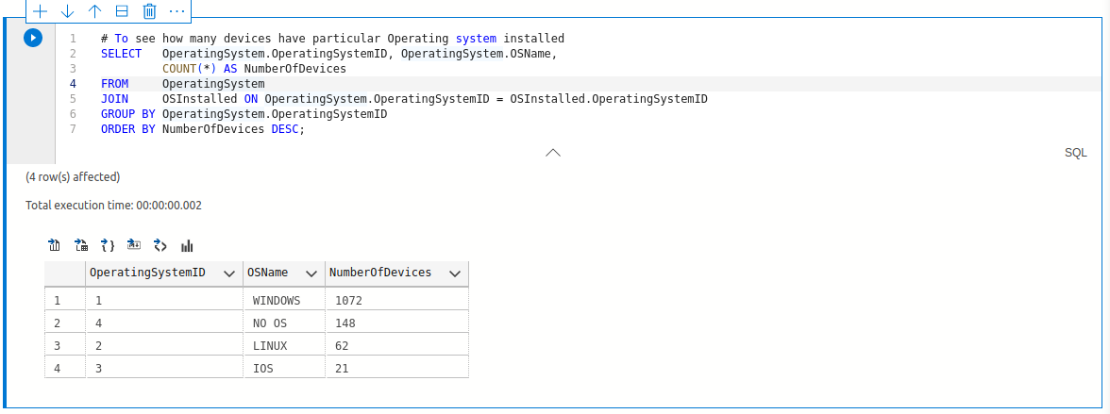

* To check all customers active loans and pending loan details

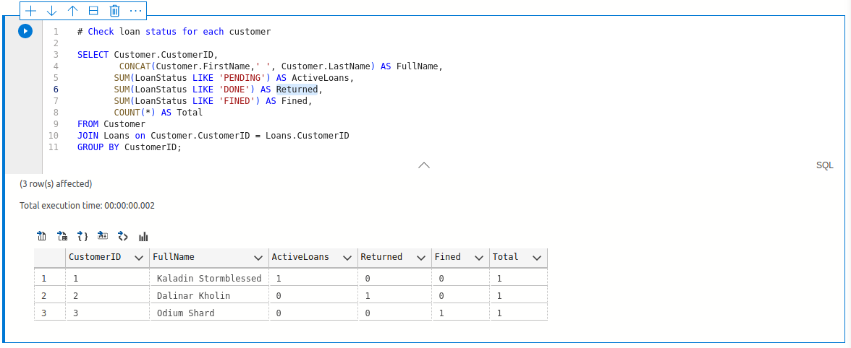

**Other Procedures and Events**

* Procedure for loaning a device to a customer.

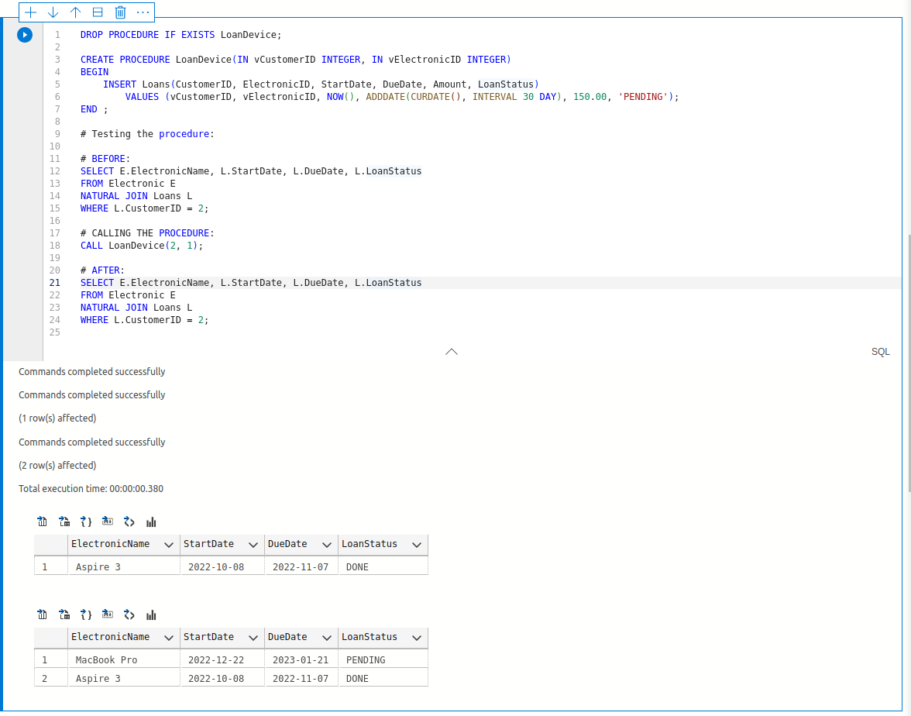

* Procedure to penalize customers if they missed the due date.

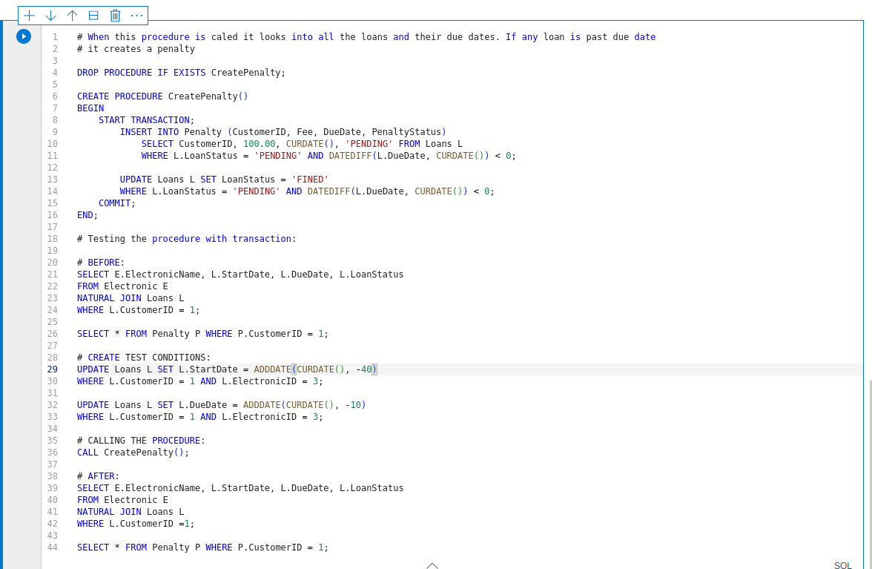

Before penalty:

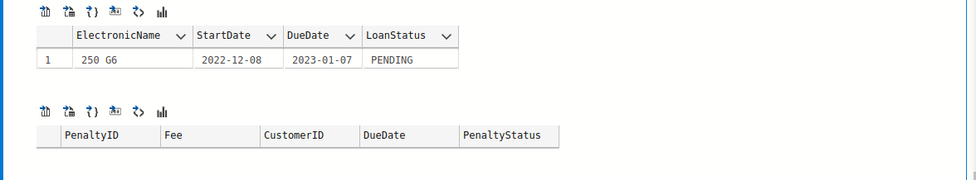

After penalty:

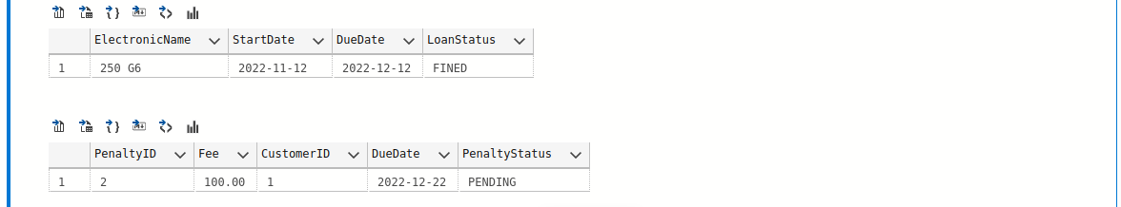

* If a customer has a pending loan and request for new loan - Deny

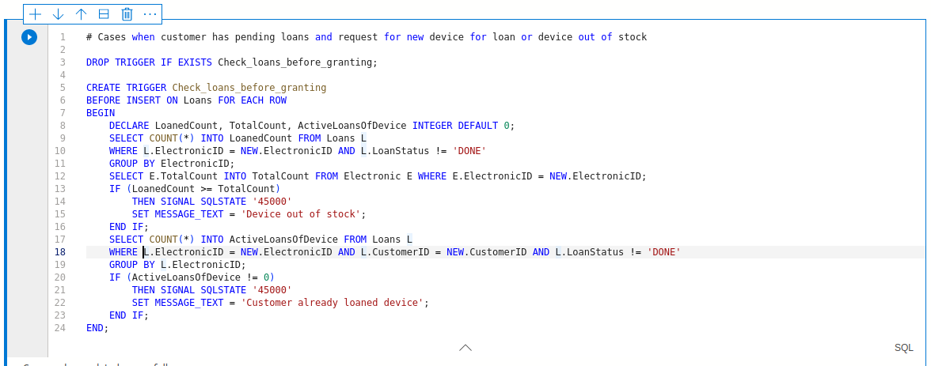

Test

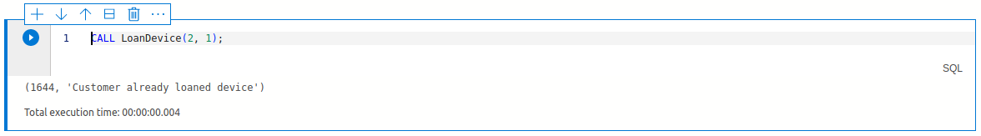

* Respond device out of stock if the electronic item is all loaned out

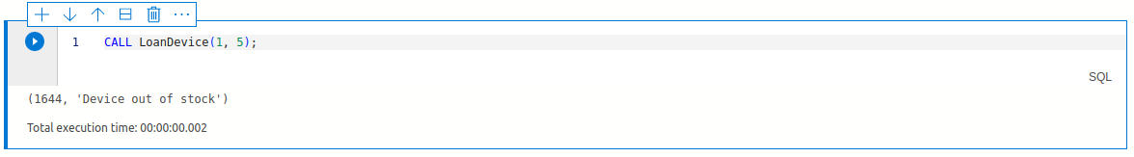

* At EOD check for all late due loans and create penalties for each of them

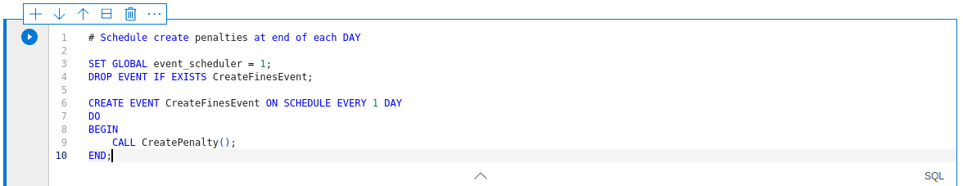

* Some updates on tables

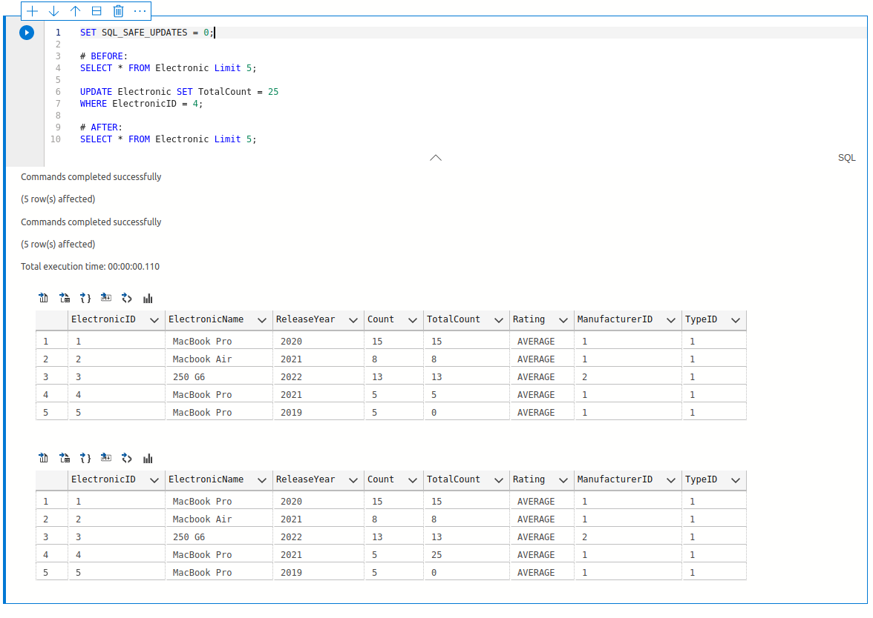

**Update on implementation progress**

All these are done in local db and later planning to do it on Azure MySQL server. For now, I was able to insert some of the data into the cloud.

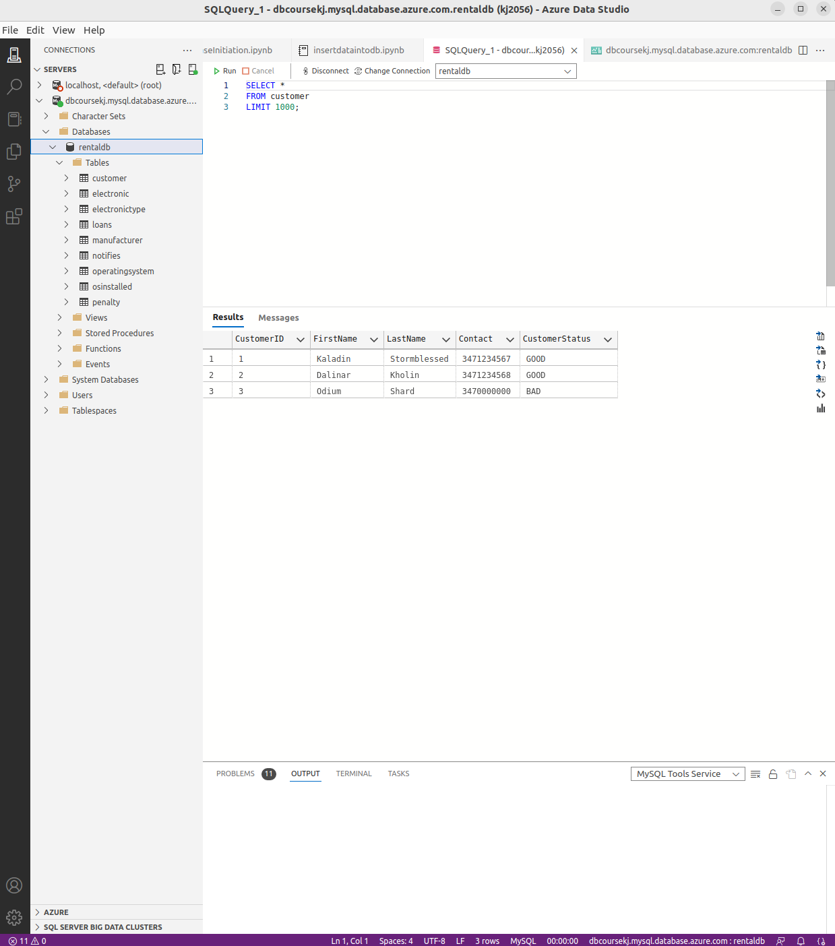

**Improvements and Future work**

* For current implementation, the laptop data processing and cleaning up is done in external python script. Ideally this can be done as a service function, where when a data dump is received, it automatically processes the data.
* More details about the electronic devices like RAM, CPU etc can be maintained in future also devices other than laptops (like mobiles, consoles etc) should be added.
* Predictions for right pricing of devices can be made in future based on popularity and depreciation from its release year.
* Simple secure login and UI could be useful to view.
* When a customer subscribes to be notified when an out of stock device is back in stock, the business should be able to notify the customer through his contact details.

**How to run this locally**

1. For the laptop pricing data, we need Python3, numpy and pandas. Or you can find the required CSV files in codebase ‘data/’ directory.
   1. RUN `python laptopdataprocessing.py`
   2. to generate the required data in csv format.
2. MySQL server running
3. Run `DatabaseInitiation.sql` SQL script that will create the database and the tables
4. Run `InsertData.sql` script to insert data into the tables. Before running the script make sure to
5. Find out the secure file directory by `SHOW VARIABLES LIKE “secure_file_priv”`
6. Move the csv files created in step 1 to the above directory
7. Or we can skip a, b if we use sql management studio and upload the CSV files.

5. Run `procedures_and_examples.sql` to run some example queries and updates.

**References and Tools**

* Dataset: <https://www.kaggle.com/code/danielbethell/laptop-prices-prediction/data>
* Cleaning up dataset: <https://www.kaggle.com/code/danielbethell/laptop-prices-prediction/notebook>
* Inspired from [library catalog system](https://github.com/seby-sbirna/Database-Design-Modeling-and-Programming-of-National-Library-Catalog-System)
* Azure Data [Studio](https://azure.microsoft.com/en-us/products/data-studio/#overview)