|  |
| --- |
| Work Force Management |
|  |
| December 13  Softura Techologies  Authored by: Krishna Keshav M |

# Executive Summary

|  |
| --- |
| This project on Workforce Management (WFM) provides an integrated package of functionalities for managers as well as the WFM member. This portal holds the central master data of employees along with their skill set for the managers to view and soft lock employer profiles. For the WFM member, this portal shall be used to view the details of the pending approvals with detailed information on requestee and appropriate description. WFM member shall approve or reject a request. |
| React framework is used for the software implementation.  Node JS is used as backend code base  DataTables are used to render the values as record wise |
| http://localhost:8000/users/sign  *Login API:* http://localhost:8000/users/signin |

High Level Architecture

Manager

WFM

Users

WFM Member

|  |  |
| --- | --- |
| View list of employees with skill set | View list of soft lock requests |
| View status of the lock request | View details by clicking on a particular request |
| Option to soft lock by entering details | Approve or Reject soft lock requests |

## Manager

*API Definitions*

*<http://localhost:8000/users/manager> - Fetch list of employees with details*

*<http://localhost:8000/users/updateEmployeeStatus> - submit softlock request*

*Database specifications*

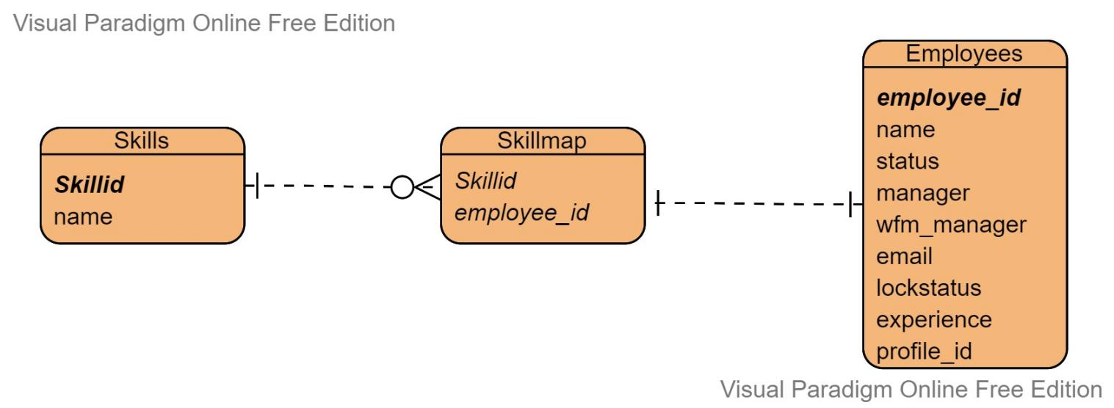

*UI Implementation*

Screen 1: List of employees with skills, experience, manager and lock status

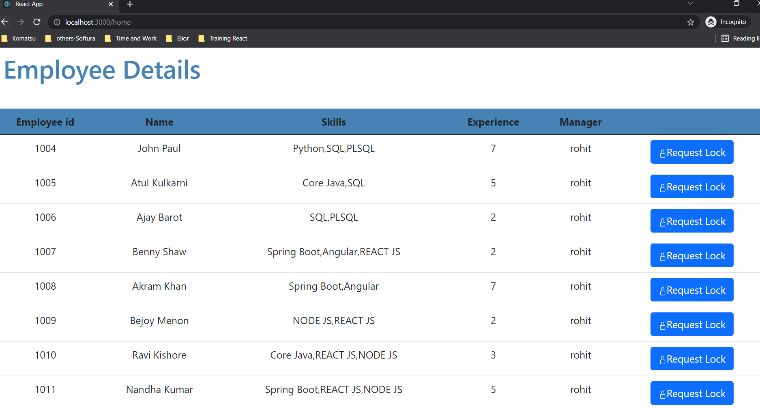

Screen 2: Soft lock confirmation screen

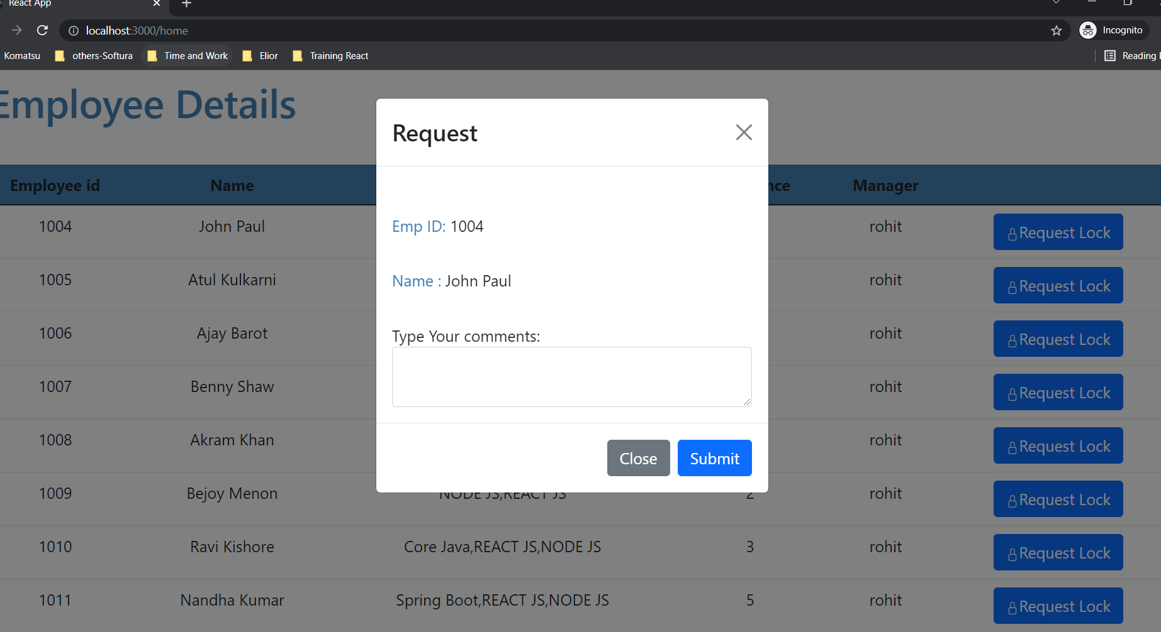

## WFM Member

*API Definitions*

*<http://localhost:8000/users/getwfmManager> - Fetch list of softlock requests*

http://localhost:8000/users/updateEmployeeStatus *- Update softlock status as approved/Rejected*

*Database specifications*

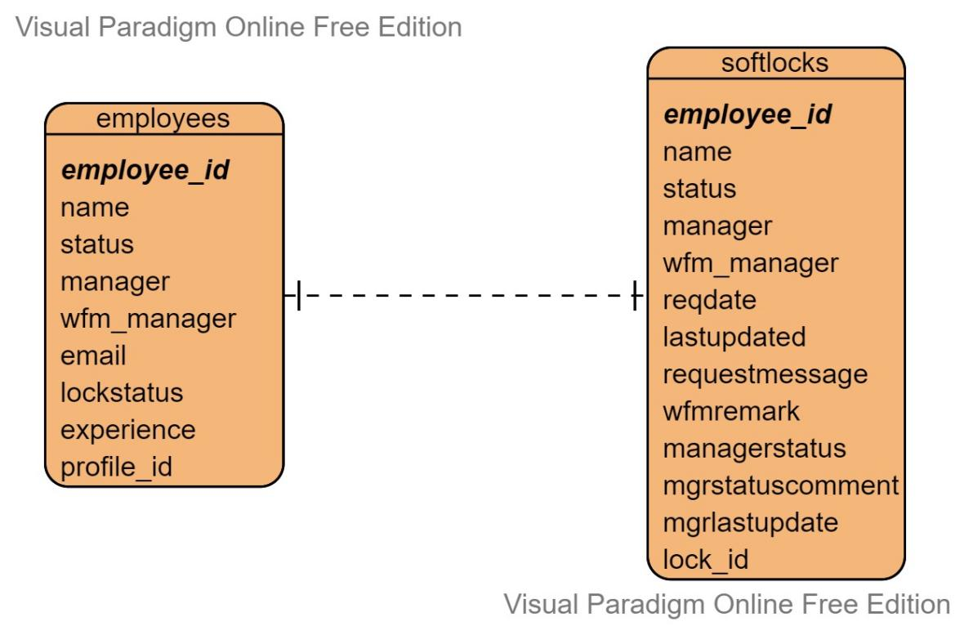

*UI Implementation*

Screen 1: List of pending softlock requests

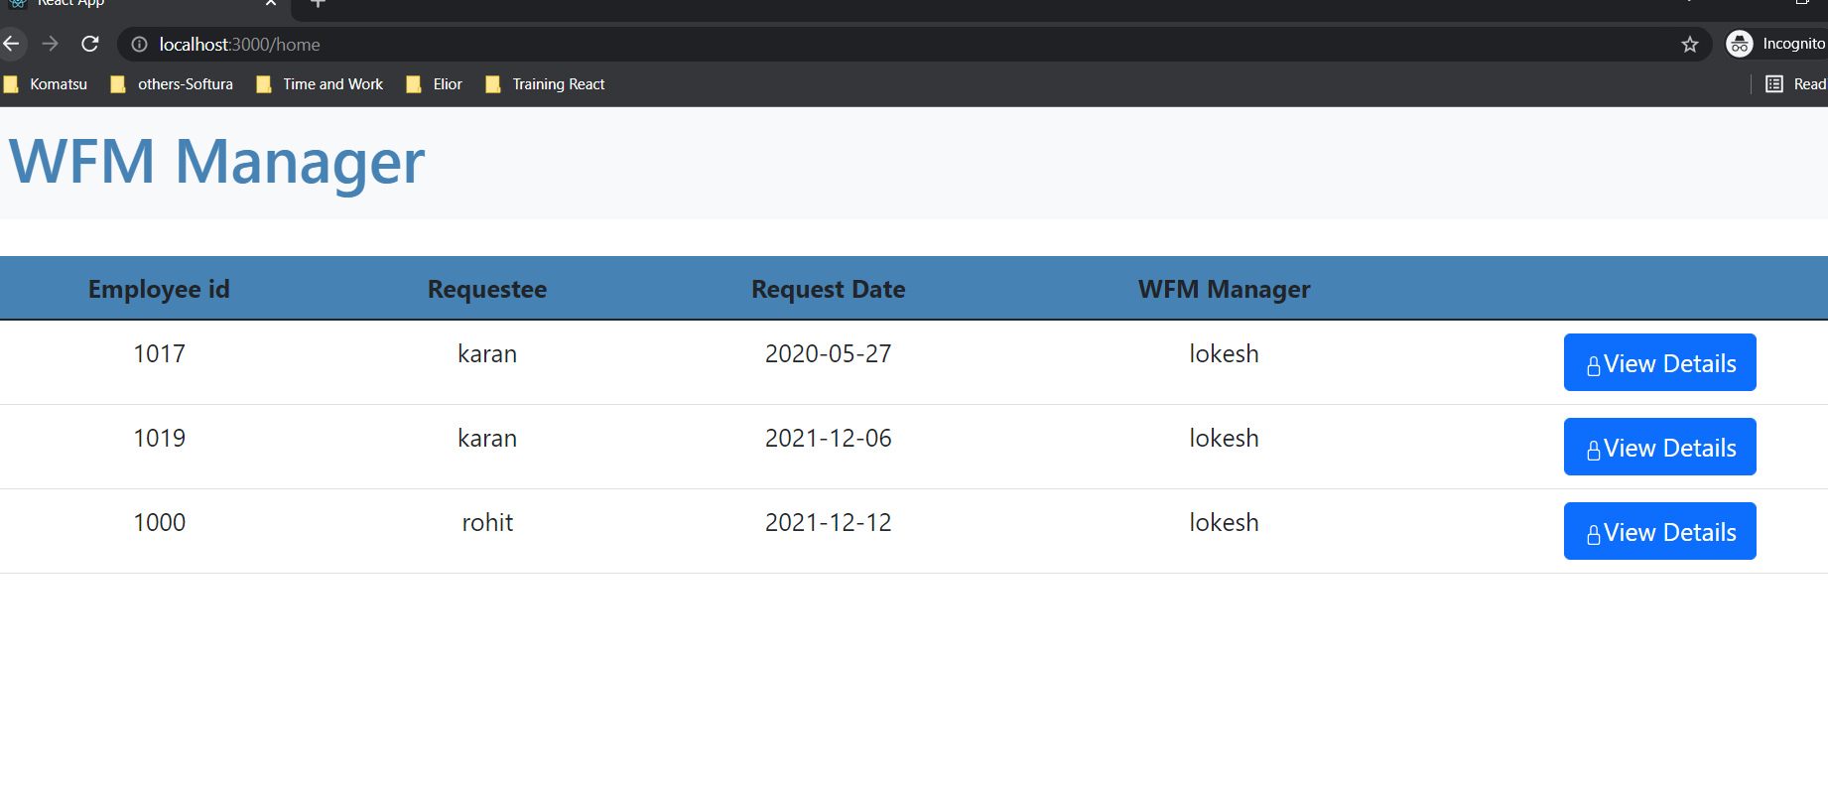

Screen 2: View details page upon clicking a particular request

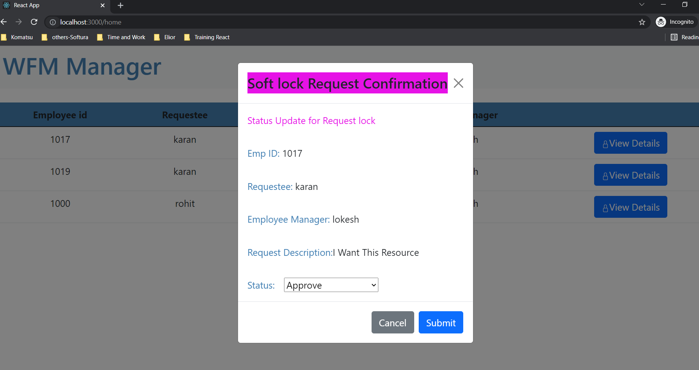

Screen 3: Updated status

