WEEK 2
DATA VISUALIZATION AND
INSIGHT COMMUNICATION USING R
Hotel Booking Demand Dataset

Submitted by | Krishna
Programme | Master of Computer Applications (MCA)
Institution | PK University, Shivpuri
Software | R / RStudio with ggplot2

1. Introduction
This Week 2 analysis continues the cleaned Hotel Booking Demand dataset prepared during Week 1. The purpose is to communicate important patterns through clear and informative visualizations in R. The analysis uses ggplot2 and includes bar charts, line charts, a histogram, scatter plot, box plot, percentage comparison, and a multi-series trend chart.

2. Objectives
- Create informative and technically accurate visualizations using R.
- Identify booking trends, cancellation patterns, pricing behaviour, market-segment differences and seasonality.
- Select chart types that match the type of data and the analytical question.
- Explain each visualization in non-technical language and communicate actionable insights.
- Produce high-quality 300 DPI chart images suitable for reporting.

3. Dataset Overview
The cleaned dataset contains 87,221 hotel booking records and 33 variables. It includes two hotel types (City Hotel and Resort Hotel), booking status, arrival month, lead time, Average Daily Rate (ADR), market segment and several other booking-related variables. Week 1 cleaning removed missing/invalid records, exact duplicates and implausible ADR records before this visualization stage.
Dataset Feature | Value
Cleaned observations | 87,221
Variables | 33
Hotel types | City Hotel, Resort Hotel
Visualization library | ggplot2
Output format | PNG, 300 DPI

4. R Setup
hotel_data <- read.csv("hotel_bookings_cleaned.csv")
library(ggplot2)
dim(hotel_data)
str(hotel_data)
The cleaned CSV was imported into R and ggplot2 was loaded for visualization. Month names were converted to an ordered factor before time-based charts so that January through December appeared chronologically.

5. Visualization Analysis and Insight Communication
The following visualizations were selected to answer different analytical questions. Each section includes the R code, the resulting chart, the reason for the chart choice and a concise interpretation.

5.1 Number of Bookings by Hotel Type
Visualization type: Bar chart
ggplot(hotel_data, aes(x = hotel, fill = hotel)) +
geom_bar() +
labs(title = "Number of Bookings by Hotel Type",
x = "Hotel Type", y = "Number of Bookings") +
theme_minimal() +
theme(legend.position = "none")
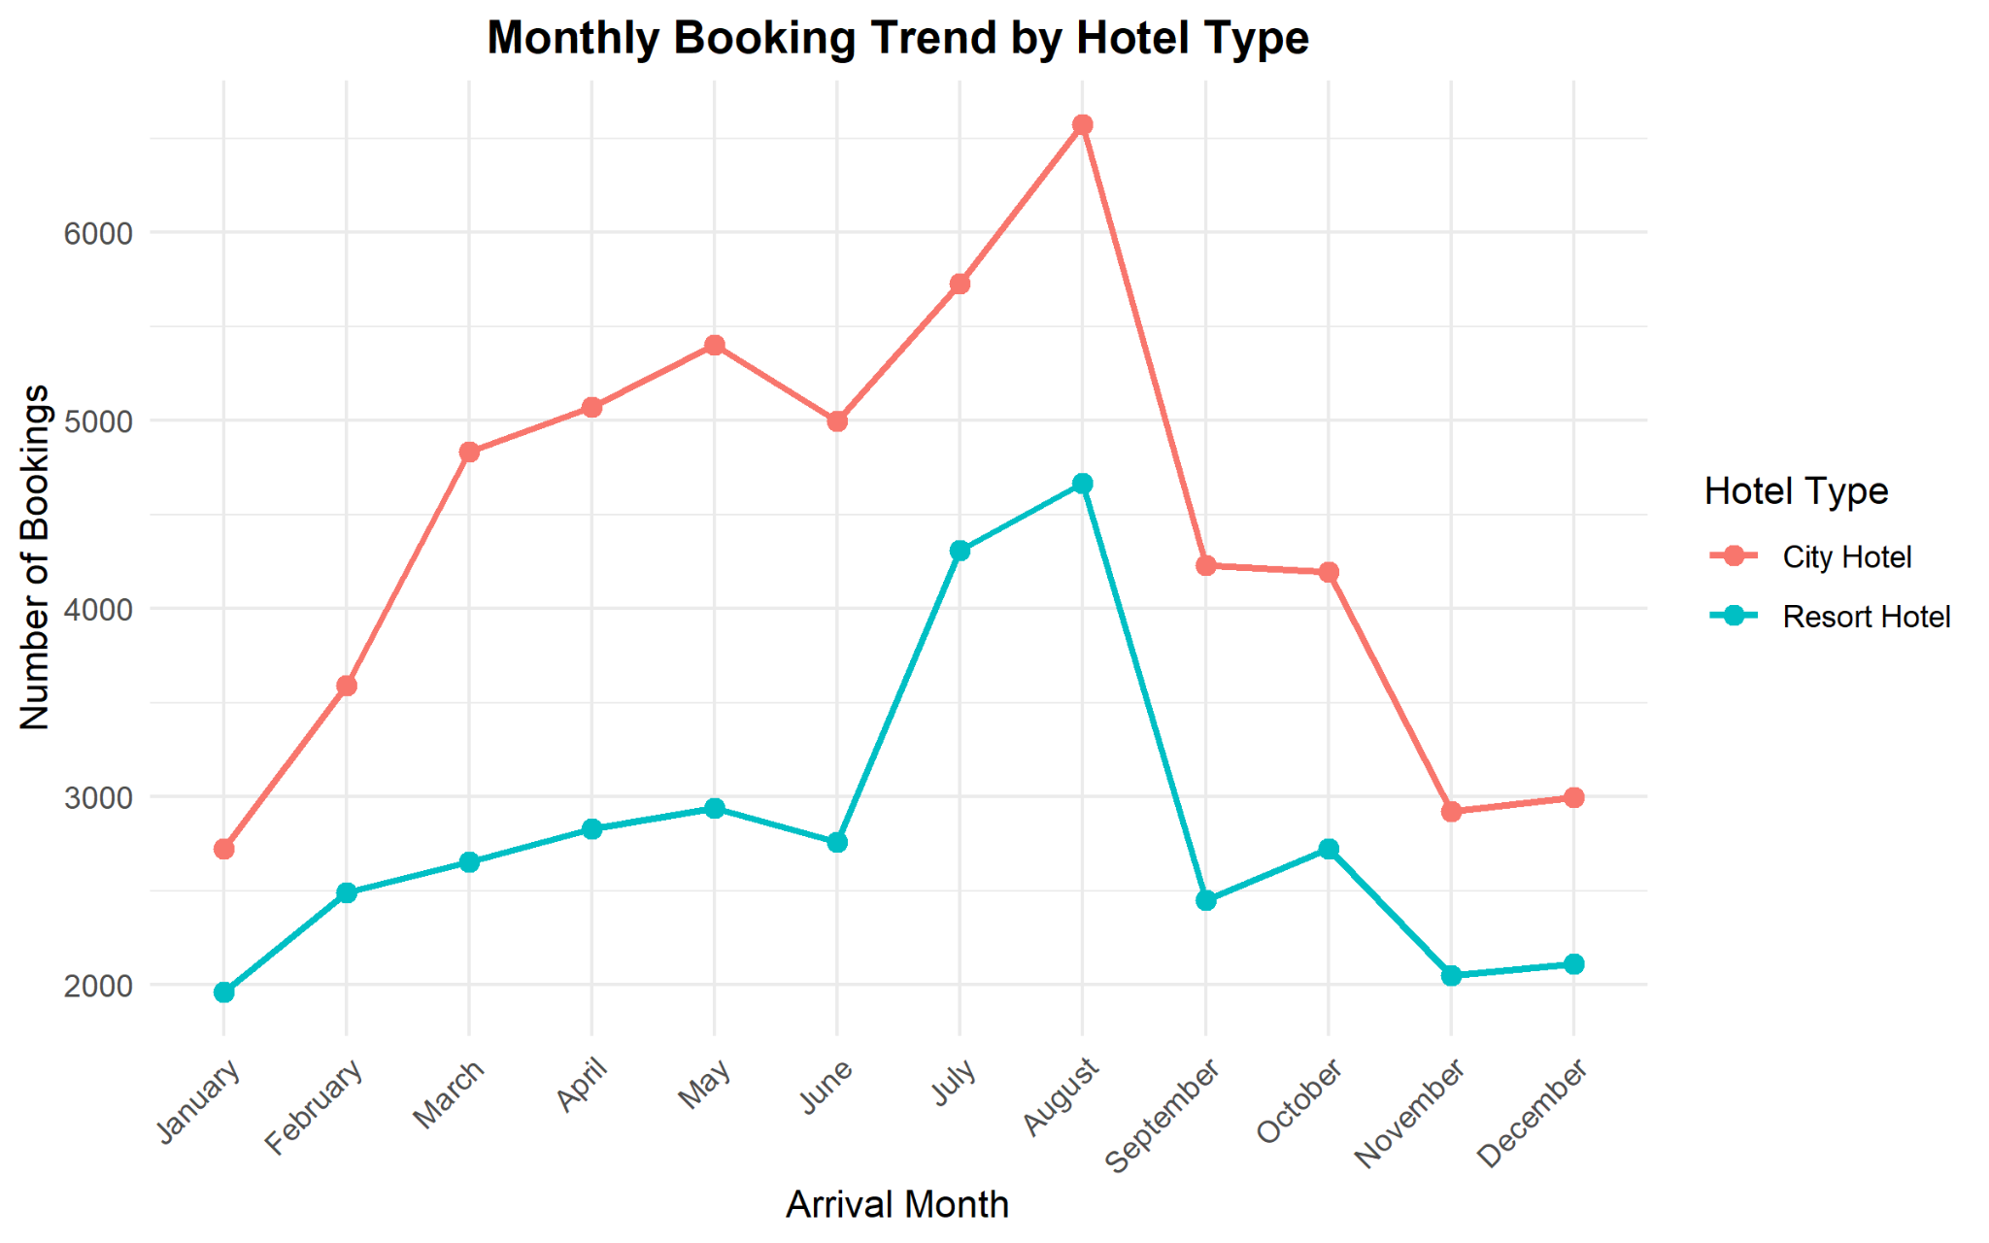
Figure 1. Number of Bookings by Hotel Type
Why this visualization was selected: A bar chart is appropriate because hotel type is categorical and the objective is to compare the number of records in each category.
Interpretation and insight: City Hotel accounts for 53,271 bookings, while Resort Hotel accounts for 33,950. City Hotel therefore represents the larger share of the cleaned dataset and shows higher overall booking demand.

5.2 Hotel Booking Cancellation Status
Visualization type: Bar chart
hotel_data$cancellation_status <- ifelse(
hotel_data$is_canceled == 1, "Cancelled", "Not Cancelled"
)
ggplot(hotel_data, aes(x = cancellation_status,
fill = cancellation_status)) +
geom_bar() +
labs(title = "Hotel Booking Cancellation Status",
x = "Booking Status", y = "Number of Bookings") +
theme_minimal()
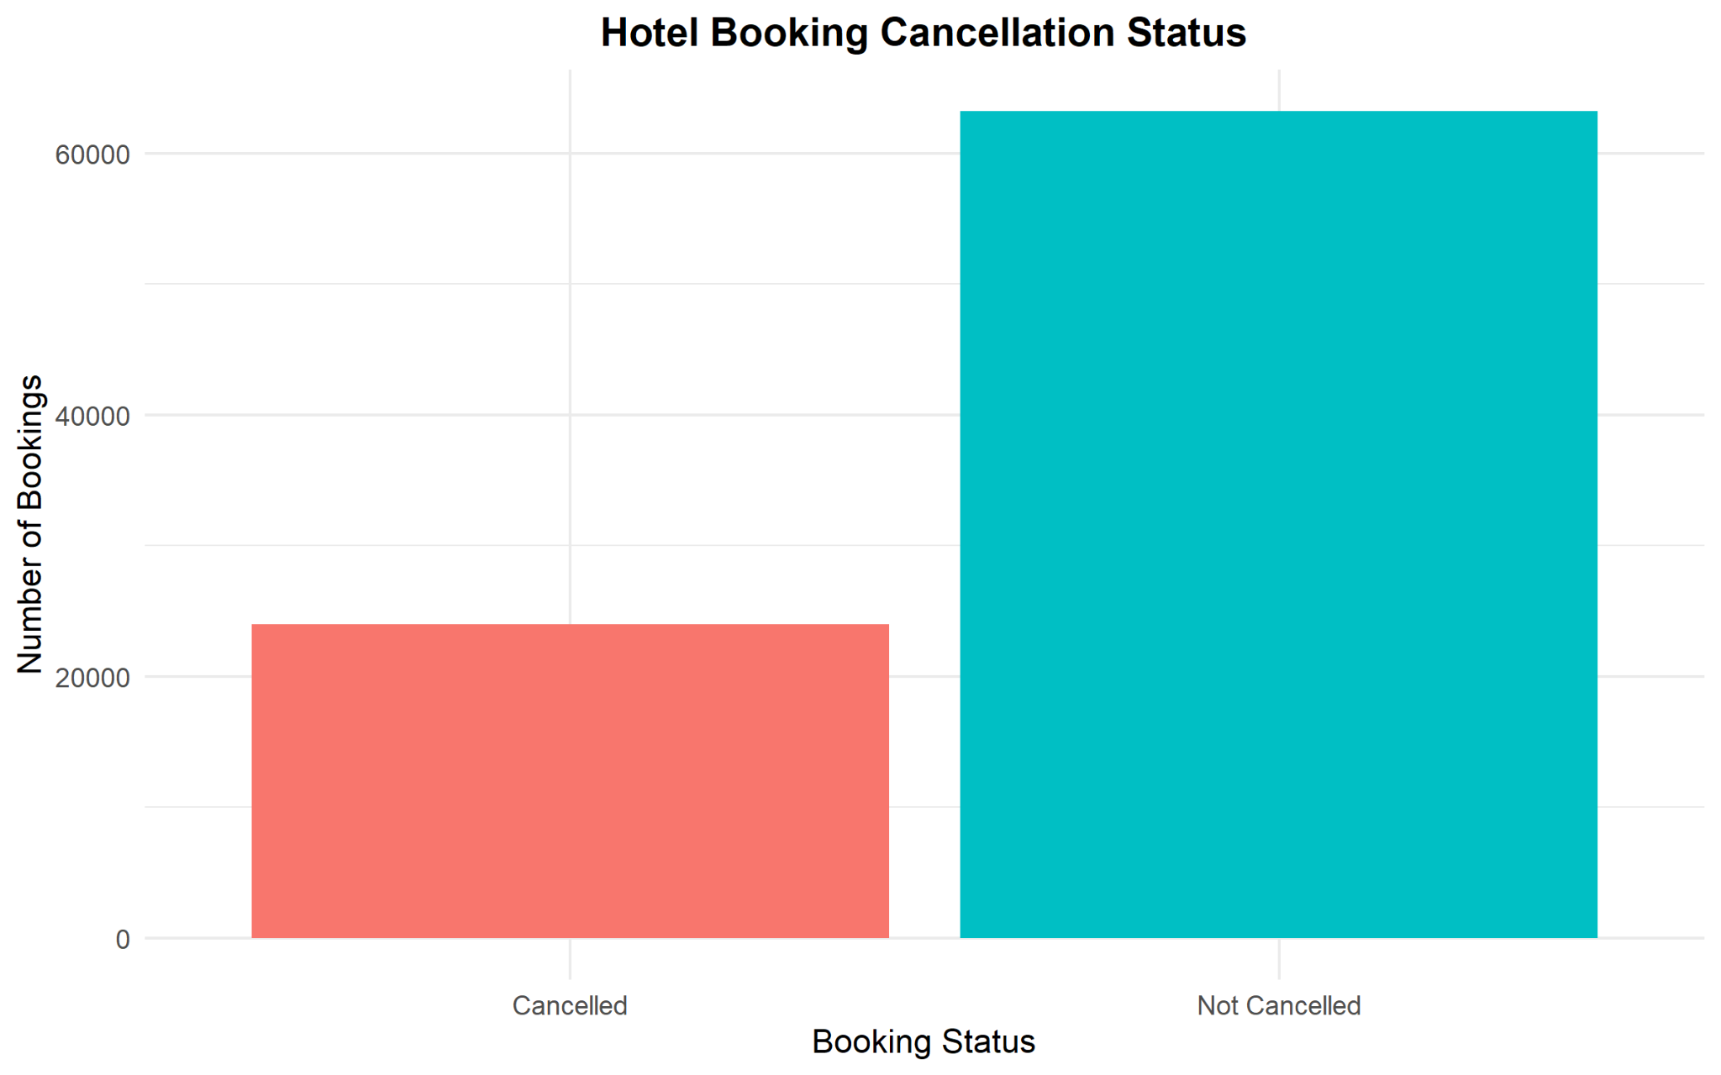
Figure 2. Hotel Booking Cancellation Status
Why this visualization was selected: The two booking-status categories are discrete, so a bar chart gives an immediate comparison of their frequencies.
Interpretation and insight: Most bookings were not cancelled. There were 63,213 non-cancelled bookings and 24,008 cancelled bookings, corresponding to an overall cancellation rate of about 27.5%.

5.3 Monthly Trend of Hotel Bookings
Visualization type: Line chart
hotel_data$arrival_date_month <- factor(
hotel_data$arrival_date_month,
levels = c("January","February","March","April","May","June",
"July","August","September","October","November","December"),
ordered = TRUE
)
monthly_bookings <- as.data.frame(
table(hotel_data$arrival_date_month)
)
colnames(monthly_bookings) <- c("Month", "Bookings")
ggplot(monthly_bookings,
aes(x = Month, y = Bookings, group = 1)) +
geom_line(linewidth = 1) +
geom_point(size = 3) +
theme_minimal()
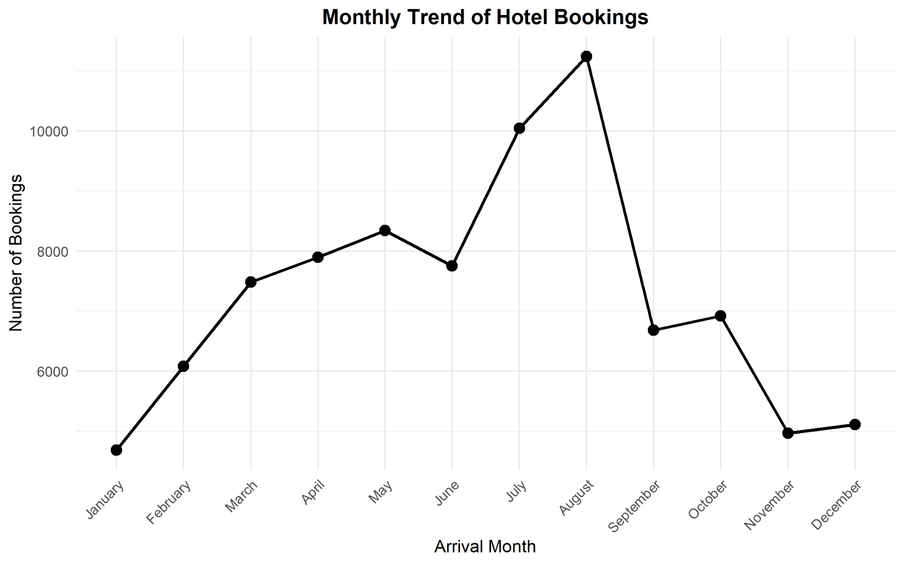
Figure 3. Monthly Trend of Hotel Bookings
Why this visualization was selected: Month is an ordered time variable. Connecting monthly totals with a line makes the direction and seasonality of demand easy to see.
Interpretation and insight: Bookings generally rise from January toward the summer period. August is the highest month with 11,242 bookings, followed by July with 10,042. January is the lowest at 4,685. The sharp fall after August indicates a clear seasonal pattern.

5.4 Distribution of Booking Lead Time
Visualization type: Histogram
ggplot(hotel_data, aes(x = lead_time)) +
geom_histogram(bins = 30, color = "white") +
labs(title = "Distribution of Booking Lead Time",
x = "Lead Time (Days)", y = "Number of Bookings") +
theme_minimal()
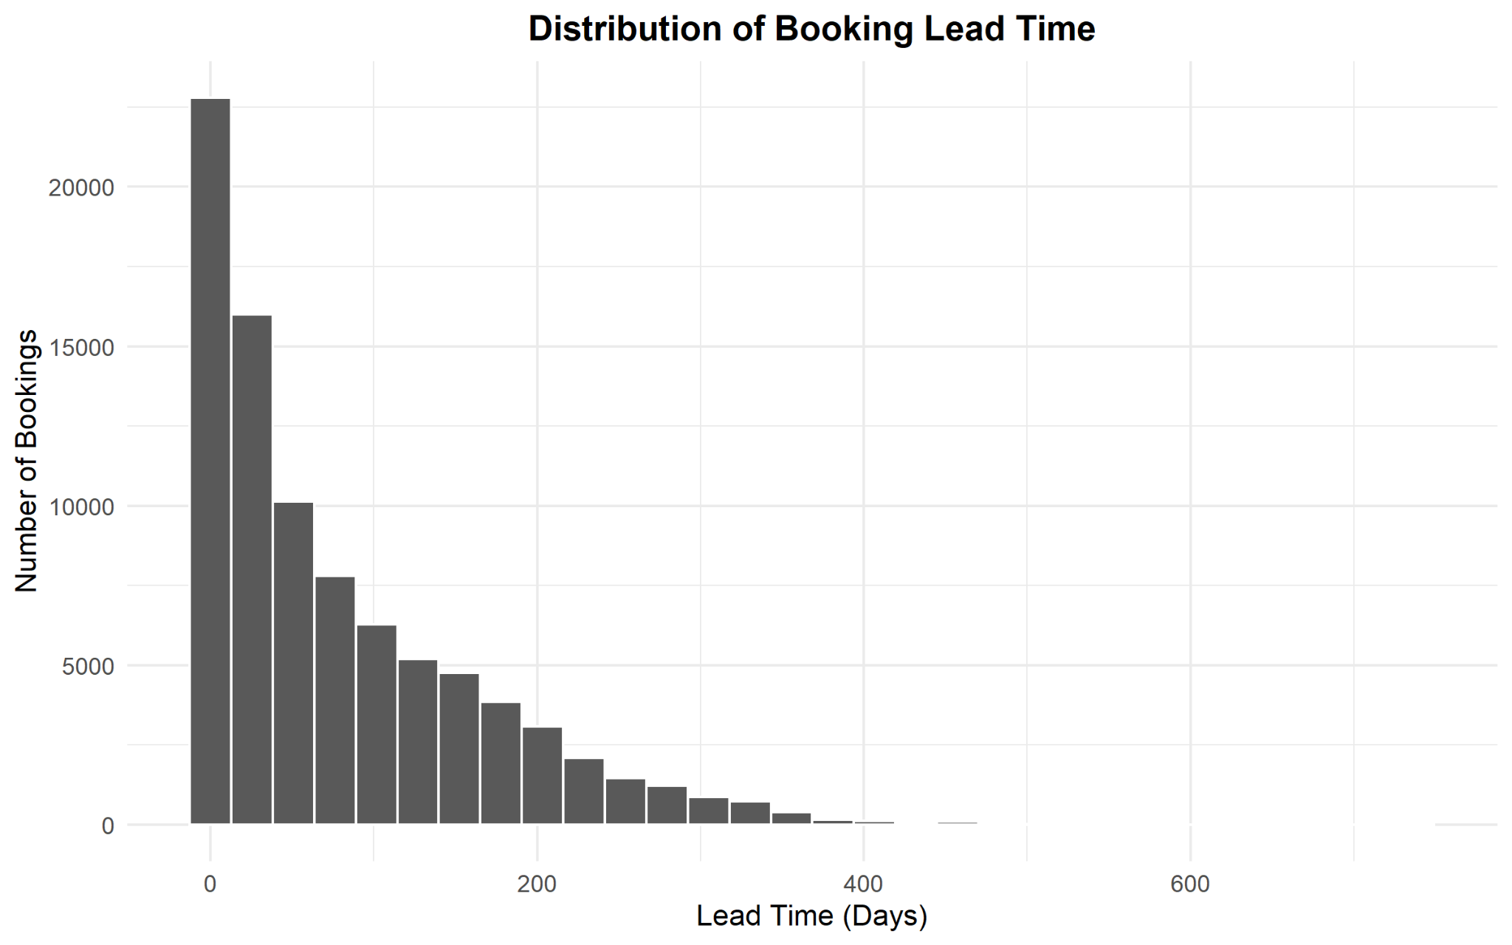
Figure 4. Distribution of Booking Lead Time
Why this visualization was selected: A histogram is designed for a continuous numerical variable and shows how booking lead times are distributed across ranges.
Interpretation and insight: The distribution is strongly right-skewed. A large concentration of bookings is made with relatively short lead times, while a much smaller number are made several hundred days in advance. This shows that long advance bookings exist but are uncommon.

5.5 Relationship Between Lead Time and ADR
Visualization type: Scatter plot with linear trend
ggplot(hotel_data, aes(x = lead_time, y = adr)) +
geom_point(alpha = 0.25, size = 1) +
geom_smooth(method = "lm", se = FALSE) +
labs(title = "Relationship Between Lead Time and ADR",
x = "Lead Time (Days)",
y = "Average Daily Rate (ADR)") +
theme_minimal()
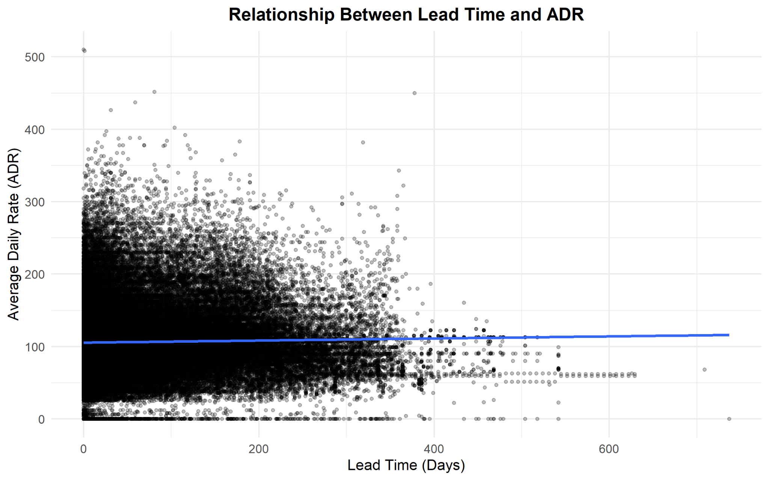
Figure 5. Relationship Between Lead Time and ADR
Why this visualization was selected: A scatter plot is suitable for examining the relationship between two numerical variables. Transparency reduces overplotting and the fitted line summarizes the overall linear direction.
Interpretation and insight: The points are widely dispersed and the fitted line is almost flat. The Week 1 correlation was approximately 0.024, indicating virtually no meaningful linear relationship between lead time and ADR in this dataset.

5.6 Average Daily Rate by Hotel Type
Visualization type: Box plot
ggplot(hotel_data,
aes(x = hotel, y = adr, fill = hotel)) +
geom_boxplot() +
labs(title = "Average Daily Rate by Hotel Type",
x = "Hotel Type",
y = "Average Daily Rate (ADR)") +
theme_minimal() +
theme(legend.position = "none")
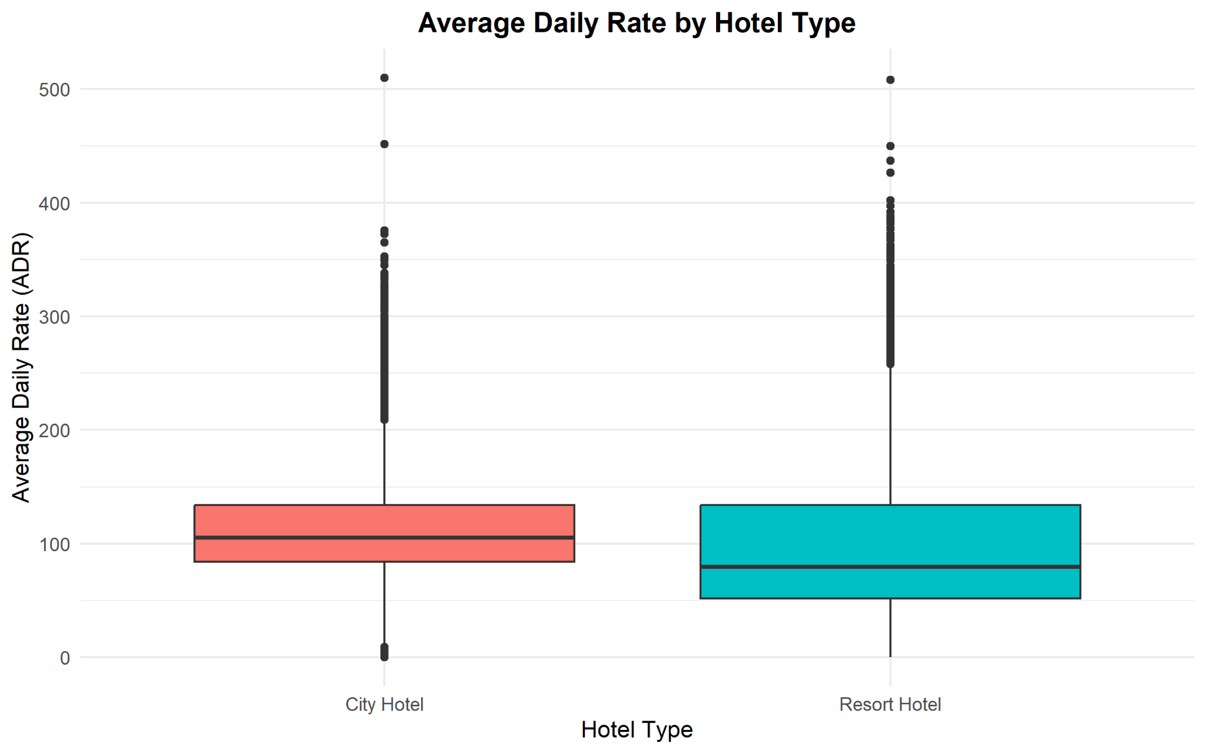
Figure 6. Average Daily Rate by Hotel Type
Why this visualization was selected: A box plot allows the median, spread and unusually high/low ADR observations to be compared between hotel categories in one view.
Interpretation and insight: City Hotel has a higher central ADR than Resort Hotel. The mean ADR calculated in Week 1 was approximately 111.17 for City Hotel and 99.07 for Resort Hotel. Both categories also contain higher-rate observations above the main distribution.

5.7 Hotel Bookings by Market Segment
Visualization type: Horizontal bar chart
ggplot(
hotel_data,
aes(x = reorder(market_segment, market_segment,
FUN = function(x) -length(x)),
fill = market_segment)
) +
geom_bar() +
coord_flip() +
labs(title = "Hotel Bookings by Market Segment",
x = "Market Segment", y = "Number of Bookings") +
theme_minimal() +
theme(legend.position = "none")
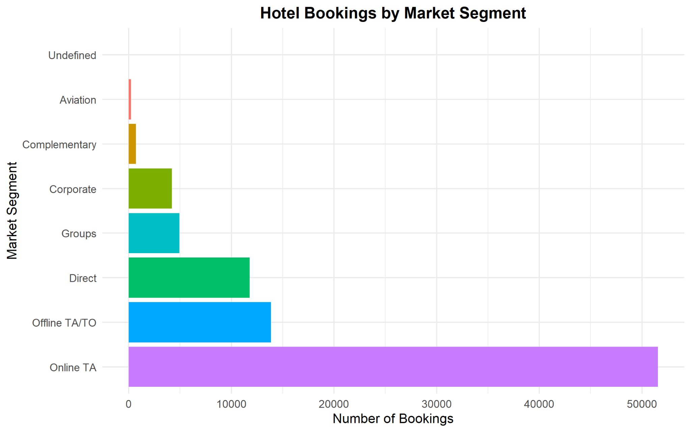
Figure 7. Hotel Bookings by Market Segment
Why this visualization was selected: A horizontal layout accommodates longer market-segment labels and makes category ranking easier to read.
Interpretation and insight: Online TA is by far the dominant market segment with 51,550 bookings. Offline TA/TO (13,854) and Direct (11,780) are the next largest sources. This indicates strong dependence on online travel agency channels.

5.8 Cancellation Rate by Hotel Type
Visualization type: Percentage bar chart
cancellation_by_hotel <- aggregate(
is_canceled ~ hotel,
data = hotel_data,
FUN = function(x) mean(x) * 100
)
ggplot(cancellation_by_hotel,
aes(x = hotel, y = is_canceled, fill = hotel)) +
geom_col(width = 0.6) +
geom_text(aes(label = paste0(round(is_canceled, 1), "%")),
vjust = -0.5) +
labs(title = "Cancellation Rate by Hotel Type",
x = "Hotel Type", y = "Cancellation Rate (%)") +
theme_minimal()
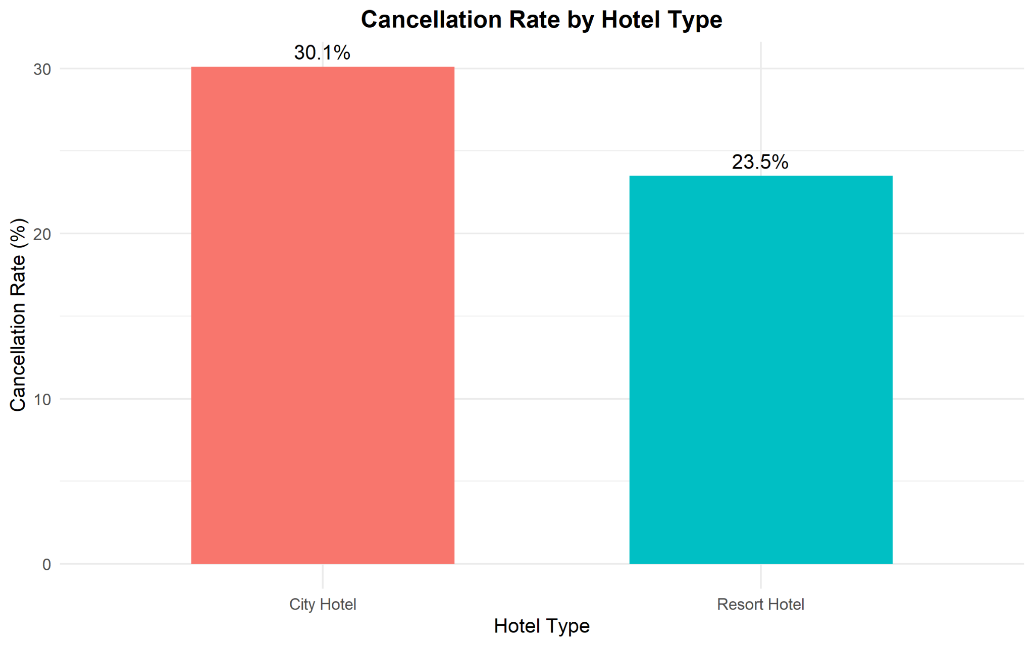
Figure 8. Cancellation Rate by Hotel Type
Why this visualization was selected: Rates are more meaningful than raw cancellation counts when the two hotel types have different total booking volumes.
Interpretation and insight: City Hotel has a cancellation rate of about 30.1%, compared with 23.5% for Resort Hotel. The difference suggests that cancellation behaviour varies by hotel type and should be considered in demand and capacity planning.

5.9 Booking Status Distribution by Hotel Type
Visualization type: 100% stacked bar chart
ggplot(hotel_data,
aes(x = hotel, fill = cancellation_status)) +
geom_bar(position = "fill") +
scale_y_continuous(labels = scales::percent) +
labs(title = "Booking Status Distribution by Hotel Type",
x = "Hotel Type",
y = "Percentage of Bookings",
fill = "Booking Status") +
theme_minimal()
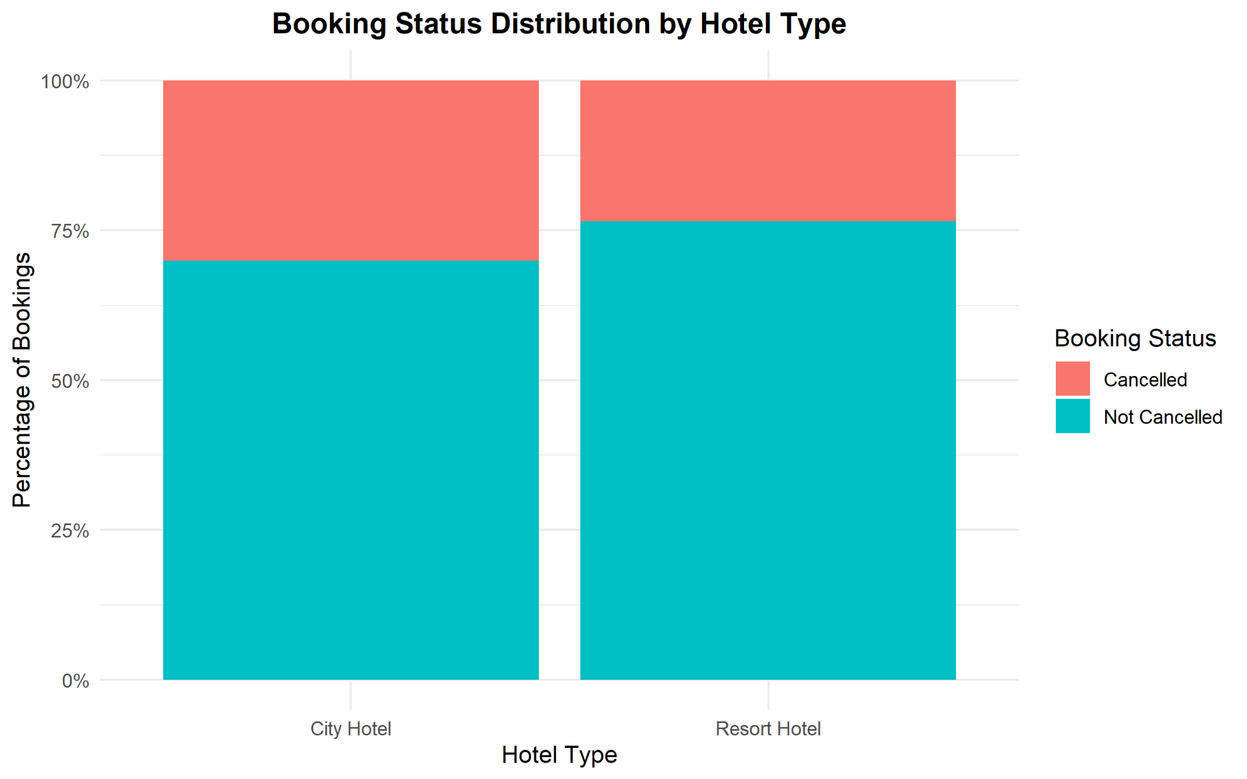
Figure 9. Booking Status Distribution by Hotel Type
Why this visualization was selected: A 100% stacked chart emphasizes the proportion of cancelled and retained bookings within each hotel type rather than differences in total volume.
Interpretation and insight: The chart confirms the percentage comparison: roughly 70% of City Hotel bookings are retained versus about 76.5% for Resort Hotel. Resort Hotel therefore shows a larger retained-booking share.

5.10 Monthly Booking Trend by Hotel Type
Visualization type: Multi-series line chart
monthly_hotel <- as.data.frame(
table(hotel_data$arrival_date_month,
hotel_data$hotel)
)
colnames(monthly_hotel) <- c("Month", "Hotel", "Bookings")
ggplot(monthly_hotel,
aes(x = Month, y = Bookings,
group = Hotel, color = Hotel)) +
geom_line(linewidth = 1) +
geom_point(size = 2.5) +
labs(title = "Monthly Booking Trend by Hotel Type",
x = "Arrival Month",
y = "Number of Bookings",
color = "Hotel Type") +
theme_minimal()
Figure 10. Monthly Booking Trend by Hotel Type
Why this visualization was selected: Two lines allow the seasonal patterns of City Hotel and Resort Hotel to be compared on the same monthly time axis.
Interpretation and insight: Both hotel types reach their highest booking levels in August and decline sharply in September. City Hotel remains above Resort Hotel throughout the year, while Resort Hotel shows a particularly strong rise in July and August. The shared summer peak supports the presence of strong seasonality.

6. Key Findings
- City Hotel has substantially more bookings than Resort Hotel.
- Approximately 27.5% of all cleaned bookings are cancelled.
- Cancellation risk is higher for City Hotel (about 30.1%) than Resort Hotel (about 23.5%).
- Hotel demand is seasonal, with the strongest booking volume in July and August and the lowest volume in January.
- Lead time is strongly right-skewed; most bookings are made comparatively closer to arrival.
- Lead time and ADR show almost no meaningful linear relationship.
- City Hotel shows a higher typical ADR than Resort Hotel.
- Online TA is the dominant market segment and contributes the majority of bookings.

7. Communication for a Non-Technical Audience
The charts show that demand is not evenly distributed across hotel type, month or booking channel. City Hotel receives more bookings but also experiences a higher cancellation percentage. Summer, especially July and August, is the busiest period for both hotels. Online travel agencies are the most important booking source. Pricing varies considerably, but booking earlier does not appear to have a strong linear relationship with ADR. These findings can support staffing, capacity planning, channel strategy and cancellation-risk management.

8. Technical Accuracy and Output Quality
All charts were generated from the cleaned Week 1 dataset in R using ggplot2. Appropriate chart types were selected according to variable type and analytical purpose. The final images were exported using ggsave() at 300 DPI with an 8 × 5 inch output size for clear inclusion in the report.
ggsave("visualization_name.png", width = 8, height = 5, dpi = 300)

9. Conclusion
Week 2 transformed the cleaned hotel booking data into a set of visual explanations that can be understood without reading raw tables. The analysis demonstrates categorical comparison, time-series trend analysis, distribution analysis, relationship analysis and proportional comparison. Together, the visualizations reveal seasonality, channel concentration, differences in cancellation behaviour and differences in ADR between hotel types. The exercise also demonstrates how R and ggplot2 can be used to communicate analytical results clearly and professionally.

Appendix A: Submitted R Script
The accompanying file week2_visualization.R contains the complete R workflow used to create and export the Week 2 visualizations.

