WEEK 3
STATISTICAL ANALYSIS AND PREDICTIVE MODELING USING R
Hotel Booking Cancellation Prediction

Student Name | Krishna
Programme | MCA
Institution | PK University, Shivpuri
Project | Hotel Booking Demand Analysis

Technical Report and Model Evaluation

1. Executive Summary
This Week 3 assignment extends the cleaned Hotel Booking Demand dataset into inferential statistics and predictive modeling. The analysis investigates distributions, normality, correlation, relationships between hotel type and cancellation, differences in Average Daily Rate (ADR), and differences in lead time. A binary logistic regression model is then used to predict whether a booking will be cancelled.
The final logistic regression model achieved 78.60% test accuracy and an AUC of 0.7949. Five-fold cross-validation produced a mean accuracy of 78.50%, which is very close to the hold-out test accuracy and indicates stable performance across folds. The model has high specificity (93.76%) but lower recall (38.14%), showing that it identifies non-cancelled bookings much better than cancelled bookings.
Metric | Result | Interpretation
Accuracy | 78.60% | Overall proportion of correct predictions
Precision | 69.60% | Reliability of predicted cancellations
Recall / Sensitivity | 38.14% | Share of actual cancellations detected
Specificity | 93.76% | Share of non-cancellations correctly detected
F1 Score | 49.27% | Balance between precision and recall
AUC | 0.7949 | Useful class-discrimination ability
Mean 5-Fold CV Accuracy | 78.50% | Stable out-of-sample performance

2. Objectives
- Identify and justify a suitable public dataset for statistical modeling.
- Explore numerical distributions and summary statistics.
- Assess normality and correlation among selected numerical variables.
- Formulate and test statistical hypotheses.
- Build a classification model for booking cancellation.
- Split the data into training and testing samples and apply 5-fold cross-validation.
- Evaluate the model using a confusion matrix, accuracy, precision, recall, specificity, F1 score and ROC-AUC.
- Inspect model diagnostics and identify strengths, limitations and possible improvements.

3. Dataset Identification and Rationale
The analysis uses the cleaned Hotel Booking Demand dataset carried forward from the previous weeks. After the Week 1 cleaning process, the working dataset contained 87,221 observations and 33 variables. It contains booking characteristics for City Hotel and Resort Hotel records, including lead time, ADR, customer and market information, previous booking behavior, special requests and cancellation status.
The dataset is appropriate for Week 3 because the response variable is_canceled is binary (0 = not cancelled, 1 = cancelled), making cancellation prediction a natural classification problem. Continuing with the same cleaned dataset also provides methodological continuity from data preparation and visualization to statistical inference and predictive modeling.

4. Analytical Approach in R
The workflow was implemented in R. The script first loads the cleaned CSV file, checks dimensions and missing values, produces descriptive summaries, performs distribution and hypothesis analysis, prepares selected variables for modeling, creates an 80/20 train-test split, fits logistic regression, evaluates predictions, performs 5-fold cross-validation, and saves report-ready outputs and visualizations.
hotel_data <- read.csv("hotel_bookings_cleaned.csv")
summary(hotel_data)
sum(is.na(hotel_data))
set.seed(123)
train_index <- sample(1:nrow(model_data),
size = 0.80 * nrow(model_data))
train_data <- model_data[train_index, ]
test_data <- model_data[-train_index, ]

5. Exploratory Statistical Analysis

5.1 Lead Time Distribution
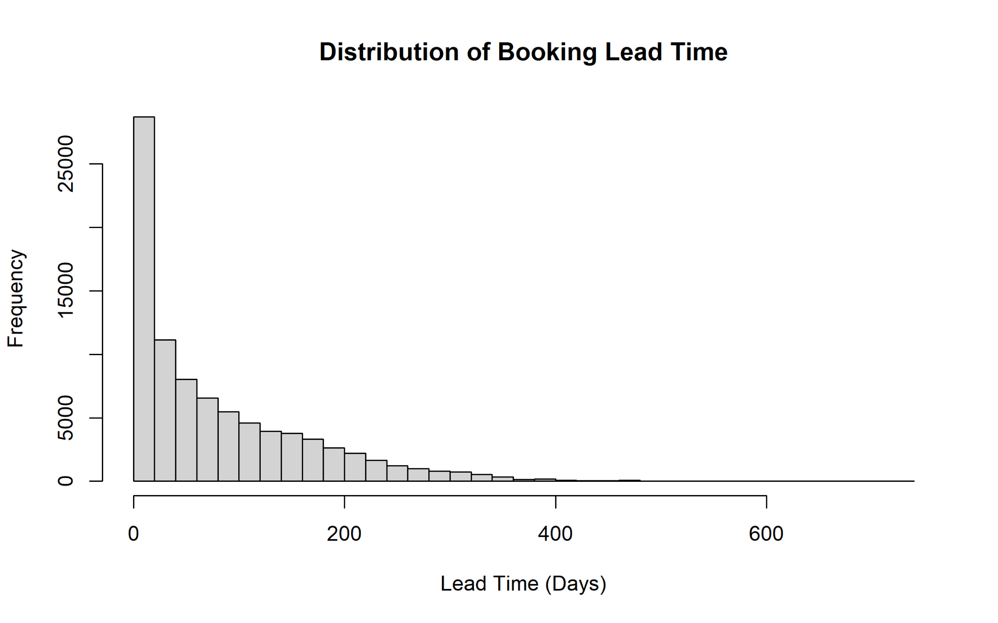
Figure 1. Distribution of booking lead time.
Lead time is strongly right-skewed. Most bookings are made relatively close to the arrival date, while a smaller number are made several hundred days in advance. The long right tail explains why a normality assumption should not be accepted automatically for this variable.

5.2 Average Daily Rate (ADR) Distribution
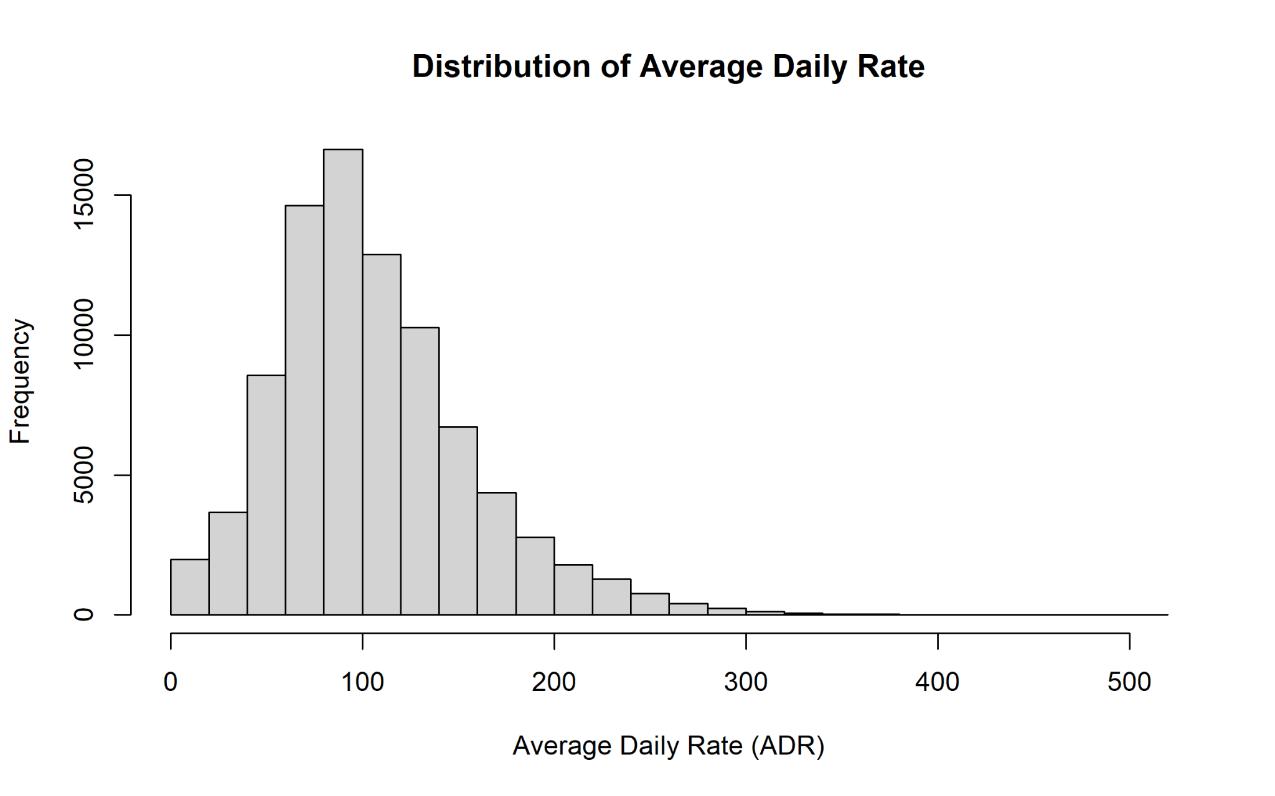
Figure 2. Distribution of Average Daily Rate (ADR).
ADR is concentrated around the lower-to-middle price range and has a positive right tail. The cleaned data removed the previously identified invalid extreme ADR values, while plausible high-value observations were retained.

5.3 ADR by Hotel Type
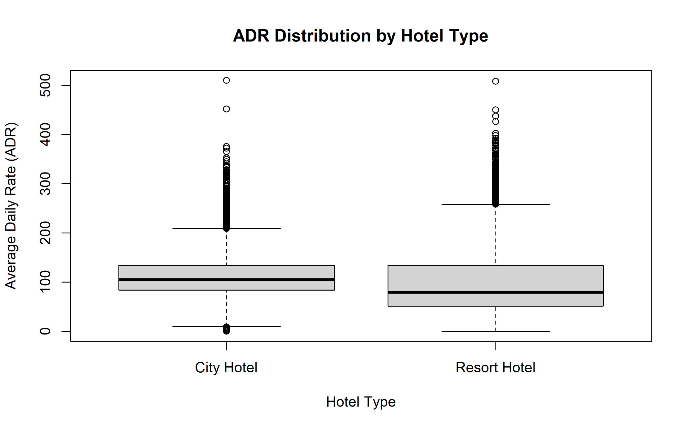
Figure 3. ADR distribution by hotel type.
The boxplots show differences in the central tendency and spread of ADR between City Hotel and Resort Hotel bookings. Both groups also contain high-value observations. This visual comparison supports formally testing whether mean ADR differs between hotel types.

6. Normality and Correlation Analysis
Shapiro-Wilk tests were applied to reproducible random samples of 5,000 observations for lead_time and adr because the complete dataset is very large. The histograms also provide visual evidence that both variables depart from a perfect normal distribution. With large samples, small deviations can become statistically significant, so graphical shape and practical effect size should be considered alongside p-values.
Pearson correlation was used to assess the linear relationship between lead time and ADR. The previously observed correlation is approximately 0.024, indicating an extremely weak positive linear association. Even when a test is statistically significant in a large dataset, a correlation of this magnitude has little practical explanatory value.

7. Hypothesis Testing

7.1 Hotel Type and Booking Cancellation
H0: Hotel type and booking cancellation are independent. H1: Hotel type and booking cancellation are associated.
Hotel Type | Not Cancelled | Cancelled
City Hotel | 37,237 | 16,034
Resort Hotel | 25,976 | 7,974
Pearson's chi-squared test with Yates' continuity correction produced χ² = 454.01 with 1 degree of freedom and p < 2.2 × 10⁻16. Therefore, the null hypothesis is rejected. Hotel type and cancellation status are statistically associated.

7.2 ADR Difference Between Hotel Types
H0: Mean ADR is equal for City Hotel and Resort Hotel. H1: Mean ADR differs between the two hotel types. A two-sample t-test was included in the R workflow. The graphical comparison shows a clear difference in the distributions and central values. The exact console output for this t-test was not saved to the supplied output text file, so no unsupplied p-value is reported here.

7.3 Lead Time: Cancelled vs Not Cancelled
H0: Mean lead time is equal for cancelled and non-cancelled bookings. H1: Mean lead time differs between cancelled and non-cancelled bookings. A two-sample t-test was executed in the analysis script. The test is part of the reproducible workflow; however, its exact console statistic was not persisted in the supplied output file, so the report does not invent an exact value.

8. Predictive Model Development
A logistic regression classifier was selected because the target variable is binary. The model uses booking and customer-related predictors such as lead_time, adr, adults, children, babies, previous cancellations, previous non-cancelled bookings, booking changes, waiting-list days, parking requirements, special requests, hotel type, deposit type, customer type and market segment.
logistic_model <- glm(
is_canceled ~ .,
data = train_data,
family = binomial(link = "logit")
)
predicted_probability <- predict(
logistic_model, newdata = test_data, type = "response"
)
predicted_class <- ifelse(predicted_probability >= 0.5, 1, 0)
Several coefficients are statistically significant. Positive coefficients for lead_time, adr and previous_cancellations indicate increasing log-odds of cancellation as these predictors increase, holding other variables constant. Non-refundable deposit status has a particularly large positive coefficient. In contrast, previous non-cancelled bookings, booking changes and total special requests have negative coefficients in the fitted model.

9. Model Evaluation

9.1 Confusion Matrix
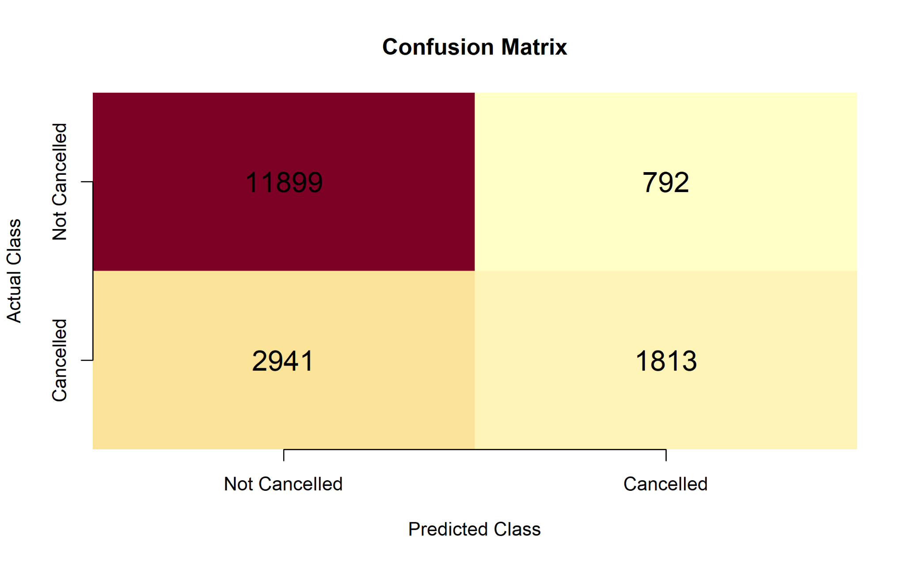
Figure 4. Confusion matrix for the hold-out test set.
Actual / Predicted | Not Cancelled | Cancelled
Not Cancelled | 11,899 (TN) | 792 (FP)
Cancelled | 2,941 (FN) | 1,813 (TP)
The model correctly classified 11,899 non-cancelled bookings and 1,813 cancelled bookings. It produced 792 false cancellation alerts and missed 2,941 actual cancellations. The large number of false negatives explains the relatively low recall.

9.2 Performance Metrics
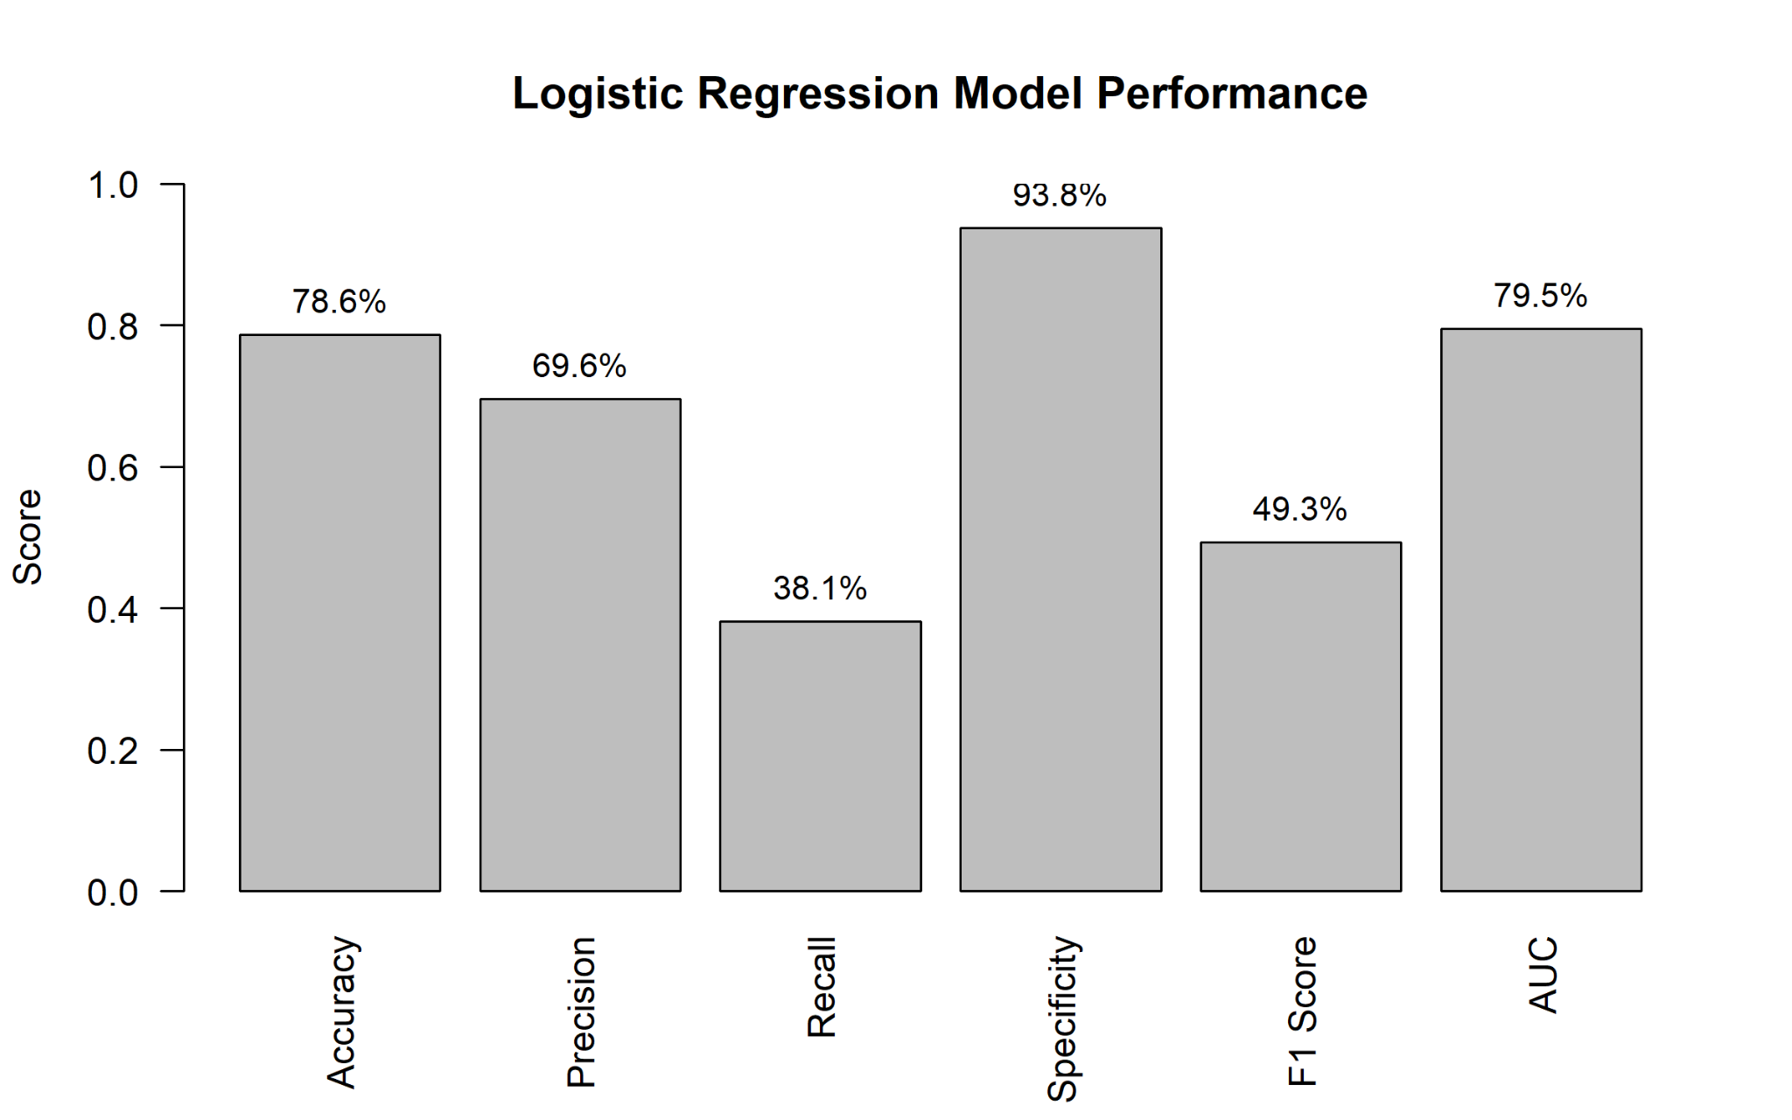
Figure 5. Logistic regression performance metrics.
Accuracy is 78.60%, but accuracy alone should not be used because the dataset contains more non-cancelled than cancelled bookings. Specificity is very high at 93.76%, while recall is only 38.14%. Therefore, the current 0.50 classification threshold favors correctly identifying non-cancellations. Precision of 69.60% means that when the model predicts a cancellation, the prediction is correct about seven times out of ten. The F1 score of 49.27% reflects the weaker balance between precision and recall.

9.3 ROC Curve and AUC
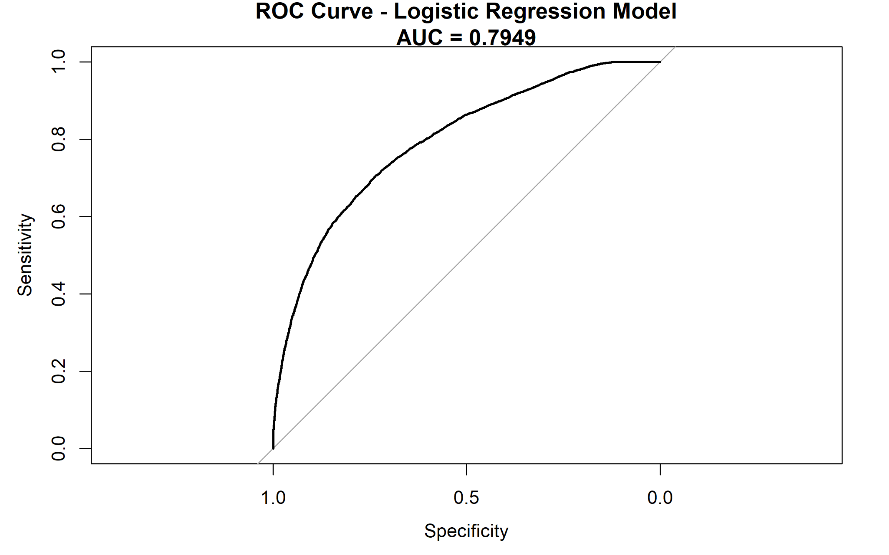
Figure 6. ROC curve for the logistic regression classifier.
The AUC is 0.7949. This indicates useful discrimination between cancelled and non-cancelled bookings across classification thresholds. The ROC curve also shows that changing the threshold can trade specificity for higher sensitivity, which is important because cancellation detection is the weaker part of the current model.

9.4 Five-Fold Cross-Validation
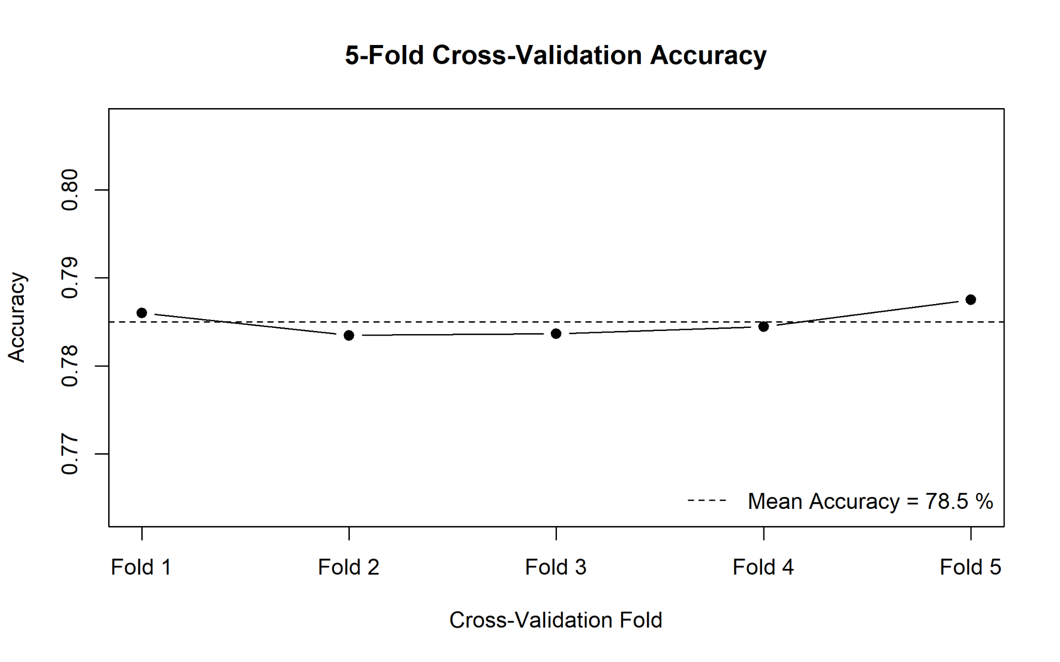
Figure 7. Accuracy across five cross-validation folds.
Mean 5-fold cross-validation accuracy is 78.50%. The fold accuracies are tightly grouped, and the mean is close to the 78.60% hold-out test accuracy. This consistency suggests that the model's overall accuracy is stable across different partitions of the data rather than being dependent on one favorable split.

10. Model Diagnostics
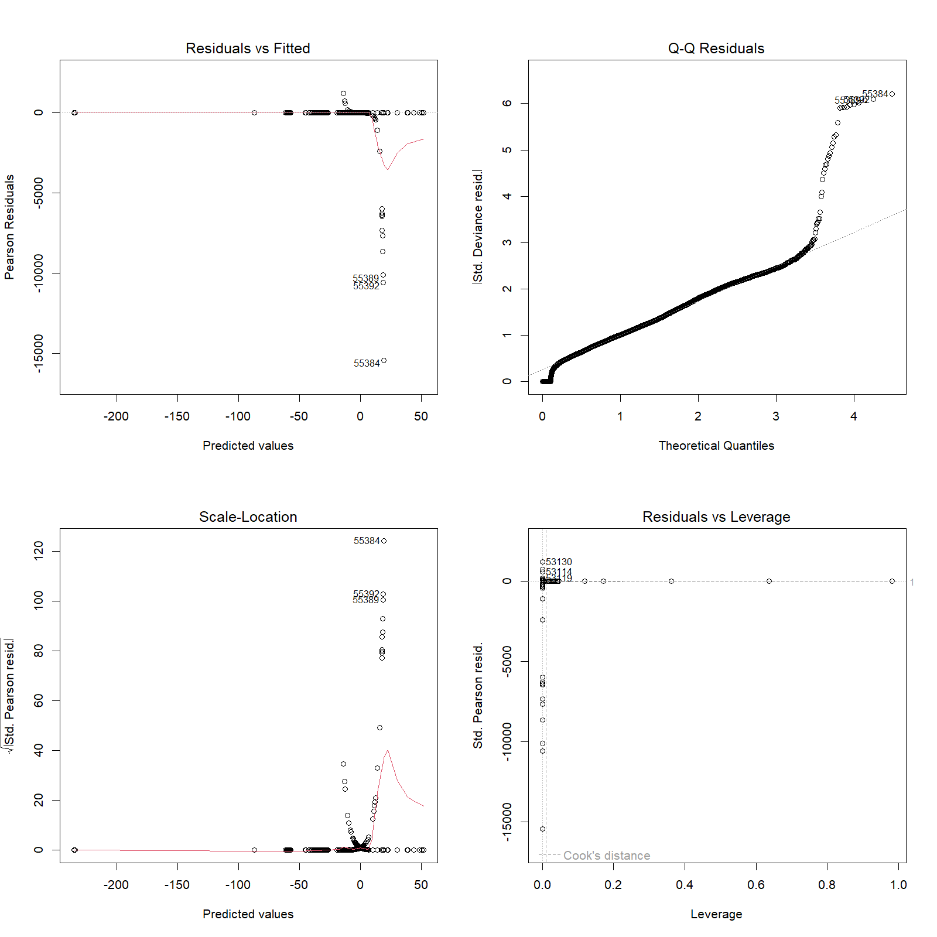
Figure 8. Logistic regression diagnostic plots.
The diagnostic plots reveal unusual and influential observations, especially in the residual and leverage views. For a binary logistic model, classical linear-regression diagnostic plots should be interpreted cautiously; nevertheless, they are useful for identifying observations with large residuals or leverage. The visible departures in the Q-Q and scale-location displays indicate that residual behavior is not ideal and that influential cases deserve further investigation rather than automatic deletion.
The model summary reports a reduction from null deviance 82,207 to residual deviance 65,577, with AIC 65,627. This indicates that the included predictors improve fit relative to an intercept-only model, although predictive usefulness must still be judged using out-of-sample metrics.

11. Predicted Probability Analysis
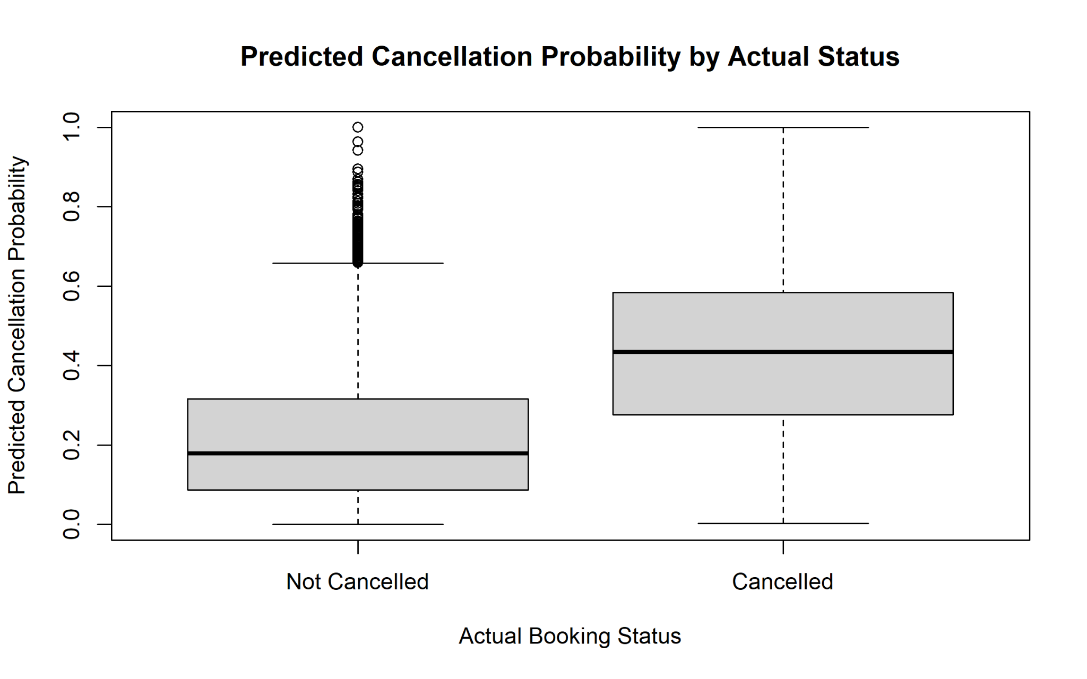
Figure 9. Predicted cancellation probability by actual booking status.
Actual cancelled bookings generally receive higher predicted cancellation probabilities than non-cancelled bookings, showing useful separation between classes. However, the two distributions overlap substantially around the middle probability range. This overlap explains why a fixed 0.50 threshold misses many cancellations and why threshold optimization could improve recall.

12. Strengths and Limitations
Strengths | Limitations
Large cleaned real-world dataset | Cancellation class is less frequent than non-cancellation
Multiple behavioral and booking predictors | Recall is only 38.14% at the 0.50 threshold
Hold-out testing plus 5-fold CV | Random split does not simulate future-time prediction
AUC evaluates ranking across thresholds | Some predictors may only become known after booking creation
Interpretable logistic coefficients | Influential observations are visible in diagnostics

13. Potential Improvements
- Tune the classification threshold using ROC, F1 score, business cost or recall requirements instead of automatically using 0.50.
- Use stratified train-test splitting and stratified cross-validation so cancellation proportions remain consistent.
- Address class imbalance using class weights or carefully evaluated resampling methods.
- Engineer additional features such as total guests, total nights, arrival season and lead-time bands.
- Compare logistic regression with regularized logistic regression, random forest and gradient-boosting models.
- Use precision-recall curves and PR-AUC because cancellation is the minority class.
- Check multicollinearity and investigate influential observations before final deployment.
- For prediction at booking creation, remove any variables that are only known later in the booking lifecycle to prevent temporal leakage.
- Use a time-based validation split to test how well the model generalizes to future bookings.

14. Overall Interpretation
The Week 3 analysis demonstrates a complete transition from descriptive analysis to statistical inference and predictive modeling. Hotel type is significantly associated with cancellation status, and the logistic model captures meaningful information from booking characteristics. The model performs consistently across the hold-out test set and five cross-validation folds and achieves an AUC close to 0.80.
The main practical weakness is cancellation sensitivity. Although overall accuracy is 78.60%, a simple majority-class rule would already benefit from the dataset's larger non-cancelled class, so accuracy should not be treated as the sole success criterion. The stronger evidence is the AUC, precision, specificity and cross-validation stability, together with the clear need to improve recall. For a hotel using the model to proactively manage cancellation risk, improving recall while controlling false positives would be the most important next step.

15. Conclusion
This project successfully applied statistical analysis and logistic regression to hotel booking cancellation prediction in R. The workflow covered distributions, normality assessment, correlation, hypothesis testing, model preparation, train-test validation, 5-fold cross-validation, confusion-matrix analysis, ROC-AUC and diagnostics. The resulting model provides useful predictive discrimination and stable overall accuracy, while also highlighting an important real-world trade-off: strong identification of non-cancelled bookings but limited detection of actual cancellations. The analysis therefore provides both a defensible baseline model and a clear roadmap for further improvement.

Appendix A. Key R Code Excerpts
# Hypothesis test: hotel type vs cancellation
hotel_cancel_table <- table(hotel_data$hotel, hotel_data$is_canceled)
chisq.test(hotel_cancel_table)
# Two-sample tests
t.test(adr ~ hotel, data = hotel_data)
t.test(lead_time ~ is_canceled, data = hotel_data)
# ROC / AUC
roc_object <- roc(test_data$is_canceled, predicted_probability)
auc_value <- auc(roc_object)
# 5-fold cross-validation
k <- 5
folds <- sample(rep(1:k, length.out = nrow(model_data)))

Appendix B. Reproducibility Notes
A fixed random seed (set.seed(123)) was used for sampling, the train-test split and cross-validation setup. The project also saves model performance, model summary, confusion matrix and hypothesis-test output to separate files, and exports report visualizations as PNG images. This makes the workflow easier to reproduce, review and submit.

