EXP.NO : 11 Study and Implement the Working of an Artificial Neural Network
Date:

Aim:
To study and implement the working of an Artificial Neural Network (ANN) by configuring the input, hidden, and output layers, assigning weights and biases, applying an activation function, and calculating the output error.

Procedure:
1. Click on the CREATE tab.
2. Select the number of nodes for all three layers and click the SUBMIT button.
3. Click on NEXT button to proceed further.
4. Choose an input value for each node in the input layer and an output value for each node in the output layer, then click the SUBMIT button.
5. Click the NEXT button to initialize the weights.
6. Choose the source (Xi) and destination (Hi), enter the weight value, then click the SUBMIT button.
7. Repeat the previous step (6) for every combination of source (Xi) and destination (Hi).
8. Now, select the source and destination to connect the hidden layer to the output layer. Enter the weight value and click the SUBMIT button.
9. Repeat step 8 for every combination of source (Hi) and destination (Yi).
10. Click the NEXT button to compute the forward propagation.
11. Enter the bias value (random) and click the SUBMIT button.
12. For each node in the hidden layer, calculate the summation by entering the appropriate input and weight values, then click the SUBMIT button.
13. Repeat the summation process for each node in the output layer, using the same method.
14. Finally, click the ERROR button to compute the Mean Squared Error (MSE).

Formulae:
i. To compute y_in for an activation function:
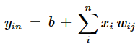

ii. Sigmoid activation function:
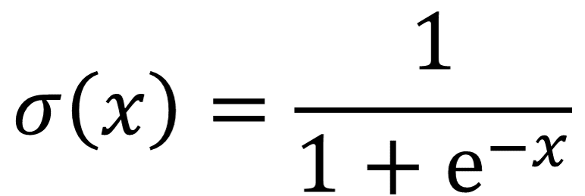

iii. Mean Squared Error (MSE):
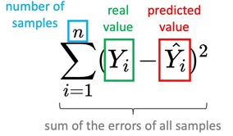

Note: In our simulation, we used the same bias for every node; however, in practice, biases are often adjusted individually to allow for more flexibility in learning complex patterns.
The ANN architecture consists of input, hidden, and output layers, while the hidden layers perform weighted computations and apply activation functions.

Observations (Simulation Screenshots):
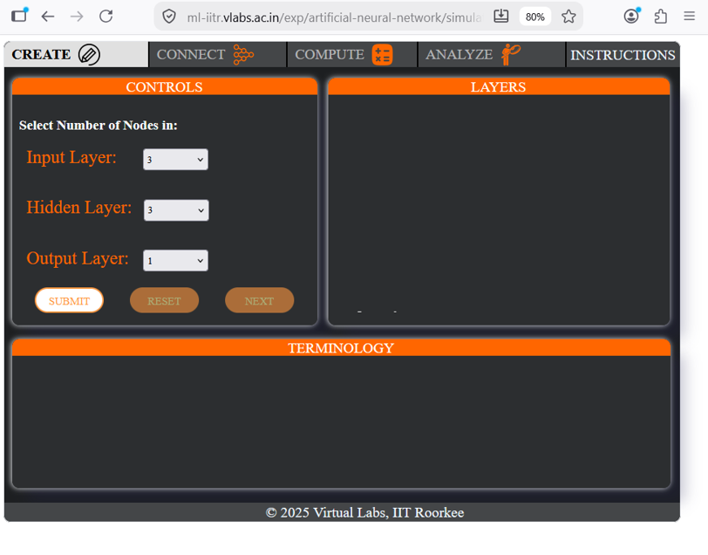
Fig 1: Selecting the number of nodes for the input, hidden, and output layers
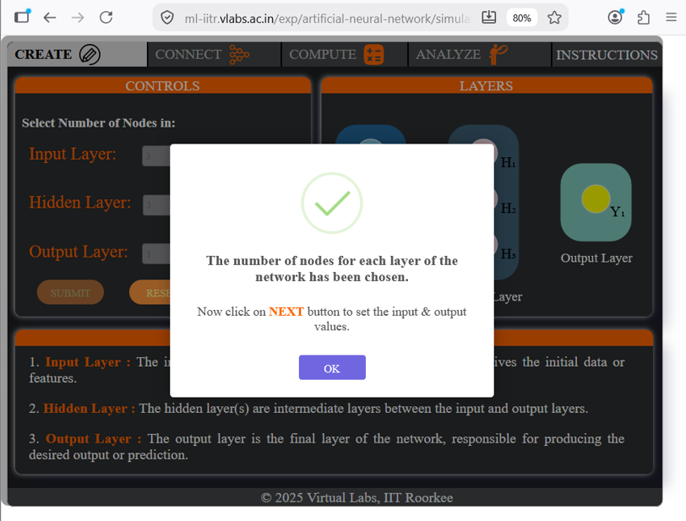
Fig 2: Confirmation message after the number of nodes is chosen

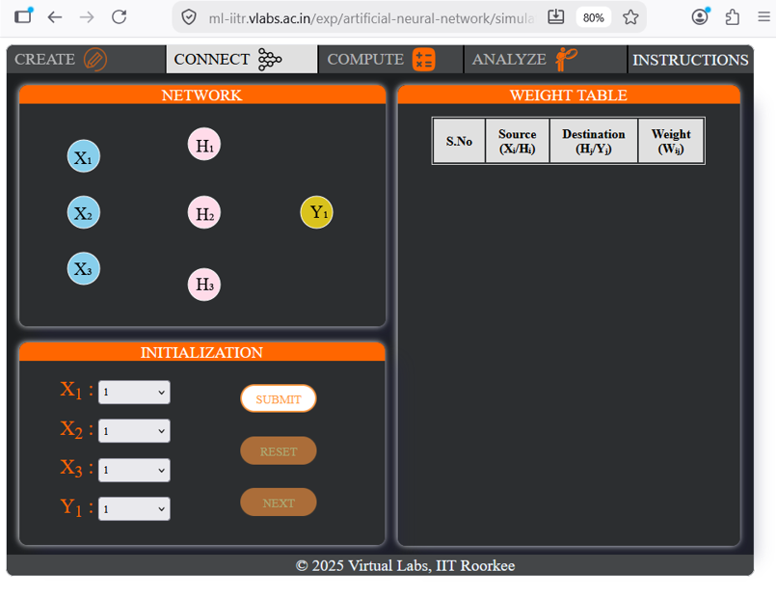
Fig 3: Network layout with fields to initialize input (Xi) and output (Yi) values
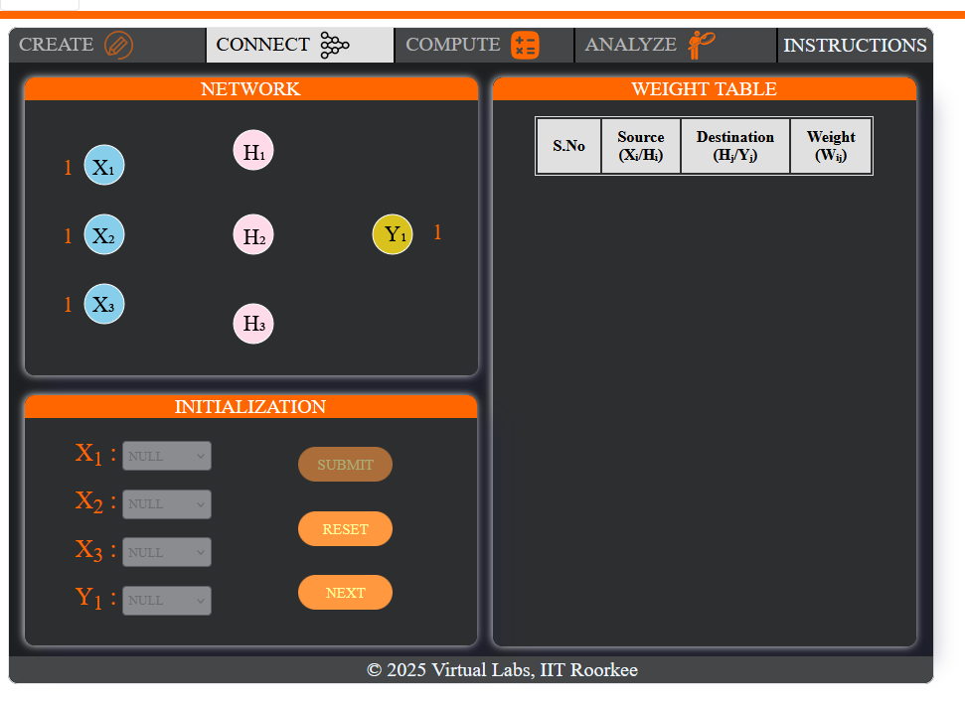
Fig 4: Input and output values submitted (X1 = X2 = X3 = 1, Y1 = 1)

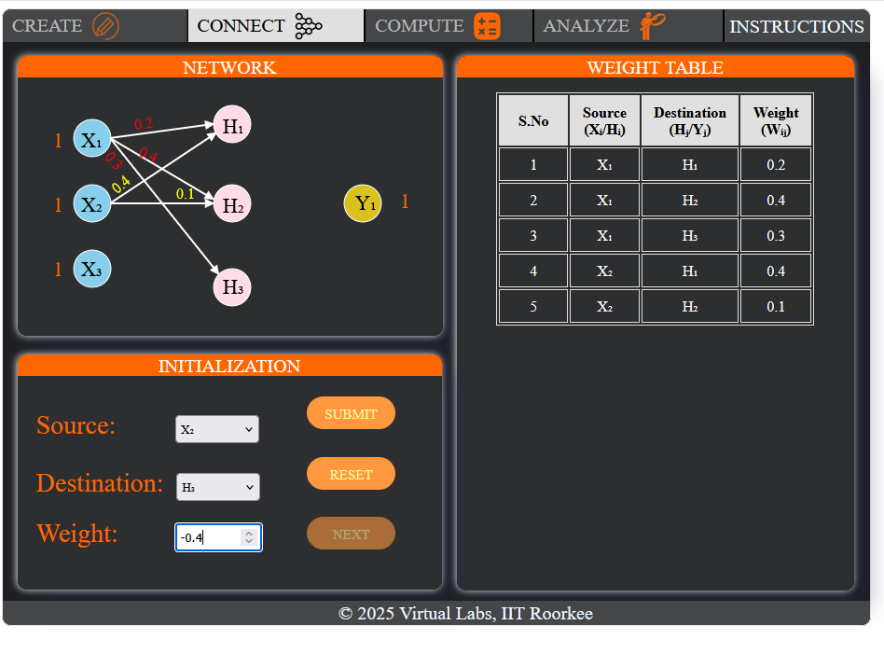
Fig 5: Assigning a weight between an input node and a hidden node (X2 → H2 = -0.4)
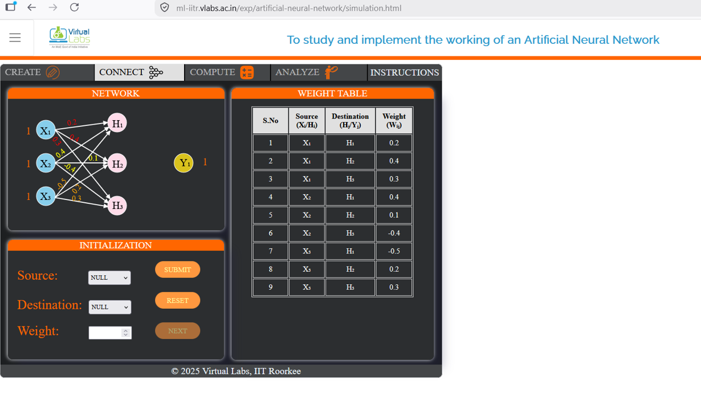
Fig 6: Weight table after all input–hidden layer connections are assigned

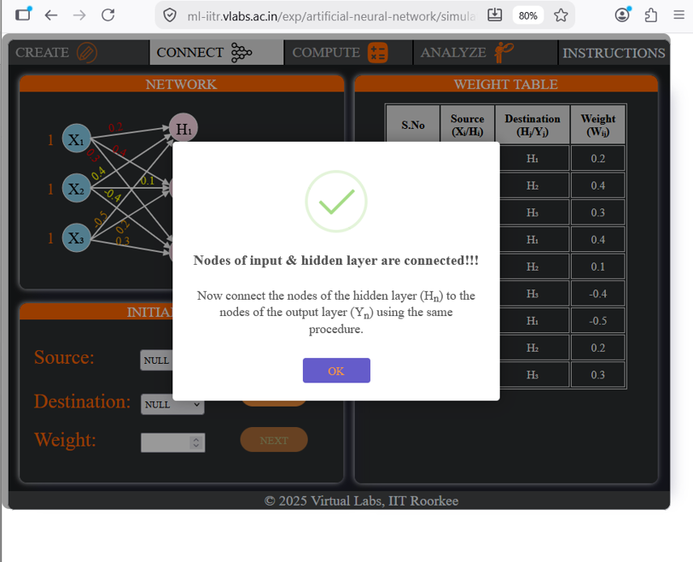
Fig 7: Confirmation — input and hidden layer nodes connected
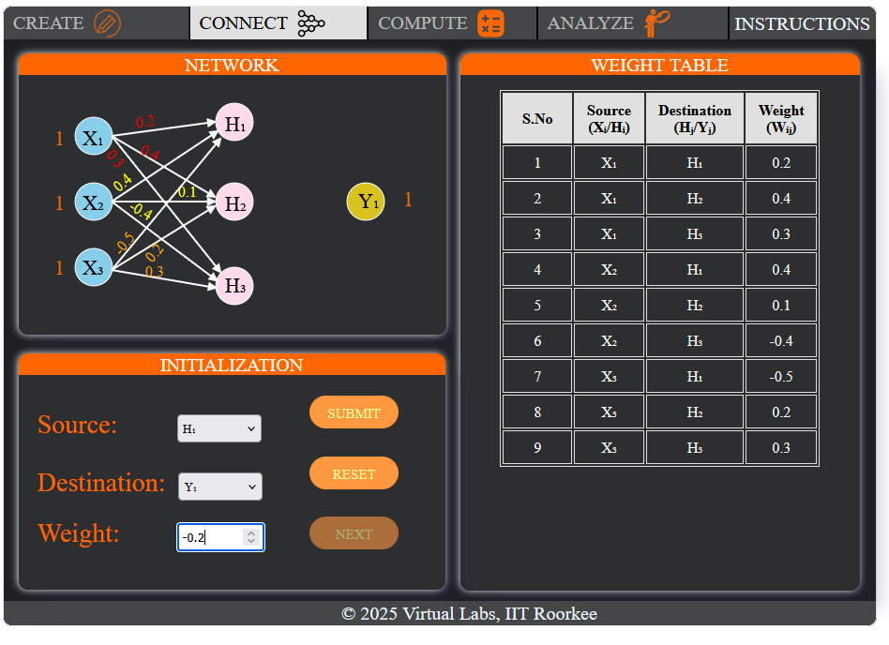
Fig 8: Assigning a weight between a hidden node and the output node (H1 → Y1 = -0.2)

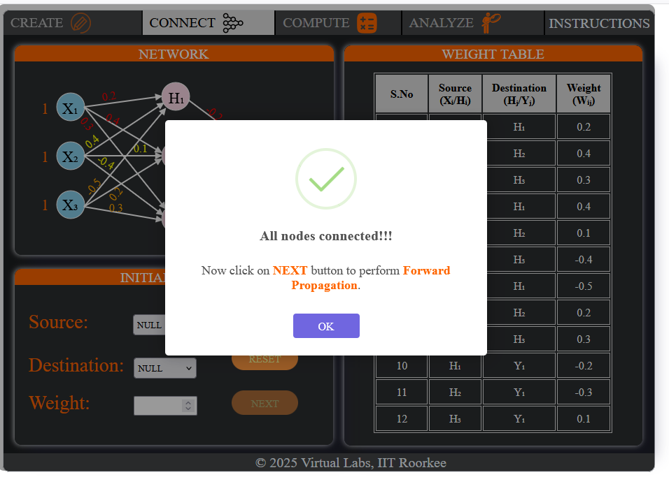
Fig 9: Confirmation — all nodes connected, complete weight table (12 connections)
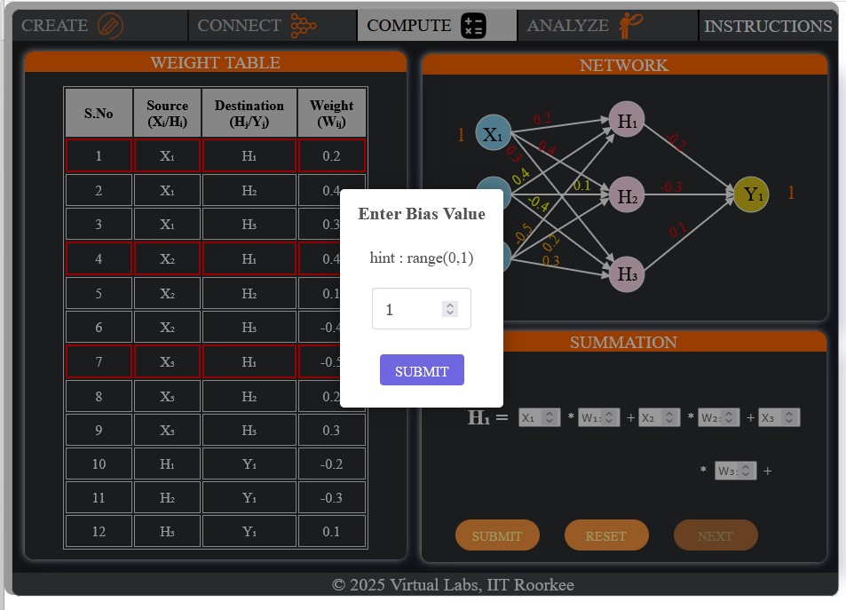
Fig 10: Entering the bias value

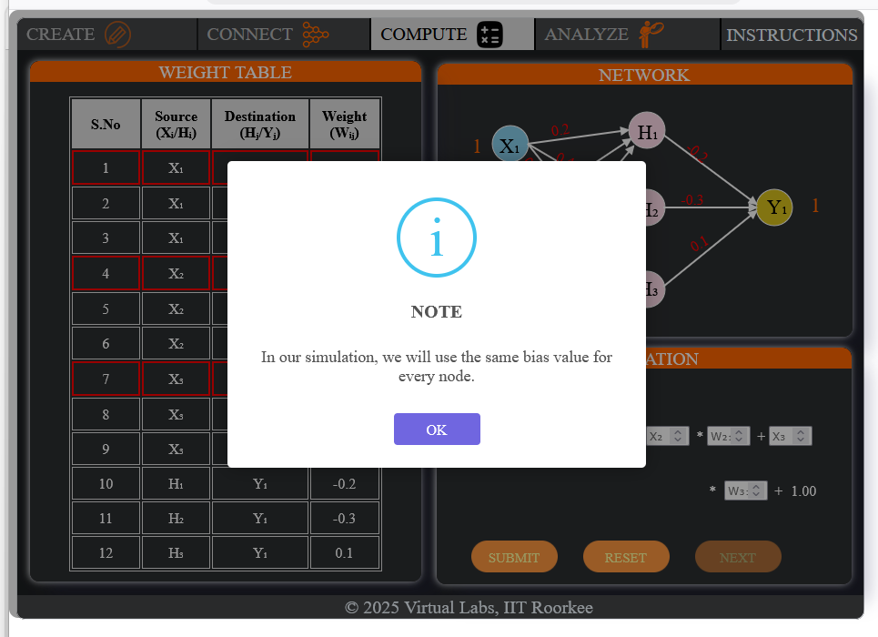
Fig 11: The simulation uses the same bias value for every node
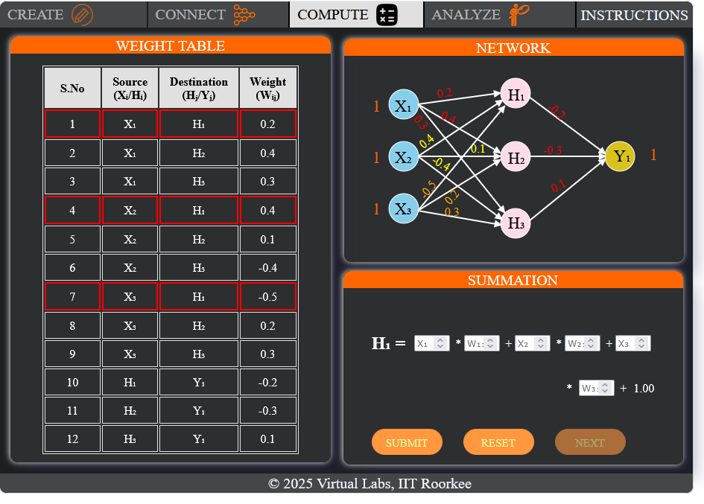
Fig 12: Summation setup for hidden layer node H1

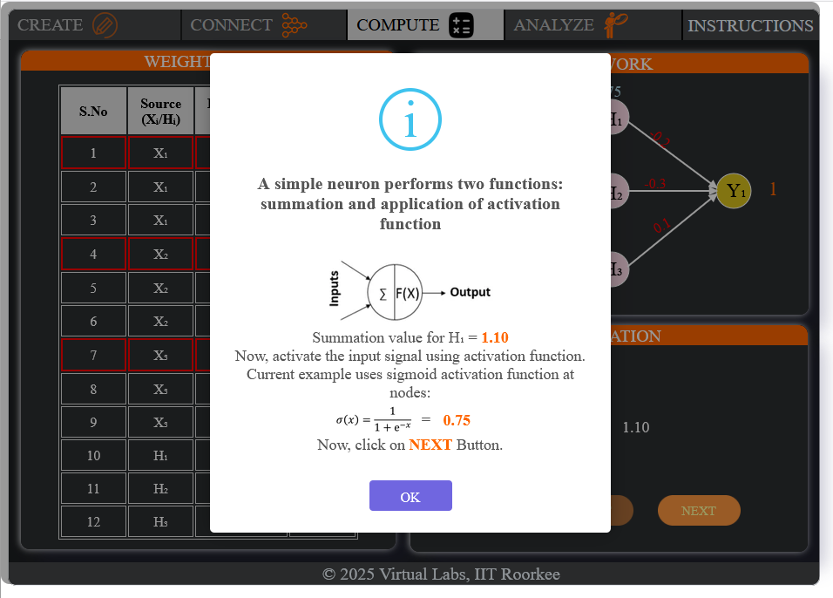
Fig 13: Summation (1.10) and sigmoid activation (0.75) computed for H1
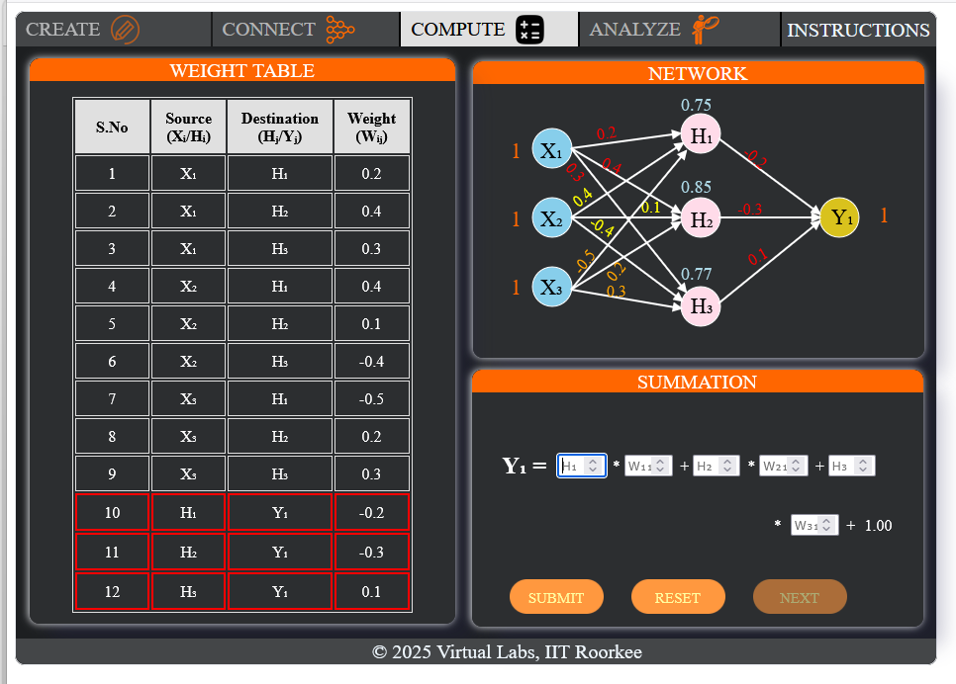
Fig 14: Hidden layer outputs obtained ; summation setup for output node Y1

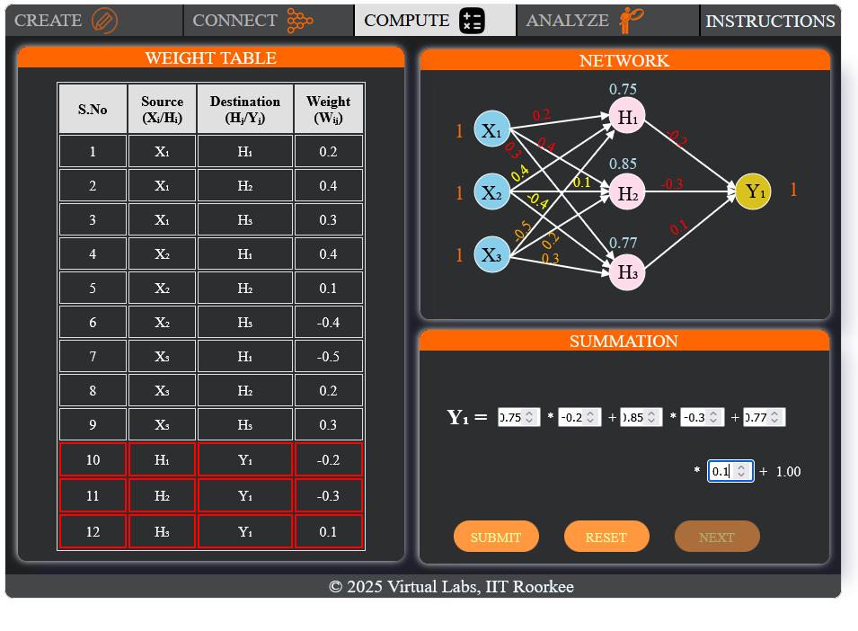
Fig 15: Output layer summation values entered for Y1
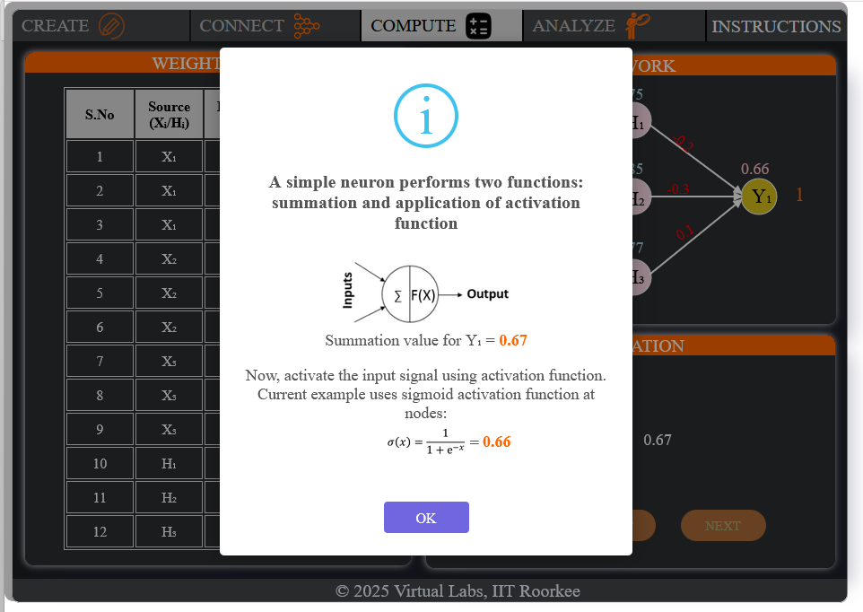
Fig 16: Summation (0.67) and sigmoid activation (0.66) computed for Y1

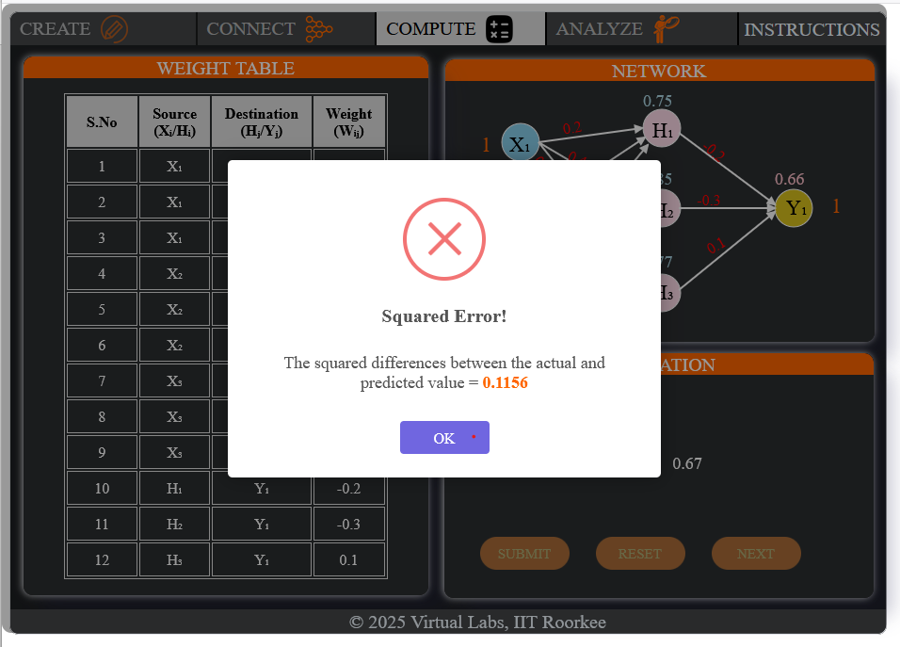
Fig 17: Squared error computed between actual and predicted output (0.1156)
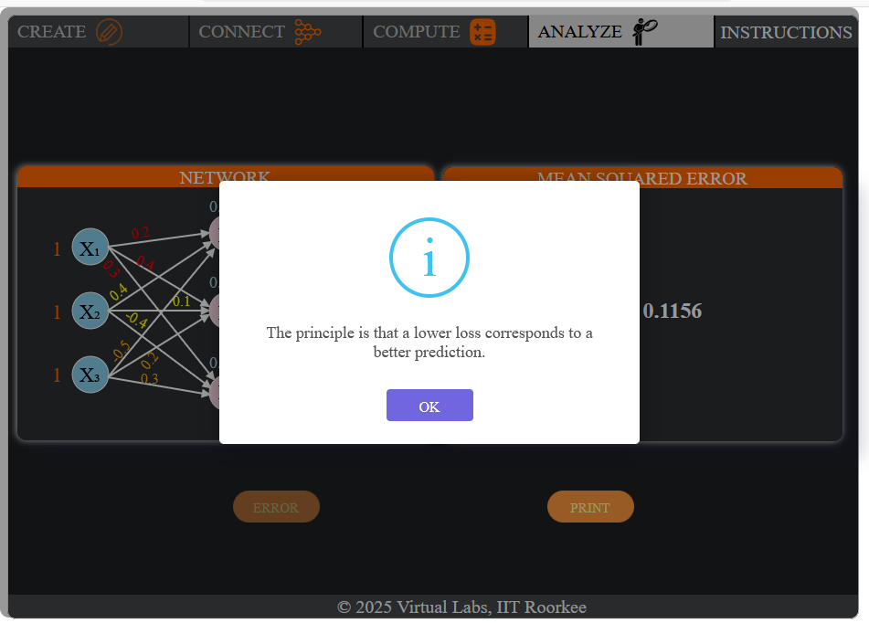
Fig 18: A lower loss corresponds to a better prediction

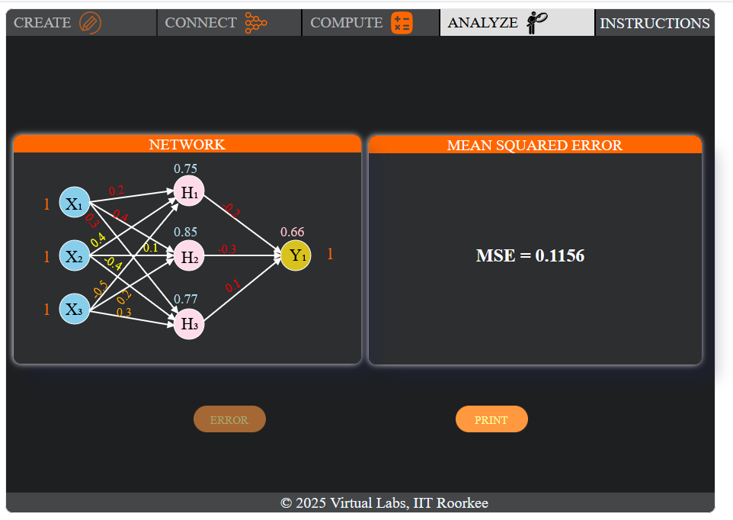
Fig 19: Final network with computed node outputs and Mean Squared Error (MSE = 0.1156)

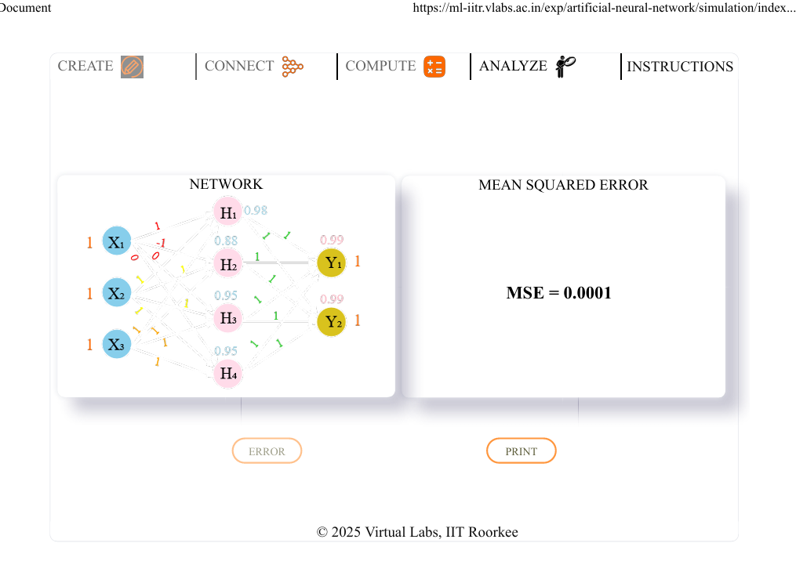
Fig 20: Printable summary view of the network and Mean Squared Error

Simulation link: https://ml-iitr.vlabs.ac.in/exp/artificial-neural-network/simulation.html

Result:
The Artificial Neural Network was successfully studied and implemented. The input, hidden, and output layers were configured, weights and biases were assigned, the activation function was applied, and the predicted output and corresponding error were obtained successfully.

