YUVA INTERN / LOGISTICS DATA ANALYST
Advanced Data Analysis and Visualization in Logistics
Week 3 task | Explore delivery performance, explain patterns, and identify bottlenecks
WEEK | CASE | DATA BASIS
03 / 04 | Pune last-mile delivery | Synthetic demonstration

Executive summary An exploratory analysis of 1,185 cleaned synthetic shipments, with KPI definitions, segment comparisons, charts, and decision-focused caveats.

Data note All shipment-level numbers in this report are generated for learning and are not real YuvaIntern, retailer, courier, or customer performance data.

1. Questions and analytical setup
- What does a typical delivery take, and how long is the upper tail?
- How does on-time performance differ across zones and observed traffic categories?
- Do distance, weather, or calendar week align with delivery-time variation?
- Which patterns merit operational investigation, rather than an immediate causal conclusion?
The analysis uses 1,185 unique shipments from 01 Jun 2026 through 29 Aug 2026. On-time means actual_delivery_min <= planned_delivery_min. The overall rate is 68.9%; delivery duration is reported with mean, median, and percentiles because the distribution has a longer high-time tail.

2. KPI snapshot
Measure | Synthetic result | Interpretation
Eligible shipments | 1,185 | One row per unique shipment after quality filtering.
Mean / median actual time | 80.7 / 78.6 min | Mean exceeds median, indicating a right tail.
P90 / P95 actual time | 115.8 / 127.6 min | A small but important share takes much longer.
On-time delivery | 68.9% | Share at or before the planned time.
Mean / median cost | INR 73.97 / INR 69.53 | Generated cost per eligible shipment.
First-attempt success | 97.0% | Share with one recorded attempt in this simulation.

3. Distribution and service-level view
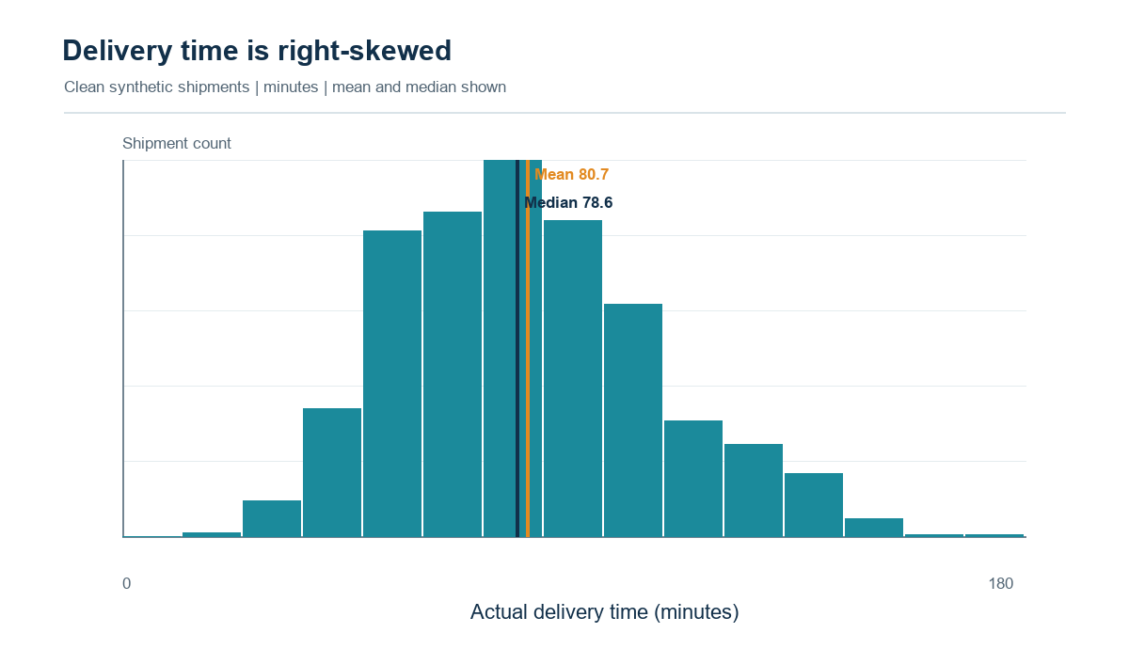
Figure 1. Delivery-time distribution; mean 80.7 min and median 78.6 min.
The mean is 80.7 minutes and the median is 78.6, a 2.1-minute gap. The P90 is 115.8 minutes. Reporting only the mean would hide the typical shipment and the long-delay tail; reporting only the median would hide service risk for the slowest orders.

4. Zone and operating-condition comparisons
Zone | Shipments | Median min | On-time | Mean cost
Outer | 187 | 82.6 | 55.6% | INR 72.96
East | 197 | 77.7 | 67.0% | INR 71.65
West | 176 | 78.4 | 69.3% | INR 74.66
Central | 233 | 78.8 | 71.2% | INR 75.28
South | 189 | 77.7 | 73.5% | INR 74.36
North | 203 | 77.3 | 75.4% | INR 74.71

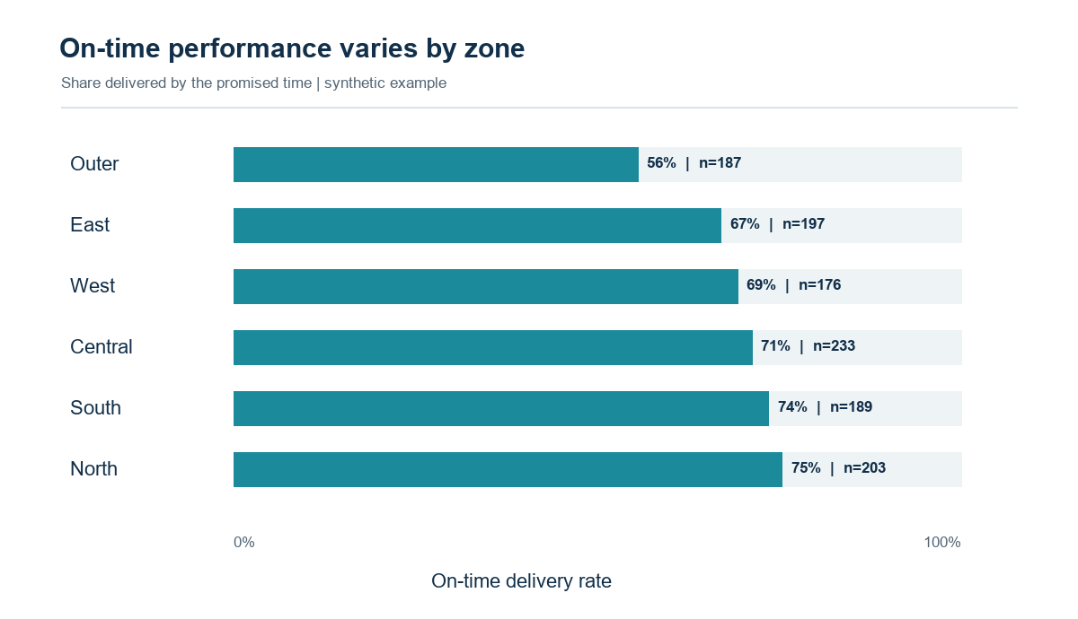
Figure 2. On-time delivery rate by zone; bars are labelled with shipment counts.
Outer has the lowest on-time share (55.6%, n=187); North has the highest (75.4%, n=203). This gap is a prioritization signal, not proof that zone geography caused delays. Route mix, traffic, dispatch timing, and sample variation need review before reallocating capacity.
Traffic | Shipments | Mean min | Median min | On-time
Low | 329 | 68.4 | 65.6 | 94.5%
Medium | 501 | 79.3 | 76.8 | 80.6%
High | 355 | 94.1 | 91.1 | 28.5%

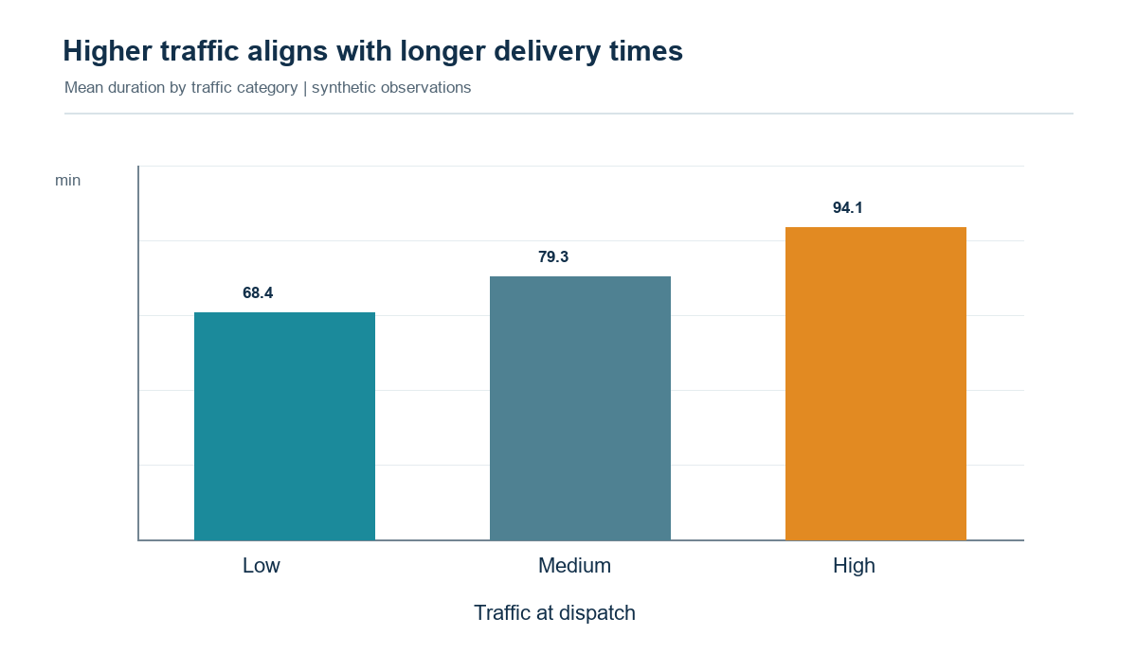
Figure 3. Mean delivery time rises across the generated traffic categories.
High-traffic shipments have a median of 91.1 minutes versus 65.6 for low traffic, a 25.5-minute difference. Their on-time rates are 28.5% and 94.5%, respectively. Rainy shipments average 89.6 minutes versus 78.6 in clear weather, an 11.1-minute difference in this simulated dataset.

5. Relationships and time pattern
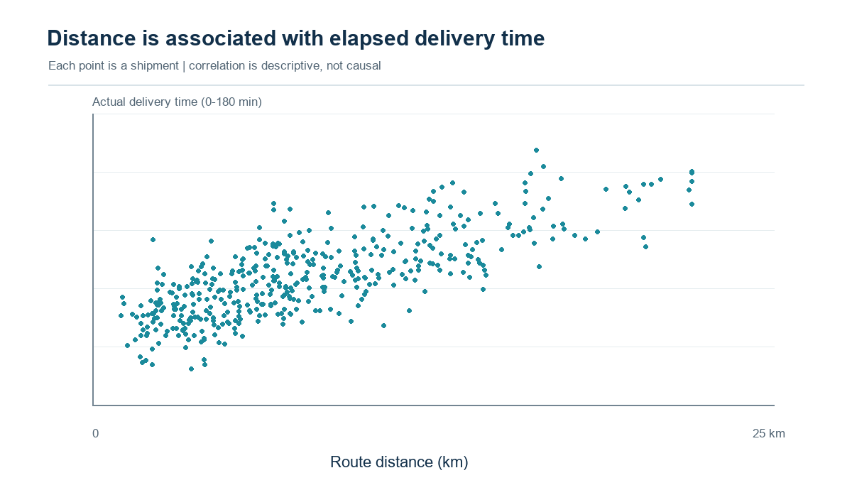
Figure 4. Route distance and actual delivery time (sample correlation r=0.77).
The Pearson correlation between distance and actual duration is 0.77. This is a descriptive linear association in generated data; congestion, route choice, and other variables may also contribute. Weekly mean time ranges from 76.4 to 86.7 minutes, with weekly shipment volumes between 75 and 123. The fluctuations do not establish a sustained trend, and no holiday or special-event calendar was simulated.
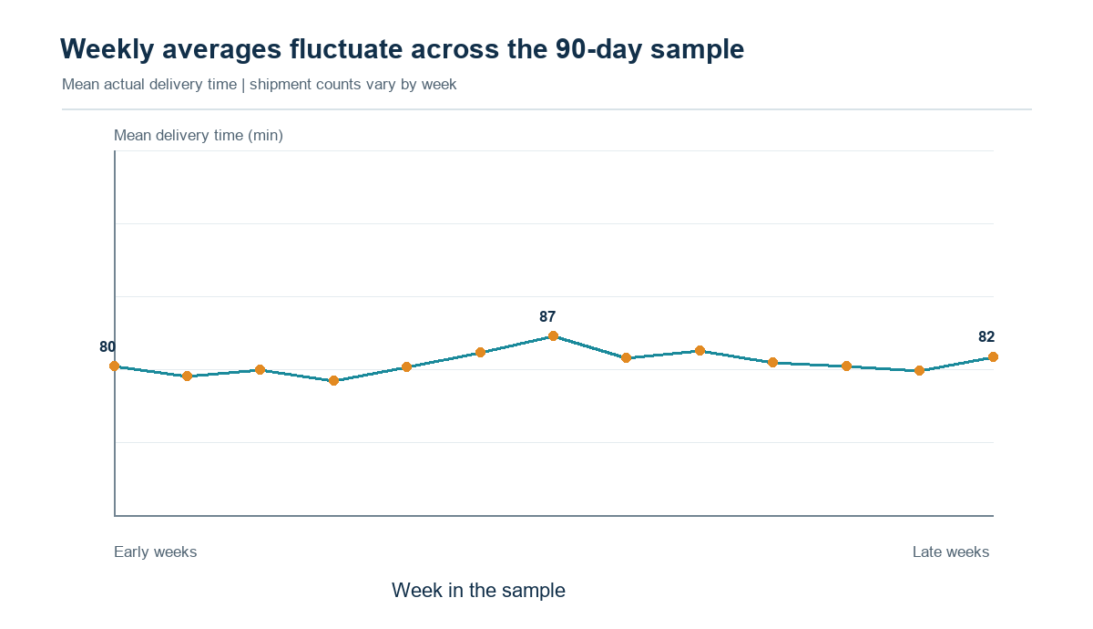
Figure 5. Weekly mean delivery duration across the 90-day sample.

6. Python illustration
# Calculate KPI and segment summaries from the cleaned shipment table
clean["on_time"] = clean["actual_delivery_min"] <= clean["planned_delivery_min"]
summary = clean.groupby("zone").agg(
shipments=("shipment_id", "count"),
median_minutes=("actual_delivery_min", "median"),
on_time_rate=("on_time", "mean"),
mean_cost_inr=("delivery_cost_inr", "mean"),
)
overall_p90 = clean["actual_delivery_min"].quantile(0.90)
traffic_summary = clean.groupby("traffic_level")["actual_delivery_min"].agg(
["mean", "median", "count"]
)

7. Findings and practical next steps
- Start the operational review with Outer-zone routes and high-traffic dispatch windows, while checking shipment counts and route mix.
- Use median and P90 together in service reviews; do not set a customer promise from this synthetic P90 without validating on real delivery scans.
- Collect route coordinates or network distance, timestamped scans, failed-attempt reasons, driver shift and capacity, and local weather/traffic snapshots.
- Run a small, pre-defined pilot and compare on-time rate, cost per shipment, first-attempt success, and route distance against a matched control period.
Interpretation limit All rates, differences, and correlations here are produced from deterministic synthetic data. They illustrate how to analyze a dataset; they do not describe a real Pune carrier or prove intervention effects.

References
[1] Government of India, DPIIT. (2022). National Logistics Policy, Gazette notification S.O. 4575(E), 28 September 2022. Open source
[2] World Bank. (2025). Logistics Performance Indicators 2.0. Open source
[3] Wu, L. et al. (2023). LaDe: The First Comprehensive Last-mile Delivery Dataset from Industry. arXiv:2306.10675. Open source

Portal description to paste (220 words)
Copy this text Paste the paragraph below into the portal's report-description box for this week.

This report explores the prepared synthetic Pune shipment dataset and presents its distributions, segment comparisons, time patterns, and operational interpretation. The analysis uses 1,185 cleaned shipments spanning 1 June through 29 August 2026. It defines the denominator for on-time delivery and reports both mean and median values so the reader can see the effect of the upper tail. The report includes a delivery-time histogram, on-time rate by delivery zone, average delivery time by traffic category, distance versus delivery-time scatter, and weekly trend chart. It explains why each chart suits its question and provides a tabular alternative for key comparisons. In this simulated sample, the mean delivery duration is about 80.7 minutes, the median is 78.6 minutes, the 90th percentile is about 115.8 minutes, and the on-time rate is 68.9 percent. The Outer zone has the lowest on-time rate, while high-traffic shipments have a substantially longer median duration than low-traffic shipments. Rainy-weather deliveries also take longer on average in this generated sample. These findings are treated as descriptive associations, not causal effects or claims about a real carrier. The report includes code snippets for grouping, KPI calculation, and visualization, discusses weekly sample-size variation and synthetic-data limits, and turns the findings into cautious next steps: inspect zone operations, use peak-period monitoring, collect route-level context, and validate any improvement with a controlled pilot.

