YUVA INTERN / LOGISTICS DATA ANALYST
Predictive Modeling and Optimization in Logistics Systems
Week 4 task | Forecast delivery time, validate the model, and design an operational pilot
WEEK | CASE | DATA BASIS
04 / 04 | Pune last-mile delivery | Synthetic demonstration

Executive summary A chronological holdout evaluation compares a simple median baseline with a multiple linear regression model on the same synthetic shipment history.

Data note All shipment-level numbers in this report are generated for learning and are not real YuvaIntern, retailer, courier, or customer performance data.

1. Prediction problem and target
Prediction target: actual delivery duration in minutes, measured from dispatch to delivery. The operational use is to flag shipments likely to miss their promise so dispatch teams can review workload and communicate realistic ETAs. Candidate inputs are available at dispatch: route-distance proxy, parcel weight, dispatch hour, weekday, delivery zone, traffic category, and weather category. Actual outcome fields, post-delivery events, and computed on-time status are excluded from the predictors to prevent target leakage.

2. Dataset and validation design
Item | Design
Data | 1,185 clean synthetic shipments; 1 June-29 August 2026.
Training period | Earlier dates through 11 Aug 2026; n=942.
Holdout period | 12-29 Aug 2026; n=243; never used to fit coefficients.
Preprocessing | Median/mode imputation completed; numeric scaling learned on training rows; categories encoded against fixed reference levels.
Baseline | Predict each holdout shipment with the training-period median duration.
Model | Multiple linear regression fitted by NumPy least squares.

A chronological split better mirrors the intended use: learn from the past and score a later operating period. It also reduces look-ahead risk compared with a random record split. This is a single holdout, not repeated cross-validation, and the 90-day synthetic history is too short to represent seasonal or holiday variation.

3. Model choice and evaluation
Multiple linear regression is chosen as an interpretable baseline. One-hot indicators represent zone, traffic, and weather; numeric predictors are scaled with training-only statistics. NumPy's least-squares solver estimates coefficients by minimizing squared residuals [1]. A tree ensemble could capture interactions, but should be compared only after a real, larger dataset is available and the same chronological validation is retained.
Metric | Median baseline | Linear regression | Reading
MAE | 20.48 min | 9.40 min | Average absolute error; easy to explain as minutes.
RMSE | 25.22 min | 11.94 min | Penalizes larger misses more heavily.
R-squared | -0.001 | 0.776 | Share of holdout variation explained relative to its mean.

On this holdout, the model reduces MAE by 54.1% relative to the training-median baseline. The model's MAE is 9.4 minutes, RMSE is 11.9 minutes, and R-squared is 0.776. This is evidence only that the chosen model fits this generated pattern better than a constant prediction; it is not a real-world accuracy promise.

4. Python implementation
import numpy as np
# Chronological split; fit scaling on training rows only
split_date = sorted(clean.order_date.unique())[
int(.80 * clean.order_date.nunique())
]
train = clean[clean.order_date < split_date]
test = clean[clean.order_date >= split_date]
numeric = ["distance_km", "package_weight_kg", "dispatch_hour", "day_of_week"]
mu = train[numeric].mean()
sd = train[numeric].std(ddof=0).replace(0, 1)
levels = {"zone": ["North", "South", "East", "West", "Outer"],
"traffic_level": ["Medium", "High"], "weather": ["Rain"]}
def matrix(frame):
scaled = ((frame[numeric] - mu) / sd).to_numpy()
flags = [(frame[col] == value).to_numpy(dtype=float)
for col, values in levels.items() for value in values]
return np.column_stack([np.ones(len(frame)), scaled, *flags])
beta = np.linalg.lstsq(matrix(train), train.actual_delivery_min, rcond=None)[0]
prediction = matrix(test) @ beta
error = test.actual_delivery_min.to_numpy() - prediction
mae = np.mean(np.abs(error)); rmse = np.sqrt(np.mean(error ** 2))
The full reproducible Python companion script includes the deterministic synthetic-data generator, quality rules, feature construction, time split, metrics, and chart creation. The core regression call follows NumPy's documented least-squares interface [1].

5. Diagnostic charts
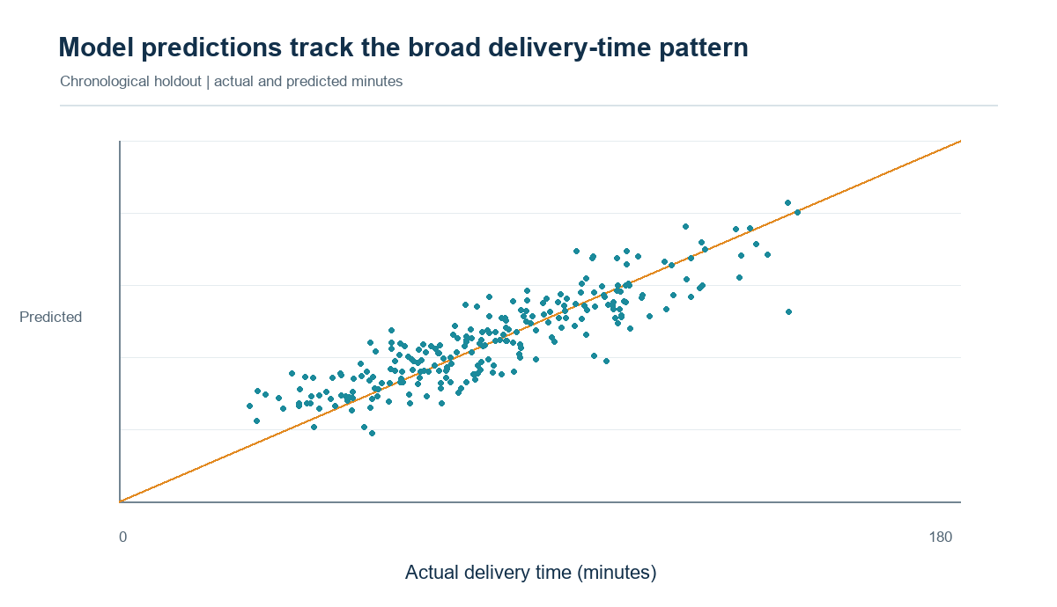
Figure 1. Holdout actual versus predicted duration; MAE 9.4 min.
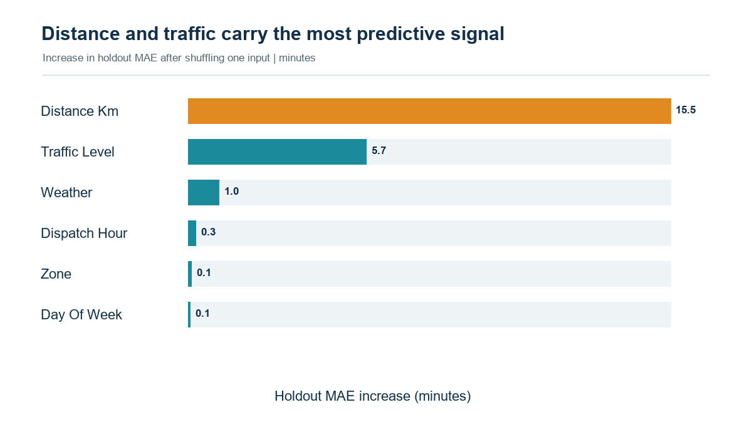
Figure 2. Permutation importance: increase in holdout MAE after shuffling an input.
Distance and traffic provide the largest predictive signal in the generated sample: distance km (+15.5 min MAE), traffic level (+5.7 min MAE), weather (+1.0 min MAE). Permutation importance is computed by shuffling one original input at a time on the holdout and measuring the change in MAE. It is a model diagnostic, not a causal effect or a stable ranking expected to transfer to real routes.

6. Optimization recommendations
Horizon | Operational action | Measure and guardrail
Near term | Use an ETA risk flag to prioritize dispatch review for high-traffic and Outer-zone shipments. | On-time rate, P90 error, failed attempts; review alert volume.
Pilot | Test staggered dispatch or a limited peak-period rider buffer in one zone against a matched comparison. | Target +5 percentage points on-time; keep cost per shipment within +3% of baseline.
Next data step | Add GPS/network travel time, stop coordinates, vehicle capacity, shift limits, and delivery windows. | Monitor route km, utilization, overtime, safety, and fairness by zone.
Future optimizer | Formulate a capacitated vehicle-routing problem with time windows; compare feasible routes under real road times. | Track service level and total operating cost; require dispatcher review.

The network P90 in the synthetic sample is 115.8 minutes and the Outer-zone on-time rate is 55.6%. These are useful only as demonstration baselines. Prediction can support prioritization, but route optimization requires stop-level coordinates, vehicle constraints, and travel-time matrices that are absent here. Do not claim fuel, time, or cost savings before a controlled pilot measures them.

7. Limitations and monitoring plan
- Synthetic observations were generated by known rules; they are not independent evidence of how a real delivery network behaves.
- The single holdout can be sensitive to the chosen date boundary. Repeat rolling-origin evaluation on a longer real history.
- Measure errors by zone, traffic, weather, and time window; watch for data drift and missingness shifts.
- Recalibrate promises only after the model demonstrates stable performance and operations approve service and safety guardrails.
- Keep a human dispatcher in the decision loop; log overrides and monitor who or which zones receive additional capacity.
Recommendation Treat the model as a prioritization aid for a small measured pilot. The analysis does not establish an optimal route plan or guarantee a reduction in late deliveries.

References
[1] NumPy developers. numpy.linalg.lstsq reference. Open source
[2] Government of India, DPIIT. (2022). National Logistics Policy, Gazette notification S.O. 4575(E), 28 September 2022. Open source
[3] World Bank. (2025). Logistics Performance Indicators 2.0. Open source

Portal description to paste (234 words)
Copy this text Paste the paragraph below into the portal's report-description box for this week.

This report develops and evaluates an interpretable delivery-time prediction baseline for the simulated Pune logistics case. The target is actual delivery duration in minutes, and the input fields are limited to information intended to be available at dispatch: route distance, parcel weight, dispatch hour, weekday, zone, traffic category, and weather. To reduce look-ahead bias, the model is trained on earlier dates and evaluated on a later chronological holdout rather than a random split. A training-set median predictor provides the benchmark, and a multiple linear regression model is fitted with one-hot categorical indicators and numeric scaling learned only from the training period. On the 243-record holdout, the model's mean absolute error is about 9.4 minutes and its root mean squared error is about 11.9 minutes, compared with about 20.5 and 25.2 minutes for the median baseline. The report explains MAE, RMSE, and R-squared; includes actual-versus-predicted and feature-permutation charts; and interprets distance and traffic as useful predictive signals within this synthetic dataset. It clearly cautions that these figures are not evidence of real-world accuracy, and that associations do not establish causation. The optimization section proposes using predicted delays to flag peak-period workload and test zone-based dispatch or rider allocation. It does not claim savings or implement a road-network optimizer, because actual GPS traces, vehicle capacities, time windows, and route constraints are absent. A pilot plan defines service, cost, and fairness measures for any future operational test.

