SECTZG629T: Dissertation (For SE)

Online Billing System for Cafeteria products using Resource Oriented architecture approach
(MID-semester Report)

By

Krishna Kumar G
(BITS ID: 2013HT78070/ Associate ID: 355228 )

Dissertation work carried out at
Cognizant Technology Solutions

Dissertation Submitted in partial fulfillment of the requirement of
M.Tech in Software Engineering

Under the Supervision of
Karthikeyan Vedagiri
Senior Manager – Projects
Cognizant Technology Solutions, Chennai


BIRLA INSTITUTE OF TECHNOLOGY AND SCIENCE
PILANI, RAJASTHAN-333031

September 2015

BIRLA INSTITUE OF TECHNOLOGY AND SCIENCE, PILANI

CERTIFICATE

This is to certify that the Dissertation entitled “Online Billing System for Cafeteria products using Resource Oriented architecture approach” submitted by Krishna Kumar G, BITS ID-No. 2013HT78070 for the partial fulfillment of the requirements of M.Tech Software engineering degree of BITS, embodies the work done by him under my supervision.

Karthikeyan Vedagiri

Signature of the Guide / Account Manager

Name : Karthikeyan Vedagiri
Designation : Senior Manager– Projects
Cognizant Technology Solutions
Location : Chennai-SRISEZ
Date : 02nd September 2015

ABSTRACT

Dissertation Title : Online Billing System for Cafeteria products using Resource Oriented architecture approach

Name of Supervisor/Guide : Karthikeyan Vedagiri
Name of the Student : Krishna Kumar G
BITS ID. No. : 2013HT78070
Semester : I Semester 2015-2016
Course Code : SECTZG629T (DS)

The basic objective of this work is to have a system that can ease the employees of Cognizant Chennai for their cafeteria billing process in an efficient and easy way. Currently the employees stand in long queue to get billed and pay for their food items losing productivity.

This online system provide various ways to search and buy food items in various food outlets in cafeteria of cognizant Chennai offices by employees with their mobile handset and also provides an easy way for vendors and admin to maintain the system through a web application. The system also provides kiosk based bill generation system reducing vendor time and resources. The Solution has been designed with ROA [Resource Oriented Architecture] which uses light weighted Restful Web services for data interchange among its components and also cost effective by employing Open source framework and tools.

Currently there is no online food management system in cognizant premises. This system can be easily implemented in cognizant premises using simple Webservers and databases. This system will help the employees of cognizant to save time and helps the admin and cafeteria vendors in crowd management aspects. Using ROA with JSON data interchange helps in minimum data usage for Mobile devices. This implementation also helps the Admin team to have single point solution for managing vendors in Cognizant. Automating the bill generation process will helps the employees to reduce stress. Also helps physically challenged employees to select their menu from their mobile itself.

The ROA architecture also supports easy enhancements like adding new platform independent components to the system. E.g.: Electronic display about the list of items for a vendor, Creating IOS and Windows Mobile App, Embedded system based KIOSK applications. Since Open source tools are used, this will be a cost effective solution. Payment gateway and HTTPS mode of data transmission can be easily integrated with the proposed system during implementation in cognizant premises.

Krishna Kumar G Karthikeyan Vedagiri

Signature of Supervisor

Date: 14th September 2015
Name of Supervisor: Karthikeyan Vedagiri

Designation: Senior Manager– Projects

Cognizant Technology Solutions

Location: Chennai - SRISEZ

Signature of Student

Date: 14th September 2015
Name: Krishna Kumar G

Designation: Associate - Projects

Cognizant Technology Solutions

Location: Chennai - SRISEZ

Acknowledgement

I take this opportunity to express my gratitude to my project guide Karthikeyan Vedagiri (Senior Manager - Projects, Cognizant Technology Solutions) for providing his insight, guidance & advice whenever & wherever I needed. His sound understanding of the IT business, project manager needs, clear communication and guidance has helped me shape the direction of this dissertation project work.

Proposed Activities

Stage | Purpose | Activities | Status | Deliverable
Stage 1 | Define Scope of Dissertation  Define Requirements | Defining business problem statement and the proposed solution framework | 100% | Preliminary Report
Stage 1 | Define Scope of Dissertation  Define Requirements | Defining functional and non-functional requirements | 100% | Preliminary Report
Stage 2 | Refining the requirements  Proposed  Solution  Detailed design for the proposed Solution | Coming up with use case scenarios for the business problem | 100% | Mid Review report
Stage 2 |  | - High level design  - Technical Requirements | 100% | Mid Review report
Stage 2 |  | - Overall architecture  - Backend Database design  - Front end screen flow | 100% | Mid Review report
Stage 3 | Development QA and Implementation | - Coding & Unit testing  - Android Mobile Application  - Web Console UI for Admin and vendor  - Rest Services for Web and Mobile.  - KIOSK Application  - Web service testing and integration testing  - Deployment of code | 60% | Final review Report

Table of Contents

1. Objective 8
2. Scope 8
Software Requirement Specification 9
2.1 Functional Requirements 9
2.1.1 Use case scenarios 9
2.1.1.1 Mobile Application Use Case 9
2.1.1.2 KIOSK Application 10
2.1.1.3 Web Application –Admin and Vendor Console 11
Solution for the business problem: 13
2.2 Proposed Solution 13
2.3 Technical Requirements 14
2.3.1 Software Requirements for End Users 14
2.3.2 Software Used in Development 14
2.4 Solution Architecture 15
2.4.1 Admin and vendor Console 16
2.4.2 My Cafeteria Application 16
2.4.3 Kiosk Application 17
2.4.4 Rest Based Web services Layer 17
2.4.5 SQL Database 17
Detailed Design (Low Level) 18
2.5 Screen Layout Diagram-Mobile Application 18
2.6 Screen Layout Diagram-Web Application for Admin and Vendor 19
2.7 Class Architecture for Restful Services in Web application 20
2.8 Data Model Design 21
3. Coding & Web Service Testing 23
3.1 Best Practices 23
3.2 Code Review 23
3.3 Web Service Testing 23
3.4 QA Strategy 23
3.4.1 QA Scope 23
4. Application Screenshots 23
5. Future Extensibility 29
5.1 Scope for Future Extension 29
5.2 Guidelines 30
References 30

Objective

The basic objective of this work is to have a system that can ease the employees of Cognizant Chennai for their cafeteria billing process in an efficient and easy way. Currently the employees stand in long queue to get billed and pay for their food items losing productivity.

This online system provide various ways to search and buy food items in various food outlets in cafeteria of cognizant Chennai offices by employees with their mobile handset and also provides an easy way for vendors and admin to maintain the system through a web application. The system also provides kiosk based bill generation system reducing vendor time and resources. The Solution has been designed with ROA [Resource Oriented Architecture] which uses light weighted Restful Web services for data interchange among its components and also cost effective by employing Open source framework and tools.

Scope

The Scope of my dissertation is to create an online system to buy food items in various food outlets in cafeteria of cognizant Chennai offices by employees with their mobile handset and also provides an easy way for vendors and admin to maintain the system. The Solution has been designed to use light weighted RestFul Web services with JSON data interchange among its components .The solution is cost effective by employing Open source framework and tools in the system.
The system consists of Android Mobile Application where the employees order the food items .The employees can register and use the application. The user can search the food items “based on the vendor:” and “based on the category”. User can pay using a feature called ”My Wallet”, which has preloaded amount that has been declared by the user previously. User can view their successful orders .Users can maintain favorite food items list.
Using the Secret Code in every successful order, the employees can generate bill from the java swing based Kiosk application.
The food items and vendor details will be updated to the backend system using web application. The communication between all the components will happen through RestFul webservices having json data format.

Out of Scope:

- Payment through Online Payment Gateway.
- Crediting declared amount to “My Wallet” feature since the declared amount need to be deducted from salary.
- Printing the bill on a real printer.

Software Requirement Specification

Functional Requirements
Various combinations of the functional requirements are covered in the below three use case scenarios -

Use case scenarios

Mobile Application Use Case

Registering as a user:

- The user selects the user settings icon in home screen.
- Sign in/Register dialog box is opened and selects the “Register” tab.
- User enters the details and submits the form.
- If the username does not exist, the new user is created.

Creating an Order using category based search:

- User opens the application and selects the corresponding Location for which food items needs to be ordered.
- User selects the category option from the Home menu.
- From the list of categories the user selects one.
- List of vendors available under that category in that location are listed.
- User selects the vendor and list of items under selected category and vendor are displayed.
- User can then add items to the cart.
- User can view the cart items by clicking the “Cart” button.
- User can select the number of count for each item in the cart window.
- User can select the “Pay” icon, and if the user is already logged in then the user will be prompted with Total amount and payment options, otherwise “Sign-In/Register “Tab will be prompted. After successful sign-in the Total amount and payment options will be displayed.
- For Demo purpose, User can select the “My wallet” option and pay for the food items.
- Once the order is successful, “Payment made successfully” message is shown.
- User can view the order in Order Menu in the Home screen with the status as “paid”.

Creating an Order using Vendor based search:

- User opens the application and selects the corresponding Location for which food items needs to be ordered.
- User selects the Vendor option from the Home menu.
- From the list of vendor the user selects one.
- List of categories available under that vendor in that location are listed.
- User selects the category and list of items under selected category and vendor are displayed.
- User can then add items to the cart.
- User can view the cart items by clicking the “Cart” button.
- User can select the number of count for each item in the cart window.
- User can select the “Pay” icon, and if the user is already logged in then the user will be prompted with Total amount and payment options, otherwise “Sign-In/Register “Tab will be prompted. After successful sign-in the Total amount and payment options will be displayed.
- For Demo purpose, User can select the “My wallet” option and pay for the food items.
- Once the order is successful, “Payment made successfully” message is shown.
- User can view the order in Order Menu in the Home screen with the status as “paid”.

Creating an order using favorite option:

- User can select his/her favorite items either using Category based search or Vendor based search.
- From the items list the user can select “Add as favorite” option .If the user has not logged in, then the Sign-In/Register Popup will be displayed. After successful sign in the user can add items to his/her favorite list.
- This Favorite list will be maintained for each user.
- The user can select the favorite option from the Home screen.
- The list of favorite items will be displayed along with their vendorname and price.
- The user can select add items to cart.
- The user can select and remove items from the favorite list.
- User can view the cart items by clicking the “Cart” button.
- User can select the number of count for each item in the cart window.
- User can select the “Pay” icon, Total amount and payment options will be displayed.
- For Demo purpose, User can select the “My wallet” option and pay for the food items.
- Once the order is successful, “Payment made successfully” message is shown.
- User can view the order in Order Menu in the Home screen with the status as “paid”.

KIOSK Application

Printing a Bill using KIOSK Application

Employee as User for Kiosk Application:

User enters the secret code
Bill Details are displayed.
User prints the bill

- Users sign in and view the order details from the Mobile Application under Order Menu.
- Each order will have a unique secret code.
- User enters the secret code in the KIOSK Application placed in the cafeteria, and press the submit button.
- The order details will be displayed in the KIOSK application.
- User can then press the print button to print the bill.
- Once the print is successful, the Order will be marked as “Expired”.
- Then the user can produce the bill at the food counter and receive the food items.

Web Application –Admin and Vendor Console

- Admin as User:

Add/Edit/Remove Categories
List of Categories

Add/Edit/Remove Vendors
List of Vendor
Admin Authentication

Add/Edit/Remove Location
List of Locations

Adding a Vendor:

- Admin enters his credentials in Login page.
- After successful authentication, list of vendors will be displayed in a grid view.
- The user selects the “Add Vendor” button.
- The user enters the new vendor details, assign an existing location or create a new location using “Add Location” button and selects “Save” button.
- New Vendor will be created.

Edit a vendor:

- Admin enters his credentials in Login page.
- After successful authentication, list of vendors will be displayed in a grid view.
- The user can find the vendor with the help of filters in the grid view.
- The user can click the vendor name and vendor Edit page will be displayed.
- User can use “Add Category” button to create a new Category.
- Then the user can edit the vendor details and save.

Remove a vendor:

- Admin enters his credentials in Login page.
- After successful authentication, list of vendors will be displayed in a grid view.
- The user can select the vendor and delete the same.

Adding a Category:

- Admin enters his credentials in Login page.
- After successful authentication, on Click of “categories” option, list of categories will be displayed in a grid view.
- The user selects the “Add Category” button.
- The user enters the new Category name, selects “Save” button.
- New Category will be created which can be used by all vendors for adding their items.

Edit a Category:

- Admin enters his credentials in Login page.
- After successful authentication, on Click of “categories” option, list of categories will be displayed in a grid view.
- The user can find the category with the help of filters in the grid view.
- The user can edit the category name and save.

Remove a Category:

- Admin enters his credentials in Login page.
- After successful authentication, on Click of “categories” option, list of categories will be displayed in a grid view.
- The user can find the category with the help of filters in the grid view.
- The user can delete the category from the grid view.

Adding a Location:

- Admin enters his credentials in Login page.
- After successful authentication, on Click of “Location” option, list of Locations will be displayed in a grid view.
- The user selects the “Add Location” button.
- The user enters the new Location name, selects “Save” button.
- New Location will be created.

Edit a Location:

- Admin enters his credentials in Login page.
- After successful authentication, on Click of “location” option, list of location will be displayed in a grid view.
- The user can find the location with the help of filters in the grid view.
- The user can edit the location name and save.

Remove a Location:

- Admin enters his credentials in Login page.
- After successful authentication, on Click of “Location” option, list of location will be displayed in a grid view.
- The user can find the location with the help of filters in the grid view.
- The user can delete the location from the grid view.

- Vendor as User:
Add/Edit/Remove Items

Vendor Authentication
List Items

Adding an Item:

- Vendor enters his credentials [Vendor Code and password] in Login page.
- After successful authentication, list of Items will be displayed in a grid view.
- The user selects the “Add Item” button.
- The user enters the new Item details, add a new category or select existing category and selects “Save” button.
- New Item will be created.

Edit an Item:

- Vendor enters his credentials [Vendor Code and password] in Login page.
- After successful authentication, list of items will be displayed in a grid view.
- The user can find the items with the help of filters in the grid view.
- The user can click on the item name and item Edit page will be displayed.
- User can use “Add Category” button to create a new Category or Reassign other category.
- User can edit the item details and save.

Remove an Item:

- Admin enters his credentials [Vendor Code and password] in Login page.
- After successful authentication, list of items will be displayed in a grid view.
- The user can select the item and delete the same.

Solution for the business problem:

Proposed Solution
The proposed system automates the billing system of cafeteria food items. Resource oriented architecture enables the system components to communicate with each other using JSON data over Restful services.
The system has an android application which helps the employees to browse through various cafeteria food products, buy and pay for cafeteria products. Once the transaction is successful the order will be created with a secret code for that each vendor related items in the cart. The bill for the products can be generated by the user using a java based kiosk application present in the cafeteria, where the user will enter the Secret code in the order to print the bill. The information about products ,users, vendors ,orders are maintained in a SQL database ,which is manipulated by RESTFUL web services with HTTP methods such as GET,POST,PUT and DELETE. Details about the food products and vendors are manipulated in the system by vendor and admin using a java based web application.

Various components of the proposed system are

- Admin Console- Java based Web application for Admin and Vendors
- My Cafeteria - Android Application for the employees to order food items.
- Kiosk Application- Java based desktop application to retrieve and print the bill
- Http Web services- Java based Restful Web Services to transmit the data from the database.
- MySQL Database- To store the data.

Note: Restful Web services and Admin Console are built in the same web Application

Technical Requirements

Software Requirements for End Users
Operating System:

- Windows for Web Application with web browsers and
- JRE for Kiosk Application
- Android Mobile Device

Software Used in Development
- Operating System : Windows XP/7, Android OS
- Languages : Java
- Framework : Android SDK, Java 1.7 JDK, Hibernate, JAX-RS
- Database : MySQL
- Web server : Apache Tomcat Server
- Build Tool : Maven
- Cloud For Demo Purpose: Amazon Cloud
- UI Framework for web application: Angular js

Solution Architecture

BASIC ARCHITECTURE OF THE PROPOSED SYSTEM:

MySQL Database

Restful Web services- Produces Data in JSON format

Admin Console –Web Application-
For Admin and Vendors
Android Application-My Cafeteria
KIOSK Application placed at cafeteria For Bill generation

Employees/Users
Admin and Vendors
Employees/Users

Presentation Layer:

- Web Application for admin and vendor can be viewed through HTML compatible browsers.
- Mobile Application for Employees or End users can be installed in Android mobile devices.
- Kiosk Application can be installed and used in desktops with JDK1.6/JRE 1.6

Business Logic Layer:

Business Logic layer will be implemented using JAX RS framework as Restful web services.

Data Access Layer:

Data access layer will be implemented using Hibernate framework, which is a open source java persistence framework.

Restful web services and Web Application will be hosted as same application for demo purpose.

Admin and vendor Console
This Component is java based web UI, which will be accessible by Admin and Vendors. This component helps the admin to manage new and existing vendors. It also enables the vendors to manage food products sold by them. All food products will be tagged under many categories like Snacks, Drinks, Meals, Chat and so on. Vendors can mark the availability and limit of supply for their products.

My Cafeteria Application
This Component is an Android Application, which will be used by Cognizant Chennai Employees. The users can install this application in their android phone, so that they can order the food items from their cafeteria through online. This app is an Ecommerce app under food category. This app gets minimum amount data dynamically over the mobile network /wifi and constructs the details for the user.

Initially the User needs to select the location of the CTS office in which he/she is going to buy the food.

The Selection of food items are based on two ways of filtering

- Category based Search- The user selects the food items by selecting the category, then the user selects the Vendors who provide services under the selected category. List of food items with price will be shown for the selected category and vendor. The user can add the food items to their cart.

- Vendor based Search-Similar to the above method the user first selects the vendor and then selects the category to view the list of food items and their corresponding prices. Then user can add the items to the cart.

Favorite items can also be marked for easy purchase under “favorite” option.

Previous Orders can also be viewed under “Order” option.

From cart the user can enter his/her credentials and can buy the food items through online money transactions via a payment gateway or My wallet utility. Successful transactions will generate a “secret code”.

Payment Module:

My Wallet: Payment for food items can be done by using “My Wallet” option in the Android Application. Any amount <3000 can be credited to this wallet from the employee’s salary by declaring it in the android application. The User can use this amount to purchase the food products. Similar to Prepaid Food card used by cognizant employees.

Payment Gateway [Not for Demo]: For reusability in production/live scenario, Payment can also be made by integrating the application with any payment gateway services like CCAvenue, Citrus [for integrating payment services, copyright and terms & conditions, legal notice are required].

Kiosk Application
Kiosk Application will be a desktop based java application where the user can enter the secret code to retrieve and print the bill details. When the bill is generated, that secret code will be marked as expired, similar to KIOSK machine in theatres used for online ticket booking

Rest Based Web services Layer
This Layer does not have any UI, The data in the SQL database can be manipulated only with the help of these services. These services have HTTP methods to manipulate data via JSON format. This Layer uses JAX-RS framework to deploy web services and Hibernate framework to maintain stateless asynchronous transactions.

SQL Database
To store all the data related to the system. This database can be accessed only by web services explained above.

Detailed Design (Low Level)

Screen Layout Diagram-Mobile Application

Home Screen with Location Option
Category based search
Vendor based Search
Favorites
Orders
List of categories
List of vendors
List of orders
List of favorite items
Vendors under selected category
Categories served by the selected vendor
List of food items for the selected category and vendor
List of food items for the selected vendor and category
Cart
Payment Module
User Authentication
User
User Details
User Authentication
User Authentication
User Authentication

- Declare wallet amount
- Change Password

Note: User Authentication is prompted only if the user hasn’t logged in previously. User Authentication contains Sign up and Register Forms.

Screen Layout Diagram-Web Application for Admin and Vendor
Login Screen

If user is Admin If User is Vendor

List of Category
List of Items
Delete Item
List of Vendors

List of Locations

Add/Edit/remove Location

Add/Edit/remove Category

Create Item
Edit Item

Add/Edit/remove Vendor

Class Architecture for Restful Services in Web application
Hibernate Framework
JAX RS Framework

My
SQL
DATABASE

Hi bernate Ut
I
l
Category Bean
Category Factory
Category Rest Service

Category.hbm.xml

Order.hbm.xml
Order Bean
Order Factory
Order Rest Service

Vendor.hbm.xml
Vendor Bean
Vendor Factory
Vendor Rest Service

Location Bean
Location Factory
Location Rest Service

Location.hbm.xml

User Bean
User Factory
User Rest Service

User.hbm.xml

Item Bean
Item Factory
Item Rest Service

Item.hbm.xml

Hibernate.cfg.xml

Data Model Design
E-R Diagram:

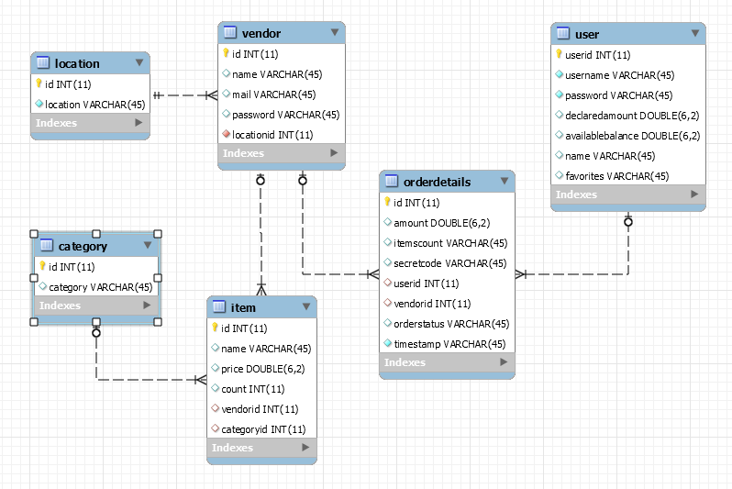

User Details

Table Name: user
Description | Column Name | Data Type
Id for the user | Userid | INT
Username of the user | Username | VARCHAR(45)
Actual name of the user | Name | VARCHAR(45)
Password for the user | Password | VARCHAR(45)
Amount declared to be deducted from the salary for crediting to “mywallet” | declaredamount | DOUBLE(6,2)
Actual balance in mywallet | availablebalance | DOUBLE(6,2)
Location Table

Table Name: location
Description | Column Name | Data Type
Id for the location | id | INT
Name of the location | location | VARCHAR(45)
Category Table
me: location
Table Name: category
Description | Column Name | Data Type
Id for the category | id | INT
Name of the category | category | VARCHAR(45)

Order Details Table
Table Name: orderdetails
Description | Column Name | Data Type
Id for the Order | id | INT
Total amount of the order | amount | DOUBLE(6,2)
Collection of Item id and their count | itemscount | VARCHAR(45)
SecretCode for the order | secretcode | VARCHAR(45)
id of the user who made the order  Foreign Key to userid in UserTable | userid | INT
id of the vendor for the order  Foreign Key to id in VendorTable | vendorid | INT
Status of the order | orderstatus | VARCHAR(45)
TimeStamp of the order | timestamp | VARCHAR(45)

Vendor Details Table
Table Name: vendor
Description | Column Name | Data Type
Id for the vendor | id | INT
Name of the Vendor | name | VARCHAR(45)
Mail Id of the vendor | mail | VARCHAR(45)
Password for the vendor | password | VARCHAR(45)
Id of the Location of the vendor  Foreign Key to id in LocationTable | locationid | INT
Item Details Table
Table Name: item
Description | Column Name | Data Type
Id for the Item | id | INT
Name of the item | name | VARCHAR(45)
Price of the item | price | DOUBLE(6,2)
Number of items | count | INT
id of the vendor for that item  Foreign Key to id in VendorTable | vendorid | INT
id of the category for that item  Foreign Key to id in CategoryTable | categoryid | INT

Coding & Web Service Testing

Best Practices
The concept of reusability and scalability are taken care in the codes.

Code Review
Manual code review will be done.

Web Service Testing
Manual Web service testing will be done.

QA Strategy

QA Scope
The scope of QA involves the testing of the entire system various use cases.

Such as

- Adding an item under a particular vendor to the system
- Adding a vendor to the system.
- Creating an order from mobile application through various use cases.
- Retrieving bill details using KIOSK application.

Application Screenshots

Below are the mock screenshots for mobile application.

Home Screen: Sign In Screen:

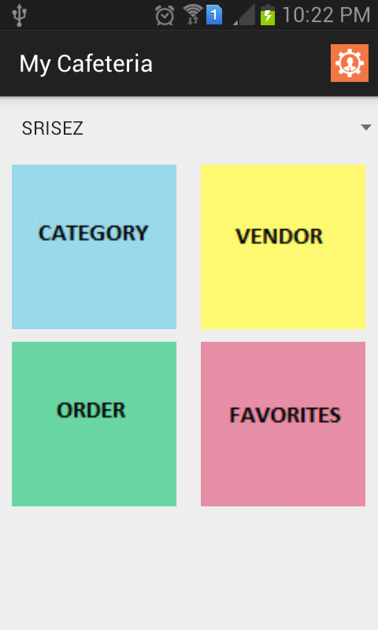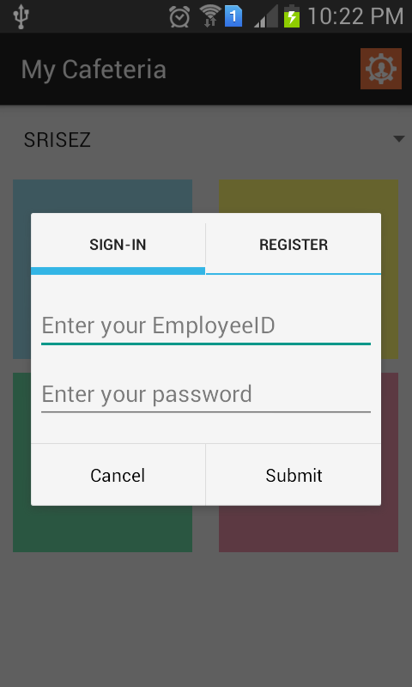

Register Screen: Location List:

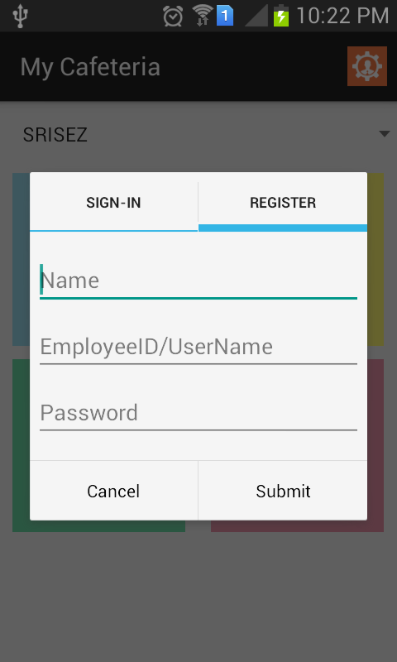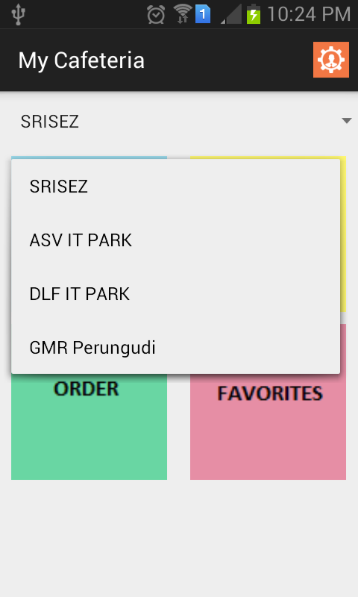
User Description Category List

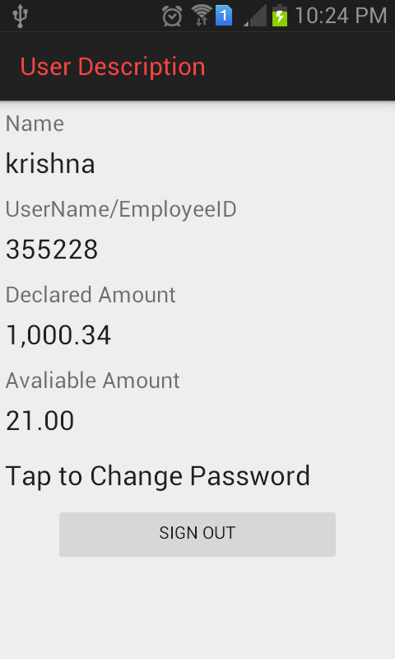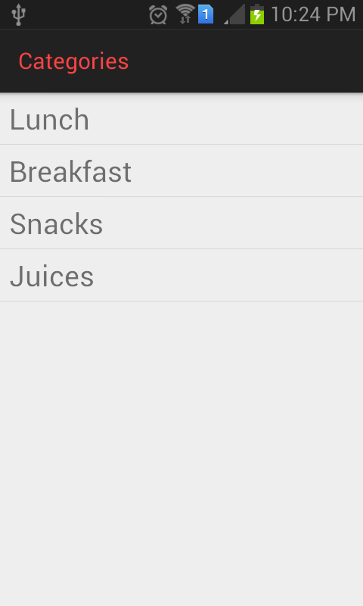

Vendor List Item List

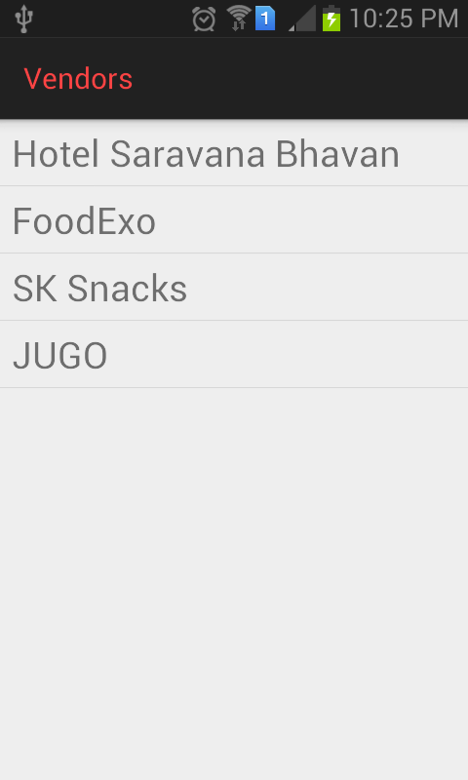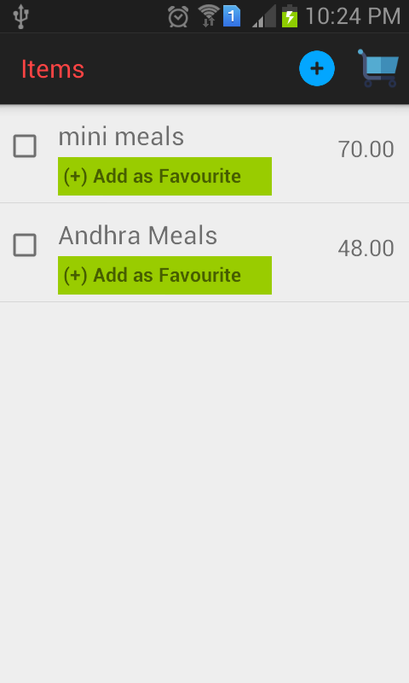
Cart Payment

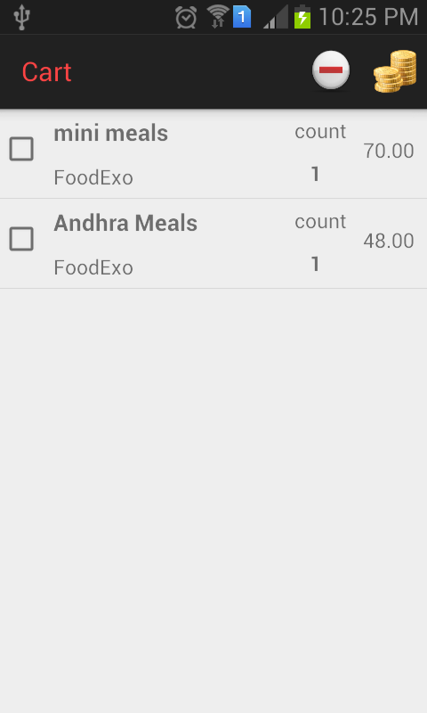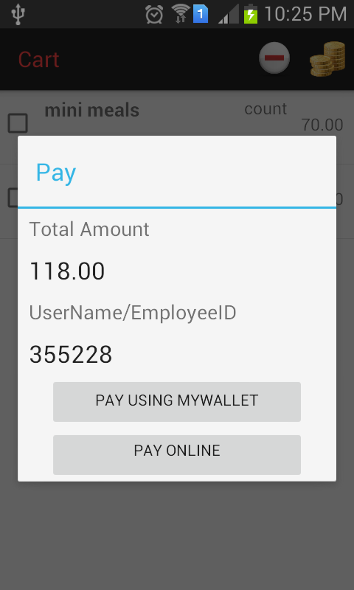

Favorites Options in Favorites

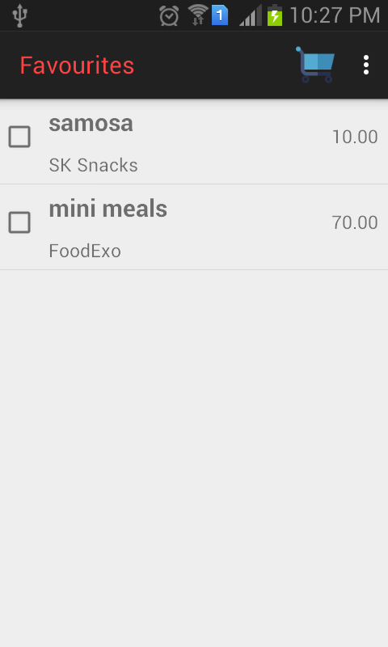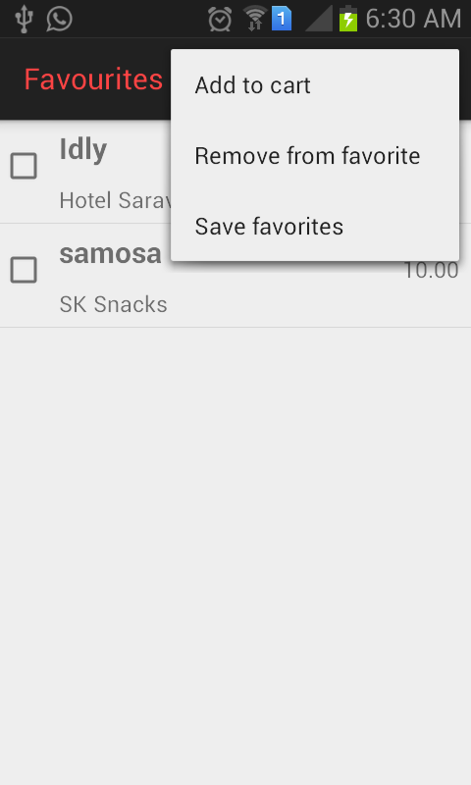
Orders

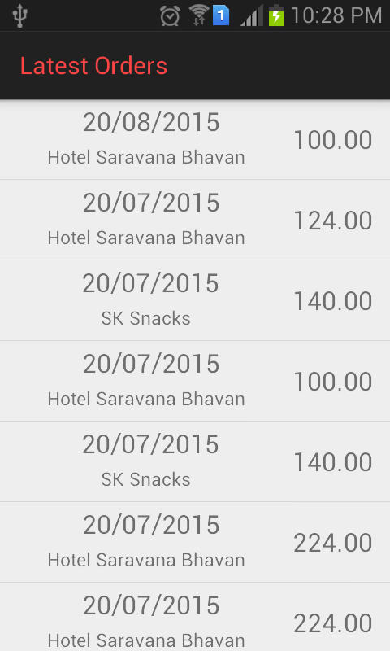

Below are the mock screenshot for the Kiosk application.

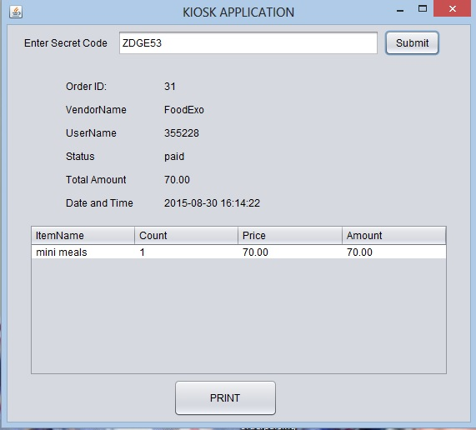

Below are the mock screenshots for the Web application.

Admin View:

List of categories

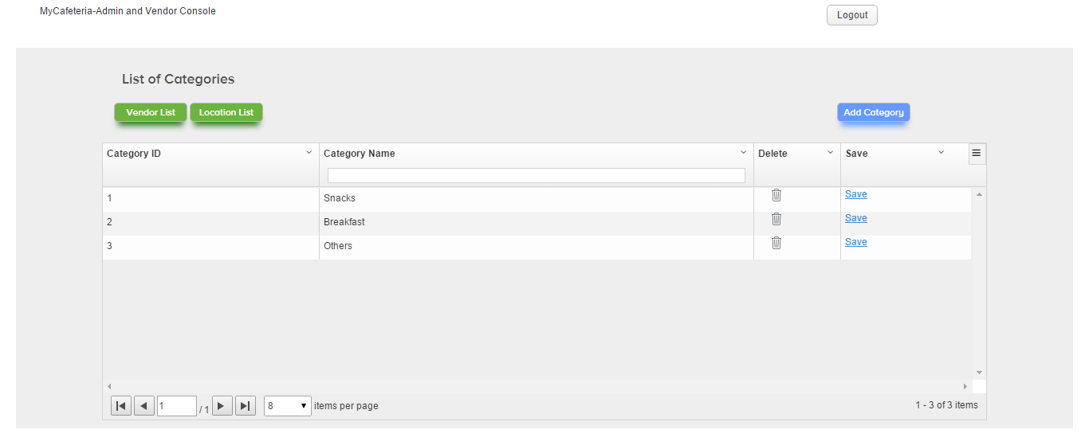

List of Locations

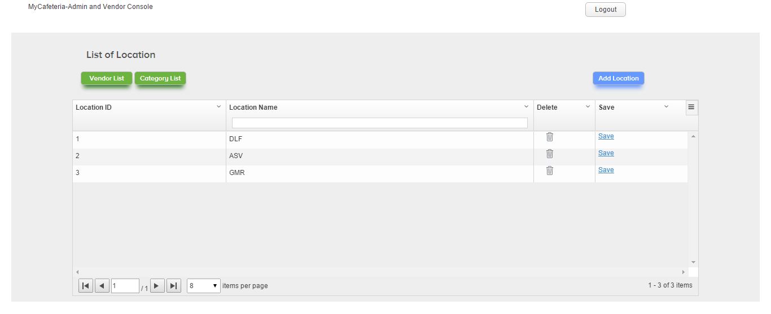

List of Vendors

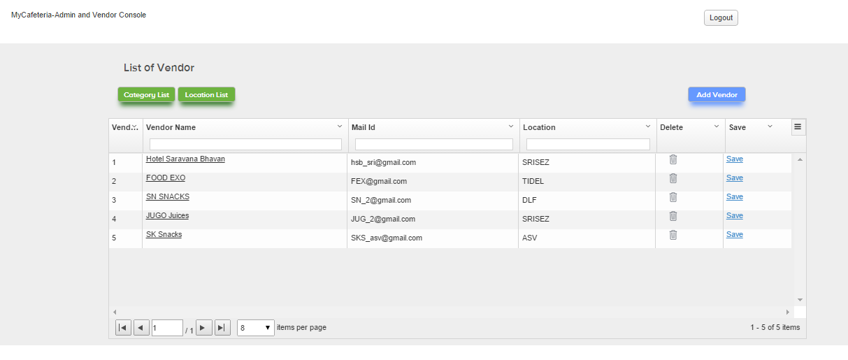

Vendor View:

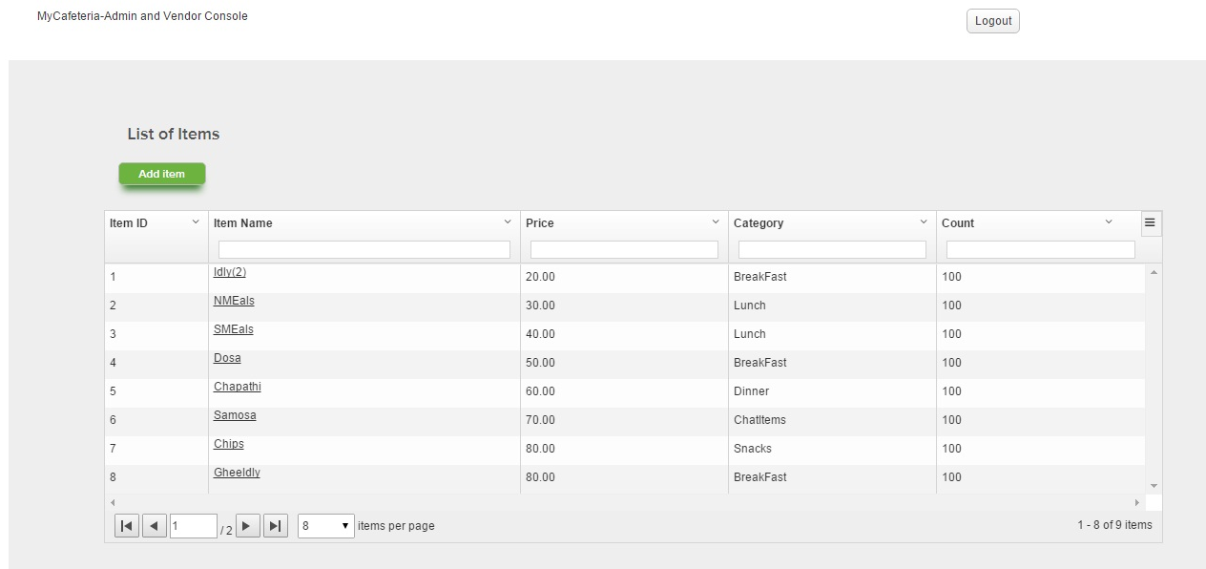

Future Extensibility

Scope for Future Extension
As an enhancement, Payment Gate way can be easily integrated with the mobile application as a part of payment process.

Real KIOSK machine along with printer can be installed and used for generating bill using the jar developed as a part of the system.

Electronic display for listing food items in vendor places can be implemented using the rest services easily.

Guidelines
The following are tips and guidelines for Admin and Vendor

The admin needs to reuse the available category name as much as possible without replicating same category name multiple times

The admin needs to reuse the available location name as much as possible without replicating multiple entries for same location.

References

