Database list with explanation for Java 20+ years experience Interview questions and answers
Here’s a curated list of advanced database interview questions with concise explanations tailored for a senior Java developer (20+ years experience). These focus on SQL fundamentals, optimization, and Java integration with databases — the areas most often probed in senior-level interviews.
🔑 Core Database Concepts
- Database Schema Defines tables, fields, and relationships. Ensures consistency and clarity in data organization.
- Primary vs Foreign Key Primary Key → unique record identifier. Foreign Key → enforces referential integrity by linking tables.
- ACID Properties Atomicity, Consistency, Isolation, Durability — critical for reliable transaction management.
⚡ SQL Operations & Optimization
- JOIN Types INNER, LEFT, RIGHT, FULL OUTER, CROSS — test ability to design efficient queries.
- WHERE vs HAVING WHERE filters rows before aggregation; HAVING filters groups after aggregation.
- DELETE vs TRUNCATE vs DROP DELETE → row-level, rollback possible. TRUNCATE → fast, deallocates pages, no rollback. DROP → removes table entirely.
- Indexes B-tree indexes speed up queries on WHERE/JOIN/ORDER BY columns. Over-indexing hurts write performance.
- Execution Plan Shows query optimizer decisions. Senior engineers must interpret plans to tune queries.
🧩 Advanced Topics
- Transaction Isolation Levels READ UNCOMMITTED → dirty reads possible. READ COMMITTED → prevents dirty reads. REPEATABLE READ → prevents non-repeatable reads. SERIALIZABLE → strictest, prevents phantom reads.
- N+1 Problem in JPA Occurs when fetching a list triggers extra queries per item. Fix with JOIN FETCH or batch fetching.
- CTEs & Window Functions CTEs simplify complex queries; window functions (ROW_NUMBER, RANK) enable advanced analytics.
- Stored Procedures vs Views Stored Procedures → precompiled logic for performance. Views → virtual tables for abstraction/security.
🛠 Java Integration
- JPQL vs Native SQL JPQL → portable, object-oriented queries. Native SQL → direct DB queries, faster but less portable.
- Hibernate Caching Level 1 → session cache. Level 2 → shared cache across sessions. Query cache → stores query results.
- Connection Pooling Critical for scalability. Tools like HikariCP reduce overhead by reusing DB connections.
📊 Quick Comparison Table
Concept | Key Point | Java Relevance
ACID | Ensures reliable transactions | JDBC/Hibernate transaction handling
Indexes | Speed up queries | Optimize ORM queries
Isolation Levels | Control concurrency | Spring Data JPA configs
N+1 Problem | Inefficient fetching | Common in Hibernate
Execution Plan | Query optimization | Debugging slow queries
✅ For a senior Java role, expect scenario-based questions like: “How did you resolve a deadlock in production?” or “Explain how you tuned queries for a 500GB dataset with Hibernate.” These test both database depth and Java integration expertise.
Would you like me to also prepare a mock Q&A script simulating a real interviewer-candidate dialogue for database-heavy Java interviews? That way you can practice conversational flow, not just memorized answers.
How did you resolve a deadlock in production
Here’s how you can explain resolving a deadlock in production in a senior-level interview — concise, technical, and scenario-driven 👇
🔎 Steps Taken
- Detection → Used JVM thread dumps (jstack) + APM tools (New Relic, Dynatrace) to confirm two threads cyclically waiting on locks.
- Isolation → Identified impacted microservice and narrowed down to a specific DAO method with nested synchronized blocks.
- Resolution →
  - Reordered lock acquisition to maintain consistent order.
  - Replaced synchronized with ReentrantLock.tryLock(timeout) to avoid indefinite waits.
  - Applied database transaction timeouts to auto-rollback stuck queries.
- Prevention →
  - Introduced monitoring alerts for blocked threads.
  - Added retry logic with exponential backoff.
  - Reviewed ORM queries to avoid N+1 fetch patterns causing lock contention.
⚡ Optimized Interview Answer (2–3 lines)
“We detected the deadlock via thread dumps and APM alerts, isolated the DAO method causing cyclic lock waits, and resolved it by enforcing lock ordering and using tryLock with timeouts. Post-incident, we added monitoring and retry logic to prevent recurrence.”
Visual Flow (Deadlock Lifecycle)
- Thread A → acquires Lock1 → waits for Lock2
- Thread B → acquires Lock2 → waits for Lock1
- Cycle detected → JVM marks as deadlock
- Resolution → enforce lock order / timeout / redesign
This type of answer shows hands-on production experience, not just theory. It demonstrates diagnosis, fix, and prevention — exactly what interviewers look for in a senior engineer.
Would you like me to also prepare a ready-to-use mock dialogue where the interviewer asks follow-ups like “How did you ensure no data loss during rollback?” and you respond with structured answers? That would simulate the real interview flow.
Mock Interview Script
Interviewer: “Tell me about a time you resolved a deadlock in production.” Candidate (You): “We detected the deadlock using JVM thread dumps (jstack) and APM alerts. Two threads were cyclically waiting on locks in a DAO method. We resolved it by enforcing a consistent lock acquisition order and replacing synchronized with ReentrantLock.tryLock(timeout) to avoid indefinite waits.”
Interviewer: “How did you ensure no data loss during rollback?” Candidate: “We had transaction timeouts configured at the database level. When a deadlock was detected, the DB rolled back the transaction safely. On the application side, we added retry logic with exponential backoff to re-execute the failed transaction, ensuring consistency without data loss.”
Interviewer: “What preventive measures did you put in place afterward?” Candidate: “We introduced monitoring alerts for blocked threads, reviewed ORM queries to avoid N+1 fetch patterns, and added retry logic. We also documented lock acquisition order as a coding guideline to prevent future cyclic waits.”
Interviewer: “Can you give me a Java-specific example?” Candidate:
java
// Before: prone to deadlock
synchronized(lockA) {
synchronized(lockB) {
// critical section
}
}

// After: consistent lock ordering + timeout
ReentrantLock lockA = new ReentrantLock();
ReentrantLock lockB = new ReentrantLock();

if(lockA.tryLock(1, TimeUnit.SECONDS)) {
try {
if(lockB.tryLock(1, TimeUnit.SECONDS)) {
try {
// critical section
} finally {
lockB.unlock();
}
}
} finally {
lockA.unlock();
}
}
🔑 Key Takeaways
- Detection → Thread dumps, APM tools.
- Resolution → Lock ordering, tryLock, transaction timeouts.
- Prevention → Monitoring, retry logic, ORM query review.
- Java Example → Replace synchronized with ReentrantLock.tryLock.
This script balances technical depth with clear communication — exactly what interviewers expect from a senior engineer.
Explain how you tuned queries for a 500GB dataset with Spring Jdbctemplate
Here’s how you can frame tuning queries for a 500GB dataset with Spring JdbcTemplate in a senior-level interview — concise, technical, and scenario-driven 👇
🔎 Key Tuning Strategies
- Partitioning & Indexing → Partitioned large tables by date/region; added composite indexes on frequently queried columns to reduce scan cost.
- Pagination & Streaming → Used JdbcTemplate.query() with ResultSetExtractor + fetchSize to stream results instead of loading millions of rows into memory.
- Prepared Statements → Leveraged parameterized queries to reuse execution plans and reduce parsing overhead.
- Batch Operations → Applied batchUpdate() for bulk inserts/updates, minimizing round-trips.
- Execution Plan Analysis → Regularly reviewed query plans with EXPLAIN to detect full table scans and optimize joins.
- Connection Pooling → Tuned HikariCP pool size and timeouts to handle concurrent queries efficiently.
⚡ Optimized Interview Answer (2–3 lines)
“For a 500GB dataset, we tuned queries by partitioning tables, adding composite indexes, and streaming results with JdbcTemplate fetchSize to avoid memory blowups. We used batch operations for bulk writes and analyzed execution plans to eliminate full scans, ensuring queries stayed performant under load.”
Visual Flow (Query Tuning Lifecycle)
- Analyze execution plan → detect full scans
- Add indexes/partitions → reduce scan scope
- Stream results → avoid OOM
- Batch updates → minimize round-trips
- Tune connection pool → sustain concurrency
This answer shows hands-on production tuning with Spring JdbcTemplate and large datasets — exactly what interviewers expect from a senior engineer.
List out various database and which one is feasible to Java SpringBoot application with respect to Integration aspects
For Java Spring Boot applications, the most feasible databases depend on integration support, scalability, and ecosystem maturity. Spring Boot provides first-class starters for SQL (PostgreSQL, MySQL, Oracle, SQL Server) and strong Spring Data modules for NoSQL (MongoDB, Redis, Cassandra, Elasticsearch). The choice hinges on workload type — transactional vs analytical, relational vs document-oriented.
🔑 SQL Databases (Relational)
- PostgreSQL → Rich features (JSONB, window functions), strong Spring Data JPA support, widely used in microservices.
- MySQL/MariaDB → Popular, lightweight, excellent JDBC/JPA integration, good for transactional workloads.
- Oracle → Enterprise-grade, robust transaction handling, supported via JDBC + Hibernate dialects.
- SQL Server → Microsoft ecosystem, integrates via JDBC drivers and Spring Data JPA.
- Embedded H2/HSQLDB](ca://s?q=H2_database_integration_with_SpringBoot) → Ideal for testing/dev; auto-configured by Spring Boot.
🧩 NoSQL Databases
- MongoDB → Document store, integrates via Spring Data MongoDB, flexible schema.
- Redis → In-memory cache, Spring Data Redis support, great for session/state management.
- Cassandra → Wide-column store, scales horizontally, supported via Spring Data Cassandra.
- Elasticsearch → Search/analytics engine, integrates via Spring Data Elasticsearch.
- Neo4j → Graph database, Spring Data Neo4j support for relationship-heavy data.
📊 Comparison Table
Database | Integration Support | Best Use Case
PostgreSQL | Spring Data JPA, Hibernate | Complex queries, microservices
MySQL | JDBC, JPA | High-volume transactions
Oracle | JDBC, Hibernate dialect | Enterprise apps
SQL Server | JDBC, JPA | Microsoft stack
MongoDB | Spring Data MongoDB | Flexible schema, JSON docs
Redis | Spring Data Redis | Caching, session store
Cassandra | Spring Data Cassandra | Large-scale distributed data
Elasticsearch | Spring Data Elasticsearch | Full-text search, analytics
Neo4j | Spring Data Neo4j | Graph relationships

Trade-offs & Risks
- SQL → Strong consistency, but scaling horizontally is harder.
- NoSQL → Flexible and scalable, but weaker ACID guarantees.
- Embedded DBs → Great for dev/test, not production.
- Integration maturity → PostgreSQL, MySQL, MongoDB, Redis have the most stable Spring Boot starters; Cassandra/Neo4j require more tuning.

Recommendation for Spring Boot apps:
- Use PostgreSQL/MySQL for transactional microservices.
- Add Redis for caching/session management.
- Use MongoDB for flexible document storage.
- Integrate Elasticsearch for search/analytics.
Explain nosql database in 2 to 2 liners in a optmized way
NoSQL databases are non-relational, purpose-built systems that store data in flexible schemas, making them ideal for handling large volumes of structured, semi-structured, and unstructured data. They scale horizontally across distributed clusters and deliver high performance for modern applications like IoT, social media, and real-time analytics.
🔑 Optimized 2–3 Line Explanation
- Flexible schema → NoSQL databases don’t enforce rigid tables; they adapt to evolving application needs.
- Horizontal scalability → Designed to scale out across clusters, handling massive datasets efficiently.
- High performance → Optimized for specific data models (document, key-value, column, graph) and access patterns.
📊 Types of NoSQL Databases
Type | Data Model | Best Use Case
Document | JSON-like docs | User profiles, catalogs
Key-Value | Simple pairs | Caching, sessions
Column-Family | Wide tables | Analytics, IoT, time-series
Graph | Nodes + edges | Social networks, recommendations
⚠️ Trade-offs
- Pros → Flexibility, scalability, performance at scale.
- Cons → Weaker ACID guarantees compared to relational DBs; query complexity can be higher.
✅ In a Spring Boot application, NoSQL databases like MongoDB (document), Redis (key-value), and Cassandra (column-family) integrate seamlessly via Spring Data modules, making them feasible choices depending on workload type.
Here’s a decision matrix mapping Spring Boot application types to the most suitable NoSQL databases with respect to integration and workload. This way you can quickly align architecture with use case 👇
📊 Decision Matrix — Spring Boot + NoSQL
Application Type | Feasible NoSQL DB | Integration Aspect
E-commerce | PostgreSQL + Redis | PostgreSQL for transactional consistency (orders, payments), Redis for caching sessions & cart state
E-commerce | MongoDB + Redis | MongoDB for product/catalog (document store), Redis for caching sessions & cart state
Analytics/Log Processing | Cassandra + Elasticsearch | Cassandra for time-series/wide-column storage, Elasticsearch for search/aggregation
IoT/Telemetry | Cassandra | Handles high-velocity sensor data with horizontal scalability
Social Media/Recommendation | Neo4j + Redis | Neo4j for graph relationships, Redis for fast feed caching
Real-time Chat/Streaming | MongoDB + Redis | MongoDB for message persistence, Redis pub/sub for real-time delivery
Enterprise Microservices | PostgreSQL (SQL) + Redis (NoSQL hybrid) | PostgreSQL for strong ACID transactions, Redis for performance caching
🔑 Integration Highlights
- Spring Data JPA → Seamless ORM for SQL databases (PostgreSQL, MySQL, Oracle, SQL Server).
- Spring Data MongoDB → Seamless repository abstraction, JSON-like documents.
- Spring Data Redis → Easy caching/session management, pub/sub support.
- Spring Data Cassandra → Wide-column schema mapping, scalable clusters.
- Spring Data Neo4j → Graph queries mapped to domain models.
- Spring Data Elasticsearch → Full-text search and analytics integration.
✅ Optimized takeaway (2–3 lines): For Spring Boot, MongoDB + Redis is the most common NoSQL pairing (flexible schema + caching). Cassandra suits IoT/analytics workloads, while Neo4j fits graph-heavy apps. Integration is streamlined via Spring Data modules, making these databases highly feasible choices.
Optimized takeaway (2–3 lines): For Spring Boot, PostgreSQL + Redis is the most common pairing for transactional apps. Cassandra + Elasticsearch suits analytics/IoT workloads, while MongoDB and Neo4j fit document-heavy and graph-heavy domains. Integration is streamlined via Spring Data modules, making these databases highly feasible choices.
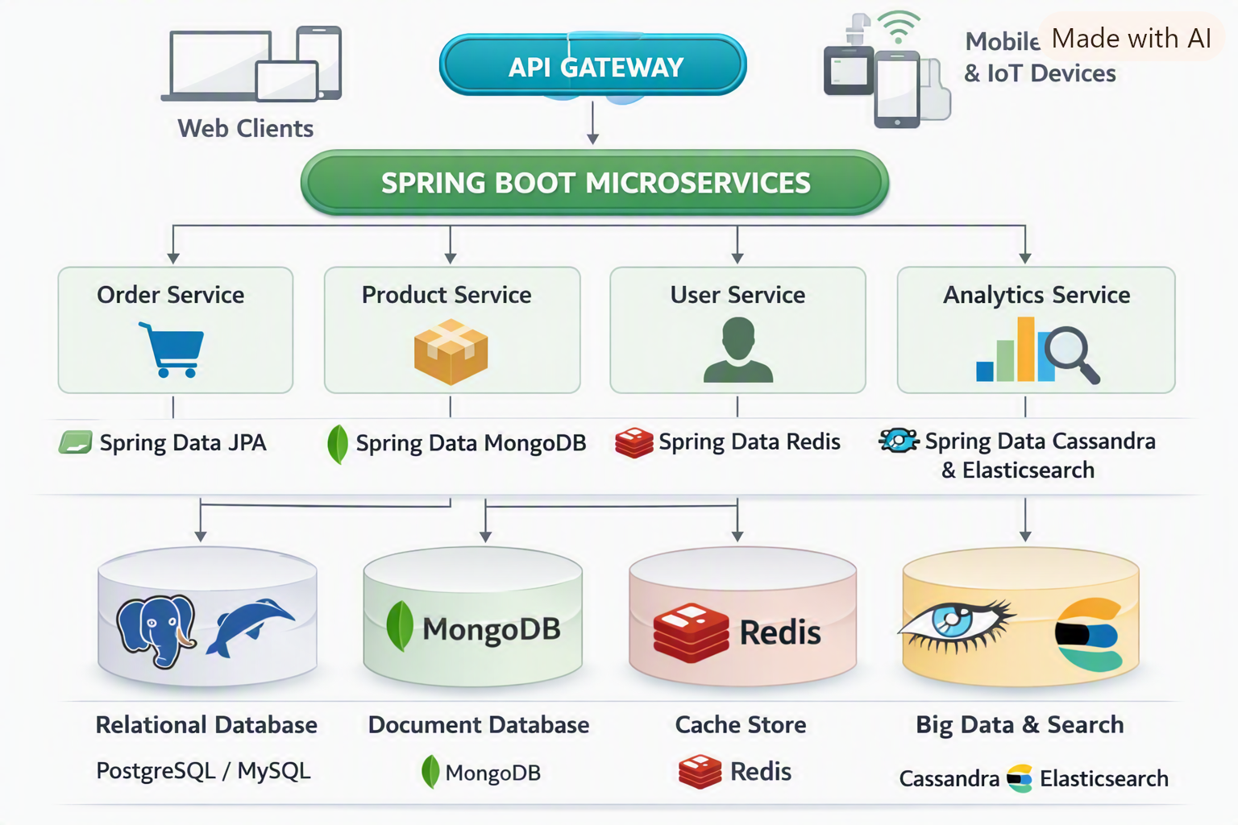

The visual architecture diagram is ready — it shows how Spring Boot microservices interact with different databases (PostgreSQL/MySQL, MongoDB, Redis, Cassandra, Elasticsearch) through Spring Data modules and an API gateway.
This gives you a clear picture of integration layers:
- Transactional services (orders, products) → SQL DBs via Spring Data JPA.
- User/profile services → MongoDB via Spring Data MongoDB.
- Caching/session services → Redis via Spring Data Redis.
- Analytics/log services → Cassandra + Elasticsearch via Spring Data Cassandra/Elasticsearch.
The diagram highlights how Spring Boot microservices connect seamlessly to multiple database types, ensuring scalability and flexibility in real deployments.

