Apache Kafka is a tool that helps move and process large amounts of data quickly, reliably, and in real time. It’s like a central hub where data flows in from different sources and gets delivered to systems that need it, without delays or losses.
⚙️ Key Features of Kafka
- High throughput: Can handle millions of messages per second efficiently.
- Low latency: Delivers data almost instantly.
- Scalability: Easily grows to handle more data by adding servers.
- Durability: Stores data safely so it won’t get lost.
- Fault tolerance: Keeps working even if some servers fail.
- Distributed system: Runs across multiple machines for reliability and speed.
🧩 Main Components of Kafka
- Producer: Applications that send (publish) data into Kafka.
- Consumer: Applications that read (subscribe to) data from Kafka.
- Topic: A category or channel where data is stored (like folders for messages).
- Broker: Kafka servers that store and manage data.
- Partition: Splits topics into smaller pieces for faster processing.
- ZooKeeper (older setups): Manages cluster coordination, though newer versions use Kafka’s own system.
🌟 Benefits of Kafka
- Real-time processing: Data is available instantly for analytics or apps.
- Reliable communication: Ensures no data is lost between systems.
- Flexibility: Works with many types of systems and applications.
- Cost-effective scaling: Add servers instead of redesigning the system.
- Widely adopted: Used by big companies like LinkedIn, Netflix, and Uber for handling massive data streams.
📌 Simple Analogy
Think of Kafka as a post office for data:
- Producers are people sending letters.
- Topics are mailboxes where letters are sorted.
- Consumers are people picking up letters.
- Brokers are the post office staff ensuring everything is delivered safely and quickly.

Apache Kafka is built around a few core components: Producers, Topics, Brokers, Partitions, Consumers, Consumer Groups, ZooKeeper (or KRaft in newer versions), and APIs (Streams, Connect). Together, they form a distributed event streaming platform that handles high-throughput, fault-tolerant messaging.
🧭 Key Kafka Components
- Producer: Applications that publish (write) messages to Kafka topics.
- Topic: A logical channel where messages are stored and categorized.
- Broker: Kafka server that stores data and serves client requests. A cluster has multiple brokers.
- Partition: Topics are split into partitions for scalability and parallelism.
- Consumer: Applications that subscribe (read) messages from topics.
- Consumer Group: A set of consumers working together to balance load.
- ZooKeeper / KRaft: Manages cluster metadata and leader election (ZooKeeper is being replaced by KRaft).
- Kafka APIs:
  - Producer API → publish data.
  - Consumer API → subscribe to topics.
  - Streams API → real-time processing.
  - Connect API → integrate with external systems (DBs, storage).
📊 Kafka Component Overview
Component | Role
Producer | Publishes messages to topics
Topic | Logical category for messages
Broker | Kafka server storing partitions
Partition | Splits topic data for scaling
Consumer | Reads messages from topics
Consumer Group | Distributes load among consumers
ZooKeeper/KRaft | Manages cluster metadata
Kafka APIs | Interfaces for producing, consuming, streaming, and connecting
Sources:
Here’s a helpful diagram to visualize how these components interact:
- 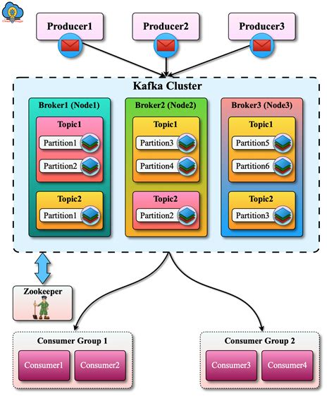
- 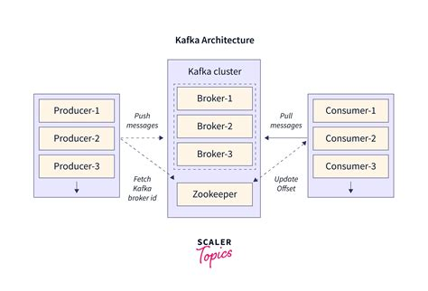
- 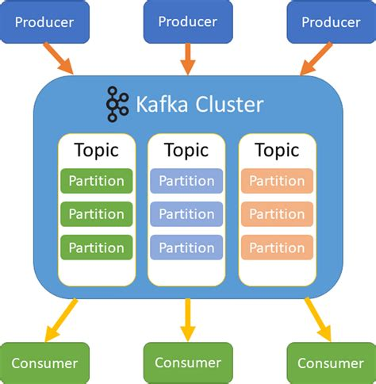
- 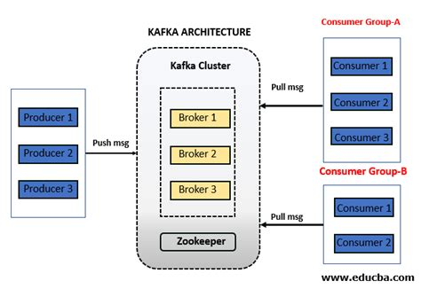
- 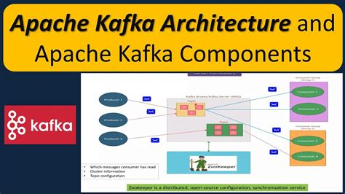
- 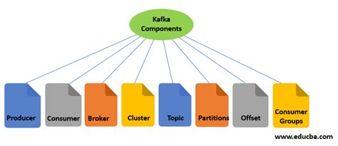
- 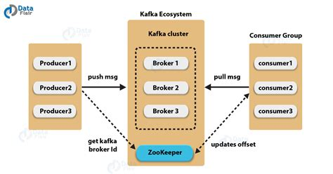
- 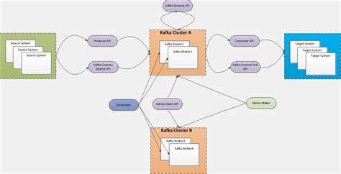
See more
👉 In short: Kafka is like a distributed commit log where producers write events into topics, brokers store them across partitions, and consumers read them in real time.

In Kafka, the retention policy defines how long messages are kept in a topic before they are deleted or compacted. It ensures efficient disk usage and controls data availability for consumers.
🧭 What Kafka Retention Policy Means
- Retention = how long Kafka stores messages in a topic.
- After the retention period expires, messages are either deleted or compacted depending on the policy.
- This prevents uncontrolled disk growth and keeps clusters predictable.
⚙️ Types of Retention Policies
- Time-based retention
  - Messages have a TTL (time-to-live).
  - Example: keep data for 7 days (log.retention.hours=168).
  - After expiry, messages are marked for deletion.
- Size-based retention
  - Kafka deletes old data once a topic exceeds a configured size (log.retention.bytes).
  - Useful when storage capacity is limited.
- Log compaction
  - Instead of deleting all old messages, Kafka keeps only the latest value for each key.
  - Ensures consumers always see the most recent state of a record.
  - Example: maintaining the latest user profile data.
📊 Key Configuration Parameters
Parameter | Purpose
log.retention.hours | Time-based retention (hours)
log.retention.bytes | Size-based retention (bytes)
cleanup.policy | delete (default) or compact
segment.ms / segment.bytes | Control log segment size and rotation
Sources:
⚠️ Risks & Trade-offs
- Too short retention → Consumers may miss data if they don’t read fast enough.
- Too long retention → Disk usage grows, risking broker failures.
- Compaction overhead → More CPU and disk I/O during cleanup.
- Cluster performance → Misconfigured retention can degrade throughput.
🔑 Takeaway
Kafka’s retention policy balances data availability vs storage efficiency.
- Use time-based retention for logs/events.
- Use size-based retention when storage is constrained.
- Use log compaction for stateful data where the latest value matters.
By default, Kafka retains messages for 7 days (168 hours) before deleting them, unless you change the configuration.
🧭 Default Retention Settings
- log.retention.hours = 168 → 7 days.
- If log.retention.hours is not set, Kafka falls back to log.retention.minutes (10,080 minutes = 7 days).
- If neither is set, it uses log.retention.ms (604,800,000 ms = 7 days).
So, out of the box, Kafka keeps data for 7 days in each topic partition before cleaning it up.
⚙️ How to Change It
You can override the default retention policy at the broker level or per topic:
bash
# Change retention for a specific topic to 3 days
kafka-configs.sh --alter --entity-type topics --entity-name my-topic \
--add-config retention.ms=259200000
🔑 Takeaway
- Default retention = 7 days.
- You can configure retention by time (retention.ms) or size (retention.bytes).
- For stateful topics (like user profiles), you might use log compaction instead of time-based deletion.
Here’s a simple way to visualize Kafka retention vs log compaction:
- Time-based retention (default)
  - Messages stay in the topic for a set duration (e.g., 7 days).
  - After that, old messages are deleted, freeing disk space.
  - Useful for event logs, clickstreams, or audit trails where history matters only for a window of time.
- Log compaction
  - Kafka keeps only the latest value for each key.
  - Older values for the same key are removed, but the newest one is retained.
  - Useful for stateful data like user profiles, account balances, or configuration settings.
So the difference is:
- Retention = “keep everything for X time, then delete.”
- Compaction = “always keep the latest version per key, discard older ones.”
Here’s a clear visualization idea for Kafka retention vs log compaction:
- On the left side (Retention): Imagine a timeline of messages flowing into a topic. Each message is stored for a fixed duration (default 7 days). After that window, older messages are deleted, freeing disk space.
- On the right side (Compaction): Messages are grouped by key (e.g., user123). Kafka keeps only the latest message per key. Older values for the same key are removed, but the newest one remains. This ensures consumers always see the current state, not the full history.
So visually:
- Retention looks like a sliding window of data.
- Compaction looks like a condensed log where only the latest version of each key survives.

