Perfect — let’s map Generative AI tools by company ecosystem so you can see who dominates which domain:
🏢 Microsoft
- Microsoft Copilot – Integrated into Word, Excel, Outlook, Teams, Windows, and Edge for productivity.
- Azure OpenAI Service – Provides access to GPT models for enterprise apps.
- Strength: Productivity + enterprise integration.
🚀 OpenAI
- ChatGPT – General-purpose assistant for text, reasoning, and coding.
- DALL-E 3 – Realistic image generation.
- Sora – Text-to-video cinematic generation.
- Strength: Cutting-edge multimodal innovation.
🌐 Google
- Gemini – Multimodal AI integrated with Google Workspace.
- Strength: Seamless productivity + search integration.
☁️ Amazon
- Amazon Bedrock – Build generative AI apps with foundation models.
- Amazon SageMaker – Train and deploy custom ML/Gen AI models.
- Amazon Lex – Conversational AI for chatbots.
- Strength: Cloud AI services for enterprises.
💻 GitHub
- GitHub Copilot – AI pair programmer suggesting code in real time.
- Strength: Developer productivity.
🎨 Independent Labs
- Midjourney – Artistic image generation.
- Stability AI – Open-source image generator.
- Strength: Creative freedom + customization.

- Quick Ecosystem Comparison
Company | Flagship Tools | Strength
Microsoft | Copilot, Azure OpenAI | Productivity + enterprise
OpenAI | ChatGPT, DALL-E, Sora | Multimodal innovation
Google | Gemini | Workspace + search
Amazon | Bedrock, SageMaker, Lex | Cloud AI services
GitHub | Copilot | Developer productivity
Independent Labs | Midjourney, Stable Diffusion | Creative visuals

Here’s a sector map visualization in words showing how the big players in Generative AI dominate different domains. Think of it as a Venn-style overlap:
🏢 Productivity AI
- Microsoft Copilot – Deeply integrated into Word, Excel, Outlook, Teams, Windows.
- Google Gemini – Embedded in Google Workspace (Docs, Sheets, Gmail).
- Overlap: Both focus on office productivity, but Microsoft dominates enterprise workflows.
☁️ Cloud AI Services
- Amazon Bedrock – Foundation models as a service.
- Amazon SageMaker – Custom ML pipelines.
- Azure OpenAI Service – Microsoft’s enterprise AI backbone.
- Overlap: Amazon leads in cloud AI breadth; Microsoft leverages Azure for enterprise AI.
👨‍💻 Developer AI
- GitHub Copilot – Real-time coding assistant in IDEs.
- Amazon CodeGuru – Code review + performance optimization.
- Overlap: GitHub Copilot dominates developer productivity; Amazon focuses on optimization.
🎨 Creative AI
- Midjourney – Artistic image generation.
- Stable Diffusion – Open-source customizable visuals.
- DALL-E 3 – Realistic image generation.
- Sora – Text-to-video cinematic clips.
- Overlap: Independent labs + OpenAI dominate creative domains.
📊 Sector Map (Textual Venn)
- Microsoft → Productivity + Enterprise AI
- Amazon → Cloud AI + Business AI
- GitHub → Developer AI
- OpenAI / Labs → Creative + Multimodal AI
- Google → Productivity + Search AI
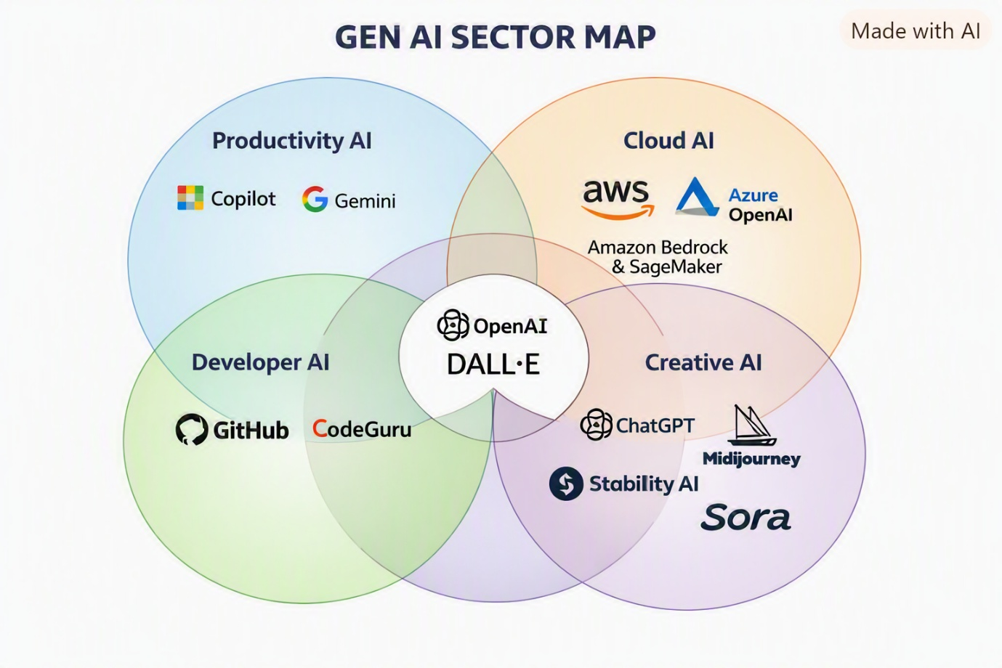

How to Read This Map
- 🏢 Productivity AI (Blue) → Microsoft Copilot & Google Gemini dominate office workflows.
- ☁️ Cloud AI (Orange) → Amazon (Bedrock, SageMaker) + Microsoft Azure OpenAI lead enterprise AI services.
- 👨‍💻 Developer AI (Green) → GitHub Copilot & Amazon CodeGuru focus on coding productivity.
- 🎨 Creative AI (Purple) → OpenAI (ChatGPT, DALL-E, Sora), Midjourney, Stability AI drive artistic and multimodal innovation.
- Central Overlap → OpenAI’s DALL-E sits at the intersection, bridging productivity, cloud, developer, and creative domains.
This map shows who dominates each sector and where overlaps exist. Would you like me to expand this into a strategic recommendation — e.g., when to choose Microsoft Copilot, Amazon Gen AI, or GitHub Copilot depending on whether your focus is enterprise workflows, cloud AI innovation, or developer productivity?
Yes
Here’s your strategic recommendation summary based on the Gen AI sector map you requested 🧭
🏢 Enterprise Productivity (Microsoft Copilot)
- Best for organizations using Microsoft 365 — integrates directly with Word, Excel, Outlook, and Teams.
- Ideal when the goal is workflow automation, document generation, and meeting summaries.
- Choose Microsoft Copilot if your focus is boosting employee efficiency and collaboration.
☁️ Cloud AI Innovation (Amazon Gen AI Tools)
- Amazon Bedrock and SageMaker excel at scalable AI model deployment.
- Perfect for enterprises building custom AI apps or integrating generative models into existing cloud systems.
- Choose Amazon Gen AI when you need flexibility, infrastructure control, and enterprise-grade scalability.
👨‍💻 Developer Productivity (GitHub Copilot)
- GitHub Copilot is unmatched for real-time code generation and debugging.
- Ideal for software teams, startups, and individual developers seeking faster coding and fewer errors.
- Choose it when your focus is developer velocity and code quality rather than general AI workflows.
🎨 Creative Innovation (OpenAI & Independent Labs)
- Tools like ChatGPT, DALL-E 3, Midjourney, and Sora dominate creative content generation.
- Choose these when your goal is design, storytelling, or multimedia creation.

- Strategic Fit Overview
Focus Area | Best Choice | Why It Fits
Enterprise Productivity | Microsoft Copilot | Deep integration with Microsoft apps
Cloud AI Innovation | Amazon Gen AI Tools | Scalable infrastructure for custom AI
Developer Productivity | GitHub Copilot | Real-time coding assistant
Creative Innovation | OpenAI & Labs | Multimodal content generation

Roadmap Matrix
Company | Short-Term Productivity | Cloud Scaling | Developer Productivity | Creative Innovation
Microsoft | Strong (Copilot 365) | Moderate (Azure AI) | Light | Weak
OpenAI | Moderate | Limited | Moderate | Strong
Google | Strong (Gemini Workspace) | Moderate | Light | Moderate
Amazon | Moderate | Strong (Bedrock, SageMaker) | Moderate | Weak
GitHub | Weak | Limited | Strong | Weak
Independent Labs | Weak | Limited | Moderate | Strong

Strategic Fit
- Choose Microsoft → If your priority is enterprise productivity.
Enterprise Productivity (in Gen AI context) → refers to AI tools that boost efficiency in everyday business workflows by automating tasks like document drafting, email summarization, meeting notes, and data analysis.
- Microsoft Copilot is the strongest example — embedded in Word, Excel, Outlook, and Teams, it helps employees work faster with contextual AI assistance.
- Google Gemini also plays here, integrated into Docs, Sheets, and Gmail for smart writing and analysis.
👉 In short: Enterprise Productivity AI = “AI that makes office work faster, smarter, and less manual.”
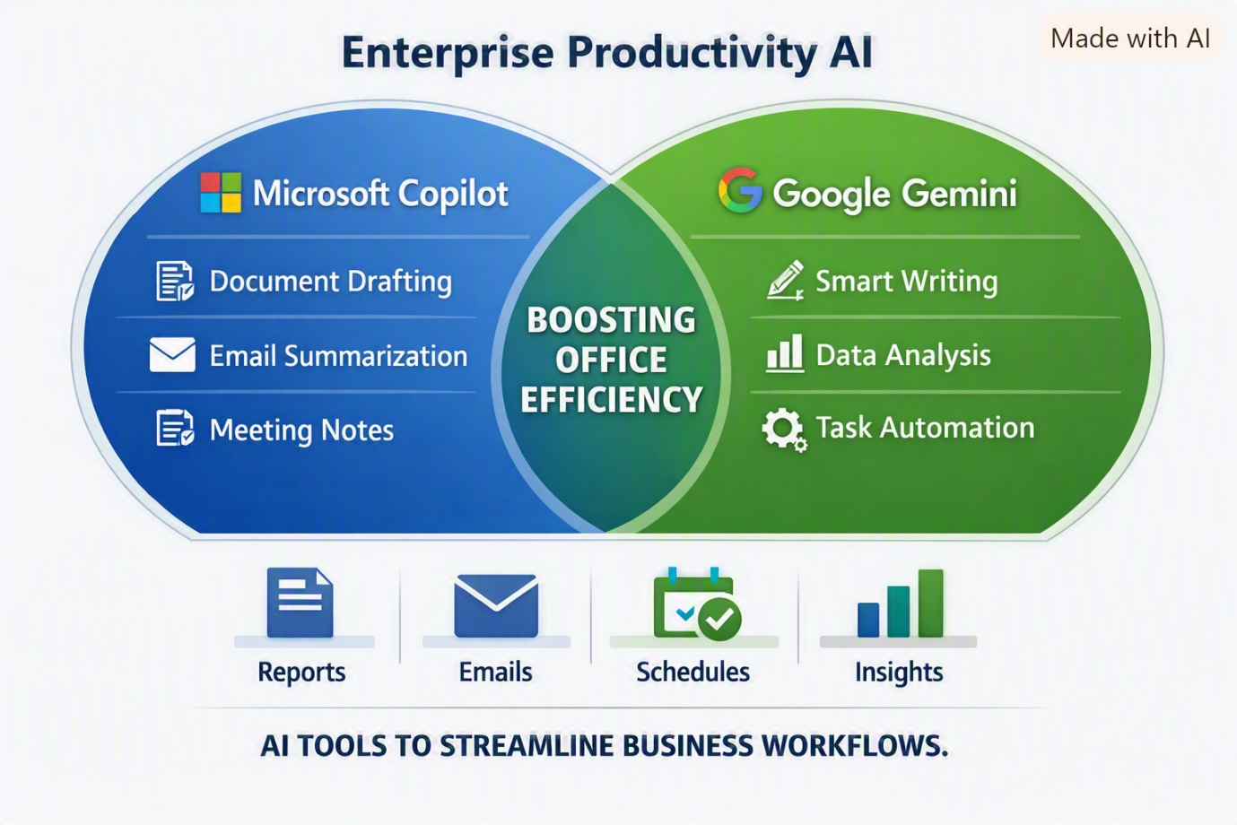

Key Takeaways
- Microsoft Copilot → Automates document drafting, email summarization, and meeting notes inside Office apps.
- Google Gemini → Enhances smart writing, data analysis, and task automation in Workspace.
- Overlap → Both aim to boost office efficiency by reducing manual effort in reports, emails, schedules, and insights.
- Choose Amazon → If your priority is cloud AI scaling.
Cloud AI Scaling means using cloud platforms to deploy, manage, and expand AI workloads automatically as demand grows — without manual infrastructure setup.
- Services like Amazon Bedrock, Azure OpenAI Service, and Google Vertex AI enable enterprises to scale generative models globally with elastic compute and storage.
- In short: it’s AI that grows with your business — scalable, reliable, and cost-efficient.
- Choose GitHub → If your priority is developer productivity.
Developer Productivity (in Gen AI) means using AI tools to accelerate coding, debugging, and software delivery by automating repetitive tasks and suggesting optimized code.
- Platforms like GitHub Copilot and Amazon CodeGuru help developers write cleaner, faster code with fewer errors.
- In short: it’s AI that boosts developer speed, accuracy, and creativity inside the IDE.
- Choose OpenAI / Independent Labs → If your priority is creative innovation.
Creative Innovation (in Gen AI) refers to AI tools that generate new artistic, multimedia, or expressive content — from visuals and video to audio and storytelling.
- Platforms like OpenAI DALL-E & Sora, Midjourney, and Stable Diffusion enable creators to design images, cinematic clips, and stylized art.
- In short: it’s AI that fuels imagination — turning ideas into visuals, sounds, and stories.

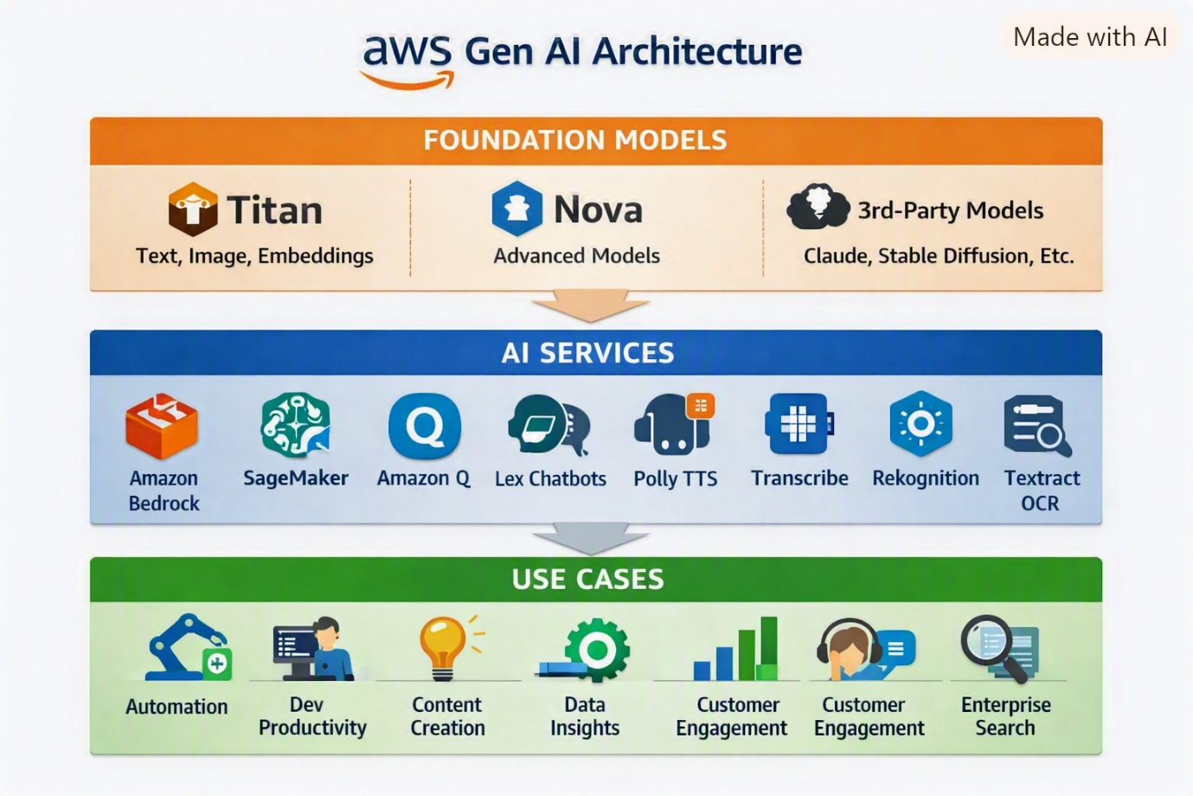

Structure Explained
- Foundation Models (Top Layer) → Titan, Nova, and 3rd-party models (Claude, Stable Diffusion, Cohere).
- AI Services (Middle Layer) → Bedrock, SageMaker, Amazon Q, Lex, Polly, Transcribe, Rekognition, Textract.
- Use Cases (Bottom Layer) → Automation, Developer Productivity, Content Creation, Data Insights, Customer Engagement, Enterprise Search.

Explain Amazon Q with list of models
Absolutely! Let’s dive into Amazon Q, Amazon’s generative AI-powered assistant designed to supercharge developer productivity and enterprise workflows.
🤖 What Is Amazon Q?
Amazon Q is a family of AI assistants built by AWS to help developers, IT professionals, and business users interact with AWS services, codebases, and enterprise data using natural language. It was introduced in April 2024 as a major evolution of AWS CodeWhisperer, expanding into broader use cases like cloud operations, coding, and business intelligence.
There are two main flavors:
1. Amazon Q Developer
Tailored for software engineers, this assistant helps with:
- Code generation and refactoring
- Test suite creation
- Dependency upgrades (e.g., Java 8 → Java 17)
- Multi-step task automation (e.g., creating branches, implementing features)
- AWS CLI command generation
- IDE integration (VS Code, JetBrains, Eclipse, etc.)
- Security scans and open-source reference tracking
- Conversational debugging and code explanation
It also supports rules-based customization, allowing teams to define coding standards in .amazonq/rules files that Q automatically respects.
2. Amazon Q Business
Focused on enterprise users, this version enables:
- Natural language querying of business data
- Integration with tools like Salesforce, ServiceNow, and Microsoft 365
- Automated report generation
- Workflow automation
- Enterprise-grade data governance and compliance
🧠 Underlying Models
Amazon Q is powered by foundation models from Amazon Bedrock, which includes:
Model Name | Provider | Description
Titan | AWS | Amazon’s own family of foundation models for text generation, embeddings, and multimodal tasks.
Claude | Anthropic | Known for safety-focused conversational AI.
Jurassic | AI21 Labs | Strong in natural language understanding and generation.
Command R | Cohere | Optimized for retrieval-augmented generation (RAG).
Llama 2 | Meta | Open-source model for general-purpose tasks.
Mistral | Mistral AI | Lightweight, fast models for code and text.
Amazon Q selects and orchestrates these models based on the task, context, and user preferences.
💸 Pricing Overview
- Amazon Q Developer: Free tier available for individuals; Pro tier starts at $19/user/month.
- Amazon Q Business: Pricing varies based on enterprise usage and integrations.
Explain Claude Sonnet
Absolutely! Let’s unpack Claude Sonnet, one of the standout models in Anthropic’s Claude family of AI systems.
🎼 What Is Claude Sonnet?
Claude Sonnet is a high-performance large language model (LLM) developed by Anthropic, designed to strike a balance between speed, cost-efficiency, and reasoning power. It’s part of the Claude 3 and Claude 4 model families and is widely used for tasks that require strong general intelligence without the computational heft of more advanced models like Claude Opus.
🧠 Key Features of Claude Sonnet
Feature | Description
Reasoning Ability | Excellent for complex tasks like summarization, analysis, and code generation.
Speed & Latency | Faster than Claude Opus, making it ideal for real-time applications.
Context Window | Supports up to 200,000 tokens, with a 1 million token beta available.
Multimodal Input | Accepts both text and image inputs, enabling document and visual understanding.
Cost Efficiency | More affordable than Opus, making it suitable for scalable deployments.
Availability | Accessible via Anthropic API, AWS Bedrock, and Google Vertex AI.
🧬 Claude Sonnet Versions
Anthropic has released multiple iterations of Sonnet:
- Claude Sonnet 3.7 – Optimized for everyday tasks with low latency and solid reasoning.
- Claude Sonnet 4 – The latest version, offering improved performance and extended context capabilities.
Each version is tuned for a mix of writing, coding, document analysis, and customer support use cases.
🆚 Sonnet vs. Other Claude Models
Model | Strengths | Use Case
Claude Haiku | Fastest, lowest latency | Quick chats, high-volume tasks
Claude Sonnet | Balanced performance and cost | General-purpose AI, enterprise apps
Claude Opus | Deep reasoning, most capable | Research, legal, advanced coding
Sonnet is often the default choice for developers and businesses who want strong performance without the premium cost of Opus.
🔧 Use Cases
Claude Sonnet excels in:
- 📄 Document summarization and analysis
- 💬 Customer support automation
- 🧑‍💻 Code generation and explanation
- 🧠 Knowledge retrieval and reasoning
- 🖼️ Image + text understanding (e.g., receipts, diagrams)

