Explain support process with different managements categories
Here’s a concise breakdown of the support process across different management categories 👇
🧩 Operational Management
- Ticket handling → Logging, categorizing, assigning, resolving, and closing issues.
- SLA tracking → Ensures timely resolution based on priority.
- Resource allocation → Assigns engineers or tools efficiently.
📊 Service Management
- Incident management → Restores normal service quickly.
- Problem management → Identifies root causes and prevents recurrence.
- Change management → Controls updates or fixes to avoid disruption.
👥 Customer Relationship Management
- Communication → Keeps users informed and builds trust.
- Feedback collection → Captures user insights for improvement.
- Customer satisfaction → Measures service quality and loyalty.
🔄 Quality & Performance Management
- Monitoring → Tracks metrics like resolution time and backlog.
- Continuous improvement → Uses analytics to refine processes.
- Training & audits → Ensures compliance and skill enhancement.
Would you like me to create a visual matrix diagram showing how these management categories interact in the overall support lifecycle?
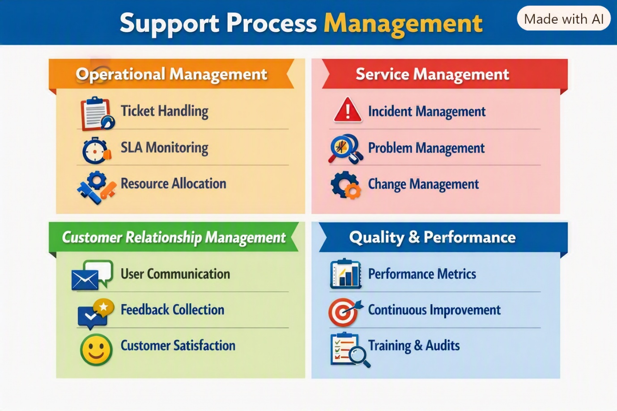

Here’s your matrix diagram of support process management categories — it’s ready now.
It organizes the flow into four quadrants:
- Operational Management → Ticket handling, SLA monitoring, resource allocation.
Here’s the Operational Management part of the support process explained in simple, structured pointers:
- Ticket Handling → Logging issues, categorizing them, assigning to the right team, and tracking progress.
- SLA Monitoring → Ensuring tickets are resolved within agreed timelines (Service Level Agreements).
- Resource Allocation → Assigning engineers, tools, or systems efficiently to handle workload.
- Workflow Standardization → Defining clear steps for issue resolution to avoid delays.
- Escalation Management → Routing unresolved or critical issues to higher support tiers.
- Reporting → Generating metrics like ticket volume, resolution time, and backlog for visibility.
⚙️ In short: Operational management ensures day-to-day efficiency in support by keeping tickets organized, monitored, and resolved within time and resource limits.
- Service Management → Incident, problem, and change management.
Here’s the Service Management part of the support process explained in clear pointers:
- Incident Management → Focuses on restoring normal service quickly when disruptions occur.
- Problem Management → Identifies root causes of recurring issues and prevents future incidents.
- Change Management → Controls and coordinates updates, fixes, or system changes to minimize risk.
- Configuration Management → Maintains accurate records of system components and their relationships.
- Release Management → Plans and deploys new features or fixes in a controlled manner.
📊 In short: Service management ensures stability, reliability, and controlled evolution of IT services, balancing quick fixes with long-term improvements.
- Customer Relationship Management → Communication, feedback, satisfaction tracking.
Here’s the Customer Relationship Management (CRM) part of the support process explained in clear, structured pointers:
- Communication → Keeping users informed about ticket progress, delays, or resolutions builds trust.
- Feedback Collection → Gathering user input after closure helps identify gaps and improve service.
- Customer Satisfaction → Measuring service quality through surveys, ratings, or NPS ensures loyalty.
- Personalization → Tailoring responses and solutions based on customer history enhances experience.
- Relationship Building → Proactive engagement (updates, tips, follow-ups) strengthens long-term trust.
👥 In short: CRM in support ensures transparent communication, continuous feedback, and stronger customer loyalty, making the support process not just reactive but relationship-driven.
- Quality & Performance → Metrics, continuous improvement, training & audits.
Here’s the Quality & Performance Management part of the support process explained in structured pointers:
- Monitoring → Track KPIs like resolution time, backlog size, SLA compliance, and customer ratings.
- Continuous Improvement → Use analytics, trend reports, and retrospectives to refine workflows.
- Training & Audits → Regular skill upgrades for staff and compliance checks to maintain standards.
- Performance Metrics → Measure efficiency (tickets closed per agent, first-contact resolution rate).
- Benchmarking → Compare support performance against industry standards or competitors.
🔄 In short: Quality & performance management ensures the support process is measurable, improvable, and compliant, driving long-term service excellence.
This structure shows how each management category contributes to a complete support lifecycle, ensuring efficiency, reliability, and customer trust.

