USAGE of mdf_udpData_Proc.exe
Below is the command format to run mdf_udpData_Proc.exe
this tool takes XML and json file as input arguments.
mdf_udpData_Proc.exe Mdf4_Converter_Config.xml BMW_fList.json
Convertor tool supports only json file as input. Flist support has been removed.
To convert the respective mdf4 formats, , configure the Mdf4_Converter_Config.xml with the below options
- Set CONVERTER_INPUT_FILE_OPTION tag to “ 1” depends on your input log
- Select CONVERTER_OUTPUT_FILE_OPTION with respect to requirement.
- Create a logs.txt file, and add the (*.dvsu,*.mf4) path into the text file
- Enable options in the XML and run the Exe
- Converted file will be generated in the same path as input file.
- This tool is able to run on following file inputs - Single DVSU,ORCAS MDF, Canape MDF, VIGEM MDF & X2E MDF

XML Converter Options
1. To convert ViGEM mf4 into CANOE SOMEIP mf4.
Select the below options in the config xml
In CONVERTER_INPUT_FILE_OPTION
<VIGEM_MDF4_INPUT_ENABLE>1</VIGEM_MDF4_INPUT_ENABLE>
In CONVERTER_OUTPUT_FILE_OPTION
<VIGEM_SOMEIP_OUTPUT_ENABLE>0<VIGEM_SOMEIP_OUTPUT_ENABLE>
2. To convert resimulated VIGEM mf4 into CANOE SOMEIP mf4
In CONVERTER_INPUT_FILE_OPTION
<RESIM_VIGEM_MDF4_INPUT_ENABLE>1</RESIM_VIGEM_MDF4_INPUT_ENABLE>
In CONVERTER_OUTPUT_FILE_OPTION
<VIGEM_SOMEIP_OUTPUT_ENABLE>1<VIGEM_SOMEIP_OUTPUT_ENABLE>
3. To convert ViGEM mf4 into CANOE CAN mf4.
Select the below options in the config xml
In CONVERTER_INPUT_FILE_OPTION
<VIGEM_MDF4_INPUT_ENABLE>1</VIGEM_MDF4_INPUT_ENABLE>
In CONVERTER_OUTPUT_FILE_OPTION
<CANAPE_MDF4_OUTPUT_ENABLE>1</CANAPE_MDF4_OUTPUT_ENABLE>
4. To convert ViGEM mf4 into ORCAS mf4.
Select the below options in the config xml
In CONVERTER_INPUT_FILE_OPTION
<VIGEM_MDF4_INPUT_ENABLE>1</VIGEM_MDF4_INPUT_ENABLE>
In CONVERTER_OUTPUT_FILE_OPTION
<ORCAS_MDF4_OUTPUT_ENABLE>1</ORCAS_MDF4_OUTPUT_ENABLE>

5. To convert ViGEM mf4 into ORCAS mf4.
Select the below options in the config xml
In CONVERTER_INPUT_FILE_OPTION
<VIGEM_MDF4_INPUT_ENABLE>1</VIGEM_MDF4_INPUT_ENABLE>
In CONVERTER_OUTPUT_FILE_OPTION
<ORCAS_MDF4_OUTPUT_ENABLE>1</ORCAS_MDF4_OUTPUT_ENABLE>
6. To convert VPCAP into ORCAS mf4.
Select the below options in the config xml
In CONVERTER_INPUT_FILE_OPTION
<VIGEM_VPCAP_INPUT_ENABLE>1</VIGEM_VPCAP_INPUT_ENABLE>
In CONVERTER_OUTPUT_FILE_OPTION
<ORCAS_MDF4_OUTPUT_ENABLE>1</ORCAS_MDF4_OUTPUT_ENABLE>
7. convert VPCAP into CANOE mf4.
In CONVERTER_INPUT_FILE_OPTION
<VIGEM_VPCAP_INPUT_ENABLE>1</VIGEM_VPCAP_INPUT_ENABLE>
In CONVERTER_OUTPUT_FILE_OPTION
<CANOE_OUTPUT_ENABLE>1<CANOE_OUTPUT_ENABLE>
8. To convert ORCAS into CAN mf4.
Select the below options in the config xml
In CONVERTER_INPUT_FILE_OPTION
<ORCAS_MDF4_INPUT_ENABLE>1</ORCAS_MDF4_INPUT_ENABLE>
In CONVERTER_OUTPUT_FILE_OPTION
<CANAPE_MDF4_OUTPUT_ENABLE>1</CANAPE_MDF4_OUTPUT_ENABLE>

In CONVERTER_INPUT_FILE_OPTION
< PCAP_INPUT_ENABLE>1</ PCAP_INPUT_ENABLE>
In CONVERTER_OUTPUT_FILE_OPTION
< VIGEM_MDF4_OUTPUT_ENABLE>1</ VIGEM_MDF4_OUTPUT_ENABLE>

In CONVERTER_INPUT_FILE_OPTION
< PCAP_INPUT_ENABLE>1</ PCAP_INPUT_ENABLE>
In CONVERTER_OUTPUT_FILE_OPTION
< CANoe_SOMEIP_OUTPUT_ENABLE>1</ CANoe_SOMEIP_OUTPUT_ENABLE>

In CONVERTER_INPUT_FILE_OPTION
< AUTERA_INPUT_ENABLE>1</ AUTERA_INPUT_ENABLE>
In CONVERTER_OUTPUT_FILE_OPTION
< ORCAS_MDF4_OUTPUT_ENABLE>1</ ORCAS_MDF4_OUTPUT_ENABLE>

<CONVERT_ONLY_SRR_DEBUG_FILES>
Input is taken from only the SRR_DEBUG folder and converts accordingly
<MERGE_CONVERTED_DATA>
MERGE_CONVERTED_DATA = MERGE_ALL_TRACES_TO_SINGLE_FILE
All datas from all folders like BN_CALIFR(VCAN),BN_FASETH(SOMEIP), SRR_DEBUG(PCAN+UDP data) and SRR_REFERENCE(GPS) will be merged into one single file. All the datas and all the logs will be merged into one single file
MERGE_CONVERTED_DATA = MERGE_RESPECTIVE_STREAMS_TO_INDIVIDUAL_FILE
Disabling this option will merge datas in each folder separately and total 4 merged outputs will be generated
< CSV_ENABLE>
This tag should be enabled in case if CSV files has to be generated along with the converted file output. Csv contains header data info of log.
<CREATE_SEPERATE_OUTPUTS>
Create seperate orcas files for each input without merging while enabled. Applicable only for vigem to ORCAS convertor.

<CONVERTOR_OUTPUT_PATH>
CONVERTOR_OUTPUT_PATH = SAME_AS_INPUT
Output will be generated at the input log file path.
CONVERTOR_OUTPUT_PATH = OUTPUT_INSIDE_CONVERTED_FOLDER
creates folder “CONVERTED” next to SRR_DEBUG and dumps results there.
CONVERTOR_OUTPUT_PATH = User defined path
Output will be generated in the path given by the customer

Notes:
MDF4_Converter_Tool package consists of the Following Contents
- convert input mdf4 format in to the user selected output format.
- write csv's with the UDP header info except for SOMEIP & CANOE mdf4 converter
- It supports Continous Log file Input.
- vpcap/pcap format files can also be converted into mdf4 format.
- Integrated vigem mdf4 into canoe SOME Ip converter tool
- Added a resim vigem mf4 into canoe SOMEIP converter tool
- bug in someip decoding been fixed
- writing Starttime to converted file
- Fixing repeated time stamp
- Mapped BUS spec ids to the below can channel numbers

Bus SpEC IDS Can channel number in CANOE
SRR_PCAN_BUS_ID_REAR (0x0000021E)//542 1
SRR_PCAN_BUS_ID_FRONT (0x00000221)//545 2

SRR_PCAN_BUS_ID_REAR_LEFT (0x0000021F)//543 4
SRR_PCAN_BUS_ID_REAR_RIGHT (0x00000220)//544 5
SRR_PCAN_BUS_ID_FRONT_LEFT (0x00000222)//546 7
SRR_PCAN_BUS_ID_FRONT_RIGHT (0x00000223)//547 6

FAS_CAN_BUS_ID (0x0000020E)//526 9
ecuVCAN_BUS_ID (0x0000020E)//526 9
SENSOR_CAN_BUS_ID (0x00000224)//548 8
BPILLAR_VCAN_BUS_ID_L (0x00000225)//549 10
BPILLAR_VCAN_BUS_ID_R (0x00000226)//550 11

How to find the DGPS data information from ORCAS.
The merged log can be converted to ORCAS using the convertor tool and this can be replayed in ORCAS.
Inorder to see the DGPS data, go to the CAN inspector from ORCAS as shown.
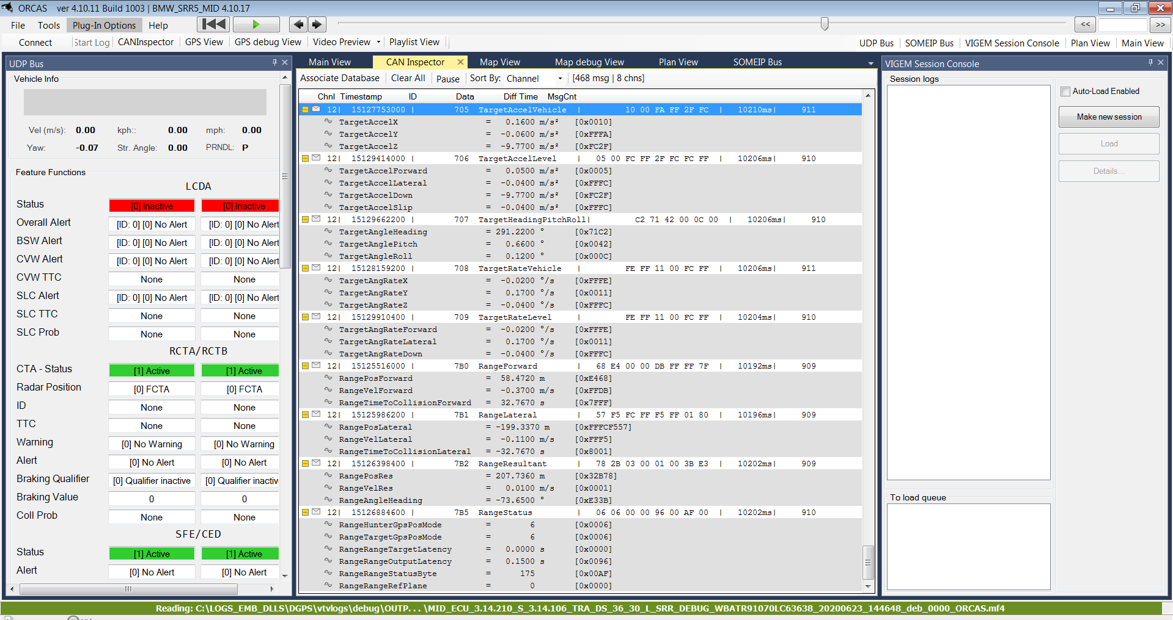
Here as shown, the channel number 12 contains the DGPS data and inorder to decode the data we need to add the dbc file.
Follow the below steps to add the dbc.
- Click on Associate database.
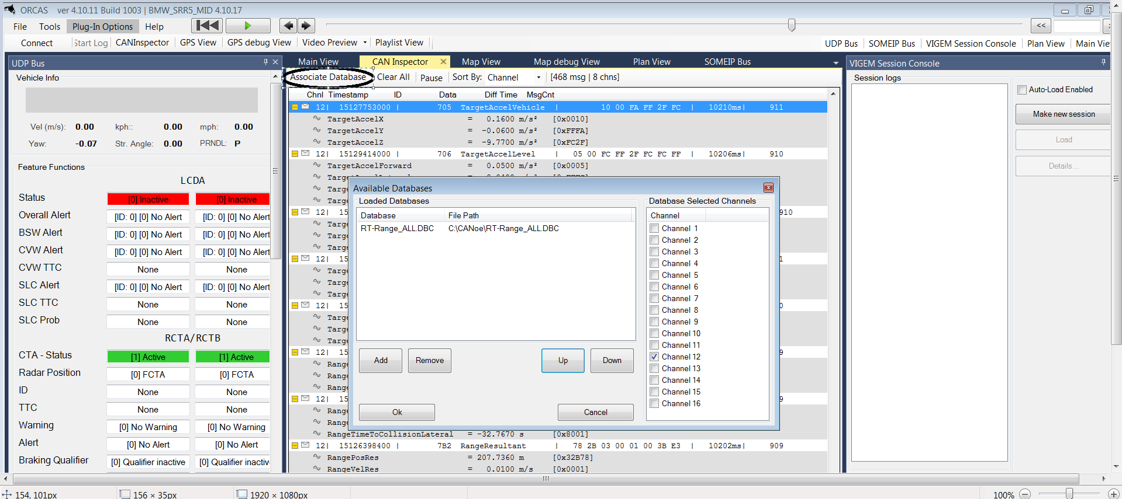
2.Click on Add button and load the dbc file and select the channel n umber as shown in the above image. Click OK and replay the ORCAS. This way the 12th channel can be decoded for viewing the DGPS data.
Video explanation of convertor tool usage
https://onedrive.aptiv.com/:v:/g/personal/anju_satheesh_aptiv_com/ERnbtNgso3NIsn4bTg2INvwBZqLzCFsNXUgUyMRzaHz_ZA?email=anju.satheesh%40aptiv.com
Contact details:
RESIM team Lead : vijayakumar.hv@aptiv.com
Tool main developer : anju.satheesh@aptiv.com
JIRA for issues : CYW

