Re-simulation?
Replaying the captured hardware/sensor data + scenarios
- Hardware (HIL)
- Software (SIL)
SIL – Software in Loop
- SIL Engine – Part 1
Resim? Virtual test drive in lab. Don’t need to go to road for testing software.
ADAS – advanced driver assistance system
  - Why Resim?
    - Growing complexity
    - Evaluate and validate functional concepts
    - Virtual test drives (in lab). No need to go to road to perform test on updates
    - Cost effective
    - Relevant tests in early stages
    - Speed up ADAS development process
    - End-to-end development and test environment
    - Sensor-realistic simulation and data replay
    - Can be extended to radars, GPS and cameras
  - Software in loop concept
    - Multi-sensor simulation software
    - Act as a virtual reality platform for intelligent vehicle
    - Recreating the real-life scenarios using a PC
Scenario is already saved in the form of logs. Logs used to recreate the scenario.
    - Delivers thousands of exploratory permutations
    - Easier debugging and verification
    - Offline simulation
  - How is APTIV solution adapted?
    - SW is build and flashed on the hardware. Embedded compiler.
    - SW is build to run in Windows. Embedded dlls using VS. Dlls used to run logs for various sensors.
    - Sensors flashed to collect ORCAS/VIGEM logs – MDF4
    - Fusion
  - Who uses SIL and Resim
    - APTIV internal
      - Tracker algo dev
      - Feature function dev
      - Systems team
      - Vehicle Testing and validation Team (VT&V)
      - Software Integration team
    - Customers
  - SIL infrastructure
    - SIL can be executed on laptops/workstations
SIL is executed in a single core (fusion dependencies between ECU/Sensor dlls)
    - Resim can be executed in HPCC
  - SIL components
    - SIL engine. ReSim.exe
Framework – common across all customers and variants
Configuration. Processing logs. Reading UDP data from log. Passes data to embedded library. Tracker algorithm. Feature function. Multithreading.
Mode of execution – sequential and continuous.
Entry points – detection, CDC
    - Embedded library
      - Low variant
Sensor data – UDP data for each sensor
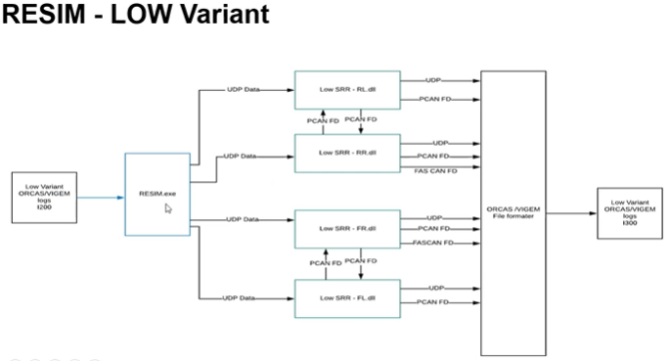
      - Mid variant
      - High variant
    - SIL Engine – it is like a game engine.
Game engine – number of players can be increased, scenario can be altered, players properties can be updated in middle of game.
Resim solution can be configured for various SIL entry point, modes of execution, and variants
  - Resim High level architecture
3 tiered Framework (SIL Engine) + Core library (modules are reused in other toolsets – plug-n-play) + Embedded library
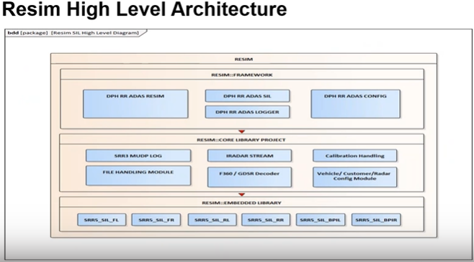
+ Framework part is called SIL engine
- XML reader – config reader
- MUX and calibration handling module – extracts calibration from log stream data.
- ADAS SIL engine – feeds data to embedded library (corresponding sensor dlls). Core module of Resim. Calls embedded library.
- Multi-threaded design. Calls made to embedded library. Each call made to sensor is in a thread. Call made after stitch and latch is completed. Boost library
- MUDP stitch and latch module
STFT
- Radar stream decoder and backward compatibility block
- Separate thread for each sensor
- Uses boost library for data processing
- Backward compatibility – playing older logs
+ Core library. Some of the modules act as plug-n-play in other tools
+ Embedded library
  - SIL configuration
    - Customer
    - Output location
    - Output file formats
    - Embedded library config path – NONE for release build
    - Sensor status
    - Vehicle injection mode
    - Replay mode
    - SIL entry point
    - Debugging
  - Demo
    - Code available in 10030156_
- SIL Engine – Part 2
  - SRR architecture
    - Vehicle setup
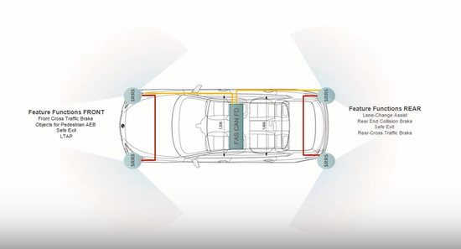
Red line – fusion capability by CAN protocol. 2 radars interact with each other.
Yellow line – FAS can FD. Customer specific. Talk to central controller (ECU).
Feature function
Front – front cross traffic brake, objects for pedestrians AES, Safe exit, LTAP
Rear – lane change assist, rear end collision brake, safe exit, rear cross traffic brake
    - Radar core architecture
Core 0 (Z4) Autosar. Triggers interrupts. OS resides. State machines. Vehicle CAN FD
Core 1 (Z7A) signals coming from radar sensors. Signal processing.
Core 2 (Z7B) application core. Ethernet logging – files can be replayed. Ethernet logging disabled when software is shipped. Private Can FD – 2 F/R sensors talking.
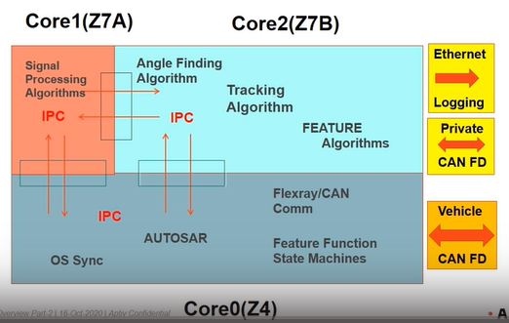
Angle finding algo – finds detections. (azimuth)
Tracking algo – finding objects (car/truck/human) from detections.
Feature algorithms – specific to a scenario. Front cross traffic brake.
Ethernet logging (UDP) – data is logged into a file which can be replayed by Resim. Is disabled in production environment.
Private CAN FD – connects two sensors (L/R)
Vehicle CAN FD -
    - Data logging schema
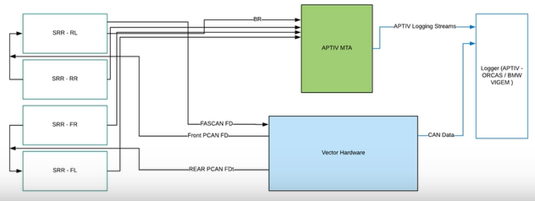
Logging module writes data into file. Re-simulation tools take the log file as input. Log files – APTIV ORCA, BMW VIGEM
Vector Hardware – logging CAN data
Aptiv Media gateway – handles only ethernet data
  - Logging stream
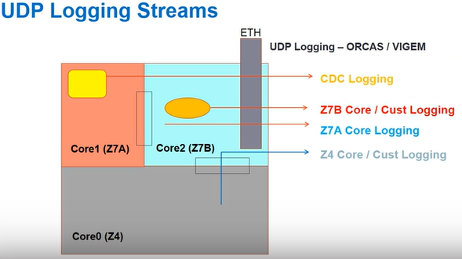
IPC – Shared memory
CDC logging?
UDP logging – structures defined in a padded manner and generated by the SW team so that collected data is reusable. Core 2. ETH pillar.
CDC – compressed data cube. Data from core 1 with minimum data processing. Row ADC data
Core features common. Customer features specific to car manufacturers.
Logging data
+ Big endian – Embedded software (microcontrollers)
+ Little endian – PC based re-simulation
Tool generates .c and .h file based on xml definition
  - Core stream definitions
  - Embedded library – low level architecture
  - Modes of sil execution and entry points
- CDC mode – CDC injection
- Detection mode – injection of detections
- DSpace mode – injection of simulated detection
  - Code organization
  - How to build?
ReSim_Windows_Build.bat
Debugging the code?
SIL_Proxy.sln
Application exe takes arguments to run
  - Standalone execution of resim
APT_SRR_RESIM.exe path/config.xml path/input_log.txt
  - Major outputs
    - Bin files – internal signals for tracker and feature function. Matlab tool chains
    - Log data – UDP logging streams and CAN output files with re-simulated results. orcas
    - Trace folder – extracted UDP data in csv format for input and output logs for all the streams
    - XML trace – input and output logging data printed in xml
  - SIL user group?
    - APTIV internal
      - Tracker algo dev
      - Feature function dev
      - Systems team
      - Vehicle testing and validation team
      - IT&V
      - Software integration team
    - Customer
- SIL Engine Tools Part1
Tools – SRR_RESIM_Release\RESIM_Toolset
  - Packet Loss tool.
  - MUDP extractor tool. Analyses UDP data. Header dump tool.
  - Bordnet tool

