Usage of the AS-bin-writer-lib

With the AS-bin-writer-lib it is not furthermore necessary to create any kind of output structure to write data. The writer handles its own data container, which is automatically extended when you pass a new variable or array to it.
To do so, create a new header in your feature function e.g. called “AS_bin_writer_FeatureFunctionName.h” and protect it with an guard like described in the example below. Include the necessary header "AS_bin_writer_wrapper.h" as well.

Example AS_bin_writer_FeatureFunctionName.h:
-----------------------------------------------------------------------------------------
#ifndef AS_BIN_WRITER_FEATUREFUNCTIONNAME_H
#define AS_BIN_WRITER_FEATUREFUNCTIONNAME_H

#ifdef BINARY_DEBUG

#include "AS_bin_writer_wrapper.h"

static char * AS_bww_FeatureFunctionName_OutputString = "FeatureFunctionNameOutput";

#define CUSTOM_FUNCTION_TO_ACCESS_BIN_WRITER_MAC(input) {\
custom_function_to_access_bin_writer(input); }

void custom_function_to_access_bin_writer(type input);

#else /* BINARY_DEBUG */

#define CUSTOM_FUNCTION_TO_ACCESS_BIN_WRITER_MAC()
#endif /* !AS_BIN_WRITER_FEATUREFUNCTIONNAME_H */
-----------------------------------------------------------------------------------------

MAC is standing here like an abbreviation for macro. It is recommended to create a “AS_bin_writer_FeatureFunctionName.c” as well, to implement the function calls for the access of the AS-bin-writer-lib . On the other hand, you would implement the function calls in *.c files that are already existing, but for better separability it is recommended to create new files to access the AS-bin-writer-lib . As you see in the example of the header, the macro CUSTOM_FUNCTION_TO_ACCESS_BIN_WRITER_MAC() will be used in your code (at the place it is required) to access the AS-bin-writer-lib . If the “BINARY_DEBUG” is not set in the preprocessor configuration of the corresponding visual studio solutions, then an empty macro will be called. This means, the embedded code will not be affected on the writer function calls. A corresponding *.c file can look like the example below, where input can be just a value, a structure or whatever you like.

Then, use either the function:
STORE_VAL_MGR_WPR(const char* type, char var_name[1024], double value)
to pass a single value, or the function:
STORE_ARRAY_ELEM_MGR_WPR(const char* type, char var_name[1024], double value,
int arr_index)
to store an array element. Where the transfer parameters have the following meaning:
type: name of the output-file to save to, creates a writer-instance which is accessible with the
given name, create it on top of the file “AS_bin_writer_FeatureFunctionName.h”
var_name: name of the variable or array which will be saved in the output file, also name of the
variable or the array in the debug structure
value: value to save for the variable or the array at given index for this run
arr_index: array index where the store the variable

Example AS_bin_writer_FeatureFunctionName.c:
-----------------------------------------------------------------------------------------
#ifdef BINARY_DEBUG
#include "AS_bin_writer_FeatureFunctionName.h"
void custom_function_to_access_bin_writer(type* input)
{
int i;
STORE_VAL_MGR_WPR(AS_bww_FeatureFunctionName_OutputString, "NameOfVariable", input->variable);

for (i = 0; i < SOME_VALUES; i++)
{
STORE_ARRAY_ELEM_MGR_WPR(AS_bww_FeatureFunctionName_OutputString, "NameOfVariable", input->variable[i], i);
}
}

#endif /* BINARY_DEBUG */
-----------------------------------------------------------------------------------------

To store data indexed for different radars, use STORE_VAL_MGR_WPR_INDEXED respectively STORE_ARRAY_ELEM_MGR_WPR_INDEXED and pass the index in addition.
After each run, all data which has been passed to the writer will be written automatically.

It is possible to create own typedef structure to store information during a cycle of the software and just to write at the end of the cycle, especially if data in a loop inside a feature function have to be stored. This example give just an short overview how to generally access and use the AS-bin-writer-lib .
IMPORTANT: It is not possible to change the number of written variables/arrays/array lengths or indexed radars, once the files header is written. Trying to do so:

static unsigned char not_on_first_run = FALSE;
STORE_VAL_MGR_WPR(AS_bww_Test_OutputString, "This_works", 5);
if(not_on_first_run)
{
STORE_VAL_MGR_WPR(AS_bww_Test_OutputString, "This_wont_work", 5);
}
not_on_first_run = TRUE;

will result in the following error message:

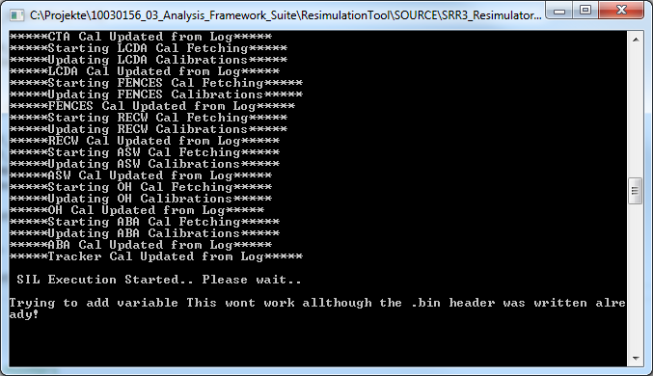

Usage with the old bin-writer:
If the new output name, specified in your file “AS_bin_writer_FeatureFunctionName.h”, equals the name specified in the old bin-writer, the resulting file will not be readable. Either turn off the old output in the “Resim_Config.h”, or change the new output name.

Possible Troubles (example from AUDI project!):
If the writer will not work in first instance, check whether the set passes match your system:
Go to corresponding customer project solution: AUDI_SRR->Configuration Properties->C/C++->General
Add path to “AS_bin_writer_wrapper.h” to “Additional Include Directories”
(typically “..\..\Audi_SIL_Library\DPH_RR_ADAS_RESIM\ApplicationProjects\DPH_RR_ADAS_SiL_Proxy\AS-bin-writer\lib” should work)

And check whether the references to AS-bin-writer-lib are set in the following projects:
SRR3_SiL_FL, SRR3_SiL_FR, SRR3_SiL_RL, SRR3_SiL_RR and AUDI_SRR or BMW_SRR
as well as if the preprocessor in every visual studio project has the define “BINARY_DEBUG” included.

