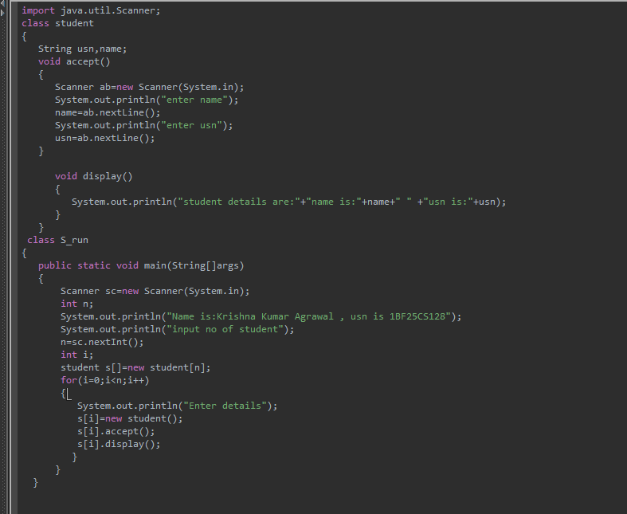
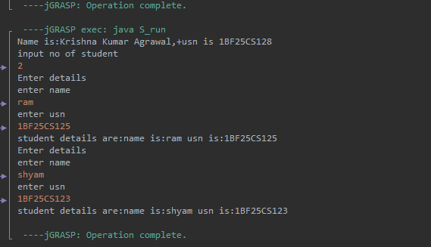
import java.util.Scanner;
class student
{
String usn,name;
void accept()
{
Scanner ab=new Scanner(System.in);
System.out.println("enter name");
name=ab.nextLine();
System.out.println("enter usn");
usn=ab.nextLine();
}
void display()
{
System.out.println("student details are:"+"name is:"+name+" " +"usn is:"+usn);
}
}
class S_run
{
public static void main(String[]args)
{
Scanner sc=new Scanner(System.in);
int n;
System.out.println("Name is: Krishna Kumar Agrawal ,usn is 1BF25CS128");
System.out.println("input no of student");
n=sc.nextInt();
int i;
student s[]=new student[n];
for(i=0;i<n;i++)
{
System.out.println("Enter details");
s[i]=new student();
s[i].accept();
s[i].display();
}
}
}

