Alerts IQ – Enterprise Architecture Blueprint
AI-Powered Enterprise Alert Lifecycle Management Platform
Generated on: 2026-05-26 17:08

Executive Summary
Alerts IQ is an enterprise-grade AI-driven alert engineering platform that automates guided discovery, content creation, workflow orchestration, AI-assisted template engineering, real-time preview rendering, JIRA/Git automation, and CMS publishing.

High-Level Enterprise Workflow
- Enterprise Login with AD / SSO
- RBAC Authorization
- Distributed Lock Acquisition
- Guided Discovery
- AI Requirement Expansion
- Workflow & To-Do Generation
- Message Spec & Liquibase Generation
- JIRA Story Automation
- Figma to HTML AI Conversion
- Dynamic Variables & Conditions
- Live Preview Rendering
- Formatter Pipeline
- Approval Workflow
- CMS Publishing
- Deploy & Test

Enterprise Architecture Diagram
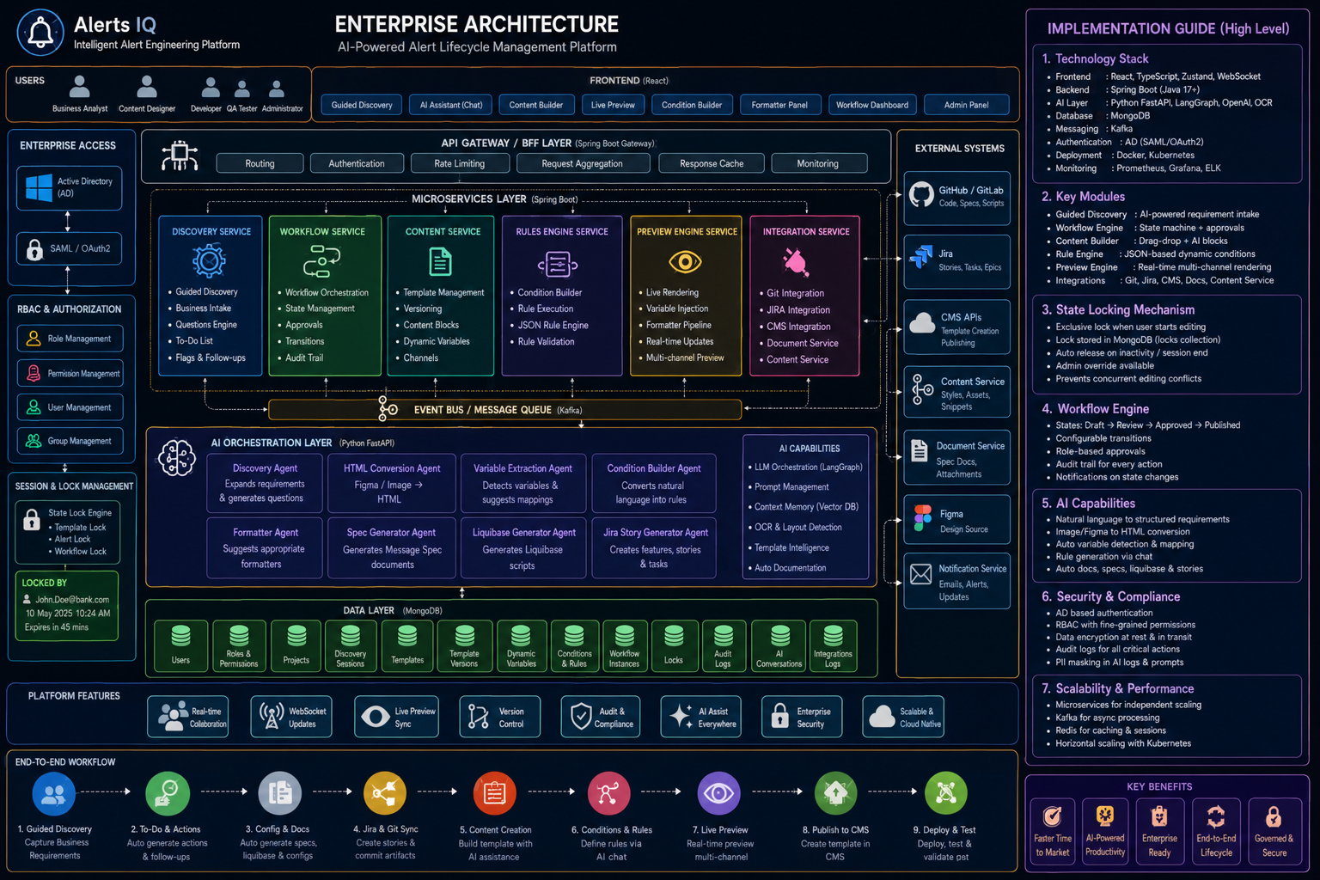

Frontend Architecture
- React + TypeScript + Zustand
- Tailwind + ShadCN UI
- Live Preview Engine
- Condition Builder
- Workflow Dashboard
- AI Chat Assistant

Backend Architecture
- Spring Boot API Gateway
- Workflow Service
- Template Service
- Preview Service
- Integration Service
- Audit Service

AI Layer
- Python FastAPI
- LangGraph AI Orchestration
- Figma to HTML Conversion
- Condition AI Agent
- Formatter AI Agent
- Liquibase Generator
- Spec Document Generator

Security Architecture
- Active Directory Integration
- SAML / OAuth2
- RBAC Authorization
- Distributed Locking
- Audit Trails
- PII Masking

Workflow Architecture
- Draft
- Discovery
- Content Creation
- Review
- Approval
- CMS Publish
- Deploy
- Testing
- Completed

Database Collections
- users
- roles
- permissions
- templates
- template_versions
- conditions
- variables
- workflows
- locks
- audit_logs

Distributed Locking Mechanism
When a user starts editing a template or alert, the system acquires a distributed lock using Redis and persists lock metadata in MongoDB. This prevents concurrent editing conflicts.

Technology Stack
Layer | Technology
Frontend | React, TypeScript, Tailwind, Zustand
Backend | Spring Boot
AI Layer | Python FastAPI, LangGraph
Database | MongoDB
Queue | Kafka
Realtime | WebSockets
Locking | Redis
Observability | Prometheus, Grafana, ELK
Deployment | Docker, Kubernetes

Final Recommendation
Alerts IQ should be positioned as an Enterprise AI Alert Engineering Platform capable of orchestrating business onboarding, technical automation, content generation, workflow governance, and intelligent publishing in a single enterprise ecosystem.

