Following are the tables we are creating.

category

addingVendor_General

addingVendor_BillHistory

addingVendor_AddedCosts

addingVendor_GLPosts

addingVehicle_General

addingVehicle_FloorPlanning

addingVehicle_Sales

addingVehicle_PreviousOwner

addingVehivle_Photos

addingVehicle_Notes

addingVehicle_VehicleBill (same as addingVendor_BillHistory)

Database Design:

Here, we create tables and populate them.

1.Lets create first table **category**.

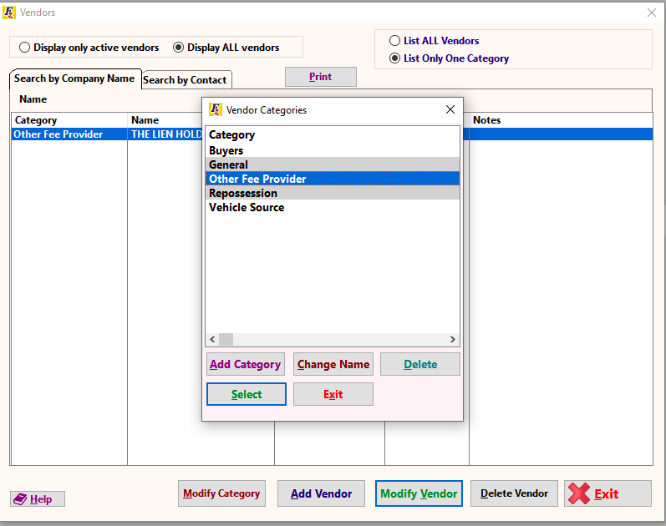

**Category** has five values:

Buyers (default)

General

Other Fee Provider

Repossession

Vehicle source

Code:

mysql> **use mydb;**

CREATE TABLE `categoryTest` (

`id` int(11) PRIMARY KEY NOT NULL AUTO_INCREMENT,

`categoryName` varchar(50) NOT NULL

)ENGINE=InnoDB DEFAULT CHARSET=utf8;

mysql> **CREATE TABLE `categoryTest` (**

**-> `id` int(11) PRIMARY KEY NOT NULL AUTO_INCREMENT,**

**-> `categoryName` varchar(50) NOT NULL**

**->**

**-> )ENGINE=InnoDB DEFAULT CHARSET=utf8;**

Query OK, 0 rows affected (1.18 sec)

INSERT INTO categoryTest(categoryName)

VALUES ('Buyers');

mysql> **INSERT INTO categoryTest(categoryName)**

**-> VALUES ('Buyers');**

Query OK, 1 row affected (0.06 sec)

INSERT INTO categoryTest(categoryName)

VALUES ('General');

mysql> **INSERT INTO categoryTest(categoryName)**

**-> VALUES ('General');**

Query OK, 1 row affected (0.04 sec)

INSERT INTO categoryTest(categoryName) VALUES ('Other Fee Provider');

mysql> **INSERT INTO categoryTest(categoryName) VALUES ('Other Fee Provider');**

Query OK, 1 row affected (0.04 sec)

INSERT INTO categoryTest(categoryName) VALUES ('Repossession');

mysql> **INSERT INTO categoryTest(categoryName) VALUES ('Repossession');**

Query OK, 1 row affected (0.05 sec)

INSERT INTO categoryTest(categoryName) VALUES ('Vehicle Source');

mysql> **INSERT INTO categoryTest(categoryName) VALUES ('Vehicle Source');**

Query OK, 1 row affected (0.06 sec)

SELECT * FROM categoryTest;

mysql> **SELECT * FROM categoryTest;**

+----+--------------------+

| id | categoryName |

+----+--------------------+

| 1 | Buyers |

| 2 | General |

| 3 | Other Fee Provider |

| 4 | Repossession |

| 5 | Vehicle Source |

+----+--------------------+

5 rows in set (0.00 sec)

**2.**Lets create another table - **addingVendorGeneral**

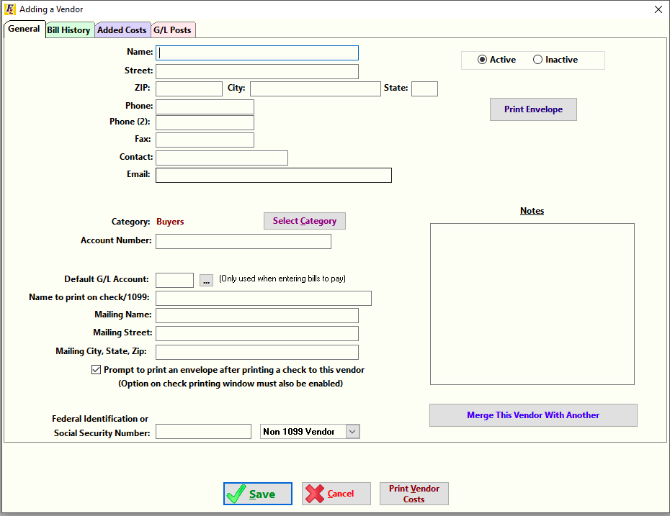

CREATE TABLE `vendorGeneralInformationC` (

`id` int(11) PRIMARY KEY NOT NULL AUTO_INCREMENT,

`name` varchar(50) NOT NULL,

`isActive` BOOLEAN NOT NULL,

`street` varchar(80) NOT NULL,

`zip` varchar(20) NOT NULL,

`city` varchar(30) NOT NULL,

`state` varchar(30) NOT NULL,

`phone` varchar(20),

`phoneTwo` varchar(20),

`fax` varchar(20),

`contact` varchar(50),

`email` varchar(50) NOT NULL,

`categoryId` int(11) DEFAULT NULL,

`accountNumber` varchar(30),

`defaultGLAccount` varchar(30),

`nameToPrintOnCheckOr1099` varchar(50),

`mailingName` varchar(50),

`mailingStreet` varchar(80),

`mailingCityStateZip` varchar(80),

`socialSecurityNumber` varchar(20),

`isNon1099Vendor` BOOLEAN NOT NULL,

`notes` varchar(400),

FOREIGN KEY (`categoryId`) REFERENCES `categoryTest` (`id`) ON DELETE SET NULL ON UPDATE CASCADE

)ENGINE=InnoDB DEFAULT CHARSET=utf8;

CREATE DATABASE dbOne;

mysql> **CREATE DATABASE dbOne;**

Query OK, 1 row affected (0.00 sec)

mysql> **use dbOne;**

Database changed

mysql> **CREATE TABLE `vendorGeneralInformationC` (**

**-> `id` int(11) PRIMARY KEY NOT NULL AUTO_INCREMENT,**

**-> `name` varchar(50) NOT NULL,**

**-> `isActive` BOOLEAN NOT NULL,**

**-> `street` varchar(80) NOT NULL,**

**-> `zip` varchar(20) NOT NULL,**

**-> `city` varchar(30) NOT NULL,**

**-> `state` varchar(30) NOT NULL,**

**-> `phone` varchar(20),**

**-> `phoneTwo` varchar(20),**

**-> `fax` varchar(20),**

**-> `contact` varchar(50),**

**-> `email` varchar(50) NOT NULL,**

**-> `categoryId` int(11) DEFAULT NULL,**

**-> `accountNumber` varchar(30),**

**-> `defaultGLAccount` varchar(30),**

**-> `nameToPrintOnCheckOr1099` varchar(50),**

**-> `mailingName` varchar(50),**

**-> `mailingStreet` varchar(80),**

**-> `mailingCityStateZip` varchar(80),**

**-> `socialSecurityNumber` varchar(20),**

**-> `isNon1099Vendor` BOOLEAN NOT NULL,**

**-> `notes` varchar(400),**

**->**

**->**

**-> FOREIGN KEY (`categoryId`) REFERENCES `categoryTest` (`id`) ON DELETE SET NULL ON UPDATE CASCADE**

**-> )ENGINE=InnoDB DEFAULT CHARSET=utf8;**

Query OK, 0 rows affected (0.35 sec)

Lets populate the data table.

INSERT INTO vendorGeneralInformationC(name,isActive,street,zip,city,state,email,categoryId,isNon1099Vendor) VALUES

('Krishna',1,'JJ nagar','99','BANGORE','Maine','abcd@gmail.com',1,0);

mysql> **INSERT INTO vendorGeneralInformationC(name,isActive,street,zip,city,state,email,categoryId,isNon1099Vendor) VALUES ('Krishna',1,'JJ nagar','99','BANGORE','Maine','abcd@gmail.com',1,0);**

Query OK, 1 row affected (0.05 sec)

SELECT * FROM vendorGeneralInformationC;

mysql> **SELECT * FROM vendorGeneralInformationC**;

+----+---------+----------+----------+-----+---------+-------+-------+----------+------+---------+----------------+------------+---------------+------------------+--------------------------+-------------+---------------+---------------------+----------------------+-----------------+-------+

| id | name | isActive | street | zip | city | state | phone | phoneTwo | fax | contact | email | **categoryId** | accountNumber | defaultGLAccount | nameToPrintOnCheckOr1099 | mailingName | mailingStreet | mailingCityStateZip | socialSecurityNumber | isNon1099Vendor | notes |

+----+---------+----------+----------+-----+---------+-------+-------+----------+------+---------+----------------+------------+---------------+------------------+--------------------------+-------------+---------------+---------------------+----------------------+-----------------+-------+

| 2 | Krishna | 1 | JJ nagar | 99 | BANGORE | Maine | NULL | NULL | NULL | NULL | abcd@gmail.com | **1** | NULL | NULL | NULL | NULL | NULL | NULL | NULL | 0 | NULL |

+----+---------+----------+----------+-----+---------+-------+-------+----------+------+---------+----------------+------------+---------------+------------------+--------------------------+-------------+---------------+---------------------+----------------------+-----------------+-------+

1 row in set (0.00 sec)

You can see the **FOREIGN KEY (`categoryId`)** is added in the table**.**

**3**.Lets create next table -**addingVendor_BillHistoryB**.

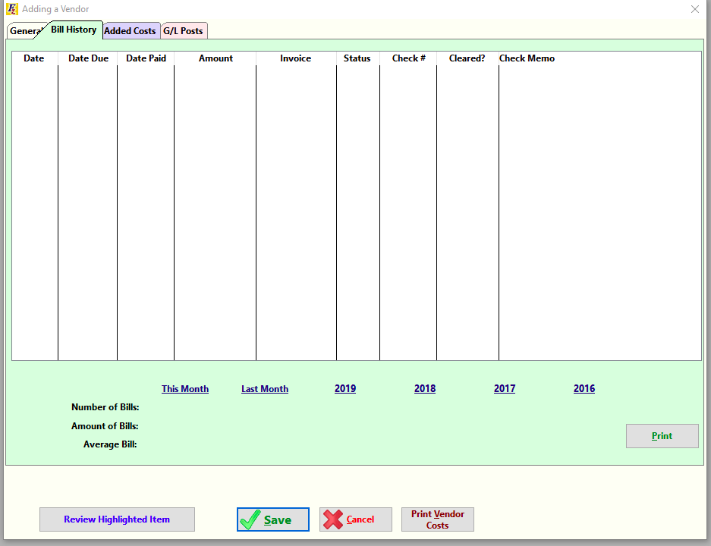

CREATE TABLE `addingVendor_BillHistoryB` (

`id` int(11) PRIMARY KEY NOT NULL AUTO_INCREMENT,

`vendorId` int(11) DEFAULT NULL,

`date` varchar(20) NOT NULL,

`dateDue` varchar(20) NOT NULL,

`datePaid` varchar(20),

`amount` DECIMAL(10,2) NOT NULL,

`invoice` varchar(50) NOT NULL,

`status` varchar(50),

`checkNumber` varchar(50),

`isCleared` BOOLEAN DEFAULT 0,

`checkMemo` varchar(200),

FOREIGN KEY (`vendorId`) REFERENCES `vendorGeneralInformationC` (`id`) ON DELETE SET NULL ON UPDATE CASCADE

)ENGINE=InnoDB DEFAULT CHARSET=utf8;

mysql> **CREATE TABLE `addingVendor_BillHistoryB` (**

**-> `id` int(11) PRIMARY KEY NOT NULL AUTO_INCREMENT,**

**-> `vendorId` int(11) DEFAULT NULL,**

**-> `date` varchar(20) NOT NULL,**

**-> `dateDue` varchar(20) NOT NULL,**

**-> `datePaid` varchar(20),**

**-> `amount` DECIMAL(10,2) NOT NULL,**

**-> `invoice` varchar(50) NOT NULL,**

**-> `status` varchar(50),**

**-> `checkNumber` varchar(50),**

**-> `isCleared` BOOLEAN DEFAULT 0,**

**-> `checkMemo` varchar(200),**

**->**

**-> FOREIGN KEY (`vendorId`) REFERENCES `vendorGeneralInformationC` (`id`) ON DELETE SET NULL ON UPDATE CASCADE**

**-> )ENGINE=InnoDB DEFAULT CHARSET=utf8;**

Query OK, 0 rows affected (0.31 sec)

To populate the table,it is a bit tricky as the values are that of the vehicle table that we need to create.

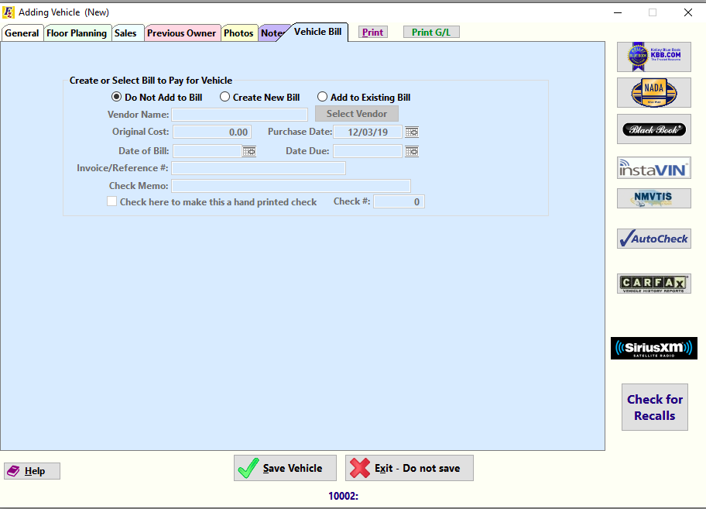

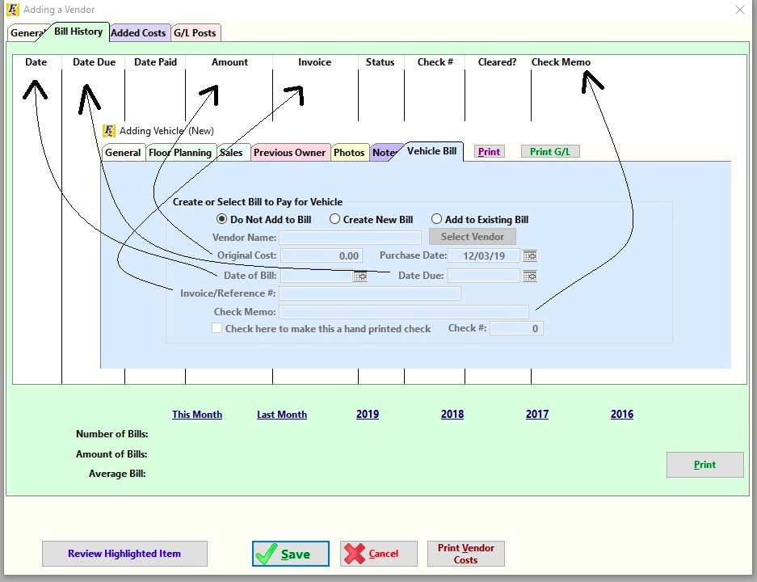

You can see the **data flow** when we add a **vehicle Bill**,it is populated in the **Vendor Bill History table**.So,there is no need to create a vehicleBill table.

**addingVehicle_VehicleBill**

vendorId

originalCost

purchaseDate

dateOfBill

dateDue

invoiceOrReference

checkMemo

**addingVendor_BillHistory**

vendorId

date

dateDue

datePaid

amount

invoice

status

checkNumber

isCleared

checkMemo

SHOW COLUMNS FROM addingVendor_BillHistoryB;

mysql> **SHOW COLUMNS FROM addingVendor_BillHistoryB;**  +-------------+---------------+------+-----+---------+----------------+

| Field | Type | Null | Key | Default | Extra |

+-------------+---------------+------+-----+---------+----------------+

| id | int(11) | NO | PRI | NULL | auto_increment |

**| vendorId** | int(11) | YES | MUL | NULL | |

| date | varchar(20) | NO | | NULL | |

| dateDue | varchar(20) | NO | | NULL | |

| datePaid | varchar(20) | YES | | NULL | |

| amount | decimal(10,2) | NO | | NULL | |

| invoice | varchar(50) | NO | | NULL | |

| status | varchar(50) | YES | | NULL | |

| checkNumber | varchar(50) | YES | | NULL | |

| isCleared | tinyint(1) | YES | | 0 | |

| checkMemo | varchar(200) | YES | | NULL | |

+-------------+---------------+------+-----+---------+----------------+

11 rows in set (0.01 sec)

As you can see the vendorId is a **FOREIGN KEY** referencing

**vendorGeneralInformationC table.**

mysql> SELECT * FROM vendorGeneralInformationC;

+----+---------+----------+----------+-----+---------+-------+-------+----------+------+---------+----------------+------------+---------------+------------------+--------------------------+-------------+---------------+---------------------+----------------------+-----------------+-------+

| id | name | isActive | street | zip | city | state | phone | phoneTwo | fax | contact | email | categoryId | accountNumber | defaultGLAccount | nameToPrintOnCheckOr1099 | mailingName | mailingStreet | mailingCityStateZip | socialSecurityNumber | isNon1099Vendor | notes |

+----+---------+----------+----------+-----+---------+-------+-------+----------+------+---------+----------------+------------+---------------+------------------+--------------------------+-------------+---------------+---------------------+----------------------+-----------------+-------+

| 2 | Krishna | 1 | JJ nagar | 99 | BANGORE | Maine | NULL | NULL | NULL | NULL | abcd@gmail.com | 1 | NULL | NULL | NULL | NULL | NULL | NULL | NULL | 0 | NULL |

+----+---------+----------+----------+-----+---------+-------+-------+----------+------+---------+----------------+------------+---------------+------------------+--------------------------+-------------+---------------+---------------------+----------------------+-----------------+-------+

1 row in set (0.01 sec)

INSERT INTO addingVendor_BillHistoryB(vendorId,date,dateDue,amount,invoice,checkMemo) VALUES (2,'26_12_19','27_12_19',1000,123,'Invoice number is 123');

mysql> **INSERT INTO addingVendor_BillHistoryB(vendorId,date,dateDue,amount,invoice,checkMemo) VALUES (2,'26_12_19','27_12_19',1000,123,'Invoice number is 123');**

Query OK, 1 row affected (0.04 sec)

SELECT * FROM addingVendor_BillHistoryB;

mysql> **SELECT * FROM addingVendor_BillHistoryB;**

+----+----------+----------+----------+----------+---------+---------+--------+-------------+-----------+-----------------------+

| id | **vendorId** | date | dateDue | datePaid | amount | invoice | status | checkNumber | isCleared | checkMemo |

+----+----------+----------+----------+----------+---------+---------+--------+-------------+-----------+-----------------------+

| 2 | 2 | 26_12_19 | 27_12_19 | NULL | 1000.00 | 123 | NULL | NULL | 0 | Invoice number is 123 |

+----+----------+----------+----------+----------+---------+---------+--------+-------------+-----------+-----------------------+

1 row in set (0.00 sec)

**4**.Another table - **addingVehicle_General**

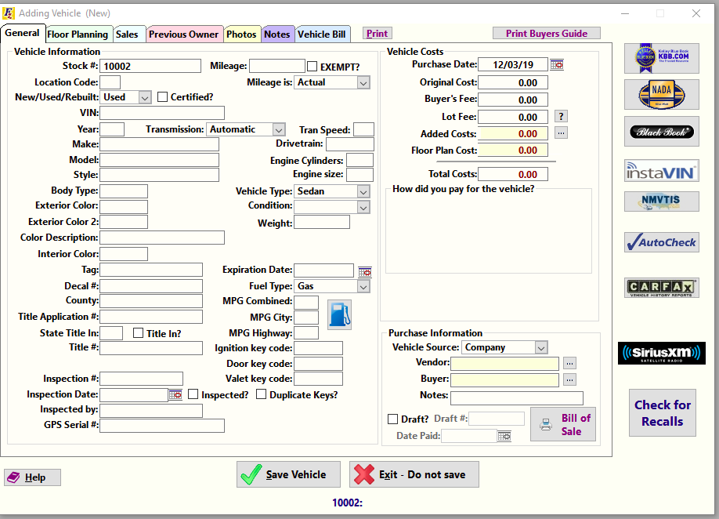

CREATE TABLE `addingVehicle_General` (

`stockNumber` int(11) PRIMARY KEY NOT NULL AUTO_INCREMENT,

`mileage` int(10),

`isExempt` BOOLEAN DEFAULT 0,

`locationCode` varchar(50),

`mileageIs` varchar(50),

`newOrUseOrRebuilt` varchar(20),

`isCertified` BOOLEAN DEFAULT 1,

`vin` varchar(20),

`year` varchar(20),

`transmission` varchar(20),

`transpeed` varchar(20),

`make` varchar(20),

`model` varchar(20),

`style` varchar(20),

`bodyType` varchar(20),

`exteriorColor` varchar(20),

`exteriorColorTwo` varchar(20),

`colorDescription` varchar(20),

`interiorColor` varchar(20),

`tag` varchar(20),

`decalNumber` varchar(20),

`county` varchar(30),

`titleApplication` varchar(50),

`stateTitleIn` varchar(30),

`isTitleIn` BOOLEAN DEFAULT 0,

`inspectionNumber` varchar(50),

`inspectionDate` varchar(20),

`inspectedBy` varchar(50),

`gpsSerialNumber` varchar(50),

`engineCylinders` varchar(20),

`engineSize` varchar(20),

`vehicleType` varchar(20),

`condition` varchar(20),

`weight` varchar(20),

`expirationDate` varchar(20),

`fuelType` varchar(20),

`mpgCombined` varchar(20),

`mpgCity` varchar(20),

`mpgHighway` varchar(20),

`ignitionKeyCode` varchar(30),

`doorKeyCode` varchar(30),

`valetKeyCode` varchar(30),

`isInspected` BOOLEAN DEFAULT 0,

`isDuplicateKeys` BOOLEAN DEFAULT 1,

`purchaseDate` varchar(30),

`originalCost` DECIMAL(10,2) DEFAULT '0.00',

`buyersFee` DECIMAL(10,2) DEFAULT '0.00',

`lotFee` DECIMAL(10,2) DEFAULT '0.00',

`addedCosts` DECIMAL(10,2) DEFAULT '0.00',

`floorPlanCost` DECIMAL(10,2) DEFAULT '0.00',

`totalCosts` DECIMAL(10,2) DEFAULT '0.00',

`vehicleSource` varchar(50) DEFAULT 'Company',

`buyer` int(11) DEFAULT NULL,

`notes` varchar(400),

`isDraft` BOOLEAN DEFAULT 1,

`draftNumber` varchar(50),

`datePaid` varchar(50)

)ENGINE=InnoDB AUTO_INCREMENT=1000 DEFAULT CHARSET=utf8;

mysql> **CREATE TABLE `addingVehicle_General` (**

**-> `stockNumber` int(11) PRIMARY KEY NOT NULL AUTO_INCREMENT,**

**-> `mileage` int(10),**

**-> `isExempt` BOOLEAN DEFAULT 0,**

**-> `locationCode` varchar(50),**

**-> `newOrUseOrRebuilt` varchar(20),**

**-> `isCertified` BOOLEAN DEFAULT 1,**

**-> `vin` varchar(20),**

**-> `year` varchar(20),**

**-> `transmission` varchar(20),**

**-> `transpeed` varchar(20),**

**-> `make` varchar(20),**

**-> `model` varchar(20),**

**-> `style` varchar(20),**

**-> `bodyType` varchar(20),**

**-> `exteriorColor` varchar(20),**

**-> `exteriorColorTwo` varchar(20),**

**-> `colorDescription` varchar(20),**

**-> `interiorColor` varchar(20),**

**-> `tag` varchar(20),**

**-> `decalNumber` varchar(20),**

**-> `county` varchar(30),**

**-> `titleApplication` varchar(50),**

**-> `stateTitleIn` varchar(30),**

**-> `isTitleIn` BOOLEAN DEFAULT 0,**

**-> `inspectionNumber` varchar(50),**

**-> `inspectionDate` varchar(20),**

**-> `inspectedBy` varchar(50),**

**-> `gpsSerialNumber` varchar(50),**

**-> `engineCylinders` varchar(20),**

**-> `engineSize` varchar(20),**

**-> `vehicleType` varchar(20),**

**-> `condition` varchar(20),**

**-> `weight` varchar(20),**

**-> `expirationDate` varchar(20),**

**-> `fuelType` varchar(20),**

**-> `mpgCombined` varchar(20),**

**-> `mpgCity` varchar(20),**

**-> `mpgHighway` varchar(20),**

**-> `ignitionKeyCode` varchar(30),**

**-> `doorKeyCode` varchar(30),**

**-> `valetKeyCode` varchar(30),**

**-> `isInspected` BOOLEAN DEFAULT 0,**

**-> `isDuplicateKeys` BOOLEAN DEFAULT 1,**

**-> `purchaseDate` varchar(30),**

**-> `originalCost` DECIMAL(10,2) DEFAULT '0.00',**

**-> `buyersFee` DECIMAL(10,2) DEFAULT '0.00',**

**-> `lotFee` DECIMAL(10,2) DEFAULT '0.00',**

**-> `addedCosts` DECIMAL(10,2) DEFAULT '0.00',**

**-> `floorPlanCost` DECIMAL(10,2) DEFAULT '0.00',**

**-> `totalCosts` DECIMAL(10,2) DEFAULT '0.00',**

**-> `vehicleSource` varchar(50) DEFAULT 'Company',**

**-> `buyer` int(11) DEFAULT NULL,**

**-> `notes` varchar(400),**

**-> `isDraft` BOOLEAN DEFAULT 1,**

**-> `draftNumber` varchar(50),**

**-> `datePaid` varchar(50)**

**->**

**-> )ENGINE=InnoDB AUTO_INCREMENT=1000 DEFAULT CHARSET=utf8;**

Query OK, 0 rows affected (0.30 sec)

INSERT INTO addingVehicle_General(mileage,locationCode,newOrUseOrRebuilt,vin,year,exteriorColor,inspectionDate,inspectedBy,vehicleType) VALUES (

100000,'ME','used','1HGBH41JXMN109186','2000','blue','24_12_2019','Mr InspectorOne','Sedan');

mysql> **INSERT INTO addingVehicle_General(mileage,locationCode,newOrUseOrRebuilt,vin,year,exteriorColor,inspectionDate,inspectedBy,vehicleType) VALUES (**

**-> 100000,'ME','used','1HGBH41JXMN109186','2000','blue','24_12_2019','Mr InspectorOne','Sedan');**

Query OK, 1 row affected (0.07 sec)

INSERT INTO addingVehicle_General(mileage,locationCode,newOrUseOrRebuilt,vin,year,exteriorColor,inspectionDate,inspectedBy,vehicleType) VALUES (

0,'ME','new','1HGBH41JXMN1091000','2019','blue','2_10_2019','Mr InspectorOne','Sedan');

mysql> **INSERT INTO addingVehicle_General(mileage,locationCode,newOrUseOrRebuilt,vin,year,exteriorColor,inspectionDate,inspectedBy,vehicleType) VALUES (**

**-> 0,'ME','new','1HGBH41JXMN1091000','2019','blue','2_10_2019','Mr InspectorOne','Sedan');**

Query OK, 1 row affected (0.04 sec)

INSERT INTO addingVehicle_General(mileage,locationCode,newOrUseOrRebuilt,vin,year,exteriorColor,inspectionDate,inspectedBy,vehicleType,originalCost,buyersFee,addedCosts,floorPlanCost,totalCosts) VALUES (

0,'ME','new','1HGBH41JXMN1091001','2018','white','2_10_2018','Mr InspectorTwo','Hatch Back',16000,200,500,100,17500);

mysql> **INSERT INTO addingVehicle_General(mileage,locationCode,newOrUseOrRebuilt,vin,year,exteriorColor,inspectionDate,inspectedBy,vehicleType,originalCost,buyersFee,addedCosts,floorPlanCost,totalCosts) VALUES (**

**-> 0,'ME','new','1HGBH41JXMN1091001','2018','white','2_10_2018','Mr InspectorTwo','Hatch Back',16000,200,500,100,17500);**

Query OK, 1 row affected (0.05 sec)

SELECT * FROM addingVehicle_General;

mysql> **SELECT * FROM addingVehicle_General;**

+-------------+---------+----------+--------------+-------------------+-------------+--------------------+------+--------------+-----------+------+-------+-------+----------+---------------+------------------+------------------+---------------+------+-------------+--------+------------------+--------------+-----------+------------------+----------------+-----------------+-----------------+-----------------+------------+-------------+-----------+--------+----------------+----------+-------------+---------+------------+-----------------+-------------+--------------+-------------+-----------------+--------------+--------------+-----------+--------+------------+---------------+------------+---------------+-------+-------+---------+-------------+----------+

| stockNumber | mileage | isExempt | locationCode | newOrUseOrRebuilt | isCertified | vin | year | transmission | transpeed | make | model | style | bodyType | exteriorColor | exteriorColorTwo | colorDescription | interiorColor | tag | decalNumber | county | titleApplication | stateTitleIn | isTitleIn | inspectionNumber | inspectionDate | inspectedBy | gpsSerialNumber | engineCylinders | engineSize | vehicleType | condition | weight | expirationDate | fuelType | mpgCombined | mpgCity | mpgHighway | ignitionKeyCode | doorKeyCode | valetKeyCode | isInspected | isDuplicateKeys | purchaseDate | originalCost | buyersFee | lotFee | addedCosts | floorPlanCost | totalCosts | vehicleSource | buyer | notes | isDraft | draftNumber | datePaid |

+-------------+---------+----------+--------------+-------------------+-------------+--------------------+------+--------------+-----------+------+-------+-------+----------+---------------+------------------+------------------+---------------+------+-------------+--------+------------------+--------------+-----------+------------------+----------------+-----------------+-----------------+-----------------+------------+-------------+-----------+--------+----------------+----------+-------------+---------+------------+-----------------+-------------+--------------+-------------+-----------------+--------------+--------------+-----------+--------+------------+---------------+------------+---------------+-------+-------+---------+-------------+----------+

| **1000** | 100000 | 0 | ME | used | 1 | 1HGBH41JXMN109186 | 2000 | NULL | NULL | NULL | NULL | NULL | NULL | blue | NULL | NULL | NULL | NULL | NULL | NULL | NULL | NULL | 0 | NULL | 24_12_2019 | Mr InspectorOne | NULL | NULL | NULL | Sedan | NULL | NULL | NULL | NULL | NULL | NULL | NULL | NULL | NULL | NULL | 0 | 1 | NULL | 0.00 | 0.00 | 0.00 | 0.00 | 0.00 | 0.00 | Company | NULL | NULL | 1 | NULL | NULL |

| **1001** | 0 | 0 | ME | new | 1 | 1HGBH41JXMN1091000 | 2019 | NULL | NULL | NULL | NULL | NULL | NULL | blue | NULL | NULL | NULL | NULL | NULL | NULL | NULL | NULL | 0 | NULL | 2_10_2019 | Mr InspectorOne | NULL | NULL | NULL | Sedan | NULL | NULL | NULL | NULL | NULL | NULL | NULL | NULL | NULL | NULL | 0 | 1 | NULL | 0.00 | 0.00 | 0.00 | 0.00 | 0.00 | 0.00 | Company | NULL | NULL | 1 | NULL | NULL |

| **1002** | 0 | 0 | ME | new | 1 | 1HGBH41JXMN1091001 | 2018 | NULL | NULL | NULL | NULL | NULL | NULL | white | NULL | NULL | NULL | NULL | NULL | NULL | NULL | NULL | 0 | NULL | 2_10_2018 | Mr InspectorTwo | NULL | NULL | NULL | Hatch Back | NULL | NULL | NULL | NULL | NULL | NULL | NULL | NULL | NULL | NULL | 0 | 1 | NULL | 16000.00 | 200.00 | 0.00 | 500.00 | 100.00 | 17500.00 | Company | NULL | NULL | 1 | NULL | NULL |

+-------------+---------+----------+--------------+-------------------+-------------+--------------------+------+--------------+-----------+------+-------+-------+----------+---------------+------------------+------------------+---------------+------+-------------+--------+------------------+--------------+-----------+------------------+----------------+-----------------+-----------------+-----------------+------------+-------------+-----------+--------+----------------+----------+-------------+---------+------------+-----------------+-------------+--------------+-------------+-----------------+--------------+--------------+-----------+--------+------------+---------------+------------+---------------+-------+-------+---------+-------------+----------+

3 rows in set (0.00 sec)

**5.**Another table-**addingVendor_GLPostsOne**

CREATE TABLE `addingVendor_GLPostsOne` (

`id` int(11) PRIMARY KEY NOT NULL AUTO_INCREMENT,

`date` varchar(30),

`amount` int(11) NOT NULL,

`referenceOrCheckNumber` varchar(30),

`description` varchar(400)

)ENGINE=InnoDB DEFAULT CHARSET=utf8;

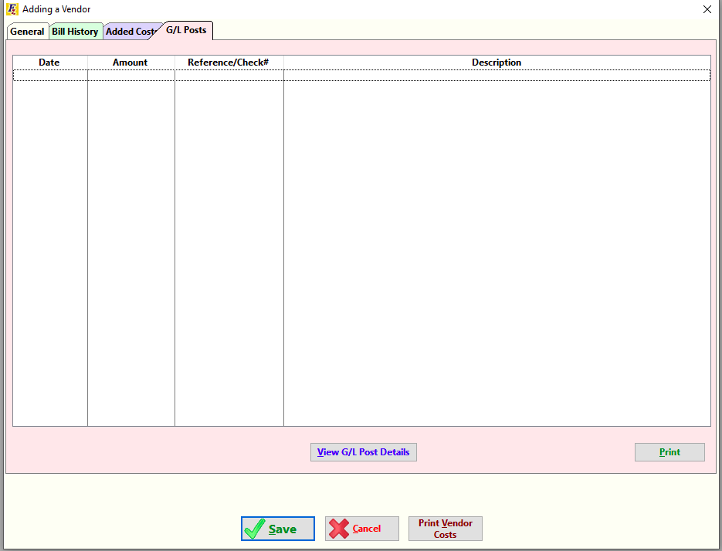

This is another important table.

This acts as GL(General Legder -

A **general ledger** is a bookkeeping [ledger](https://en.wikipedia.org/wiki/Ledger) that serves as a central repository for accounting data transferred from all subledgers like **accounts payable, accounts receivable, cash management, fixed assets, purchasing and projects**. Each account maintained by an organization is known as a ledger account, and the collection of all these accounts is known as the general ledger. The general ledger is the backbone of any accounting system which holds financial and non-financial data for an organization.)

In this table,

The addingVendor_GLPostsOne database has 2 G/L Accounts,**Purchase Vehicles** and **Vehicle Added Costs**.

All the records in this database can have **referenceOrCheckNumber** field as **Purchase Vehicles** or **Vehicle Added Costs**.

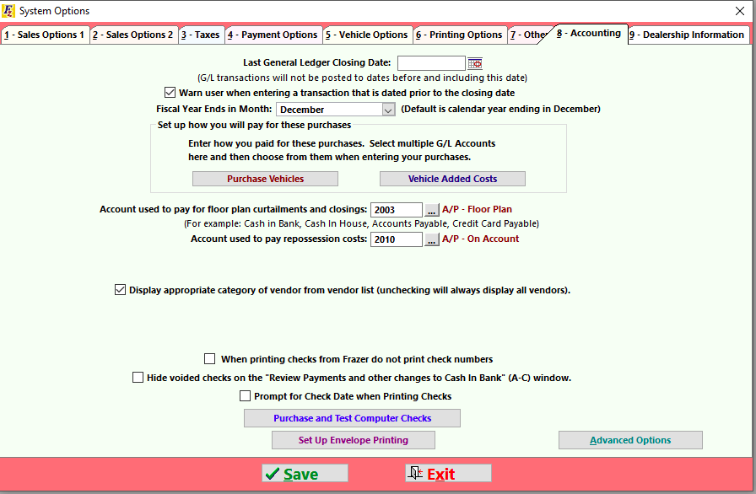

mysql> **CREATE TABLE `addingVendor_GLPostsOne` (**

**-> `id` int(11) PRIMARY KEY NOT NULL AUTO_INCREMENT,**

**-> `date` varchar(30),**

**-> `amount` int(11) NOT NULL,**

**-> `referenceOrCheckNumber` varchar(30),**

**-> `description` varchar(400)**

**-> )ENGINE=InnoDB DEFAULT CHARSET=utf8;**

Query OK, 0 rows affected (0.28 sec)

INSERT INTO addingVendor_GLPostsOne(date,amount,referenceOrCheckNumber,description) VALUES ('26_12_19',500,'Vehicle Added Costs','This is posted in Vehicle Added Costs column of the Ledger.');

mysql> **INSERT INTO addingVendor_GLPostsOne(date,amount,referenceOrCheckNumber,description) VALUES ('26_12_19',500,'Vehicle Added Costs','This is posted in Vehicle Added Costs column of the Ledger.');**

Query OK, 1 row affected (0.05 sec)

INSERT INTO addingVendor_GLPostsOne(date,amount,referenceOrCheckNumber,description) VALUES ('24_12_19',16000,'Purchase','This is posted under Purchase column of G/L.');

mysql> **INSERT INTO addingVendor_GLPostsOne(date,amount,referenceOrCheckNumber,description) VALUES ('24_12_19',16000,'Purchase','This is posted under Purchase column of G/L.');**

Query OK, 1 row affected (0.04 sec)

SELECT * FROM addingVendor_GLPostsOne;

mysql> **SELECT * FROM addingVendor_GLPostsOne;**

+----+----------+--------+------------------------+-------------------------------------------------------------+

| id | date | amount | referenceOrCheckNumber | description |

+----+----------+--------+------------------------+-------------------------------------------------------------+

| 1 | 26_12_19 | 500 | **Vehicle Added Costs** | This is posted in Vehicle Added Costs column of the Ledger. |

| 2 | 24_12_19 | 16000 | **Purchase**  | This is posted under Purchase column of G/L. |

+----+----------+--------+------------------------+-------------------------------------------------------------+

2 rows in set (0.00 sec)

SHOW COLUMNS FROM addingVendor_GLPostsOne;

mysql> **SHOW COLUMNS FROM addingVendor_GLPostsOne;**

+------------------------+--------------+------+-----+---------+----------------+

| Field | Type | Null | Key | Default | Extra |

+------------------------+--------------+------+-----+---------+----------------+

| id | int(11) | NO | PRI | NULL | auto_increment |

| date | varchar(30) | YES | | NULL | |

| amount | int(11) | NO | | NULL | |

| **referenceOrCheckNumber** | varchar(30) | YES | | NULL | |

| description | varchar(400) | YES | | NULL | |

+------------------------+--------------+------+-----+---------+----------------+

5 rows in set (0.00 sec)

All the records in this database can have **referenceOrCheckNumber** field as **Purchase Vehicles** or **Vehicle Added Costs**.

Note:

**How the values are added to this database ?**

**6.**Another table- **addingVendor_addedCosts**

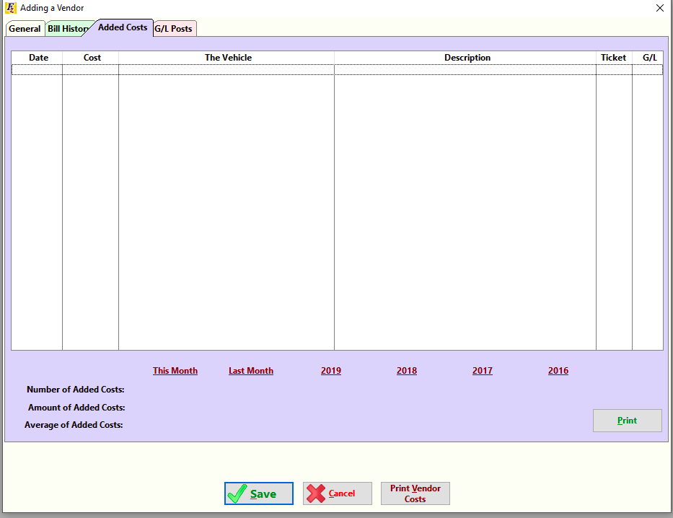

CREATE TABLE `addingVendor_addedCosts` (

`id` int(11) PRIMARY KEY NOT NULL AUTO_INCREMENT,

`date` varchar(30),

`cost` DECIMAL(10,2) DEFAULT '0.00',

`vehicleId` int(11) DEFAULT NULL,

`description` varchar(400),

`ticket` varchar(50),

`gl` int(11) DEFAULT NULL,

FOREIGN KEY (`vehicleId`) REFERENCES `addingVehicle_General` (`stockNumber`) ON DELETE SET NULL ON UPDATE CASCADE,

FOREIGN KEY (`gl`) REFERENCES `addingVendor_GLPostsOne` (`id`) ON DELETE SET NULL ON UPDATE CASCADE

)ENGINE=InnoDB DEFAULT CHARSET=utf8;

mysql> **CREATE TABLE `addingVendor_addedCosts` (**

**-> `id` int(11) PRIMARY KEY NOT NULL AUTO_INCREMENT,**

**-> `date` varchar(30),**

**-> `cost` DECIMAL(10,2) DEFAULT '0.00',**

**-> `vehicleId` int(11) DEFAULT NULL,**

**-> `description` varchar(400),**

**-> `ticket` varchar(50),**

**-> `gl` int(11) DEFAULT NULL,**

**-> FOREIGN KEY (`vehicleId`) REFERENCES `addingVehicle_General` (`stockNumber`) ON DELETE SET NULL ON UPDATE CASCADE,**

**-> FOREIGN KEY (`gl`) REFERENCES `addingVendor_GLPostsOne` (`id`) ON DELETE SET NULL ON UPDATE CASCADE**

**-> )ENGINE=InnoDB DEFAULT CHARSET=utf8;**

Query OK, 0 rows affected (0.42 sec)

INSERT INTO addingVendor_addedCosts(date,cost,vehicleId,description,ticket,gl) VALUES ('14_12_19',500,1002,'Added costs for vehicle stock number 1002','ticketno:123',1);

mysql> **INSERT INTO addingVendor_addedCosts(date,cost,vehicleId,description,ticket,gl) VALUES ('14_12_19',500,1002,'Added costs for vehicle stock number 1002','ticketno:123',1);**

Query OK, 1 row affected (0.03 sec)

SELECT * FROM addingVendor_addedCosts;

**mysql> SELECT * FROM addingVendor_addedCosts;**

+----+----------+--------+-----------+-------------------------------------------+--------------+------+

| id | date | cost | **vehicleId** | description | ticket | **gl** |

+----+----------+--------+-----------+-------------------------------------------+--------------+------+

| 1 | 14_12_19 | 500.00 | 1002 | Added costs for vehicle stock number 1002 | ticketno:123 | 1 |

+----+----------+--------+-----------+-------------------------------------------+--------------+------+

1 row in set (0.00 sec)

**Data flow:**

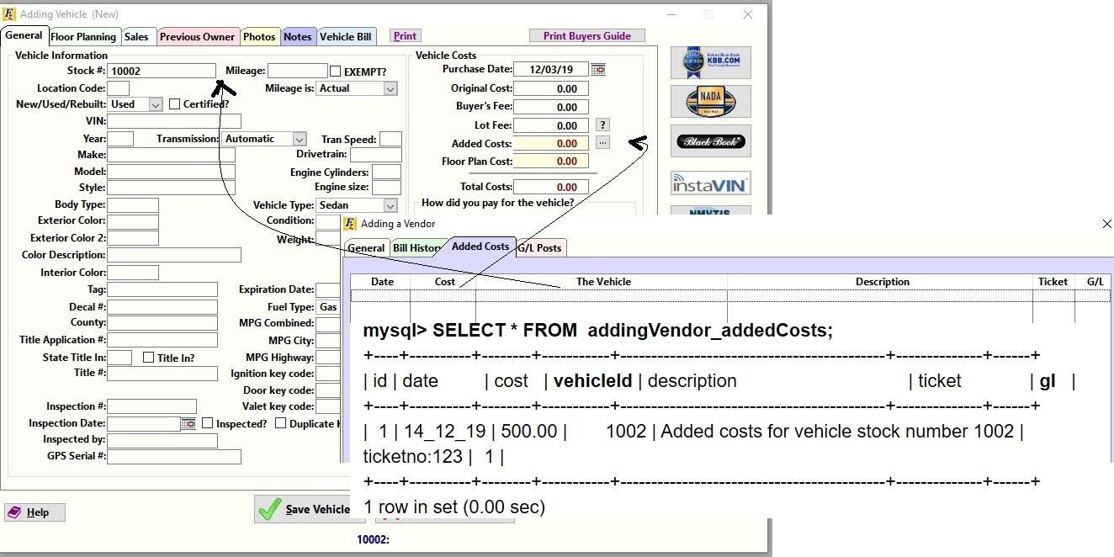

As we see,the **Stock#** is added to the **vehicleId** column and the **Added Costs** is added to the **amount** column**.**

SHOW COLUMNS FROM addingVendor_addedCosts;

mysql> **SHOW COLUMNS FROM addingVendor_addedCosts;**

+-------------+---------------+------+-----+---------+----------------+

| Field | Type | Null | Key | Default | Extra |

+-------------+---------------+------+-----+---------+----------------+

| id | int(11) | NO | PRI | NULL | auto_increment |

| date | varchar(30) | YES | | NULL | |

| cost | decimal(10,2) | YES | | 0.00 | |

| **vehicleId** | int(11) | YES | MUL | NULL | |

| description | varchar(400) | YES | | NULL | |

| ticket | varchar(50) | YES | | NULL | |

| **gl**  | int(11) | YES | MUL | NULL | |

+-------------+---------------+------+-----+---------+----------------+

7 rows in set (0.00 sec)

Here,you can see there are 2 **FOREIGN** keys.

vehicleId pointing to the vehicle database **addingVehicle_General** and gl pointing to the **addingVendor_GLPostsOne** database.

The addingVendor_GLPostsOne database has 2 G/L Accounts,Purchase Vehicles and Vehicle Added Costs.

All the records in this database can have referenceOrCheckNumber field as Purchase Vehicles and Vehicle Added Costs.

mysql> **SELECT * FROM addingVendor_GLPostsOne;**

+----+----------+--------+------------------------+-------------------------------------------------------------+

| id | date | amount | referenceOrCheckNumber | description |

+----+----------+--------+------------------------+-------------------------------------------------------------+

| 1 | 26_12_19 | 500 | **Vehicle Added Costs** | This is posted in Vehicle Added Costs column of the Ledger. |

| 2 | 24_12_19 | 16000 | **Purchase**  | This is posted under Purchase column of G/L. |

+----+----------+--------+------------------------+-------------------------------------------------------------+

2 rows in set (0.00 sec)

**Data flow**:

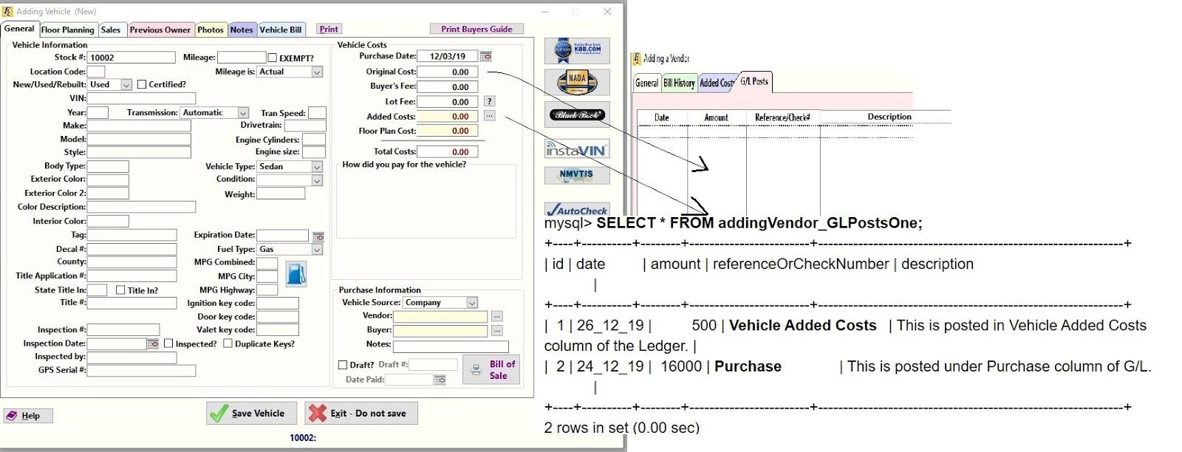

As seen above,the **originalCost** is added to **amount** column as **Purchase** and **added costs** is also added to **amount** column as **Vehicle Added Costs**.This way GL Account is filled.

Now lets **recap** !

Category 

addingVendor_General 

addingVendor_BillHistory 

addingVendor_AddedCosts 

addingVendor_GLPosts 

addingVehicle_General 

addingVehicle_FloorPlanning

addingVehicle_Sales

addingVehicle_PreviousOwner

addingVehivle_Photos

addingVehicle_Notes

addingVehicle_VehicleBill (same as addingVendor_BillHistory) 

We are left with **5** more tables.