Grafana Dashboard:

LINE CHARTS:

1.

As we can see, we are showing the records for 2 different blocks, i.e, DS_Id = 0 and DS_Id = 1.The timestamp is the same for both the blocks, 1598918400, 1598918402,

1598918403 ….. .The date for the above can be obtained from the link: <https://www.epochconverter.com/>

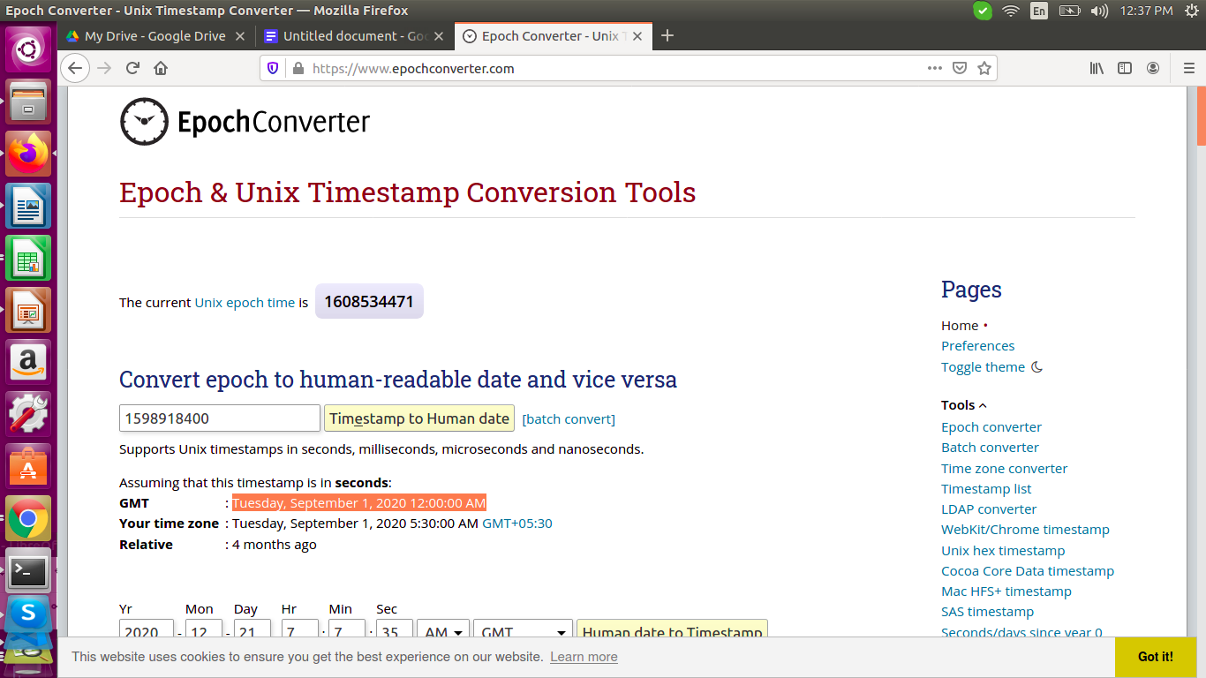

|  |  |  |  |  |
| --- | --- | --- | --- | --- |
| TIMESTAMP | DS_Id | POWER_A | POWER_B | POWER_C |
| 1598918400 | 0 | 1403.421 | 712.372 | 1680.471 |
| 1598918402 | 0 | 1423.817 | 731.249 | 1680.658 |
| 1598918403 | 0 | 1444.172 | 749.339 | 1700.859 |
| 1598918404 | 0 | 1774.402 | 1106.427 | 2041.954 |
| 1598918405 | 0 | 1774.402 | 1106.427 | 2041.954 |
| 1598918406 | 0 | 2907.728 | 2262.41 | 3294.891 |
| 1598918407 | 0 | 4473.881 | 3846.113 | 5008.417 |
| 1598918408 | 0 | 3408.858 | 2772.619 | 3856.164 |
| 1598918409 | 0 | 3408.858 | 2772.619 | 3856.164 |
| 1598918410 | 0 | 3418.469 | 2777.669 | 3860.896 |

|  |  |  |  |  |
| --- | --- | --- | --- | --- |
| 1598918400 | 1 | 821.847 | 574.748 | 1203.807 |
| 1598918402 | 1 | 823.367 | 574.315 | 1203.795 |
| 1598918403 | 1 | 819.939 | 574.261 | 1203.647 |
| 1598918404 | 1 | 819.939 | 574.261 | 1203.647 |
| 1598918405 | 1 | 821.288 | 574.918 | 1205.744 |
| 1598918406 | 1 | 819.307 | 575.267 | 1203.968 |
| 1598918407 | 1 | 818.012 | 575.168 | 1205.09 |
| 1598918408 | 1 | 817.876 | 574.067 | 1203.813 |
| 1598918409 | 1 | 820.74 | 575.795 | 1204.758 |
| 1598918410 | 1 | 819.226 | 573.985 | 1203.027 |

Our requirement is to get the aggregated power for POWER_A, POWER_B, POWER_C fields.

For example, for the timestamp 1598918400,

|  |  |  |  |  |
| --- | --- | --- | --- | --- |
| 1598918400 | 0 | 1403.421 | 712.372 | 1680.471 |

|  |  |  |  |  |
| --- | --- | --- | --- | --- |
| 1598918400 | 1 | 821.847 | 574.748 | 1203.807 |

we have values for POWER_A as 1403.421 and 821.847 as 2225.268. Likewise, we have to calculate for all the time-series values(1598918402, 1598918403, 1598918404, …) for POWER_A, POWER_B and POWER_C also.

This computation has to be done by Grafana. We are implementing this using the SQL syntax like queries as shown below:

We are going to compute the aggregated power for the field POWER_A now.

We have our first query below:

**SELECT POWER_A as AA FROM "hdb2" WHERE "DS_ID" = '0'**

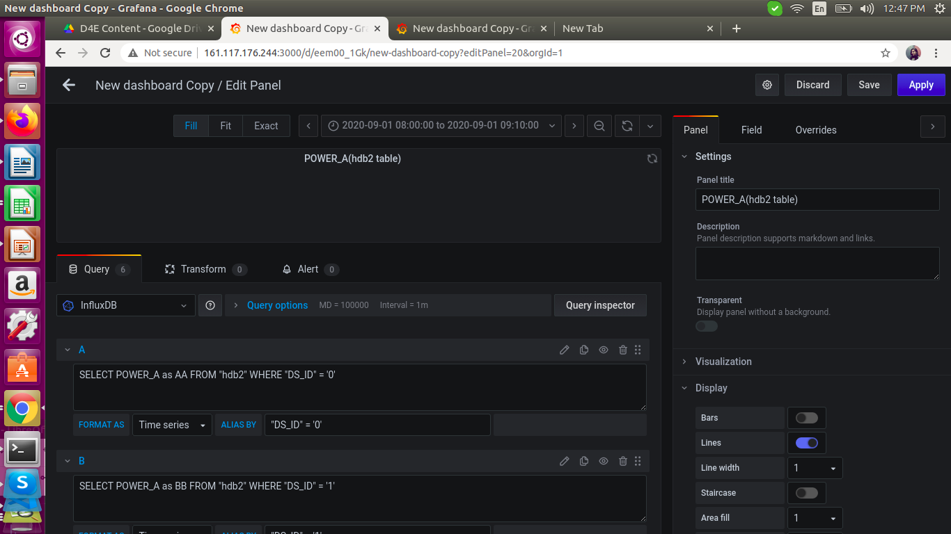

The same thing is followed for other 4 blocks also(DS_ID =’1’, DS_ID=’2’, DS_ID=’3’, DS_ID=’4’)

**SELECT POWER_A as BB FROM "hdb2" WHERE "DS_ID" = '1'**

**SELECT POWER_A as CC FROM "hdb2" WHERE "DS_ID" = '2'**

**SELECT POWER_A as DD FROM "hdb2" WHERE "DS_ID" = '3'**

**SELECT POWER_A as EE FROM "hdb2" WHERE "DS_ID" = '4'**

Now, we compute the aggregated power for POWER_A with the below query:

**SELECT sum(ds1) + sum(ds0) + sum(ds2) + sum(ds3) + sum(ds4) AS Total**

**FROM**

**(**

**SELECT POWER_A as ds0 FROM "hdb2" WHERE "DS_ID" = '0'**

**),**

**(**

**SELECT POWER_A as ds1 FROM "hdb2" WHERE "DS_ID" = '1'**

**),**

**(**

**SELECT POWER_A as ds2 FROM "hdb2" WHERE "DS_ID" = '2'**

**),**

**(**

**SELECT POWER_A as ds3 FROM "hdb2" WHERE "DS_ID" = '3'**

**),**

**(**

**SELECT POWER_A as ds4 FROM "hdb2" WHERE "DS_ID" = '4'**

**) WHERE $timeFilter GROUP BY time(1s) fill(null)**

Here**,** hdb2 is the table name in our INFLUXDB1.8 database from where we are fetching our data into the Grafana dashboard running at port 3000.

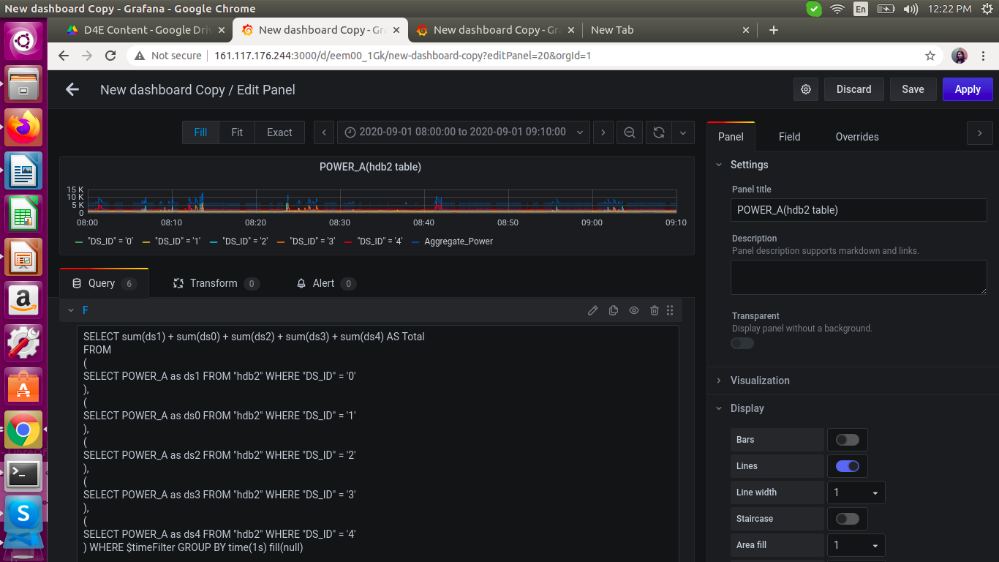

We get the graph as shown below:

TIMESTAMP: 2020-09-01 08:27:16

Aggregate_Power: 7.92k

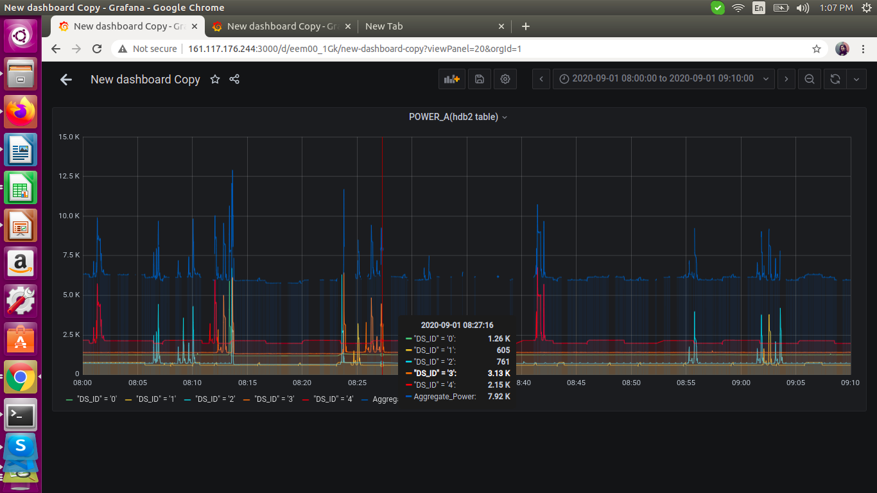

TIMESTAMP: 2020-09-01 08:17:08

Aggregate_Power: 5.77k

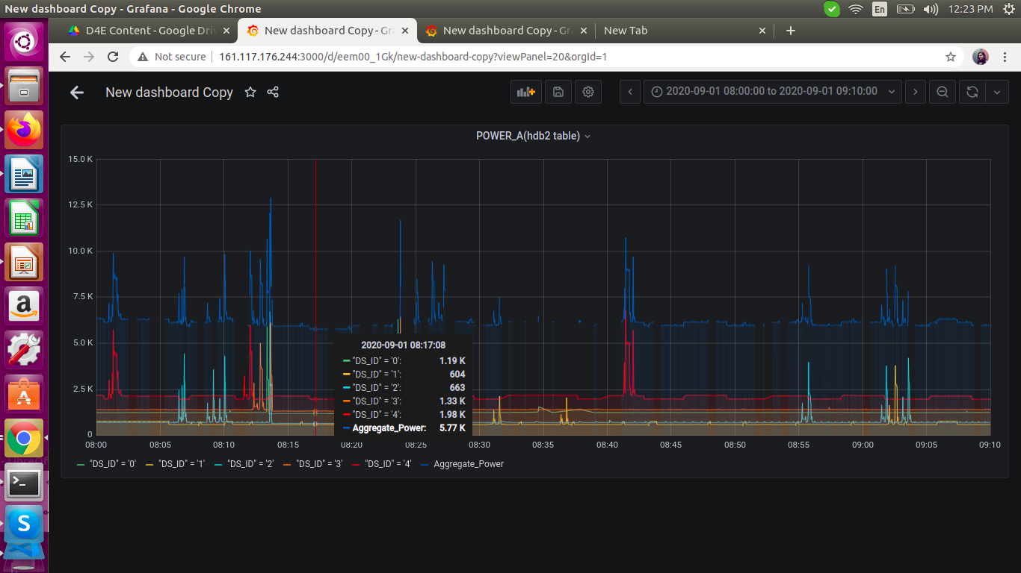

We are getting the correct aggregated values for POWER_A. We need to do the same for POWER_B and POWER_C.

For POWER_B:

SELECT sum(ds1) + sum(ds0) + sum(ds2) + sum(ds3) + sum(ds4) AS PB

FROM

(

SELECT POWER_B as ds1 FROM "hdb2" WHERE "DS_ID" = '1'

),

(

SELECT POWER_B as ds0 FROM "hdb2" WHERE "DS_ID" = '0'

),

(

SELECT POWER_B as ds2 FROM "hdb2" WHERE "DS_ID" = '2'

),

(

SELECT POWER_B as ds3 FROM "hdb2" WHERE "DS_ID" = '3'

),

(

SELECT POWER_B as ds4 FROM "hdb2" WHERE "DS_ID" = '4'

) WHERE $timeFilter GROUP BY time(1s) fill(null)

For POWER_C:

SELECT sum(ds1) + sum(ds0) + sum(ds2) + sum(ds3) + sum(ds4) AS PC

FROM

(

SELECT POWER_C as ds1 FROM "hdb2" WHERE "DS_ID" = '1'

),

(

SELECT POWER_C as ds0 FROM "hdb2" WHERE "DS_ID" = '0'

),

(

SELECT POWER_C as ds2 FROM "hdb2" WHERE "DS_ID" = '2'

),

(

SELECT POWER_C as ds3 FROM "hdb2" WHERE "DS_ID" = '3'

),

(

SELECT POWER_C as ds4 FROM "hdb2" WHERE "DS_ID" = '4'

) WHERE $timeFilter GROUP BY time(1s) fill(null)

We will get the graph as shown below:

TIMESTAMP: 2020-09-01 08:27:12

Aggregate_Power: 7.89k

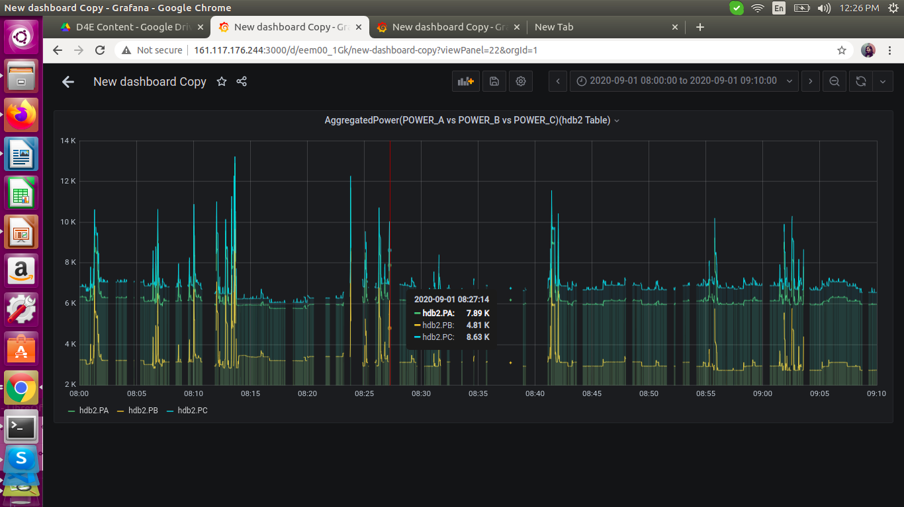

TIMESTAMP: 2020-09-01 08:17:08

Aggregate_Power: 5.77k

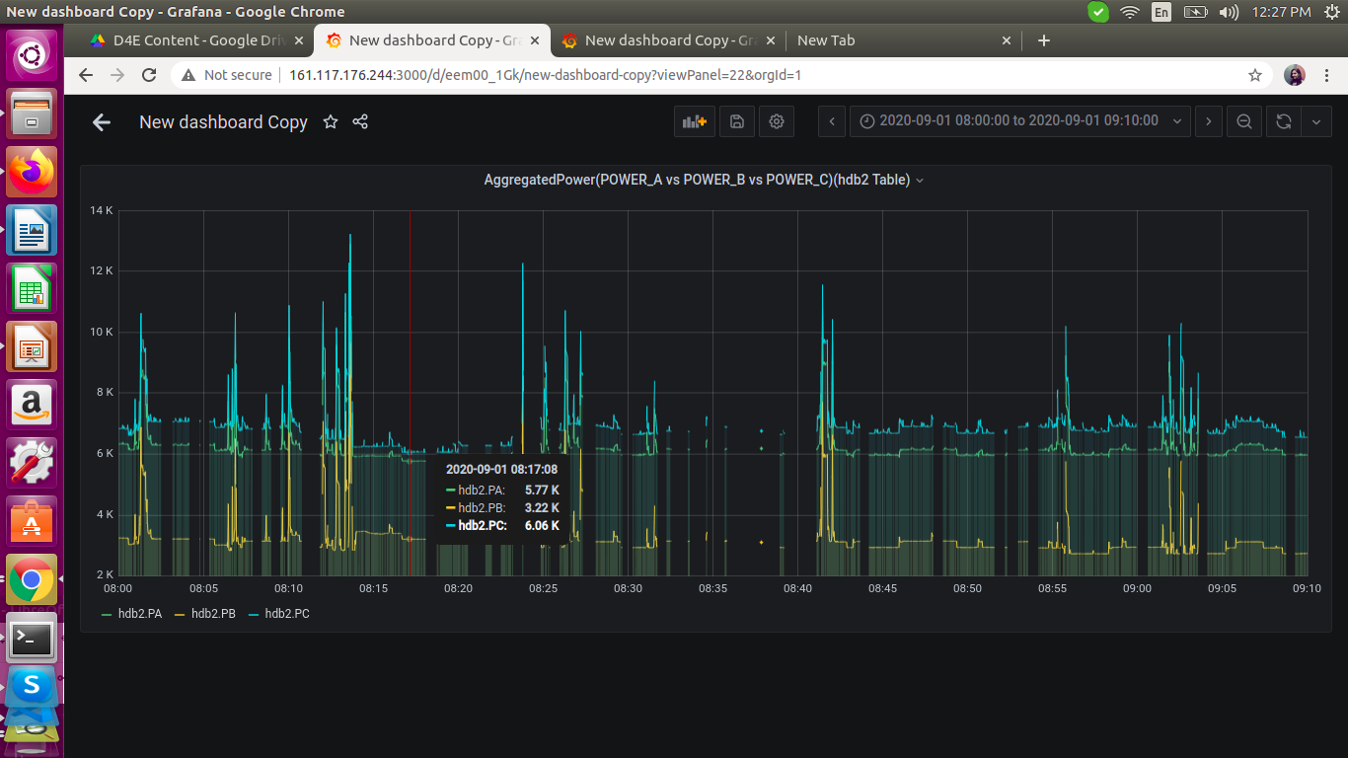

As we can see, these aggregated values for POWER_A confirm with the values shown in the previous graphs with the same timestamp.