**TASKS**

**OBJECTIVE QUESTIONS**

1. **What is the total no. of tables present in the data?**

* Our dataset comprises two main tables: the "Raw Data" table, which contains detailed information about each restaurant, and the "Country Description" table, which provides a brief overview of the countries listed in our dataset.

1. **What is the total no. of attributes present in the data?**

* In total, there are 20 attributes or columns in the "Raw Data" table and 2 in the "Country Description" table. These attributes provide a range of information, from restaurant names and locations to pricing and customer feedback.
* **Approach** - I have used excel formula =COUNTA and selected the range of header cells of the table to get the number

1. **How many categorical columns are there in the data? [Search about categorical and continuous data, and try to answer this question]**

* There are 16 categorical columns in the table which is in the raw data.
* Restaurant Name, Country, City, Address, Locality, Locality Verbose, Cuisines, Currency, Has Table booking, Has Online delivery, Is delivering now, Switch to order menu, Currency Symbol, Average Cost for two(Currency), Average Cost for two(INR) ,Average Cost for two(USD).
* There are 2 categorical columns in the table which is in the Country Description.
* Country name, Currency
* **Approach –** I counted categorical columns manually.

1. **The data consists of some inconsistent and missing values so ensure that the data used for further analysis is cleaned.**

* It is vital to ensure that our data is clean before conducting any analysis. I checked for duplicate entries in the "Raw Data" using the “Remove Duplicates” feature in Google Sheet and found none, ensuring all data points are unique. However, there were 9 missing values in the dataset. There are some fields in “average cost of two” column are 0.
* 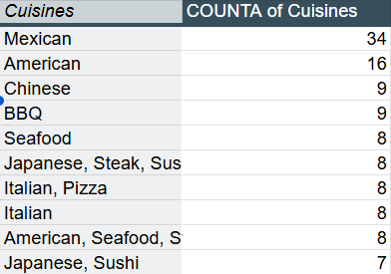**Approach** - I created a pivot table where rows are cuisines, values are count of cuisines and filters consists of filter where country is USA ,because all the missing values are from USA country.
* I filled in missing entries with "Mexican" in the "Cuisine" column because Mexican is most used cuisine in restaurant in USA country .For fields with 0 value I replace those fields with 1199 which is mean of that column. Then I sort the data by Restaurant ID with Smallest to largest. I apply filter to all the data for further processing.

1. **Using the Look Up functions, fill up the countries in the original data using the country code.**

* Created new column “country” to fill the countries from “country description” sheet.
* **Approach -** I used the Vlookup function to extract the country

**=VLOOKUP($C2,'country description'!$A:$B,2,0)**

1. **Create a table to represent the number of restaurants opened in each country.**

* 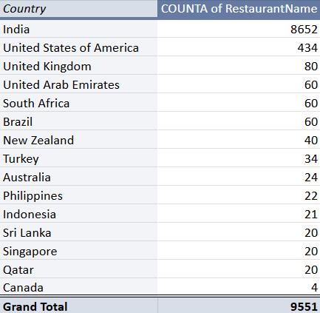**Approach -** We have created a new sheet named objective and then added a pivot table to it. We have given the whole raw data as its range and added the Country column as its rows and selected Count of Restaurants ID as its values

1. **Also, the management wants to look at the number of restaurants opened each year, so provide them with something here.**

* In the raw data sheet, date is not present in proper format so I have to first convert that date in proper format.
* **Approach –** For this first to separate year from “Datekey_Opening” column, I used a TEXT function i.e. **=Left($Y2,4)** , it will separate year from that column. Then I created pivot table in which year drag in row label and restaurant Id in value field.

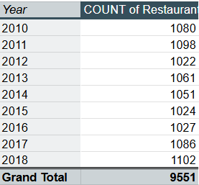

1. **What is the total number of restaurants in India in the price range of 4?**

* There are total **388** restaurant in India in the price range of 4.
* Approach – I have used pivot table, country in rows,count of restaurant id in values and filtering the country as “India” and the price range equal to 4.

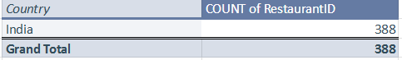

1. **What is the average number of voters for the restaurants in each country according to the data?**

* **Approach** -For this I have used the pivot table in that I include Countries in rows and votes in values and I select average to calculate the average of voters in value field.

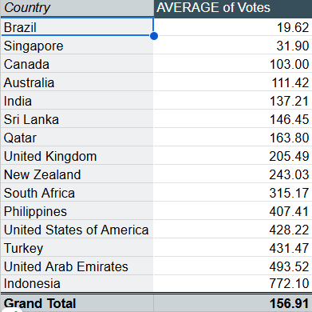

1. **Calculate the average rating for all the restaurants that have price range < 4 and provide online delivery. Use only the “IF” function, Logical Operators, and Aggregation functions to solve this problem. [Note: Don’t use Conditional aggregation in this question.]**

* I got an average rating as 3.274
* **Approach –** I used the formula as:

**=AVERAGEIFS('RawData'!$X:$X,'RawData'!$Q:$Q,"<4",'Raw Data'!N:N,"Yes")**

1. **Using Conditional formatting highlight the rows of restaurants that are located in the countries or cities that you’ve suggested to the management for opening new restaurants.**

* **Approach –**

**Most suitable countries for opening new restaurants** based on criteria where total number of restaurants are less than 100, average ratings are higher than or equal to 4, with less than $70 average expenditure for two person to have a meal and number of voters higher than 150, are :

**Turkey, Indonesia, South Africa, UAE, Qatar**

* Select the "Restaurant Name" column.
* Go to Format -> Conditional Formatting -> New Rule.
* Choose Use a formula to determine which cells to format.
* Enter the formula: =$D1="Turkey ", then click Apply and OK.
* And again repeat the same for Turkey, Indonesia, South Africa, UAE, Qatar

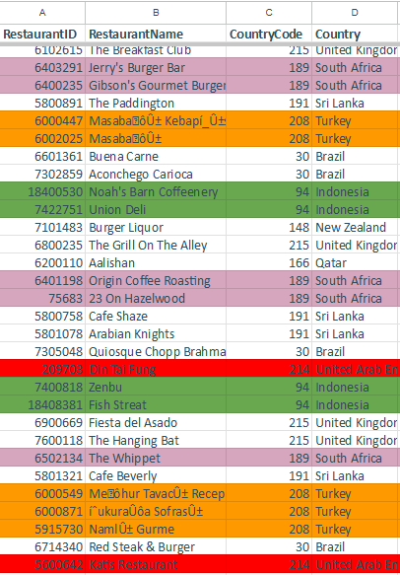

1. **Create a new customized price column that consists of the abbreviation/symbol of the currency along with the Average cost for two value. [Use string operations to do this task]**

* **Approach –** I used left, right length and search functions to extract the currency symbol .
* The formula is –

**=left(right(L2,(len(L2)-search("(",L2))),search(")",right(L2,len(L2)-search("(",L2)-1)))**

* Then I used concatenate function to merge currency symbol and Average cost for two column . The formula is

**=CONCATENATE(S2," ",T2)**

1. **How can you create an array formula in Excel or Google Sheets to count the number of restaurants listed that do not offer online delivery, are in the lowest price range, and have an average cost for two people less than or equal to 250 Indian Rupees?**

* **Approach :** To count the number of restaurants that do not offer online delivery, are in the lowest price range, and have an average cost for two people less than or equal to 250 Indian Rupees,
* Use the following array formula: =SUMPRODUCT(('Raw Data'!N:N="No") * ('Raw Data'!T:T=1) * ('Raw Data'!S:S<=250))
* This formula multiplies the conditions to filter the data accordingly and then sums the results to get the total count.
* The Final count was 1694.

**SUBJECTIVE QUESTIONS**

1. **Suggest a few countries where the team can open newer restaurants with lesser competition. Which visualization/technique will you use here to justify the suggestions?**

* **Approach** - **Most suitable countries for opening new restaurants** based on criteria where total number of restaurants are less than 100, average ratings are higher than or equal to 4, with less than $70 average expenditure for two person to have a meal and number of voters higher than 150, are :
* Turkey, Qatar, South Africa, Indonesia, UAE So management can open new restaurant in those countries.

**Explanation-**

* The data shows that most locations have significantly more than 100 restaurants, a threshold of 100 could be chosen to represent areas with relatively low competition.
* The $70 is considered mid-dining, suitable for casual fine dining or premium casual restaurants. Many budget friendly options exist below this range, making $70 a reasonable threshold for distinguishing affordable vs premium dining.
* I used Chart visualization technique to justify the suggestions.

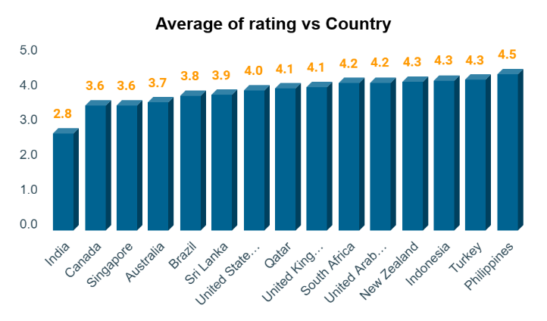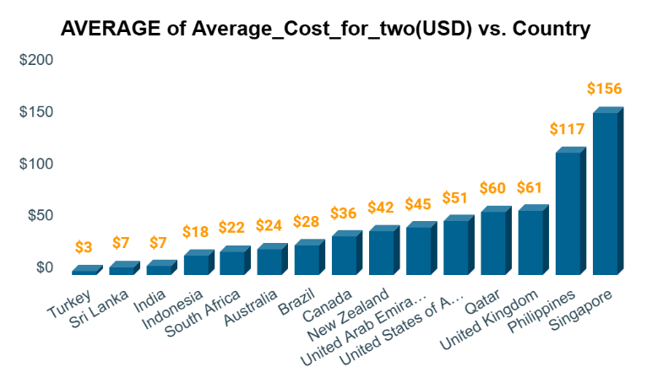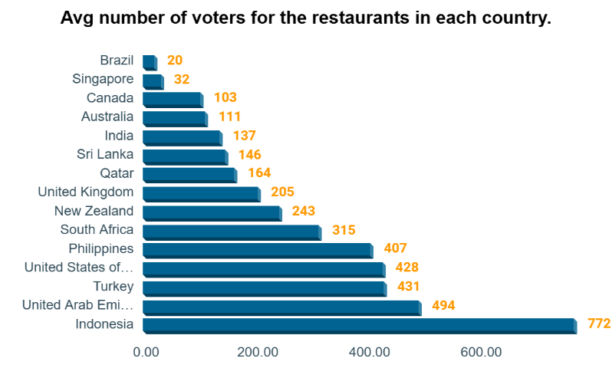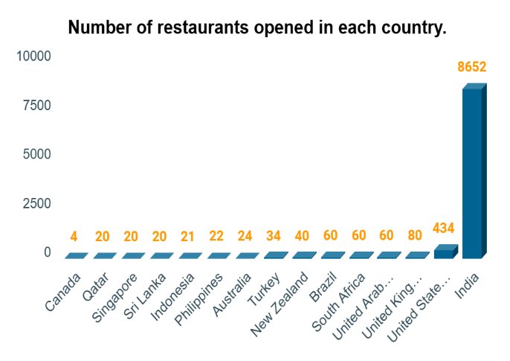 **Insights -** These countries are characterized by moderate competition and positive customer satisfaction landscape. They provide Zomato with the potential to enter and quickly establish a presence, leveraging local preferences and trends. By focusing on these countries, Zomato can balance risk and reward.

1. **Come up with the names of States and cities in the suggested countries suitable for opening restaurants.**

* **Approach -** For this I create the pivot table in which I Include Country and cities in rows and restaurant Id and rating in values field. On the basis of no of restaurant id and average of rating I have come with some state where management can open new restaurant which are –
* Indonesia **-** Badung, Tangerang, Jakarta
* Qatar – Doha
* South Africa – Inner city, Johannesburg, Randburg
* Turkey – Ankara, Uastanbul
* United Arab Emirates – Abu Dhabi, Sharjah, Dubai
* **Insights:** The chosen locations generally have fewer restaurants, suggesting less market saturation. This presents a significant opportunity for Zomato to enter these markets with less competition, high average ratings indicate satisfied customers who are likely to appreciate new dining options.

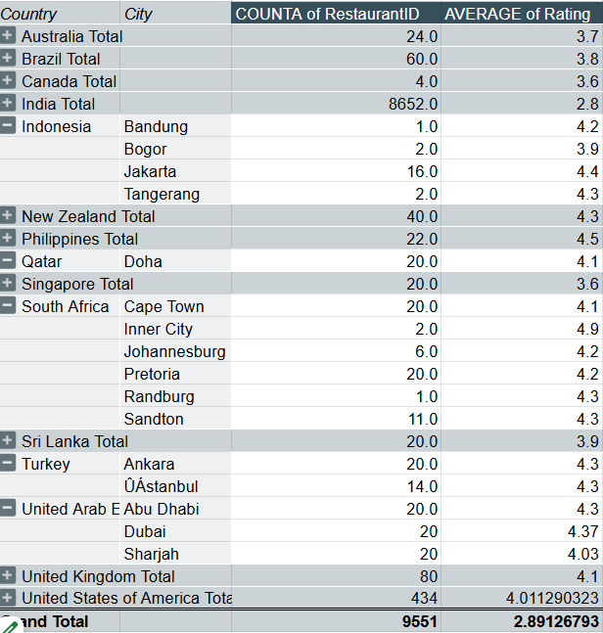

1. **According to the countries you suggested, what is the current quality regarding ratings for restaurants that are open there?**

* **Approach** - For this I have inserted the pivot table in which added average of rating in value fields and countries in rows label.
* Countries that I suggested for opening new restaurant have the average rating of -
* Indonesia – 4.3
* South Africa – 4.2
* Qatar – 4.1
* Turkey – 4.3
* UAE – 4.2

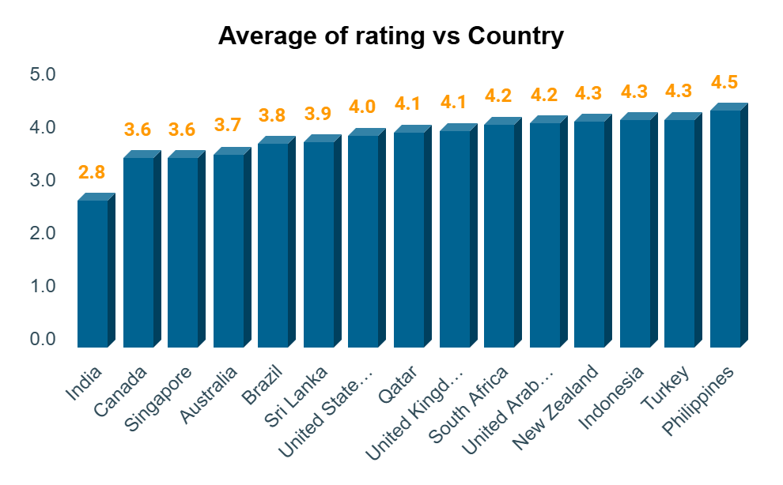

* **Insights -** The high average ratings indicate that customers in these markets are generally very satisfied with their dining experiences. Zomato, this suggests an opportunity to introduce high-quality or niche restaurants that meet the current standards.

1. Also, what is the current expenditure on food in the suggested countries, so we can keep our financial expenditure in control?

* **Approach -** I have added new column to the raw data which cost in dollar currency, in which I have converted all different countries currency into dollar currency. The calculation of expenditures in dollars helps in standardizing costs across different countries, making it easier to compare. However, it’s important to monitor currency fluctuations, as they can impact profitability and cost management in international operations.
* I used pivot table in which inserted countries in row field and Average of cost for two in Dollar currency in value field.
  + Indonesia – $18
  + South Africa – $22
  + Qatar – $60
  + Turkey – $3
  + UAE – $45

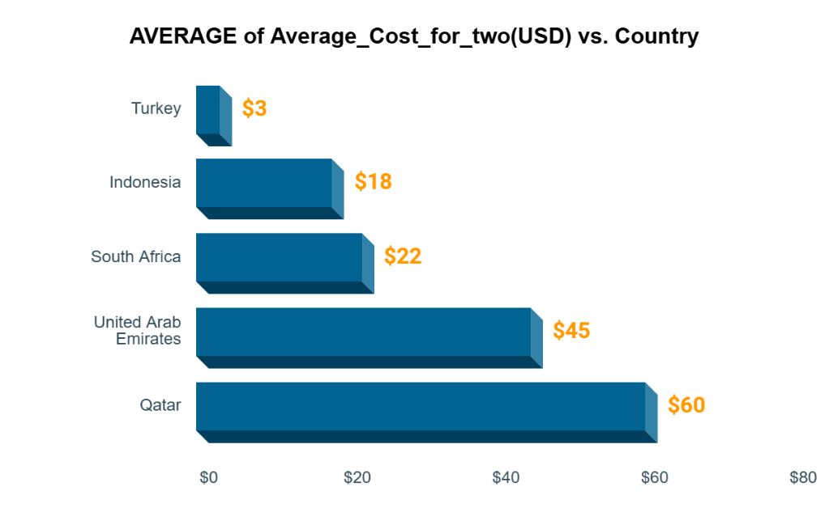

* **Insights -** **High Expenditure Markets (UAE and Qatar):** These markets may cater to a more affluent customer base or have a stronger demand for luxury dining. Restaurants in these locations may need to maintain high standards of quality and service to meet customer expectations.
* **Moderate to Low Expenditure Markets (Indonesia, South Africa, and Turkey):** These markets might be more suitable for mid-range or budget-friendly dining options, appealing to a broader customer base that seeks value for money.

1. **Come up with the names of restaurants from the recommended states that are our biggest competitors and also those that are rated in the lower brackets, i.e. 1-2 or 2-3.**

* **Approach:** For this I have used pivot table and in which I insert countries and restaurant name in row label and average of rating & sum of votes in value field. I apply this criteria to find out the biggest competitor :
  + - 1. Restaurant rating>=4.5
      2. Number of Voters >150
* This are biggest competitor restaurant having rating greater than 4 and votes greater than 150 –

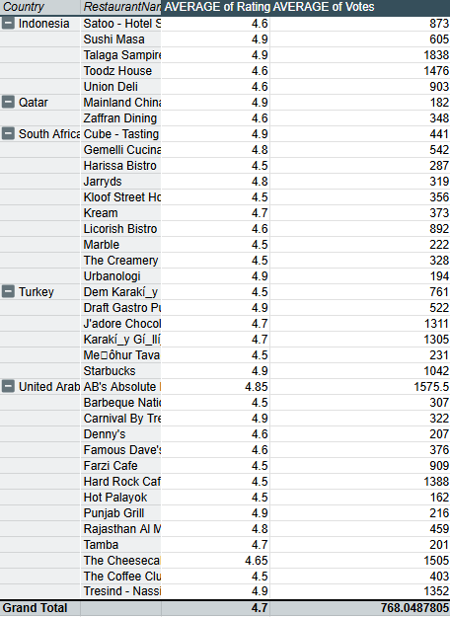

**Approach-** For this I have used pivot table in which data source is all raw data, in row field inserted Country and restaurant name, and in value field inserted rating and applied value filter to country column and select less than or equal to 3. And also selected country which I suggested for opening new restaurant such as Turkey, Qatar, Indonesia, South Africa, UAE.

**Insights:** For restaurant which have ratings in lower brackets.

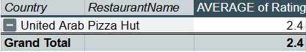

* The analysis shows that in the recommended countries only UAE country restaurant has less than 3 average rating. The restaurant name is Pizza Hut.
* This low rating indicate that restaurant in that region struggle to meet customer expectations, which could be due to a variety of factors such as menu options, service, or price-value perception.

1. **Which cuisines should we focus on in the newer restaurants to get better feedback? Does the choice of cuisines affect the restaurant ratings?**

* **Approach:** I have used Pivot table in which I added cuisines in row label and rating in value field. Taking only top 10 cuisines with high ratings.

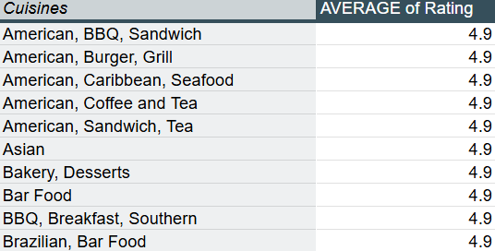

* 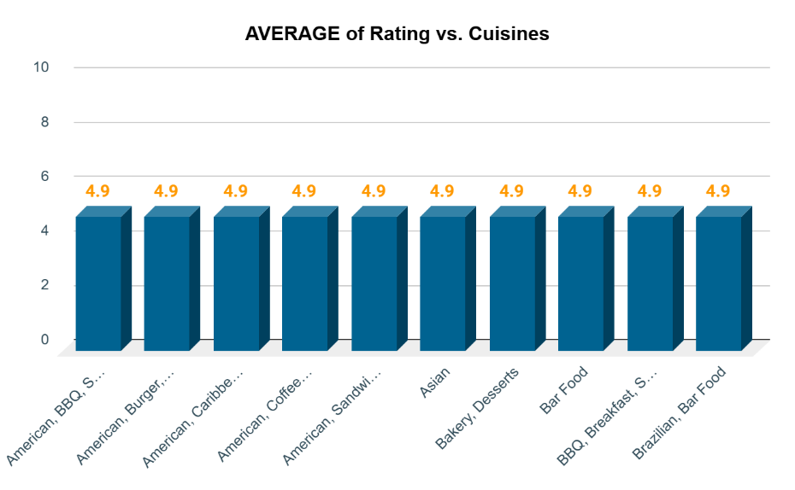**Insights -** The analysis shows a strong correlation between certain popular cuisines and higher restaurant ratings. Focusing on these top-rated cuisines in new restaurants is likely to enhance customer satisfaction and overall feedback.
* By prioritizing these popular and highly-rated cuisines, Zomato can increase the likelihood of positive customer experiences, leading to better ratings and stronger brand loyalty in new markets. Balancing local favorites with globally popular dishes will be key to maximizing customer satisfaction and success in these new ventures.

1. **According to our current data, should we go for online delivery and table booking? Does that affect the customer’s ratings?**

**Approach:**

* Created a pivot table with "Online Delivery" and "Table Booking" in the Rows section and their counts in the Values section.
* Added a slicer for country filtering and converted the data into a chart for visualization.

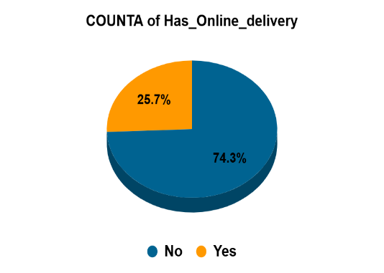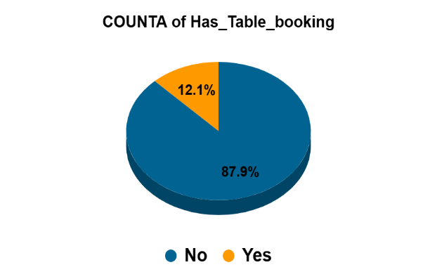

* Insights - The pivot table provided insights into how the presence of online delivery and table booking affects restaurant ratings. By analysing the data, it was observed that restaurants offering both services generally received higher ratings compared to those that did not. This trend was consistent across different countries, as visualized through the chart.
* The slicer allowed for filtering by country, helping to identify specific regions where these features had a notable impact on ratings. This visualization made it clear that implementing online delivery and table booking enhances customer convenience and satisfaction, which in turn improves ratings.

1. **Should the team keep the rate of cuisines higher? Will that affect the feedback? According to our data are the rates of cuisines and ratings, correlated?**

* **Approach-** Calculated the correlation coefficient between cuisine rates and ratings using the formula

=CORREL('Raw Data'!W2:W9552,'Raw Data'!S2:S9552).

* **Insights** **-** The correlation coefficient between cuisine rates and ratings is approximately 0.14, indicating a weak to moderate positive correlation. This suggests that while there is a slight relationship between higher cuisine rates and improved ratings, the impact is minimal.
* A higher rate for cuisines may lead to a slight increase in ratings, but the effect is not significant enough to rely on pricing adjustments alone for improving customer feedback.
* **Suggestion -** Given the weak correlation between cuisine rates and ratings, adjusting rates alone is unlikely to significantly impact customer feedback. Focus on improving quality and service to enhance overall customer satisfaction.

1. **What is the distribution of the number of restaurants of different price ranges in all the countries?**

**Approach:**

* Created a pivot table with Price Range in rows and Count of Restaurant ID in values.
* Added a slicer to filter data by country.

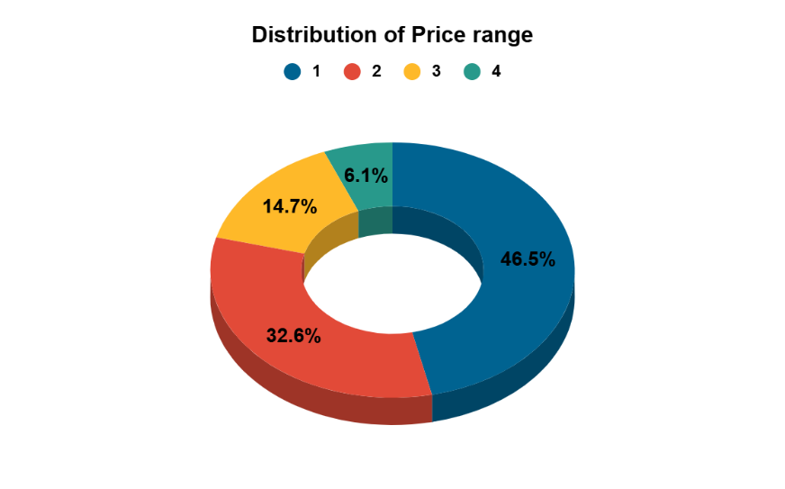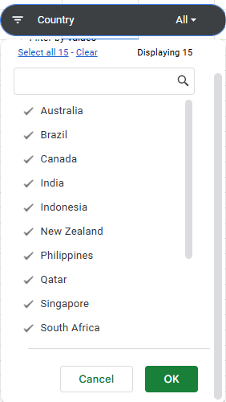

**Insights:**

* **India Dominates in Low-Price Range:** The vast majority of restaurants in the lowest price range (Price Range 1) are located in India, with 4,295 out of 4,444 restaurants. This suggests a strong market preference for budget-friendly dining options in India.
* **Mid-Range Popularity in Several Countries:** Countries like the United States, New Zealand, United Kingdom, and Turkey have a significant number of restaurants in mid-price ranges (Price Range 2 and 3), indicating a balanced demand for moderate-priced dining experiences.
* **High-End Dining Concentrated in Specific Countries:** High-price range restaurants (Price Range 4) are more concentrated in countries like Brazil, Qatar, Singapore, and the United Arab Emirates, reflecting a market that supports luxury dining experiences.

1. **Explain your approach in brief for suggesting countries/cities in order to open new restaurants.**

**1. Market Research:**

- Analyse Zomato ratings, reviews, and popularity of restaurants in target countries.

- Identify top-performing cuisines, dishes, and price ranges.

**2. Competitor Analysis:**

- Study successful restaurants' menus, pricing, and marketing strategies.

- Identify gaps in the market and opportunities for differentiation.

**3. Customer Segmentation:**

- Analyse Zomato user demographics, preferences, and behaviour.

- Identify target audience segments and tailor restaurant concepts accordingly.

**4. Location Analysis:**

- Evaluate city-wise demand, competition, & footfall using Zomato data.

- Identify prime locations for the new restaurant.

1. **Identify key questions:**
   * Determine what questions need to be answered to make informed decisions about new restaurant openings.
   * Document these questions to guide the analysis process.