2. Place the downloaded project in this directory and extract the maven project.

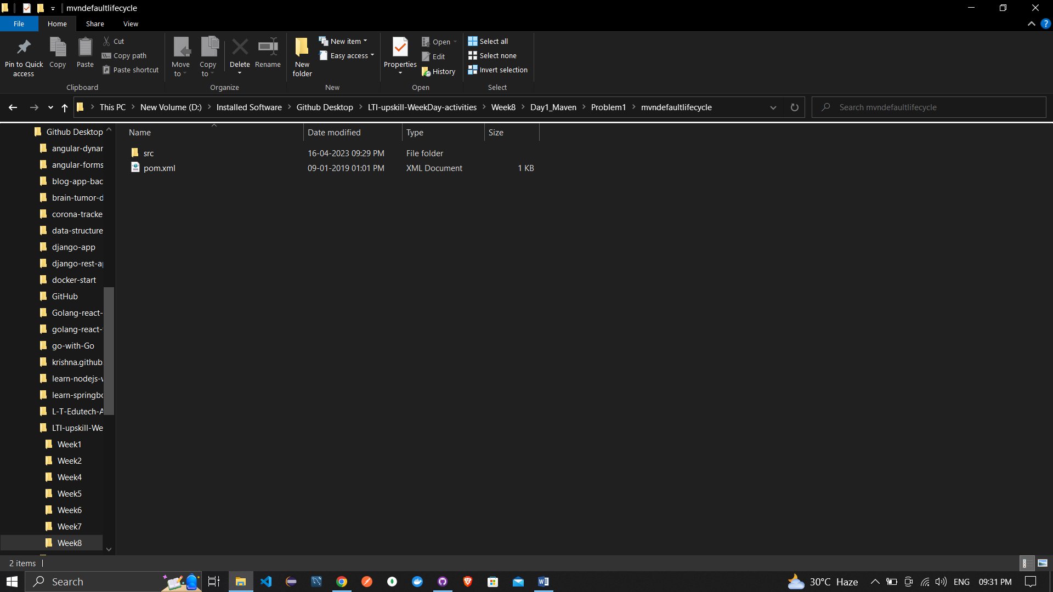

3. Open the command prompt and go to the Project Path in command prompt.

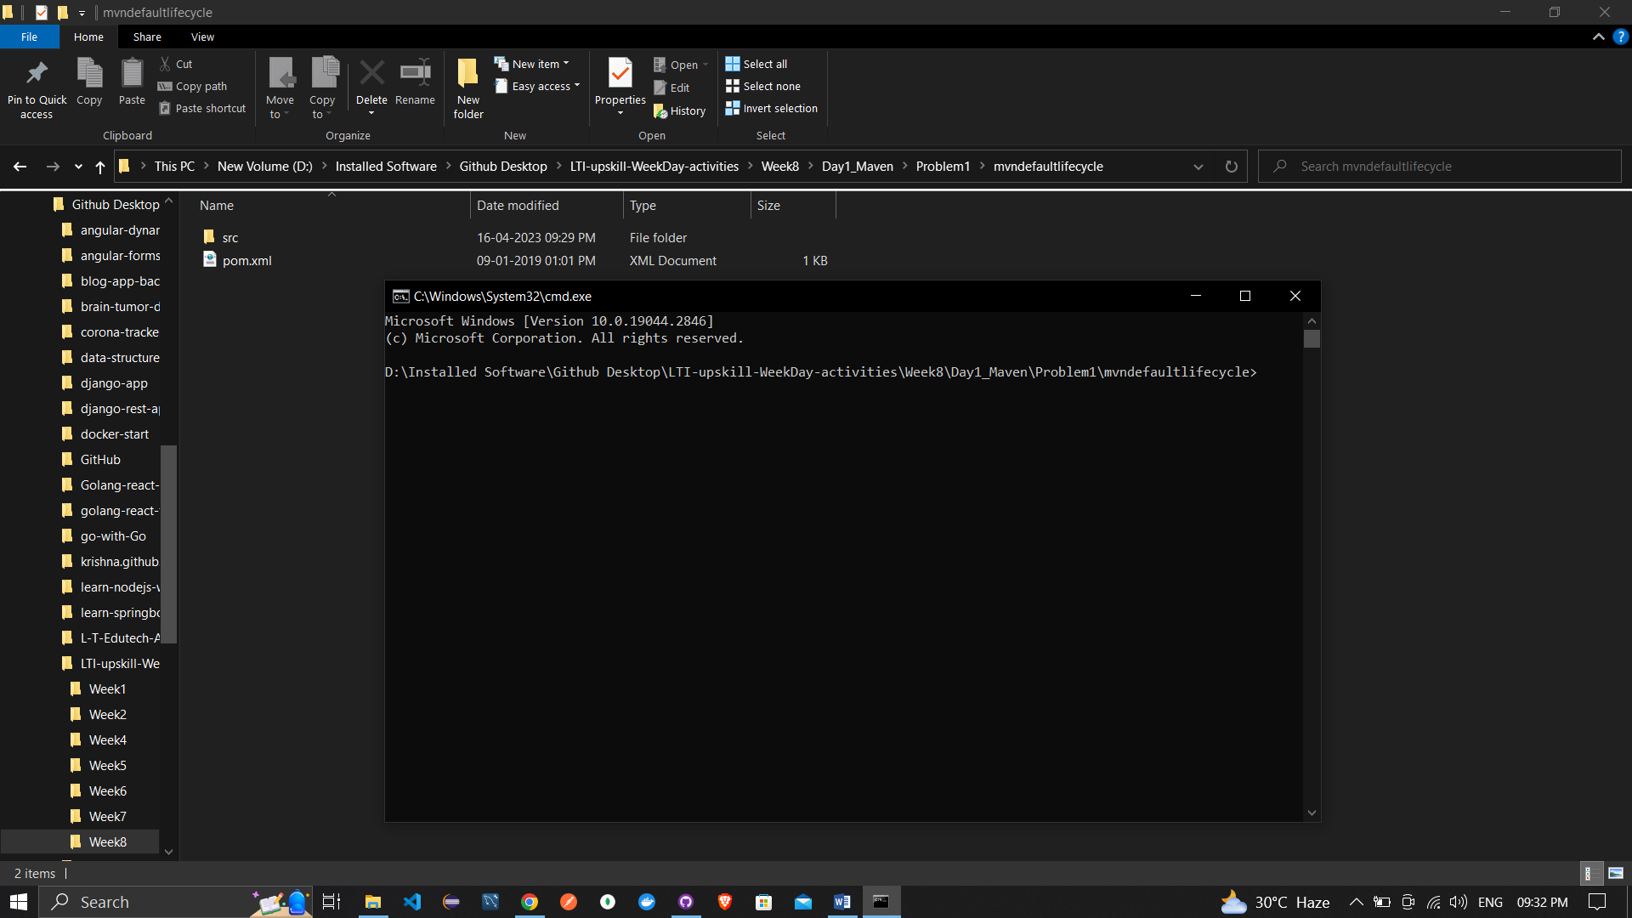

4. Give the command "mvn validate" in command prompt.