PERSONAL FINANCIAL
ADVISOR
Project Documentation
A web-based application for monthly income tracking,
expense management, budgeting and financial guidance

DOCUMENT DETAILS | DESCRIPTION
Project | Personal Financial Advisor
Application Type | Web-based personal finance management tool
Documentation Basis | User-provided interface screenshots and repository link
Prepared | October 2026

Repository: github.com/krishnalagas531-ux/personal-financial-advisor
Author – Krishna Lagas

1. Project Overview
Personal Financial Advisor is a browser-based finance management interface intended to help users understand their monthly financial position. The visible application includes a dashboard, expense-entry and filtering interface, an AI Financial Advisor page, and a Monthly Financial Summary. The screens are organized around a month selector and quick actions for setting income and adding expenses.

1.1 Project Objectives
- Provide a central dashboard for monthly income, expenses, savings and savings percentage.
- Allow users to record individual expenses with an amount, category, date and description.
- Present spending by category and indicate the overall financial health status.
- Offer budget-oriented guidance and rule-based financial insights.
- Summarize the selected month's financial performance in a compact report.
- Keep common actions accessible from the persistent sidebar and top action area.

1.2 Main Application Areas
Area | Purpose visible in the interface
Dashboard | Shows headline financial metrics, expense breakdown and financial-health status.
Expenses | Captures new expenses and provides search, category filtering and a transaction list.
Budget Advisor | Dedicated navigation entry for comparing spending against suggested budget limits.
AI Financial Advisor | Offers quick analysis prompts and a question field, with rule-based offline mode indicated.
Monthly Summary | Shows income, expenses, net savings, savings rate, highlights and recommendations.

1.3 Scope Note
This document describes the screens and workflows supported by the supplied screenshots. The repository page could not be fetched for source-code verification during document generation, so implementation-specific claims such as exact programming languages, database schema, API routes, and test counts are intentionally not asserted unless they are directly visible in the interface.

2. Project Scenarios and User Workflow

Scenario 1 — Review the Month
The user selects a month from the top control. The dashboard presents the current totals for that period, while the Monthly Summary provides a more detailed breakdown and highlights.

Scenario 2 — Record an Expense
The user opens Expense Tracking, enters the amount, chooses a category, selects the date, adds a short description and presses Add Expense. The lower portion of the page supports searching and filtering the recorded expense list.

Scenario 3 — Check Financial Health
The dashboard displays a Financial Health Status panel with a grade, score, transaction count, top expense category and savings target. When income is not configured, the interface explicitly asks the user to enter monthly income before personalized insights can be unlocked.

Scenario 4 — Ask the Advisor
The AI Financial Advisor page offers quick analysis prompts such as boosting monthly savings, auditing discretionary spending and checking emergency-fund readiness. The captured screen indicates a rule-based financial engine in offline mode.

Scenario 5 — Review Recommendations
The Monthly Summary presents total income, total expenses, net savings and savings rate, alongside spending highlights and advisor recommendations. These sections help the user decide which financial data to update or which spending areas to review.

Typical User Flow
Step | Action | Result
1 | Choose the month | All monthly views use the selected period.
2 | Set income | Income-dependent savings and guidance can be calculated.
3 | Add expenses | Transactions are available for totals and category analysis.
4 | Review Dashboard | Headline metrics and health indicators are visible.
5 | Open Advisor | Use quick prompts or ask a finance-related question.
6 | Open Monthly Summary | Review detailed highlights and suggested next steps.

3. Module 1 — Dashboard
The Dashboard is the application's overview screen. It combines four key financial metric cards with an expense-breakdown area and a Financial Health Status panel. The top bar includes the month selector, Set Income and Add Expense actions.
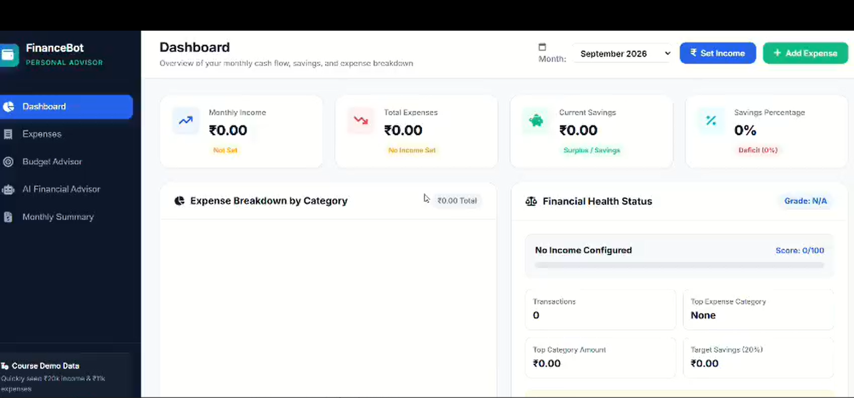
Figure 1. Dashboard interface for September 2026.

3.1 Dashboard Components
Component | Role
Monthly Income | Displays income recorded for the selected month.
Total Expenses | Displays the sum of recorded expense transactions.
Current Savings | Shows the current savings value derived from the available monthly data.
Savings Percentage | Shows savings as a percentage of income when the required data is available.
Expense Breakdown by Category | Provides a space for category-based spending visualization.
Financial Health Status | Displays grade/score, transaction count, leading expense category and target savings.

3.2 Captured State
In the supplied September 2026 screenshot, the headline amounts are ₹0.00 and the savings percentage is 0%. The health panel says “No Income Configured,” shows a score of 0/100, and lists zero transactions. This describes the captured screen state rather than a claim that the application always starts with these values.

4. Module 2 — Expense Tracking
The Expense Tracking screen is designed for entering individual transactions and reviewing existing records. It separates the expense form from the search/filter controls and the transaction table.
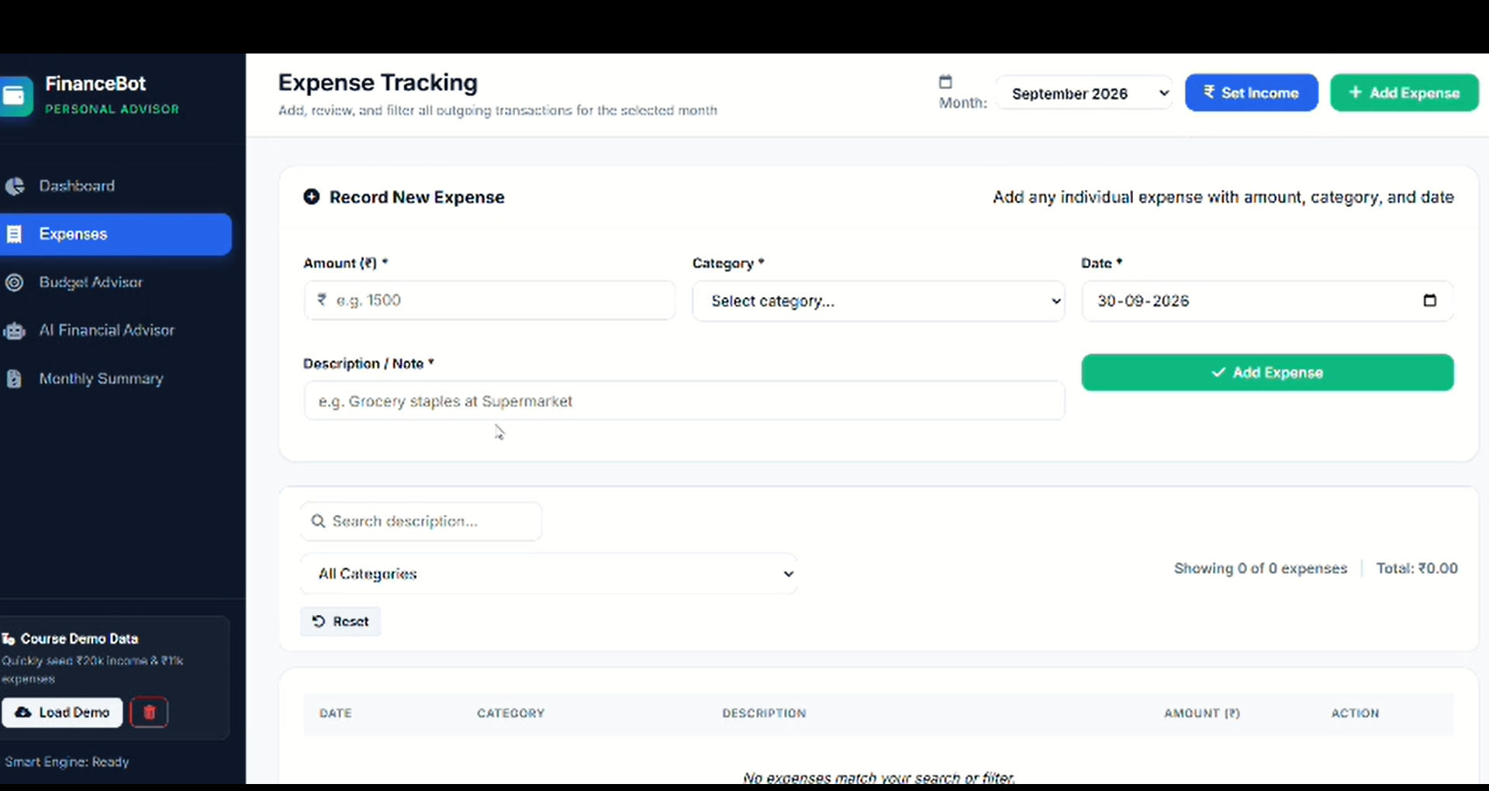
Figure 2. Expense Tracking form, filters and transaction table.

4.1 Expense Fields
Field | Description
Amount (₹) | The value of the expense. The form marks this field as required.
Category | A required category selected from the dropdown.
Date | The date on which the expense occurred.
Description / Note | A short explanation, such as a grocery purchase.

4.2 List Review and Filtering
- Search description lets the user locate expenses by text.
- The category dropdown narrows the list to a selected category.
- The Reset control clears the current search/filter state.
- The page shows the number of matching expenses and the total amount.
- The transaction table is structured around date, category, description, amount and action.
The screenshot shows zero listed expenses for September 2026. The placeholder in the amount field is an example, not a saved transaction.

5. Module 3 — Budget Advisor
Budget Advisor appears as a dedicated module in the left navigation. It is intended to help users compare their spending with category-level recommendations and understand where adjustments may be useful.

5.1 Intended Review Process
Stage | Description
Review category guidance | Inspect the recommended budget for each spending category.
Compare actual spending | Compare the recommended amount with expenses recorded for the selected month.
Identify variances | Look for categories where actual spending is higher or lower than the suggested amount.
Adjust future spending | Use the comparison as a planning aid for the next period.

5.2 Categories and Interpretation
The visible navigation and companion project screenshots establish budgeting as a core workflow. Exact percentages, formula definitions and category thresholds for this repository were not independently verified from source code; they should therefore be treated as implementation-specific details to confirm against the repository.
- Budget recommendations are planning guidance rather than guaranteed financial outcomes.
- The usefulness of comparisons depends on complete and correctly categorized income and expense records.

6. Module 4 — AI Financial Advisor
The advisor screen presents a dark, high-contrast panel titled Personal AI Financial Advisor. It includes quick-analysis prompts, a natural-language question field and a status badge identifying the current engine as rule-based and offline.
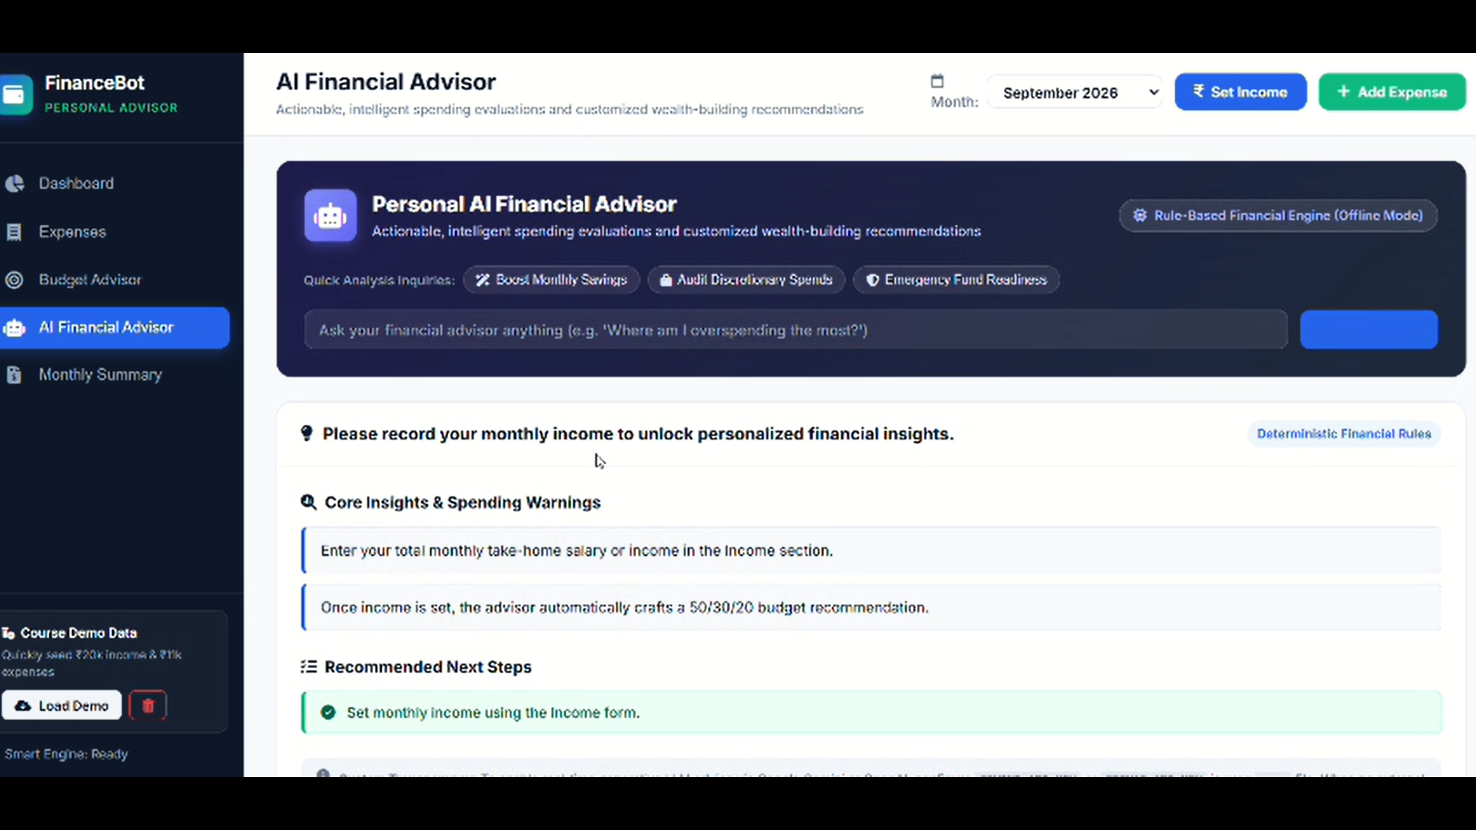
Figure 3. AI Financial Advisor page with offline rule-based mode.

6.1 Quick Analysis Options
Prompt | Purpose
Boost Monthly Savings | Review potential ways to improve the monthly savings position.
Audit Discretionary Spending | Focus attention on non-essential or flexible spending.
Emergency Fund Readiness | Review preparedness for unexpected expenses.

6.2 Advisor Input and Guidance
The question field invites questions such as “Where am I overspending the most?” The page also asks the user to record monthly income before personalized financial insights are available. The displayed guidance describes an automatic 50/30/20 budget recommendation after income is set.

6.3 Offline Mode
The supplied screenshot explicitly labels the feature “Rule-Based Financial Engine (Offline Mode)” and “Deterministic Financial Rules.” This means the captured experience is presenting rule-based guidance rather than confirming a live generative-AI response. Availability of any external AI provider, credentials, model name or fallback logic should be verified from the repository before being described as a guaranteed capability.

7. Module 5 — Monthly Financial Summary
The Monthly Financial Summary provides a consolidated view of the selected month. The upper summary strip shows the main financial indicators, while the lower panels organize spending highlights and advisor recommendations.
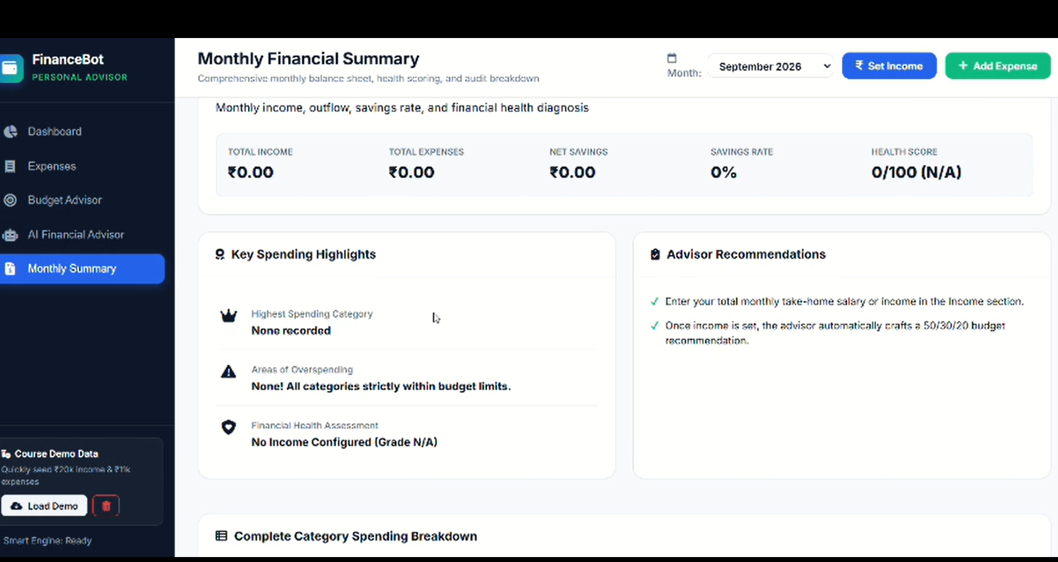
Figure 4. Monthly Financial Summary for September 2026.

7.1 Summary Indicators
Indicator | Meaning
Total Income | Income recorded for the selected month.
Total Expenses | Total of the expense records included in the month.
Net Savings | The remaining amount after expenses are accounted for.
Savings Rate | The percentage of income represented by net savings.
Health Score | A displayed financial-health score, when the application can calculate one.

7.2 Highlights and Recommendations
The Key Spending Highlights panel reports the highest-spending category, areas of overspending and a financial-health assessment. The Advisor Recommendations panel presents next steps, including entering monthly take-home income so the application can generate budget guidance.
The captured September 2026 screen displays ₹0.00 for income, expenses and net savings, 0% savings rate, and a health score of 0/100 (N/A). It also says no income is configured and no spending category has been recorded.

8. Application Structure and Data Flow
At a functional level, the interface follows a familiar browser-based workflow: the user chooses a page and supplies financial inputs; the application processes the inputs and displays updated metrics, lists or recommendations. The screenshots establish the visible user experience, but do not by themselves prove the exact backend framework, persistence mechanism or network protocol.

8.1 High-Level Functional Flow
Layer | Responsibility
Presentation layer | Sidebar navigation, month selector, forms, metric cards, panels and tables.
Input handling | Collects income, expense amount, category, date, description and advisor questions.
Financial calculations | Derives totals, savings-related metrics, category summaries and health indicators.
Guidance layer | Displays budget guidance, quick-analysis prompts and recommendations.
Data persistence | Stores records between interactions; exact database and persistence design require repository verification.

8.2 Conceptual Request Flow
User Action → Form / Filter → Application Logic → Financial Metrics → Updated Screen

8.3 Data Quality Considerations
- Income and expense records should use consistent month/date conventions.
- Expense amounts and categories should be validated before saving.
- Monthly totals should include only transactions relevant to the selected period.
- Empty states should clearly explain what data is missing, as the supplied screens do for income and expenses.
- Any AI-powered output should be distinguished from deterministic rule-based guidance.

9. User Interface and Design

9.1 Navigation
A persistent dark sidebar provides access to Dashboard, Expenses, Budget Advisor, AI Financial Advisor and Monthly Summary. A course-demo data card is visible near the bottom of the sidebar, with a Load Demo action and a delete/reset-style icon.

9.2 Visual Hierarchy
- Blue highlights identify the currently selected navigation item.
- The top bar groups month selection with Set Income and Add Expense actions.
- White cards and bordered panels separate key data areas.
- Large numeric values emphasize income, expenses and savings.
- The advisor uses a darker feature panel to distinguish its question and quick-analysis area.

9.3 Empty-State Feedback
The screenshots show explicit empty-state messaging rather than leaving the user to guess why data is missing. Examples include “No Income Configured,” zero transactions, and a prompt to enter monthly income before personalized insights become available.

10. Testing and Validation Plan
The following checklist is a proposed validation plan based on the visible workflows. It is not a statement that these tests have already been executed.
Test Area | Test Case | Expected Result
Income | Set a valid monthly income | Dashboard and summary reflect the configured income.
Expense entry | Submit a valid amount, category, date and description | A new expense appears in the list and contributes to totals.
Validation | Try submitting a missing required field | The form prevents or clearly reports the invalid submission.
Search | Search for a phrase in an expense description | Only matching records remain visible.
Category filter | Choose a specific category | The list and displayed count reflect the filter.
Month selection | Switch between months with different data | Metrics and records update for the selected month.
Calculations | Compare totals against known test transactions | Expense totals, net savings and savings rate are consistent.
Advisor offline mode | Use the advisor when an external AI service is unavailable | The interface clearly identifies rule-based/offline guidance.
Empty state | Open views without income or expense data | Helpful prompts appear and calculations avoid misleading values.
Demo data | Load demo data, then reset if supported | Demo records appear and reset behavior is clear.

11. Usage and Deployment Notes

11.1 Basic Usage
- Open the application in a browser.
- Select the month to review.
- Use Set Income to enter monthly income.
- Use Add Expense or open Expenses to record transactions.
- Review the Dashboard for headline metrics and financial-health indicators.
- Open the AI Financial Advisor for quick analysis prompts and guidance.
- Open Monthly Summary to review highlights and recommendations.

11.2 Repository and Configuration
The project repository link is included at the end of this document. Because the repository contents were not retrievable for direct inspection during generation, this report does not prescribe framework-specific installation commands, environment variable names, API routes, database migrations or hosting steps. These should be taken from the repository's own README and configuration files.

11.3 Responsible Use
The application should be treated as a personal budgeting and educational guidance tool. Recommendations are not a substitute for regulated financial advice. Users should review the accuracy of their inputs and avoid entering sensitive banking credentials or confidential account information unless the application explicitly supports secure handling.

12. Conclusion
Personal Financial Advisor brings together the key steps of personal finance tracking: recording income, logging expenses, reviewing spending, checking financial-health indicators and reading monthly recommendations. Its sidebar-based organization keeps the core features accessible, while the dashboard and summary provide complementary levels of detail. The captured AI Advisor screen also makes its offline rule-based mode visible, helping users understand the type of guidance currently being presented.
The next practical improvement is to validate the application against the repository's source and README, then execute the proposed tests for income entry, expense CRUD, monthly filtering, calculations and offline advisor behavior. Doing so would make the documentation more precise about implementation details and verified test results.

Project Links
Resource | Link
GitHub Repository | https://github.com/krishnalagas531-ux/personal-financial-advisor
Demo Video | https://drive.google.com/file/d/1IuY2l9sJT3vHeIYzK87R4dtsDo3lET8w/view?usp=drivesdk

— End of Documentation —

