**System Analysis and Design Project Description**

CST 2406

04/03/2016

Krishna Lama

**Company Description**:

Everest Mobile USA is a telecommunication company based in USA.The company is an incorporated private company that carries out telecommunication service and offers a selection of quality handsets ranging from entry-level to Android™-powered and iOS smartphones available at more than 1,00 retail stores throughout the country, including Target, Walmart, Best Buy, RadioShack and hundreds of convenience and electronics stores. It is a postpaid, a prepaid wireless voice, messaging, text and mobile broadband service provider throughout the United States, Hawaii and Puerto Rico under the Everest Mobile Wireless. It is founded in 2020 as a wholly owned subsidiary of Big Mobile Corporation with the projected workforce of 80 people. On June 31, 2022 Everest Mobile USA began offering products and services compatible with the Big's 2500 MHz 4G WiMAX network, and on August, 2025,Everest Mobile USA began offering its first 4G LTE device, the Samsung Galaxy Whoo!! 4G LTE made available for $109.99 without contract. Everest Mobile USA is headquartered in Queens, New York, United States, and its branches located in 4 major states of USA include New York, California, Georgia and Washington, and provides services to approximately 1 million customers.

Although it is a new and middle size company mobile company, Everest mobile USA already employs more than 2000 people. Everest Mobile had a revenue of 100 million from its normal business activities includes sales of handsets and communication services in 2021.But Business revenue has increased dramatically to 200 million in 2022. Everest Mobile USA sells wireless products and services through Big Mobile; it usually generates the profit through its different types of transactions that are mainly three different types. In person (Retail to Customer) transaction that involves a customer going into a store, selecting items to purchase and buying the items using cash, check or a credit card., Not in person (Retail to Customer) that involves selling products to customers without ever interacting in person. Customers can order products from a catalog by calling the business, placing an order over the phone and paying for the retail price, applicable sales tax and applicable shipping charges. Lastly, company to consumer where Company sells products directly to consumers without any mediator or retailer. Most of these transactions are done online from Company websites, or over the phone.

**Scope Definition (FAST Phase 1)**:

Everest mobile USA’s project is initiated very lately and member service system project is still underway. In order to achieve the desire goal of assigned project, a system of this project uses

the information system along with its every possible system class includes Transaction Processing System, Management Information System, Executive information System, Decision Supportive System, Expert System, communication and collaboration System and Office automation System. Requirements gathering of the project has not been completed and the detailed scope have been defined for the project. At this stage, project constraints, deliverables and acceptance criteria need to be documented. In this phase an assigned project manager conducting initial activities to collect everyone’s perspective on the system to find out the potential achievement. This system also has both Front Office Information System and Back Office Information System which literally supports various external and internal business functions to fulfil its goal.

Using the information system in project it is much easier to build the visual framework of project to avoid unnecessary too much work and detail early. Besides, Information System will be made every single process of system easier to be done. It helps to analyze, design and problem solving the business requirement, and achieve the targeted goal. The estimated time of compliance is a year from launched date if at least 50 employees carry out activities for this project. The cost of this project is 10 million US dollars.

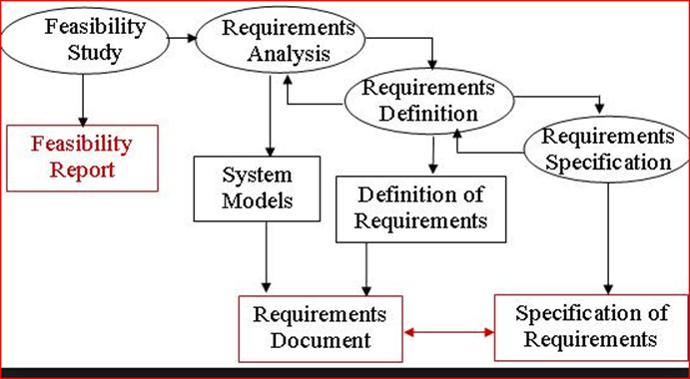

**Problem Analysis (FAST Phase 2)**:

No matter what information system is currently being used, there is always an existing system which has its own terminology, history, culture, and nuances. The goal of the problem analysis phase of Everest Mobile is to study and understand the problem domain well enough to

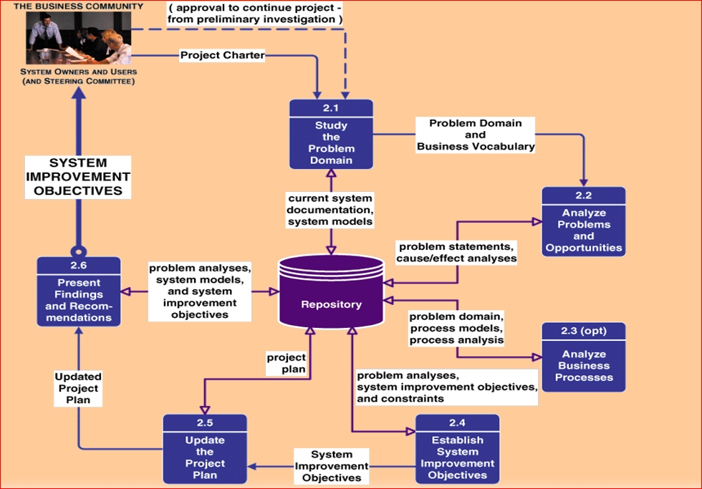

thoroughly analyze its problems, opportunities and constraints. Hence, the Everest Mobile at the moment working with analyzing the problem it is confronting which would be typically includes the following tasks:

(1) Understand the problem domain;

(2) Analyze problems and opportunities;

(3) analyze business processes;

(4) establish system improvement objectives;

(5) Update or refine the project plan;

(6) Communicate findings and recommendations. In other word this phase is by the statement, "Don't try to fix it unless you understand it."

-Problems come in a variety of shapes and sizes. For example; reducing the duration of Everest Mobile project compliance if hiring few more people to support the system team.

-Qualification for beginner: Will this project system team be able to address the financial aid federal qualification if required?

-Hiring employee: will hiring employees could help the better performance of the system, or else exceed the total cost of project.

-Threats for New beginner: Since mobile company is highly concentrated and the startup cost is very high and a few existing major company’s which has already been operating with distinguish strategies that control 75% of total today market, where Everest Mobile as a beginner has to go through massive hardship to sustain in market.

- Threat of substitute products and services: The cell phone market is increasing very fast with today’s ever-emerging technology and innovation in improving cell phones.e.g. Some major operators are upgrading their networks to advance wireless and other third and fourth generation services along with GPS and entertaining technology. So with the limited technology the company could compete the market?

-Dealing with Suppliers: Established Mobile phone operators provide such a high volume order that suppliers have not been considered the relationship which could lead the new beginner like Everest Mobile end up being in low bargaining position. Phone carriers tending to seek for even more features in the handsets and increase the pressure on Suppliers with the reverse auction.

**Requirements Analysis (FAST Phase 3)**:

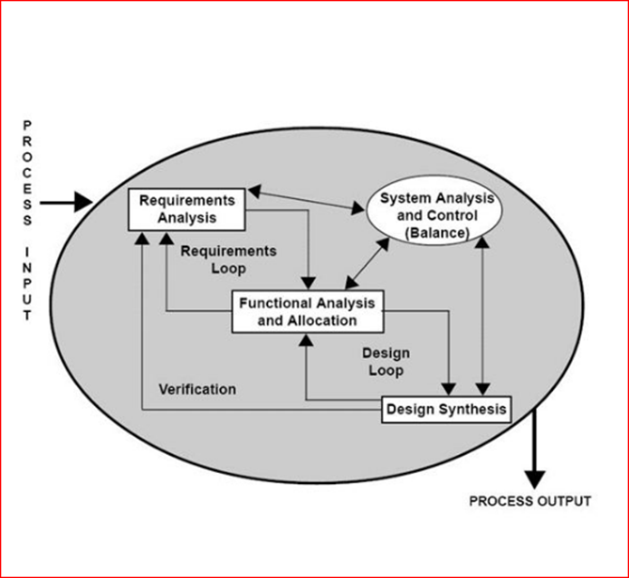

Every new activity, every new product, every new project in the workplace is created in response to a business need. A focused and detailed business requirements analysis can help Everest Mobile avoid problems as given below. This is the process of discovering, analyzing, defining, and documenting the requirements that are related to a specific business objective of this Company. In Requirement Analysis phase, Everest Mobile needs to define and prioritize the business requirements in according to the real world market requirements. In this phase consist of system users, systems analyst and project managers to determine business requirements that are based on the business's goals, processes, need for business information and system interface requirements. Two types of Stake holders as an External and Internal Stake holders for this Company includes the customer, users, project management, system analysts (i.e., developers who may participate in the requirements), and system designers (i.e., developers who may participate in the system design)]. Everest mobile USA already has established procedures and methodologies for conducting business requirements analyses, which may have been optimized specifically for this organization.

Analysis Objectives of Everest Mobile USA

• Identify customer’s needs.

• Evaluate system for feasibility.

• Perform economic and technical analysis.

• Allocate functions to system elements.

• Establish schedule and constraints.

• Create system definitions.

However, the requirement analysis phases typically includes different tasks where the proposed system should provide utility and functionality that falls into four categories for specific internal or external functional requirement includes;

1. **Features used to administer the system;**

• A deeper understanding of Mobile Audience (Learn how customers are using Everest mobile site or app and understand their device-specific needs, wants, intents and expectations.)

• Service using telephone orders, mail upgrading to automate the ordering process by developing an online system.

• Identify IT processes that support each of the business processes includes

Modify priorities of existing order, add or remove user privileges, update users’ information, create store associates passwords, reset password, create or delete user account

|  |  |  |  |  |
| --- | --- | --- | --- | --- |
| ID | Name | Requirement Description | Priority | Complexity |
| A | John | Considering Loyal customer | High | Low |
| B | Robert | Shipment in given date | NA | High |

2. **Features used by the clients;**

• Select the mobile plan and handsets, designs, and number of mobiles.

• Log in and enter the delivery address.

• Specify the time of delivery

• Revise or delete their orders.

• Check Status

• Check loyalty points

3. **Strategic and Analytic Functionality;**

• List the name and address of Suppliers and prioritize them

• List the clients and their address and prioritize them.

• Gather daily, weekly, monthly and quarterly sales report.

• Summarize sales activities by region, states and country.

• Summarize client’s feedback.

4.  **Suppliers Functionality;**

• List the clients name and address.

• Categorize the clients.

• Receive the orders.

• Submit the invoice.

• Send the orders.

**Logical Design (FAST Phase 4):**

Suppliers

Supplier ID

**Retail**

**Market**

**Wholesale**

**Industries**

**Customers**

**Customer ID**

**Sales Rep.**

**Sales Rep. ID**

**Sales Area**

**State ID**

**Sales Details**

**Sales Record ID**

**Everest Mobile**

**Everest Mobile ID**

**Branches**

**Branches ID**

**Product**

**Product SKU**

**Product Sales Plan**

**Plan ID**

The logical design phase is normally interpreted business requirements into system models to show the system independent of any possible technical solution. In this phase include system analysts, system users and the project managers. Usually project managers need to ensure that system model meets in standards, structured analysis and design. System analyst can draw system models to classify in logical data models, logical process models and logical interface models that represent data and information requirements (Knowledge), business processes requirements (Process) and system interface requirements (Communication).

A logical data model describes the data in as much detail as possible, without regard to how they will be physical implemented in the database. Features of a logical data model include:

Includes all entities and relationships among them.

All attributes for each entity are specified.

The primary key for each entity is specified.

Foreign keys (keys identifying the relationship between different entities) are specified.

Normalization occurs at this level.

The steps for designing the logical data model are as follows:

Specify primary keys for all entities.

Find the relationships between different entities.

Find all attributes for each entity.

Resolve many-to-many relationships.

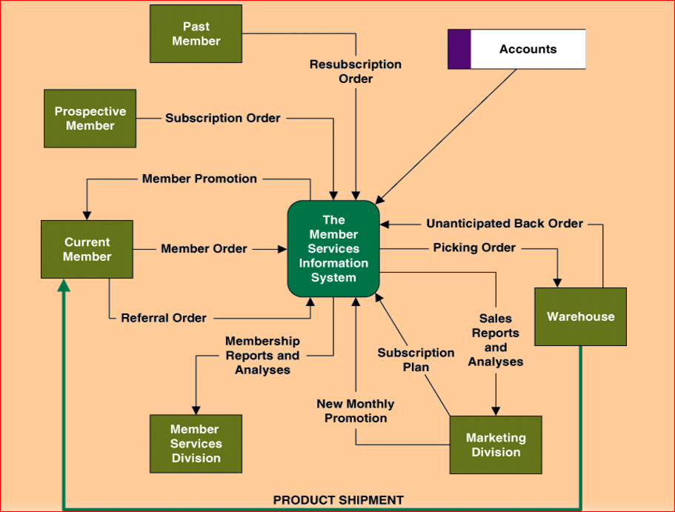

**Logical interface model Of Everest Mobile**

A Process Model of the Everest Mobile proposed System

The process modeling is an important building block in a systems development activities as it defines what’s going on now, and what should be going on in the new system. Of course, narrative explanation of the processes is one way to do; more and more organizations rely on visual presentation of systems.

**Decision Analysis (FAST Phase 5):**

During the Design Phase, the system of Everest Mobile is designed to satisfy the requirements identified in the previous phases. The requirements identified in the Requirements Analysis Phase are transformed into a System Design Document that accurately describes the design of the system and that can be used as an input to system development in the next phase.

*Feasibility Analysis:* Technical, operational, economic, schedule feasibilities

Technical feasibility: Is the solution technically practical? Does company staff have the technical expertise to design and build this solution?  
Operational feasibility. Will the solution fulfill the users’ requirements? To what degree? How will the solution change the users’ work environment? How do users feel about such a solution?

Economic feasibility. Is the solution cost-effective?  
Schedule feasibility. Can the solution be designed and implemented within an acceptable time period?

|  |  |  |  |  |  |
| --- | --- | --- | --- | --- | --- |
| **Feasibility Criteria** | **Weight** | **Stake holders 1** | **Stakeholders 2** | **Stakeholder3** | **Stakeholders** |
| Operation feasibility: A description about benefit from stake holder to Company | 25% | Only Supports members service requirement and current system processes | Fully supports user required Functionality | Same as Stakeholder 2 |  |
| Technical Feasibility: An assessment about technology and expertise | 35% | Maturity of product is risk and company charges an additional monthly fee.  Required to hire Java programmer | Programmer is easier to find than PowerBuilder | T SQL is current company standard |  |
| Economic Feasibility:  Development cost  Pay Back Period  Net Present Value | 30% | App. $  “ 4 Years  “ $20 millions | App. $  “ 3.5 Years  “ $24 millions | App. $  “ 3 Years  “ $28 millions |  |
| Schedule Feasibility:  An assessment of duration of design and implementation. | 10% | Less than 6 months | Less than 9 months | Less than 4 months |  |
| Ranking | 100% |  |  |  |  |

**Physical Design and Integration (FAST Phase 6):**

An organization’s data will be physically stored in many different places, e.g. paper files, computer files. This data will almost inevitably contain duplications and compromises due to the physical restrictions of storage, processing or practicality.e.g: A physical purchase order form will hold information about products (product name, product number, and product price), suppliers (supplier name, supplier address), the order’s heading (purchase order number, purchase order date) as well as the quantity of each product ordered (quantity ordered).

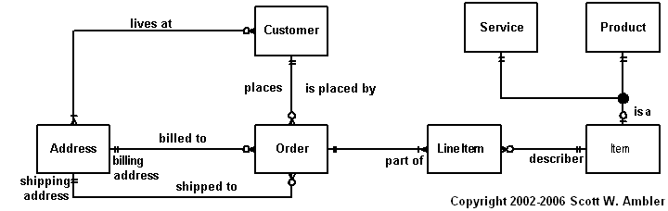

**Entity relationship diagram (ERD) –** a data model utilizing several notations to depict data in terms of the entities and relationships described by that data.

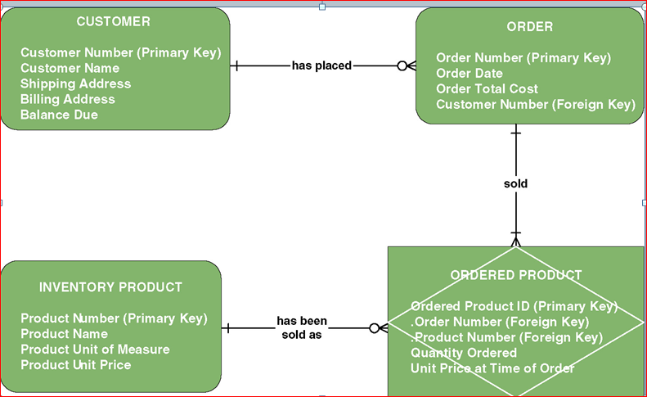

**A simple physical data model:**

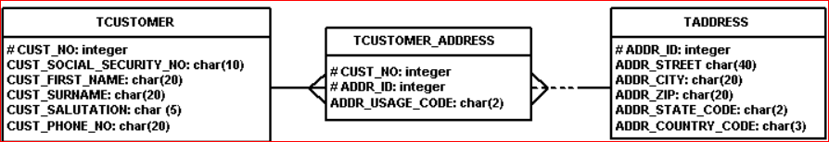

**A normalized schema in 3NF (UML Notation):**

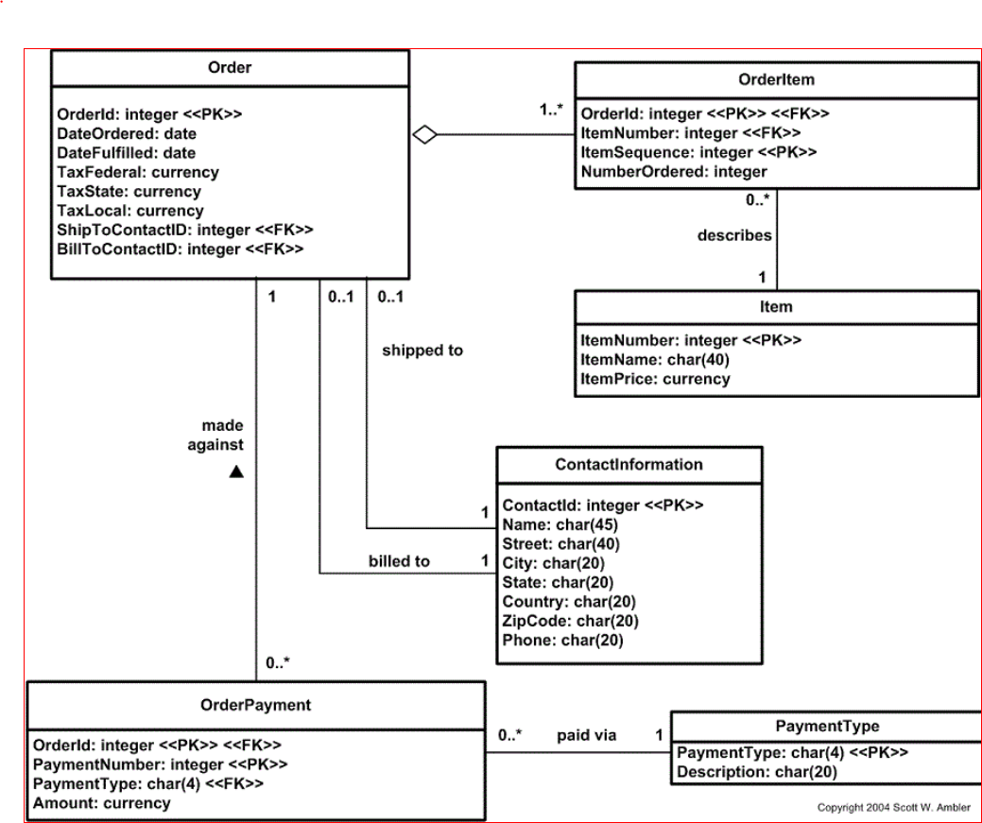

**Construction and Testing (FAST Phase 7):**

The purpose of the Test Phase is to guarantee that system successfully built and tested in the Development Phase meet all requirements and design parameters. Testing early in the system life cycle reduces risks such as schedule delays or cost overruns due to incomplete or unacceptable components. In the Test Phase, testing of the system proves that the system meets all requirements, including those for performance and security. In order to perform this phase, Everest Mobile used two different techniques as follow:

**Structural testing techniques**: “white box” testing that based on statements in the code, coverage criteria related to physical parts of the system. It does test how a program/system does something.

**Functional testing techniques:** “black box” testing that **based** on input and outputcoverage criteria based on behavior aspects and **tests** the behavior of a system or program.

**Installation and Delivery (FAST Phase 8):**

The Goal of the Implementation Phase is to deploy and enable operations of the new information system by installing the new system in its target environment. Everest mobile develop unit for Supporting actions include training end-users and preparing to turn the system over to maintenance personnel. After this phase, the system enters the Operations and Maintenance Phase for the remainder of the system’s operational life. Multiple-release projects require multiple iterations of the Implementation Phase – one for each release.

In this phase, administrative system of this company perform an intensity demand analysis of every products which allow Everest Mobile to understand the basic requirement of operation which includes hiring new employees and finding the great deals on products from suppliers in lower prices.in the meantime, in house feedback system online help this company to get an idea about customers perception. Besides, it has an option to allow its customer to contact the company in direct manner in order to avoid any complain about its products and customer service.