VISVESVARAYA TECHNOLOGICAL UNIVERSITY
“JnanaSangama”, Belgaum -590014, Karnataka.


LAB REPORT

On

ANALYSIS AND DESIGN OF ALGORITHMS (23CS4PCADA)

Submitted by

KRISHNA LATH (1BF24CS149)

in partial fulfillment for the award of the degree of
BACHELOR OF ENGINEERING
in
COMPUTER SCIENCE AND ENGINEERING



B.M.S. COLLEGE OF ENGINEERING
(Autonomous Institution under VTU)
BENGALURU-560019
February to June 2026
CERTIFICATE

B. M. S. College of Engineering,
Bull Temple Road, Bangalore 560019
(Affiliated To Visvesvaraya Technological University, Belgaum)
Department of Computer Science and Engineering



This is to certify that the Lab work entitled “ANALYSIS AND DESIGN OF ALGORITHMS” carried out by KRISHNA LATH(1BF24CS149), who is bonafide student of B. M. S. College of Engineering. It is in partial fulfillment for the award of Bachelor of Engineering in Computer Science and Engineering of the Visvesvaraya Technological University, Belgaum during the year 2025-26. The Lab report has been approved as it satisfies the academic requirements in respect of Analysis and Design of Algorithms Lab - (23CS4PCADA) work prescribed for the said degree.

Dr. Manjula S Dr. Kavitha Sooda
Assistant Professor Professor and Head
Department of CSE Department of CSE
BMSCE, Bengaluru BMSCE, Bengaluru

Index Sheet
Sl.  No. | Experiment Title | Page No.
1 | Write program to obtain the Topological ordering of vertices in a given digraph. | 4-7
2 | Implement Johnson Trotter algorithm to generate permutations. | 8-9
3 | Sort a given set of N integer elements using Merge Sort technique and compute its time taken. Run the program for different values of N and record the time taken to sort. | 10-13
4 | Sort a given set of N integer elements using Quick Sort technique and compute its time taken. | 14-16
5 | Sort a given set of N integer elements using Heap Sort technique and compute its time taken. | 17-18
6 | Implement 0/1 Knapsack problem using dynamic programming. (5 Marks) | 19-21
7 | Implement All Pair Shortest paths problem using Floyd’s algorithm. | 22-24
8 | - Find Minimum Cost Spanning Tree of a given undirected graph using Prim’s algorithm.  - Find Minimum Cost Spanning Tree of a given undirected graph using Kruskal’s algorithm. | 25-28
9 | Implement Fractional Knapsack using Greedy technique. | 29-31
10 | From a given vertex in a weighted connected graph, find shortest paths to other vertices using Dijkstra’s algorithm. | 32-33
11 | Implement “N-Queens Problem” using Backtracking. | 34

Course outcomes:
CO1 | Analyze time complexity of algorithms using asymptotic notations.
CO2 | Apply various algorithm design techniques for the given problem.
CO3 | Evaluate the appropriate algorithm/design technique for solving a given problem.
CO4 | Conduct practical experiments by applying appropriate algorithm design technique to solve problems.

Lab program 1:
CODE:

#include <stdio.h>

#define MAX 100

int graph[MAX][MAX];
int indegree[MAX];
int queue[MAX];
int front = 0, rear = 0;

void topologicalSort(int n)
{
int i, j, count = 0;

// Calculate indegree of each vertex
for(i = 0; i < n; i++)
{
indegree[i] = 0;
}

for(i = 0; i < n; i++)
{
for(j = 0; j < n; j++)
{
if(graph[i][j] == 1)
{
indegree[j]++;
}
}
}

for(i = 0; i < n; i++)
{
if(indegree[i] == 0)
{
queue[rear++] = i;
}
}

printf("Topological Ordering: ");

while(front < rear)
{
int vertex = queue[front++];
printf("%d ", vertex);
count++;

// Reduce indegree of adjacent vertices
for(i = 0; i < n; i++)
{
if(graph[vertex][i] == 1)
{
indegree[i]--;

if(indegree[i] == 0)
{
queue[rear++] = i;
}
}
}
}

if(count != n)
{
printf("\nGraph contains a cycle. Topological ordering not possible.");
}
}

int main()
{
int n, i, j;

printf("Enter number of vertices: ");
scanf("%d", &n);

printf("Enter adjacency matrix:\n");

for(i = 0; i < n; i++)
{
for(j = 0; j < n; j++)
{
scanf("%d", &graph[i][j]);
}
}

topologicalSort(n);
return 0;
}

OUTPUT:

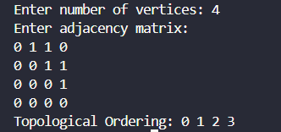

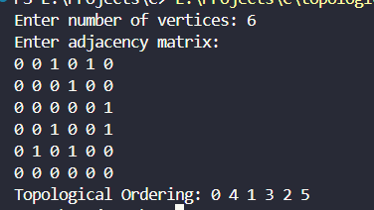

LEETCODE 207.Course Schedule

CODE:

#include <stdbool.h>
#include <stdlib.h>

bool canFinish(int numCourses, int** prerequisites, int prerequisitesSize, int* prerequisitesColSize) {

int graph[2000][2000] = {0};
int indegree[2000] = {0};

for(int i = 0; i < prerequisitesSize; i++) {
int a = prerequisites[i][0];
int b = prerequisites[i][1];

graph[b][a] = 1; // b -> a
indegree[a]++;
}

int queue[2000];
int front = 0, rear = 0;

for(int i = 0; i < numCourses; i++) {
if(indegree[i] == 0) {
queue[rear++] = i;
}
}

int count = 0;

while(front < rear) {
int node = queue[front++];
count++;

for(int i = 0; i < numCourses; i++) {
if(graph[node][i] == 1) {
indegree[i]--;

if(indegree[i] == 0) {
queue[rear++] = i;
}
}
}
}

return count == numCourses;
}

OUTPUT:



Lab program 2:
CODE:

#include <stdio.h>

int mobile(int p[],int d[],int n){
int m=-1;
for(int i=0;i<n;i++){
if(d[i]==-1 && i>0 && p[i]>p[i-1] && p[i]>m)
m=p[i];
if(d[i]==1 && i<n-1 && p[i]>p[i+1] && p[i]>m)
m=p[i];
}
return m;
}

int main(){
int n;
printf("Enter n: ");
scanf("%d",&n);
int p[n],d[n];
for(int i=0;i<n;i++){
d[i]=-1;
p[i]=i+1;
}
while(1){
for(int i=0;i<n;i++)
printf("%d",p[i]);
printf("\n");
int m=mobile(p,d,n);
if(m==-1) break;
int pos;
for(int i=0;i<n;i++){
if(p[i]==m)
pos = i;
}
int next = pos+d[pos];
int temp = p[pos];
p[pos]=p[next];
p[next]=temp;
temp=d[pos];
d[pos]=d[next];
d[next]=temp;

for(int i=0;i<n;i++){
if(p[i]>m)
d[i]=-d[i];
}
}
return 0;
}

OUTPUT:

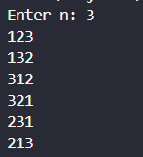

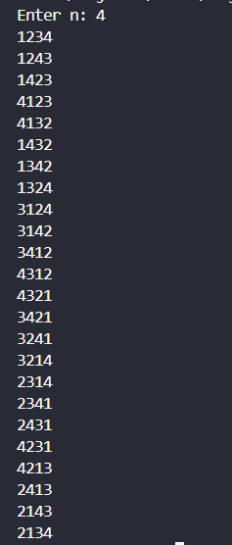

Lab program 3:
CODE:

#include <stdio.h>
#include <stdlib.h>
#include <time.h>

void merge(int arr[], int low, int mid, int high) {
int i = low, j = mid + 1, k = low;
int temp[high+1];

while (i <= mid && j <= high) {
if (arr[i] < arr[j])
temp[k++] = arr[i++];
else
temp[k++] = arr[j++];
}

while (i <= mid)
temp[k++] = arr[i++];

while (j <= high)
temp[k++] = arr[j++];

for (i = low; i <= high; i++)
arr[i] = temp[i];
}

void mergeSort(int arr[], int low, int high) {
if (low < high) {
int mid = (low + high) / 2;

mergeSort(arr, low, mid);
mergeSort(arr, mid + 1, high);
merge(arr, low, mid, high);
}
}

int main() {
int n = 60000;
int arr[n];

srand(time(NULL));

for (int i = 0; i < n; i++) {
arr[i] = rand() % 2*n;
}

clock_t start, end;
double cpu_time;

start = clock();

mergeSort(arr, 0, n - 1);

end = clock();

cpu_time = (((double)(end - start)) / CLOCKS_PER_SEC)*1000.0;

printf("Time taken = %f miliseconds\n", cpu_time);

return 0;
}

OUTPUT:

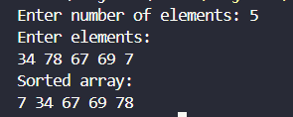

GRAPH:

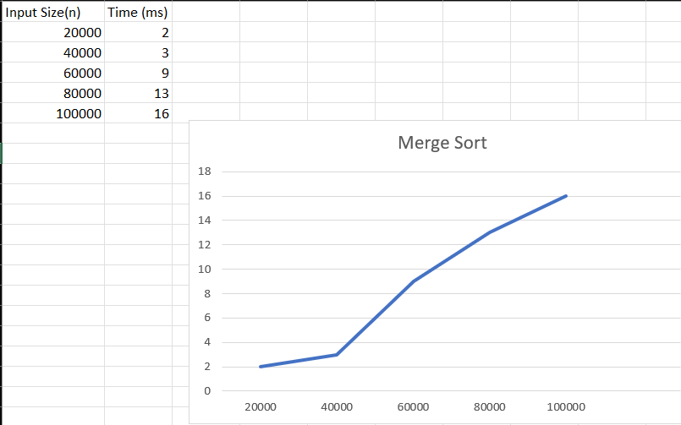

LEETCODE 912: Sort an Array

CODE:

#include <stdlib.h>

void merge(int* nums, int left, int mid, int right) {
int i, j, k;
int n1 = mid - left + 1;
int n2 = right - mid;

int* L = (int*)malloc(n1 * sizeof(int));
int* R = (int*)malloc(n2 * sizeof(int));

for (i = 0; i < n1; i++) {
L[i] = nums[left + i];
}
for (j = 0; j < n2; j++) {
R[j] = nums[mid + 1 + j];
}

i = 0;
j = 0;
k = left;

while (i < n1 && j < n2) {
if (L[i] <= R[j]) {
nums[k] = L[i];
i++;
} else {
nums[k] = R[j];
j++;
}
k++;
}

while (i < n1) {
nums[k] = L[i];
i++;
k++;
}

while (j < n2) {
nums[k] = R[j];
j++;
k++;
}

free(L);
free(R);
}

void mergeSort(int* nums, int left, int right) {
if (left < right) {
int mid = left + (right - left) / 2;

mergeSort(nums, left, mid);
mergeSort(nums, mid + 1, right);

merge(nums, left, mid, right);
}
}

int* sortArray(int* nums, int numsSize, int* returnSize) {
mergeSort(nums, 0, numsSize - 1);
*returnSize = numsSize;
return nums;
}

OUTPUT:

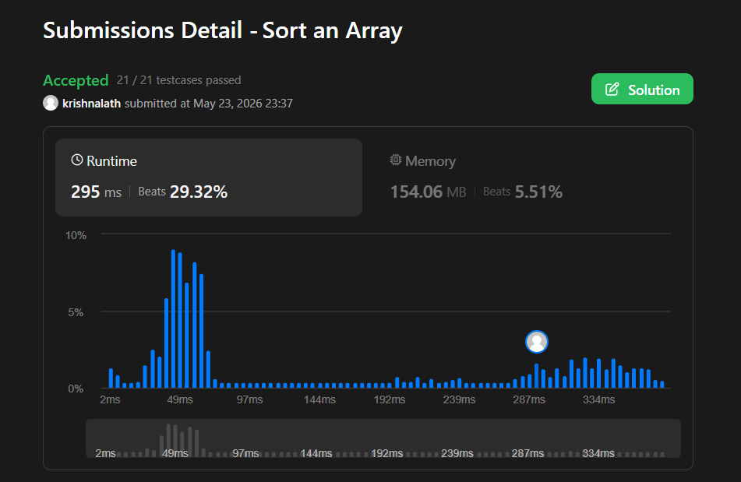

Lab program 4:

CODE:

#include <stdio.h>
#include <stdlib.h>
#include <time.h>
int partition(int low,int high,int arr[]){
int i=low;
int j=high+1;
int pivot=arr[low];
while(i<j){
do{
i++;
}while(i<=high && arr[i]<=pivot);
do{
j--;
}while(arr[j]>pivot);
if(i<j){
int temp=arr[i];
arr[i]=arr[j];
arr[j]=temp;
}
}
int temp2 = arr[j];
arr[j]=pivot;
arr[low]=temp2;
return j;
}

void quickSort(int low,int high,int arr[]){
if(low<high){
int p=partition(low,high,arr);
quickSort(low,p-1,arr);
quickSort(p+1,high,arr);
}
}

int main() {
int n = 75000;
int arr[n];

srand(time(NULL));

for (int i = 0; i < n; i++) {
arr[i] = rand() % (2 * n);
}

clock_t start, end;
double cpu_time;

start = clock();

quickSort(0, n - 1, arr);

end = clock();

cpu_time = ((double)(end - start) / CLOCKS_PER_SEC) * 1000.0;

printf("Time taken = %.3f milliseconds\n", cpu_time);

return 0;
}

OUTPUT:

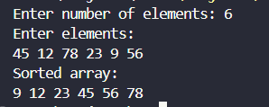

GRAPH:

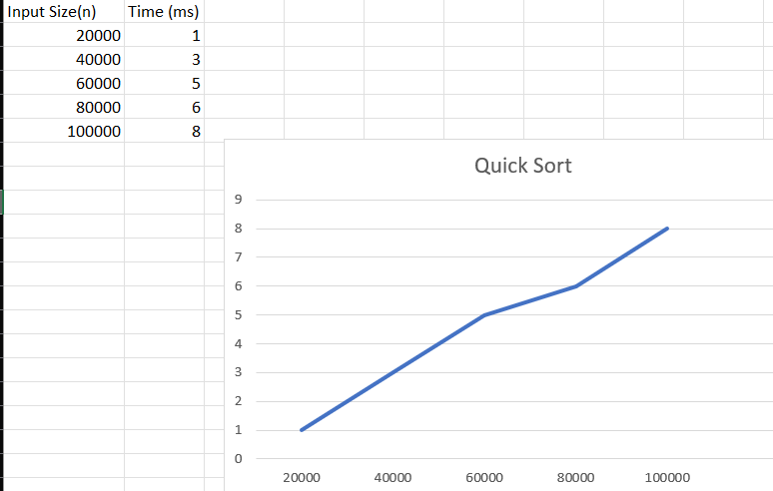

LEETCODE 1636: Sort Array By Increasing Frequency

CODE:

int* frequencySort(int* nums, int numsSize, int* returnSize) {

int freq[201] = {0};

for(int i = 0; i < numsSize; i++){
freq[nums[i] + 100]++;
}

for(int i = 0; i < numsSize-1; i++){
for(int j = i+1; j < numsSize; j++){

if(freq[nums[i]+100] > freq[nums[j]+100] ||
(freq[nums[i]+100] == freq[nums[j]+100] && nums[i] < nums[j])){

int temp = nums[i];
nums[i] = nums[j];
nums[j] = temp;
}
}
}

*returnSize = numsSize;
return nums;
}

OUTPUT:

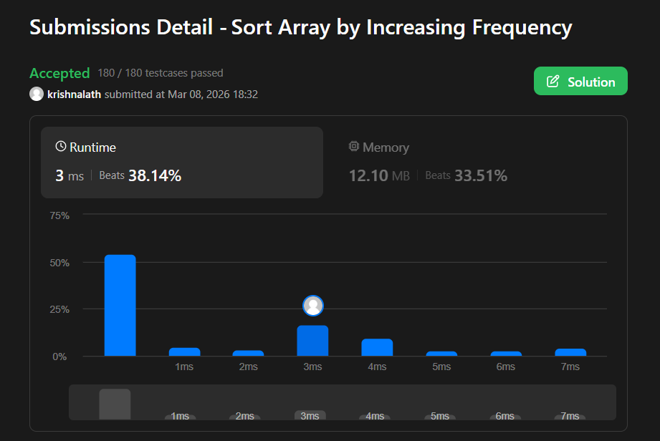

Lab program 5:
CODE:

#include <stdio.h>
#include <time.h>
#include <stdbool.h>

void heapify(int H[], int n) {

for (int i = n / 2; i >= 1; i--) {

int v = H[i];
int k = i;
bool heap = false;

while (!heap && 2 * k <= n) {

int j = 2 * k;
if (j < n && H[j] < H[j + 1])
j = j + 1;

if (v >= H[j])
heap = true;
else {
H[k] = H[j];
k = j;
}
}

H[k] = v;
}
}

void heapsort(int H[], int n) {

heapify(H, n);

for (int i = n; i >= 2; i--) {
int temp = H[1];
H[1] = H[i];
H[i] = temp;
heapify(H, i - 1);
}
}

int main() {

int n;

printf("Enter no. of elements: ");
scanf("%d", &n);

int H[n + 1];

printf("Enter the elements:\n");

for (int i = 1; i <= n; i++)
scanf("%d", &H[i]);

clock_t start, end;

start = clock();

heapsort(H, n);

end = clock();

double cpu_time_used =
(((double)(end - start)) / CLOCKS_PER_SEC) * 1000;

printf("Sorted Elements:\n");

for (int i = 1; i <= n; i++)
printf("%d ", H[i]);

printf("\n");

printf("Input size: %d\n", n);
printf("Execution time: %.5f ms\n", cpu_time_used);
}

OUTPUT:

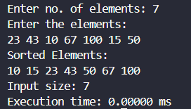

GRAPH:

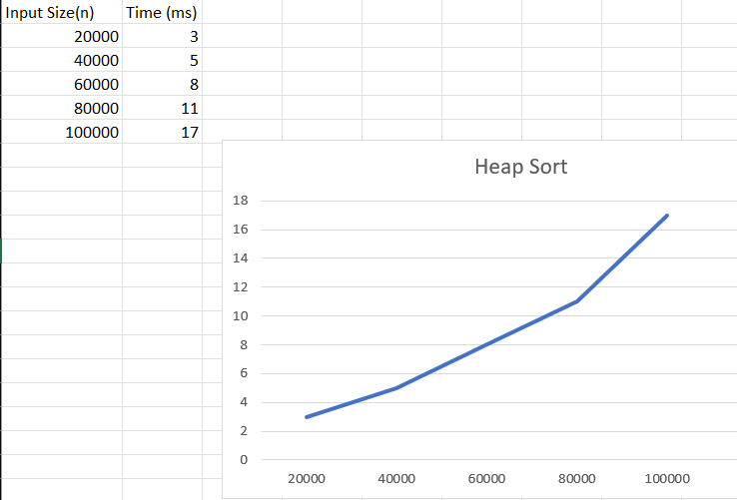
Lab program 6:
CODE:

#include<stdio.h>
int max(int a,int b){
return (a>b)?a:b;
}
void main(){
int n,m;
printf("Enter the number of objects and capacity:");
scanf("%d %d",&n,&m);
int v[n+1][m+1];
int p[n+1],w[n+1],x[n+1];
printf("Enter the weight and profit:\n");
for(int i=1;i<=n;i++){
scanf("%d %d",&w[i],&p[i]);
}
for(int i=0;i<=n;i++){
x[i]=0;
}
for(int i=0;i<=n;i++){
for(int j=0;j<=m;j++){
if(i==0 || j==0) v[i][j]=0;
else if(w[i]<=j) v[i][j]=max(v[i-1][j],p[i]+v[i-1][j-w[i]]);
else v[i][j]=v[i-1][j];
}
}
int i=n;
int j=m;
while(i>0 && j>0){
if(v[i][j]!=v[i-1][j]){
x[i]=1;
j=j-w[i];
}
i=i-1;
}
printf("Selected objects weight and profit:\n");
printf("%-5s %-5s","w","p");
for(int i=0;i<=n;i++){
if(x[i]==1) printf("\n%-5d %-5d",w[i],p[i]);
}
printf("\nTotal profit:%d",v[n][m]);
}

OUTPUT:

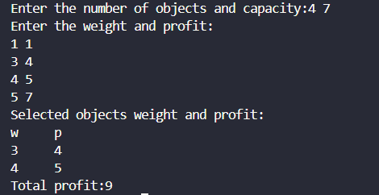

LEETCODE 322: Coin Change

CODE:

int coinChange(int* coins, int coinsSize, int amount) {
int dp[amount + 1];
for (int i = 0; i <= amount; i++) {
dp[i] = amount + 1;
}

dp[0] = 0;
for (int i = 1; i <= amount; i++) {
for (int j = 0; j < coinsSize; j++) {
if (coins[j] <= i) {
if (dp[i - coins[j]] + 1 < dp[i]) {
dp[i] = dp[i - coins[j]] + 1;
}
}
}
}

return (dp[amount] > amount) ? -1 : dp[amount];
}

OUTPUT:



Lab program 7:
CODE:

#include<stdio.h>
#include<limits.h>

int main() {
int n;
printf("Enter number of vertices : ");
scanf("%d", &n);

int a[n][n];
printf("Enter adjacency matrix:\n");
for(int i = 0; i < n; i++){
for(int j = 0; j < n; j++){
scanf("%d", &a[i][j]);
}
}
for(int i=0;i<n;i++){
for(int j=0;j<n;j++){
if(i!=j && a[i][j]==0)
a[i][j] = INT_MAX;
}
}
for(int i=0;i<n;i++){
for(int j=0;j<n;j++){
for(int k=0;k<n;k++){
if(a[i][k]!=INT_MAX && a[k][i] != INT_MAX){
if(a[i][k]+a[k][j] < a[i][j])
a[i][j] = a[i][k] + a[k][j];
}
}
}
}
printf("Shortest Path: \n");
for(int i=0;i<n;i++){
for(int j=0;j<n;j++){
if(a[i][j] == INT_MAX)
printf("INFINITY");
else
printf("%d",a[i][j]);
}
}
}

OUTPUT:

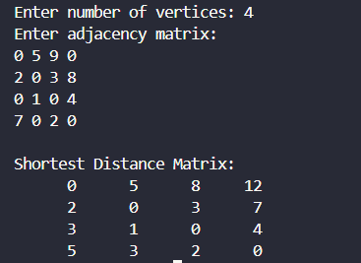

LEETCODE 783: Minimum Distance Between BST Nodes

CODE:

/**
* Definition for a binary tree node.
* struct TreeNode {
* int val;
* struct TreeNode *left;
* struct TreeNode *right;
* };
*/

int prev;
bool hasPrev = false;
int ans;

void inorder(struct TreeNode* root) {
if (root == NULL)
return;

inorder(root->left);

if (hasPrev) {
int diff = root->val - prev;
if (diff < ans)
ans = diff;
}

prev = root->val;
hasPrev = true;

inorder(root->right);
}

int minDiffInBST(struct TreeNode* root) {
ans = INT_MAX;
hasPrev = false;

inorder(root);

return ans;
}

OUTPUT:

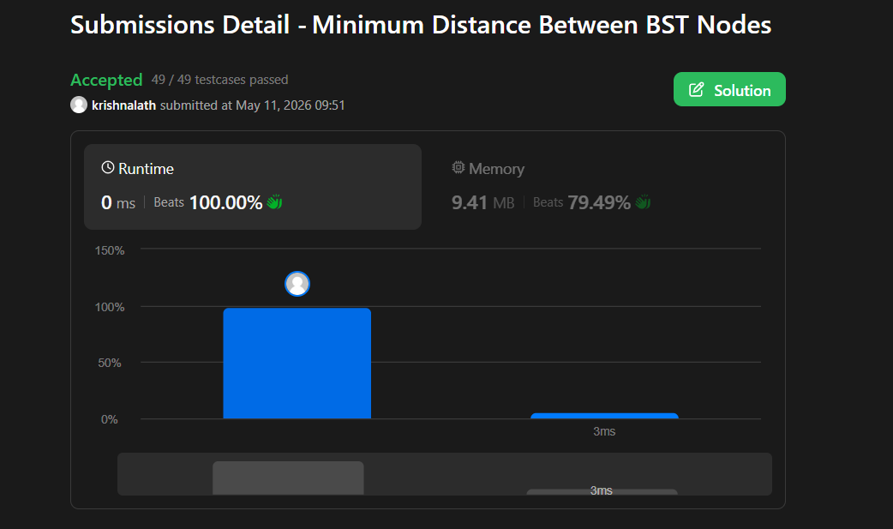

Lab program 8:
8(a)
CODE:

#include <stdio.h>
#define MAX 10
#define INF 999

int parent[MAX];

int find(int x)
{
while(parent[x] != x)
x = parent[x];

return x;
}

void unionSet(int a, int b)
{
parent[find(a)] = find(b);
}

int main()
{
int cost[MAX][MAX];
int n, i, j;
int min, a, b;
int edges = 0, minCost = 0;

printf("Enter number of vertices: ");
scanf("%d", &n);

printf("Enter adjacency matrix:\n");

// Read matrix
for(i = 0; i < n; i++)
{
for(j = 0; j < n; j++)
{
scanf("%d", &cost[i][j]);

// 0 means no edge
if(cost[i][j] == 0)
cost[i][j] = INF;
}
}

for(i = 0; i < n; i++)
{
parent[i] = i;
}

printf("Edges in MST:\n");

while(edges < n - 1)
{
min = INF;

for(i = 0; i < n; i++)
{
for(j = i + 1; j < n; j++)
{
if(cost[i][j] < min)
{
min = cost[i][j];
a = i;
b = j;
}
}
}

if(find(a) != find(b))
{
printf("%d - %d = %d\n", a, b, min);

minCost += min;

unionSet(a, b);

edges++;
}

cost[a][b] = cost[b][a] = INF;
}

printf("Minimum Cost = %d\n", minCost);

return 0;
}

OUTPUT:

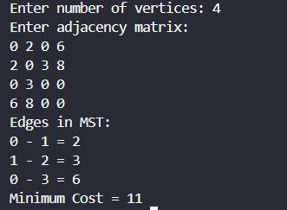
8(b)
CODE:

#include <stdio.h>

#define MAX 10
#define INF 999

int main()
{
int cost[MAX][MAX];
int visited[MAX] = {0};

int n, i, j;
int min, a, b;
int edges = 0;
int minCost = 0;

printf("Enter number of vertices: ");
scanf("%d", &n);

printf("Enter adjacency matrix:\n");

for(i = 0; i < n; i++)
{
for(j = 0; j < n; j++)
{
scanf("%d", &cost[i][j]);

if(cost[i][j] == 0)
cost[i][j] = INF;
}
}

visited[0] = 1;

printf("Edges in MST:\n");

while(edges < n - 1)
{
min = INF;
for(i = 0; i < n; i++)
{
if(visited[i])
{
for(j = 0; j < n; j++)
{
if(!visited[j] && cost[i][j] < min)
{
min = cost[i][j];
a = i;
b = j;
}
}
}
}

printf("%d - %d = %d\n", a, b, min);

minCost += min;

visited[b] = 1;

edges++;
}

printf("Minimum Cost = %d\n", minCost);

return 0;
}

OUTPUT:

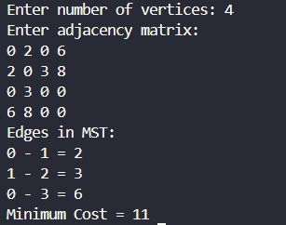

Lab program 9:
CODE:

#include <stdio.h>

struct object {
int weight;
int profit;
float pwRatio;
};

void sort(struct object o[], int n) {
struct object temp;
for (int i = 0; i < n - 1; i++) {
for (int j = 0; j < n - i - 1; j++) {
if (o[j].pwRatio < o[j + 1].pwRatio) {
temp = o[j];
o[j] = o[j + 1];
o[j + 1] = temp;
}
}
}
}

int main() {
int n;
printf("Enter number of objects: ");
scanf("%d", &n);

struct object o[n];

for (int i = 0; i < n; i++) {
printf("Object %d (weight profit): ", i + 1);
scanf("%d %d", &o[i].weight, &o[i].profit);
o[i].pwRatio = (float)o[i].profit / o[i].weight;
}

sort(o, n);

int size;
printf("Enter size of knapsack: ");
scanf("%d", &size);

float totalProfit = 0.0;
int rem_wt = size;

int i = 0;
while (rem_wt !=0) {
if (o[i].weight <= rem_wt) {
totalProfit += o[i].profit;
rem_wt -= o[i].weight;
} else {
totalProfit += (o[i].profit * (float)rem_wt) / o[i].weight;
rem_wt = 0;
}
i++;
}

printf("MAXIMUM PROFIT : %.2f\n", totalProfit);

return 0;
}

OUTPUT:

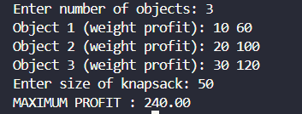

LEETCODE 455.Assign Cookies

CODE:

#include <stdio.h>
#include <stdlib.h>

int compare(const void *a, const void *b) {
return (*(int*)a - *(int*)b); //dereferencing
}

int findContentChildren(int* g, int gSize, int* s, int sSize) {
qsort(g, gSize, sizeof(int), compare); //greed
qsort(s, sSize, sizeof(int), compare); //cookies
int i = 0; // children
int j = 0; // cookies
int count = 0;

while (i < gSize && j < sSize) {
if (s[j] >= g[i]) {
count++;
i++;
j++;
} else {
j++;
}
}
return count;
}
OUTPUT:

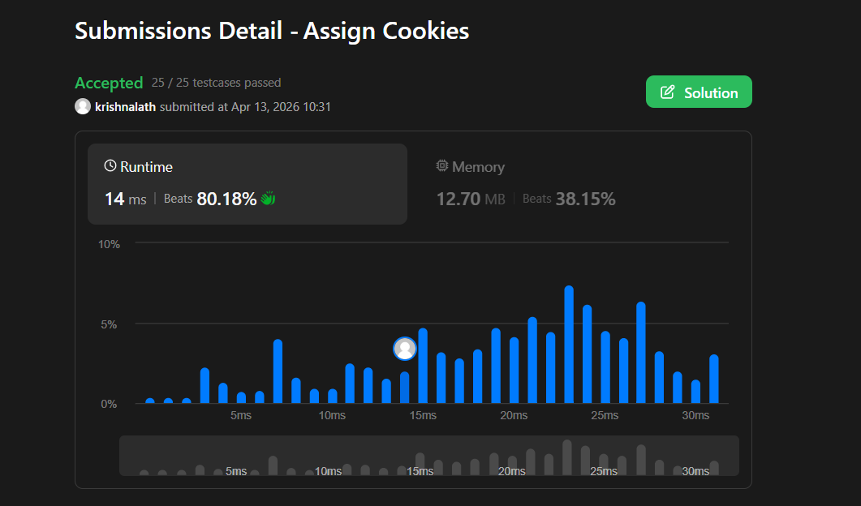

Lab program 10:
CODE:

#include<stdio.h>
#include<limits.h>
void p(int parent[],int j){
if(parent[j]==j){
printf(" Path:%d ",j);
return;
}
p(parent,parent[j]);
printf("%d ",j);
}
void main(){
int n;
printf("Enter the number of vertices:");
scanf("%d",&n);
int a[n][n];
printf("Enter the weights and enter 0 for no edges:\n");
for(int i=0;i<n;i++){
for(int j=0;j<n;j++){
scanf("%d",&a[i][j]);
}
}
int distance[n];
int visited[n];
int parent[n];
int source;
printf("Enter the source vertex:");
scanf("%d",&source);
for(int i=0;i<n;i++){
distance[i]=(i!=source && a[source][i]==0)?INT_MAX:a[source][i];
parent[i]=source;
visited[i]=0;
}
distance[source]=0;
visited[source]=1;
for(int i=1;i<n;i++){
int min=INT_MAX;
int u=-1;
for(int j=0;j<n;j++){
if(!visited[j] && distance[j]<min){
min=distance[j];
u=j;
}
}
if(u==-1) break;
visited[u]=1;
for(int v=0;v<n;v++){
if(a[u][v]!=0 && !visited[v]){
if(distance[u]+a[u][v]<distance[v]){
distance[v]=distance[u]+a[u][v];
parent[v]=u;
}
}

}
}
printf("The distances are:\n");
for(int i=0;i<n;i++){
printf("%d to %d",source,i);
if(distance[i]==INT_MAX) printf(":No path");
else{
p(parent,i);
printf(":%d",distance[i]);
}
printf("\n");
}
}

OUTPUT:

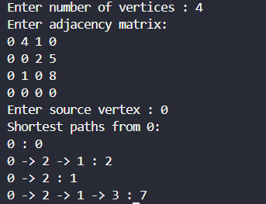

Lab program 11:
CODE:

#include <stdio.h>
#include <stdlib.h>

int x[20];
int place(int k,int i){
for(int j=1;j<k;j++){
if(x[j]==i || (abs(k-j)==abs(i-x[j])))
return 0;
}
return 1;
}

void nQueens(int k,int n){
for(int i=1;i<=n;i++){
if(place(k,i)){
x[k]=i;
if(k==n){
printf("\n");
for(int j=1;j<=n;j++){
printf("\nRow: %d , Column: %d",j,x[j]);
}

}else nQueens(k+1,n);
}
}
}

int main(){
int n;
printf("Enter number of queens: ");
scanf("%d",&n);
nQueens(1,n);
return 0;
}

OUTPUT:

