**Chapter 1 Intro**

What is React

JavaScript library for building user interfaces

React is a View layer library, not a frame work like Backbone or angular

Why is it compelling ?

Declarative & Composable

Virtual Dom

One-way data flow

Declarative & Composable

1.3 State Machines

1.4 First Component

First Component

JSX : Java Script and XML

1.5 Class components

1.6 States

State establishes Reactive relation between component and UI

Counter app

**Chapter 2 Lifecycle Methods**

**2.1 Mounting**

**2.2 Updating**

**2.3 Unmounting**

**2.4**

**2.4 Error handling using Error boundaries**

**Chapter 3 Hooks**

**3.1 The State Hook**

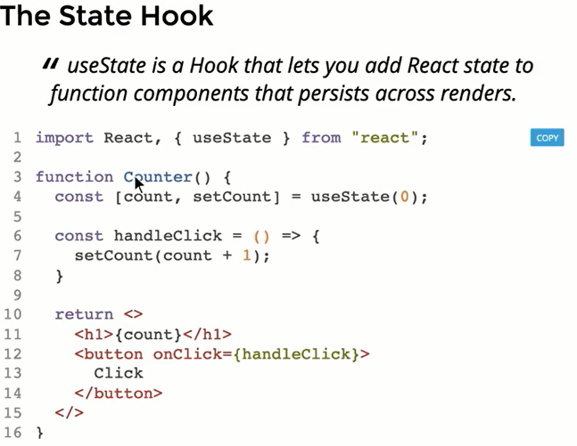

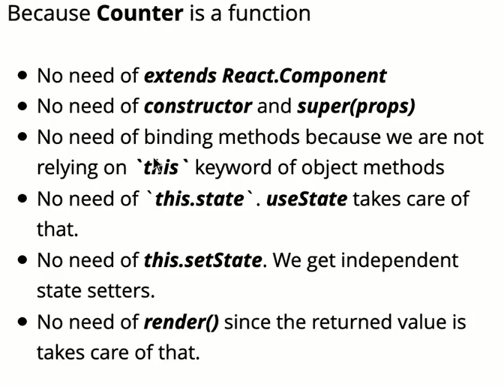

**3.2 – 3.3 The Effect Hook**

