

**EXPERIMENT: 1**

**1.TITLE:**

Library Management System.

**2.OBJECTIVE:**

1. Book issue and return.
2. Add new book to the library.
3. Add new student.
4. Show the Statistics.

**3.THEORY:**

Library Management System is an application which refers to library systems which is used by librarian to manage the library using computerized system where the records of various transactions like issue of books, returns of books, addition of new books, addition of new students, etc can be done.

**4.IMPLEMENTATION:**

**4.1.User Login**

*package kpk;*

*import javax.swing.*;*

*import java.awt.*;*

*import java.awt.event.*;*

*public class login {*

*JFrame f;*

*JLabel un,pw;*

*JTextField username;*

*JPasswordField password;*

*Font f1,f2;*

*JButton b;*

*login()*

*{*

*f = new JFrame("login");*

*f.setSize(500,400);*

*f.setLocationRelativeTo(null);*

*f1=new Font("TIMES NEW ROMAN",Font.PLAIN,24);*

*f2=new Font("TIMES NEW ROMAN",Font.PLAIN,28);*

*un=new JLabel("Username");*

*un.setBounds(70, 100, 150, 50);*

*f.add(un);*

*un.setFont(f2);*

*pw=new JLabel("Password");*

*pw.setBounds(70, 180, 150, 50);*

*pw.setFont(f2);*

*f.add(pw);*

*username=new JTextField(20);*

*username.setBounds(220, 100, 200, 50);*

*f.add(username);*

*username.setFont(f1);*

*password=new JPasswordField( 50);*

*password.setBounds(220, 180, 200, 50);*

*f.add(password);*

*b=new JButton("LOGIN");*

*b.setBounds(200, 250, 100, 50);*

*f.add(b);*

*b.addActionListener(new ActionListener() {*

*public void actionPerformed(ActionEvent e)*

*{*

*String uname=username.getText();*

*String pword=password.getText();*

*if(uname.equals("")&&pword.equals(""))*

*{*

*JOptionPane.showMessageDialog(f,*

*"enter username and password", "warning", 0);*

*}*

*else if(uname.equals("")&&!pword.equals(""))*

*{*

*JOptionPane.showMessageDialog(f,*

*"enter username", "warning", 0);*

*}*

*else if(!uname.equals("")&&pword.equals(""))*

*{*

*JOptionPane.showMessageDialog(f,*

*"enter password", "warning", 0);*

*}*

*else if(uname.equals("admin") && pword.equals("admin@123"))*

*{*

*new home();*

*f.dispose();*

*}*

*else*

*{*

*JOptionPane.showMessageDialog(f,*

*"enter correct password and username ", "warning", 0);*

*}*

*}*

*});*

*f.setLayout(null);*

*f.setVisible(true);*

*}*

*public static void main(String[] args) {*

*new login();*

*}*

*void setVisible(boolean b) {*

*throw new UnsupportedOperationException("Not supported yet."); // Generated from nbfs://nbhost/SystemFileSystem/Templates/Classes/Code/GeneratedMethodBody*

*}*

*}*

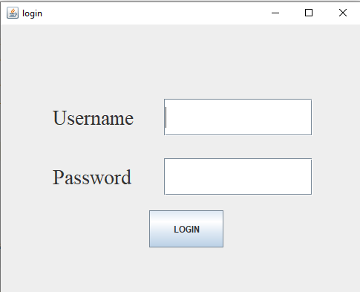

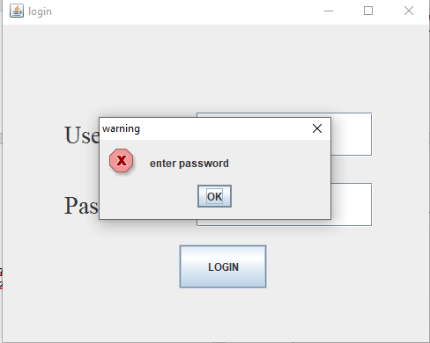

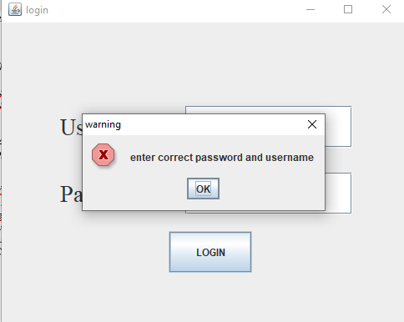

* 1. **Home Page:**

*package kpk;*

*import javax.swing.*;*

*import java.awt.*;*

*import java.awt.event.*;*

*public class home*

*{*

*JFrame j;*

*JLabel p2;*

*JPanel p1,p3;*

*Font f1,f2;*

*JButton create,retrieve,delete,create2,return1,reset,book,students;*

*home()*

*{*

*j=new JFrame("Our Home Page");*

*j.setSize(600,250);*

*j.setLocationRelativeTo(null);*

*f1=new Font("TIMES NEW ROMAN",Font.PLAIN,24);*

*f2=new Font("TIMES NEW ROMAN",Font.PLAIN,28);*

*p3=new JPanel();*

*p3.setBounds(0, 0, 500, 250);*

*p2=new JLabel();*

*p2.setIcon(new ImageIcon("C:\\Users\\Dell\\Desktop\\java 2\\kpk\\jmc.jpg"));*

*p3.add(p2);*

*p1=new JPanel();*

*p1.setBounds(0, 250, 500, 50);*

*p1.setLayout(new GridLayout(3,3));*

*create=new JButton("ADD BOOK");*

*p1.add(create);*

*create.setFont(f1);*

*create.addActionListener(new ActionListener()*

*{*

*public void actionPerformed(ActionEvent e1)*

*{*

*j.setVisible(false);*

*new Book().setVisible(true);*

*}*

*});*

*create2=new JButton("ADD STUDENTS");*

*p1.add(create2);*

*create2.setFont(f1);*

*create2.addActionListener(new ActionListener()*

*{*

*public void actionPerformed(ActionEvent e)*

*{*

*j.setVisible(false);*

*new student().setVisible(true);*

*}*

*} );*

*retrieve=new JButton("ISSUE BOOK");*

*p1.add(retrieve);*

*retrieve.setFont(f1);*

*retrieve.addActionListener(new ActionListener()*

*{*

*public void actionPerformed(ActionEvent e1)*

*{*

*j.setVisible(false);*

*new issue().setVisible(true);*

*}*

*} );*

*create=new JButton("RETURN BOOK");*

*p1.add(create);*

*create.setFont(f1);*

*create.addActionListener(new ActionListener()*

*{*

*public void actionPerformed(ActionEvent e1)*

*{*

*j.setVisible(false);*

*new returnbook().setVisible(true);*

*}*

*});*

*delete=new JButton("STATISTICS");*

*p1.add(delete);*

*delete.setFont(f1);*

*delete.addActionListener(new ActionListener()*

*{*

*public void actionPerformed(ActionEvent ee)*

*{*

*j.setVisible(false);*

*new stat().setVisible(true);*

*}*

*});*

*reset=new JButton("LOGOUT");*

*p1.add(reset);*

*reset.setFont(f1);*

*reset.addActionListener(new ActionListener()*

*{*

*public void actionPerformed(ActionEvent ee)*

*{*

*j.setVisible(false);*

*new login().setVisible(true);*

*}*

*});*

*j.setLayout(new BorderLayout());*

*j.add(p3,"North");*

*j.add(p1,"South");*

*j.setVisible(true);*

*}*

*public static void main(String[] args) {*

*new home();*

*}*

*void setVisible(boolean b) {*

*throw new UnsupportedOperationException("Not supported yet."); // Generated from nbfs://nbhost/SystemFileSystem/Templates/Classes/Code/GeneratedMethodBody*

*}*

*}*

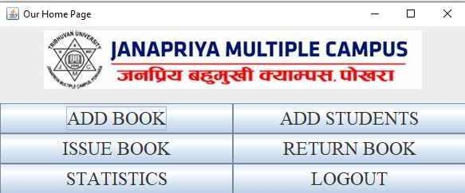

**4.3.Add New Book:**

**Main Source Code:**

*btnSave=new Button("Add");*

*btnSave.setBounds(200,450,150,30);*

*btnSave.setFont(labelFont);*

*btnSave.setBackground(Color.BLACK);*

*btnSave.setForeground(Color.WHITE);*

*add(btnSave);*

*btnClear=new Button("Back");*

*btnClear.setBounds(360,450,150,30);*

*btnClear.setFont(labelFont);*

*btnClear.setBackground(Color.BLACK);*

*btnClear.setForeground(Color.WHITE);*

*add(btnClear);*

*btnSave.addActionListener(new ActionListener() {*

*public void actionPerformed(ActionEvent e) {*

*//dispose();*

*try{*

*conn.dbconnect();*

*insert();*

*conn.close();*

*}*

*catch(Exception ee)*

*{*

*}*

*}*

*});*

*this.addWindowListener(new WindowAdapter() {*

*public void windowClosing(WindowEvent we) {*

*System.exit(0);*

*}*

*});*

*btnClear.addActionListener(new ActionListener() {*

*public void actionPerformed(ActionEvent e)*

*{*

*setVisible(false);*

*new home().setVisible(true);*

*}*

*});*

*setLayout(null);*

*setVisible(true);*

*}*

*public void insert()*

*{*

*String sql="Insert into book values(?,?,?,?,?,?)";*

*try*

*{*

*int i=Edition.getSelectedIndex();*

*s=con.prepareStatement(sql);*

*s.setString(1,txtName.getText());*

*s.setString(2,txtBookID.getText());*

*s.setString(3,Edition.getItem(i));*

*s.setString(4,txtPrice.getText());*

*s.setString(5,textStocks.getText());*

*s.setString(6,txtPublisher.getText());*

*s.executeUpdate();*

*JOptionPane.showMessageDialog(null,"A new nook is added");*

*}*

*catch(Exception ee)*

*{*

*}*

*}*

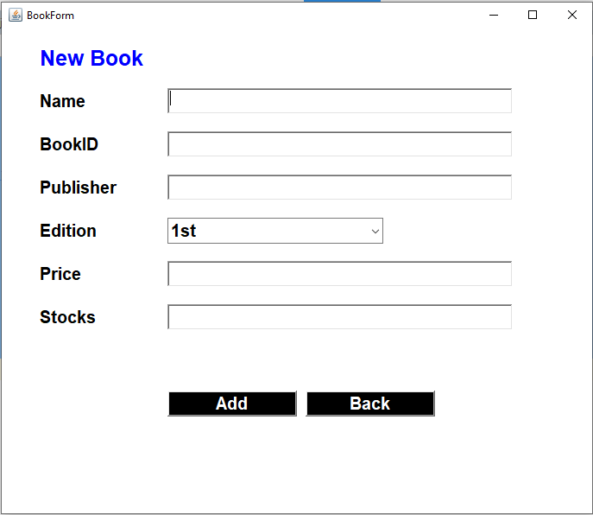

**4.4 Add New Student:**

*register = new JButton("Register");*

*register.setBounds(200, 480, 150, 40);*

*register.setBackground(Color.BLACK);*

*register.setForeground(Color.WHITE);*

*register.setFont(labelFont);*

*F.add(register);*

*back = new JButton("Back");*

*back.setBounds(400, 480, 150, 40);*

*back.setBackground(Color.BLACK);*

*back.setForeground(Color.WHITE);*

*back.setFont(labelFont);*

*F.add(back);*

*back.addActionListener(new ActionListener() {*

*public void actionPerformed(ActionEvent e)*

*{*

*F.setVisible(false);*

*new home().setVisible(true);*

*}*

*});*

*register.addActionListener(new ActionListener() {*

*public void actionPerformed(ActionEvent e) {*

*try*

*{*

*conn.dbconnect();*

*insert();*

*conn.close();*

*}*

*catch(Exception ee)*

*{*

*}*

*}*

*});*

*F.setLayout(null);*

*F.setVisible(true);*

*}*

*public void insert()*

*{*

*String std="Insert into student values(?,?,?,?,?,?,?)";*

*try*

*{*

*int i=course.getSelectedIndex();*

*int j=year.getSelectedIndex();*

*int k=sem.getSelectedIndex();*

*stmt=con.prepareStatement(std);*

*stmt.setString(1,sID.getText());*

*stmt.setString(2,name.getText());*

*stmt.setString(3,Fname.getText());*

*stmt.setString(4,course.getItem(i));*

*stmt.setString(5,branch.getText());*

*stmt.setString(6,year.getItem(j));*

*stmt.setString(7,sem.getItem(k));*

*stmt.executeUpdate();*

*stmt.close();*

*con.close();*

*JOptionPane.showMessageDialog(null, "A student is added");*

*}*

*catch(Exception ee)*

*{*

*ee.printStackTrace();*

*}*

*}*

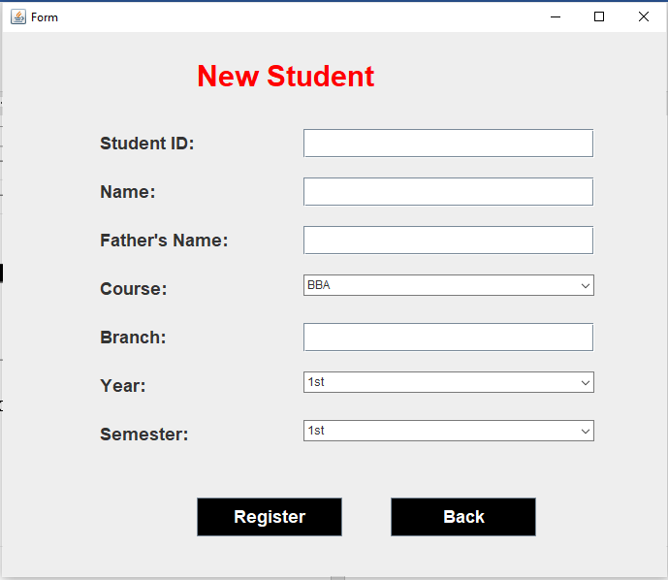

**4.5 Issue Book**

*search1=new Button("Search");*

*search1.setBounds(560,100,80,30);*

*search1.setFont(labelFont);*

*search1.setBackground(Color.BLACK);*

*search1.setForeground(Color.WHITE);*

*add(search1);*

*txtName.setEditable(true);*

*txtBookID.setEditable(false);*

*txtPublisher.setEditable(false);*

*txtPrice.setEditable(false);*

*textStocks.setEditable(false);*

*Edition.setEditable(false);*

*this.addWindowListener(new WindowAdapter() {*

*public void windowClosing(WindowEvent we) {*

*System.exit(0);*

*}*

*});*

*search1.addActionListener(new ActionListener()*

*{*

*public void actionPerformed(ActionEvent ee)*

*{*

*try*

*{*

*conn.dbconnect();*

*searching();*

*conn.close();*

*}*

*catch(Exception e)*

*{*

*}*

*}*

*});*

*back = new JButton("Back");*

*back.setBounds(1060, 530, 140, 30);*

*back.setBackground(Color.BLACK);*

*back.setForeground(Color.WHITE);*

*back.setFont(labelFont);*

*add(back);*

*issue2= new JButton("Issue");*

*issue2.setBounds(900, 530, 140, 30);*

*issue2.setBackground(Color.BLACK);*

*issue2.setForeground(Color.WHITE);*

*issue2.setFont(labelFont);*

*add(issue2);*

*sID.setEditable(true);*

*name.setEditable(false);*

*Fname.setEditable(false);*

*branch.setEditable(false);*

*course.setEditable(false);*

*year.setEditable(false);*

*sem.setEditable(false);*

*date.setEditable(true);*

*issue2.addActionListener(new ActionListener(){*

*public void actionPerformed(ActionEvent e)*

*{*

*try*

*{*

*conn.dbconnect();*

*issue1();*

*conn.close();*

*}*

*catch(Exception ee)*

*{*

*ee.printStackTrace();*

*}*

*}*

*});*

*back.addActionListener(new ActionListener() {*

*public void actionPerformed(ActionEvent e)*

*{*

*dispose();*

*}*

*});*

*setLayout(null);*

*setVisible(true);*

*}*

*public void searching()*

*{*

*String s="Select * from book where bookid=?" ;*

*try*

*{*

*p=con.prepareStatement(s);*

*p.setString(1,txtName.getText());*

*ResultSet rs=p.executeQuery();*

*if(rs.next())*

*{*

*txtBookID.setText(rs.getString(1));*

*txtPublisher.setText(rs.getString(3));*

*txtPrice.setText(rs.getString(4));*

*textStocks.setText(rs.getString(5));*

*Edition.setText(rs.getString(6));*

*}*

*else*

*{*

*JOptionPane.showMessageDialog(null, "Book Id Not Found");*

*}*

*}*

*catch(Exception ee)*

*{*

*System.out.println(ee);*

*}*

*}*

*public void searching2()*

*{*

*String std="Select *from student where stdid=?";*

*try{*

*q=con.prepareStatement(std);*

*q.setString(1,sID.getText());*

*ResultSet rst=q.executeQuery();*

*if(rst.next())*

*{*

*name.setText(rst.getString(2));*

*Fname.setText(rst.getString(3));*

*branch.setText(rst.getString(4));*

*course.setText(rst.getString(5));*

*year.setText(rst.getString(6));*

*sem.setText(rst.getString(7));*

*}*

*else*

*JOptionPane.showMessageDialog(null, "Student id not found");*

*}*

*catch(Exception e)*

*{*

*e.printStackTrace();*

*}*

*}*

*public void issue1()*

*{*

*String stmt="Insert into issue values(?,?,?,?,?,?,?,?,?,?,?,?,?,?) ";*

*try*

*{*

*PreparedStatement st=con.prepareStatement(stmt);*

*st.setString(1, txtBookID.getText());*

*st.setString(2, txtName.getText());*

*st.setString(3, txtPublisher.getText());*

*st.setString(4, txtPrice.getText());*

*st.setString(5, textStocks.getText());*

*st.setString(6, Edition.getText());*

*st.setString(7, sID.getText());*

*st.setString(8, name.getText());*

*st.setString(9, Fname.getText());*

*st.setString(10, course.getText());*

*st.setString(11, branch.getText());*

*st.setString(12, year.getText());*

*st.setString(13, sem.getText());*

*st.setString(14, date.getText());*

*st.executeUpdate();*

*JOptionPane.showMessageDialog(null, "The book is issued");*

*}*

*catch(SQLException ee)*

*{*

*System.out.println(ee);*

*}*

*}*

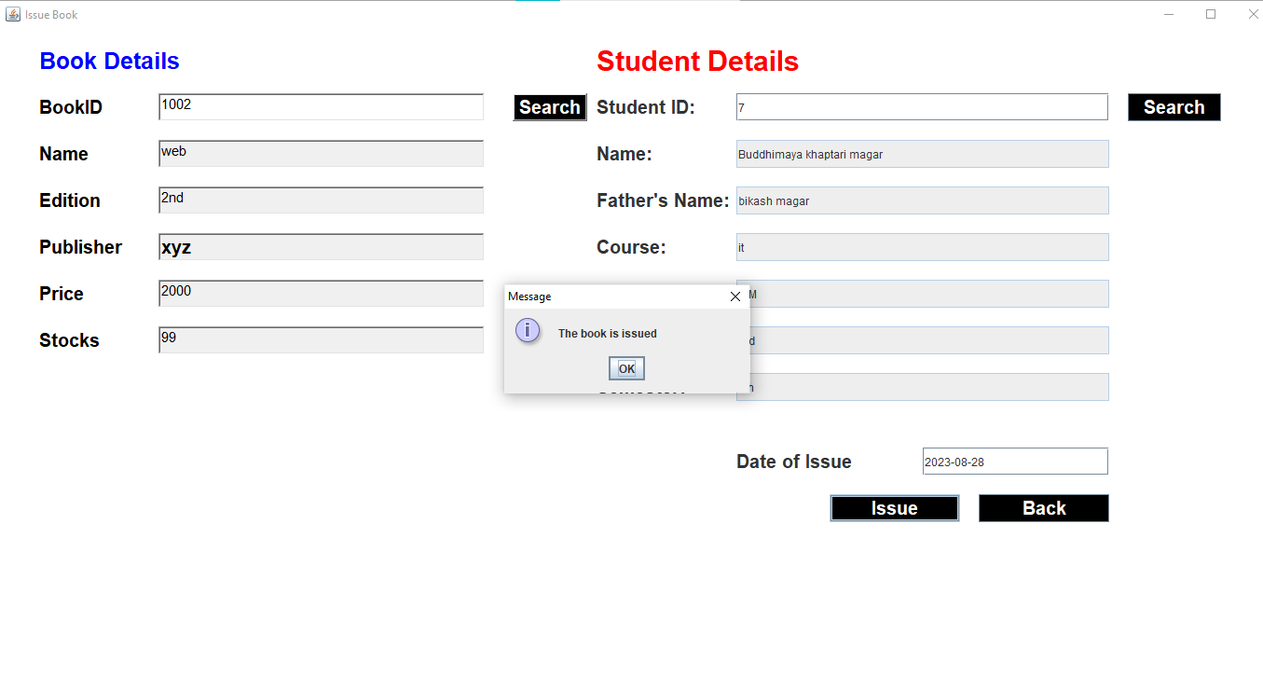

**4.6.Return Book:**

*search = new JButton("Search");*

*search.setBounds(630, 100, 100, 30);*

*search.setBackground(Color.BLACK);*

*search.setForeground(Color.WHITE);*

*search.setFont(labelFont);*

*F.add(search);*

*search.addActionListener(new ActionListener()*

*{*

*public void actionPerformed(ActionEvent e)*

*{*

*try{*

*conn.dbconnect();*

*searching();*

*conn.close();*

*}*

*catch(Exception ee)*

*{*

*ee.printStackTrace();*

*}*

*}*

*});*

*return1=new Button("Return");*

*return1.setBounds(920,530,150,30);*

*return1.setFont(labelFont);*

*return1.setBackground(Color.BLACK);*

*return1.setForeground(Color.WHITE);*

*F.add(return1);*

*return1.addActionListener(new ActionListener() {*

*public void actionPerformed(ActionEvent e)*

*{*

*try {*

*conn.dbconnect();*

*returning();*

*returnupdate();*

*conn.close();*

*} catch (Exception ex) {*

*Logger.getLogger(returnbook.class.getName()).log(Level.SEVERE, null, ex);*

*}*

*}*

*});*

*back = new Button("Back");*

*back.setBounds(1090, 530, 150, 30);*

*back.setBackground(Color.BLACK);*

*back.setForeground(Color.WHITE);*

*back.setFont(labelFont);*

*F.add(back);*

*back.addActionListener(new ActionListener() {*

*public void actionPerformed(ActionEvent e)*

*{*

*F.setVisible(false);*

*new home().setVisible(true);*

*}*

*});*

*public void searching()*

*{*

*String std="Select *from issue where stdid=?";*

*try*

*{*

*q=con.prepareStatement(std);*

*q.setInt(1,Integer.parseInt(sID.getText()));*

*ResultSet rst=q.executeQuery();*

*if(rst.next())*

*{*

*txtName.setText(rst.getString(1));*

*txtBookID.setText(rst.getString(2));*

*Edition.setText(rst.getString(3));*

*txtPrice.setText(rst.getString(4));*

*textStocks.setText(rst.getString(5));*

*txtPublisher.setText(rst.getString(6));*

*name.setText(rst.getString(8));*

*Fname.setText(rst.getString(9));*

*course.setText(rst.getString(10));*

*branch.setText(rst.getString(11));*

*year.setText(rst.getString(12));*

*sem.setText(rst.getString(13));*

*textidate.setText(rst.getString(14));*

*rst.close();*

*q.close();*

*}*

*else*

*{*

*JOptionPane.showMessageDialog(null,*

*"Book is not issued by this student");*

*}*

*}*

*catch(Exception e)*

*{*

*e.printStackTrace();*

*}*

*}*

*public void returning()*

*{*

*String sql="delete from issue where stdid=?";*

*try*

*{*

*p=con.prepareStatement(sql);*

*p.setString(1,sID.getText());*

*p.execute();*

*}*

*catch(Exception e)*

*{*

*JOptionPane.showMessageDialog(null, e);*

*}*

*}*

*public void returnupdate()*

*{*

*String sql="insert into returnbook values(?,?,?,?,?,?,?,?,?,?,?,?,?,?,?)";*

*try{*

*p=con.prepareStatement(sql);*

*//txtName,txtBookID,txtPublisher,txtPrice,textStocks,textidate,textrdate,Edition;*

*//sID, name, Fname, branch,course,year,sem;*

*p.setString(1,sID.getText());*

*p.setString(2,name.getText());*

*p.setString(3,Fname.getText());*

*p.setString(4,course.getText());*

*p.setString(5,branch.getText());*

*p.setString(6,year.getText());*

*p.setString(7,sem.getText());*

*p.setString(8,txtName.getText());*

*p.setString(9,txtBookID.getText());*

*p.setString(10,Edition.getText());*

*p.setString(11,txtPrice.getText());*

*p.setString(12,textStocks.getText());*

*p.setString(13,txtPublisher.getText());*

*p.setString(14,textidate.getText());*

*p.setString(15,textrdate.getText());*

*p.execute();*

*JOptionPane.showMessageDialog(null,"Book Returned");*

*}*

*catch(Exception e)*

*{*

*e.printStackTrace();*

*}*

*}*

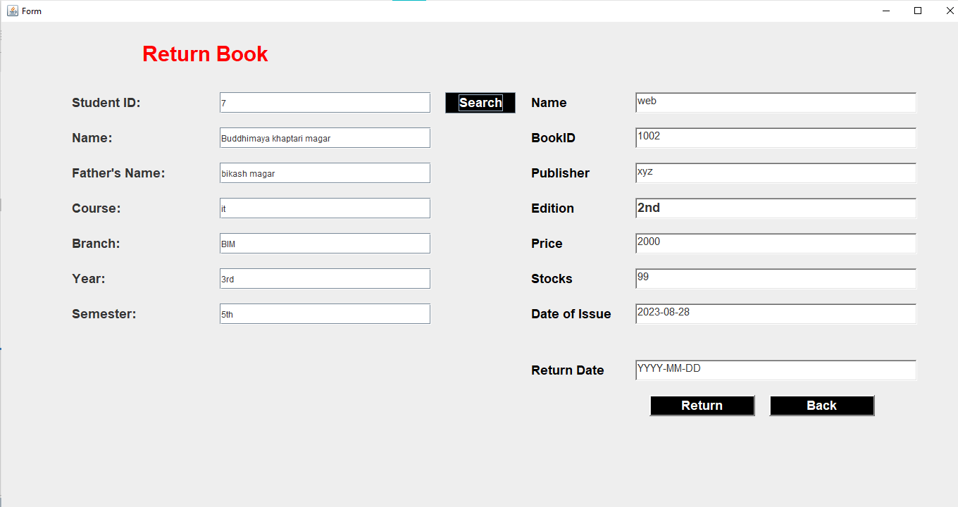

**4.7. Statistics:**

*public void jTable()*

*{*

*try*

*{*

*String sql="Select bookid,bname,edition,publisher,price,stock from issue";*

*pst=con.prepareStatement(sql);*

*rs=pst.executeQuery();*

*//jTable.setModel(DbUtils.resultSetToTableModel(rs));*

*DefaultTableModel model=new DefaultTableModel();*

*model.setColumnIdentifiers(column);*

*t1.setModel(model);*

*String bookid1="";*

*String bname1="";*

*String edition1="";*

*String publisher1="";*

*String price1="";*

*String stock1="";*

*while(rs.next())*

*{*

*bookid1=rs.getString(1);*

*bname1=rs.getString(2);*

*edition1=rs.getString(3);*

*publisher1=rs.getString(4);*

*price1=rs.getString(5);*

*stock1=rs.getString(6);*

*model.addRow(new Object[]{bookid1,bname1,edition1,publisher1,price1,stock1});*

*}*

*}*

*catch(Exception e)*

*{*

*e.printStackTrace();*

*}*

*}*

*public void jTable2()*

*{*

*try*

*{*

*String sql="Select stdid,name,fname,course,branch,year,semester from returnbook";*

*pst=con.prepareStatement(sql);*

*rs=pst.executeQuery();*

*//jTable2.setModel(DbUtils.resultSetToTableModel(rs));*

*DefaultTableModel model=new DefaultTableModel();*

*model.setColumnIdentifiers(column2);*

*t2.setModel(model);*

*String stdid1="";*

*String name1="";*

*String fname1="";*

*String course1="";*

*String branch1="";*

*String year1="";*

*String semester1="";*

*while(rs.next())*

*{*

*stdid1=rs.getString(1);*

*name1=rs.getString(2);*

*fname1=rs.getString(3);*

*course1=rs.getString(4);*

*branch1=rs.getString(5);*

*year1=rs.getString(6);*

*semester1=rs.getString(7);*

*model.addRow(new Object[]{stdid1,name1,fname1,course1,branch1,year1,semester1});*

*}*

*}*

*catch(Exception e)*

*{*

*e.printStackTrace();*

*}*

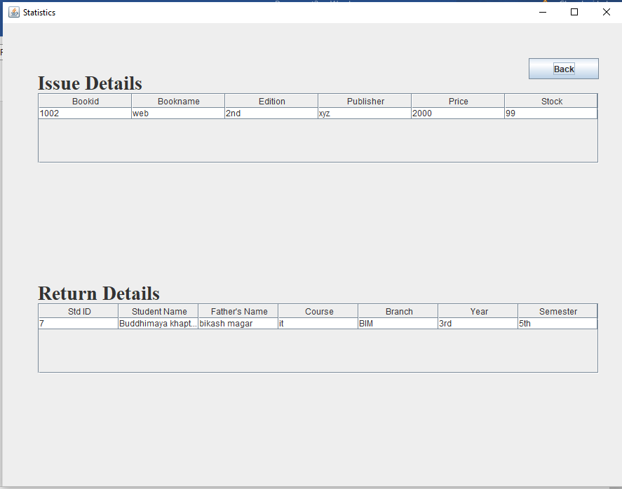

**5.CONCLUSION:**

Library Management System is successfully created as an application.

.