ONLINE NOTES SHARING SYSTEM

21CSC205P Database Management Systems MINI PROJECT REPORT
Submitted by

K. BHARATH [RA2311028010016]
Under the Guidance of

DR. P. MAHALAKSHMI
Assistant Professor, Department of NWC

In partial fulfillment of the requirements for the degree of

BACHELOR OF TECHNOLOGY
in
COMPUTER SCIENCE ENGINEERING
with specialization in CLOUD COMPUTING



DEPARTMENT OF NETWROKING AND COMMUNICATIONS SCHOOL OF COMPUTING
COLLEGE OF ENGINEERING AND TECHNOLOGY SRM INSTITUTE OF SCIENCE ANDTECHNOLOGY KATTANKULATHUR- 603 203

MAY 2025



SRM INSTITUTE OF SCIENCE AND TECHNOLOGY KATTANKULATHUR – 603 203

BONAFIDE CERTIFICATE

Certified that Project Report Titled “ONLINE NOTES SHARING SYSTEM” is the Bonafide work of K.BHARATH [RA2311028010016] who carried out the 21CSC205P DATABASE MANAGEMENT
SYSTEMS mini project work under my supervision

Dr. P. MAHALAKSHMI Dr. M. LAKSHMI
COURSE FACULTY PROFESSOR & HEAD
Assistant Professor Department of
Department Of Networking And
Networking And Communications
Communications

Chapter No | Chapter Name | Page No
1. | Problem understanding, Identification of Entity and Relationships, Construction of DB using ER Model for the project | 1-6
2. | Design of Relational Schemas, Creation of Database Tables For The Project | 7-14
3. | Complex queries based on the concepts of constraints, sets, joins, views, Triggers and Cursors. | 15-21
4. | Analyzing the pitfalls, identifying the dependencies, and applying normalizations | 22-23
5. | Implementation of concurrency control and recovery mechanisms | 24-28
6. | Code For The Project | 29-38
7. | Result and Discussion (Screen shots of the implementation with front end.) | 39-45

ABSTRACT

The Online Notes Sharing System is a web-based application that aims to provide an efficient platform for students, teachers, and academic professionals to share educational materials in the form of notes, study guides, and resources. This system enables users to upload, organize, and share notes with peers, making academic resources more accessible. Built using modern web technologies and a Database Management System (DBMS), the platform offers a user-friendly interface where notes can be categorized by subjects, topics, or courses.
The application ensures data integrity, security, and privacy, with features such as user authentication, role- based access control, and customizable privacy settings for each note shared. A powerful search engine allows users to quickly find the materials they need based on keywords, subjects, or tags. The system also supports the download and review of shared content, encouraging collaboration and enhancing the learning experience. This project aims to bridge the gap between students and teachers, promoting the exchange of knowledge and fostering a community of shared academic resources.

INTRODUCTION
In the modern era of education, digital tools have revolutionized the way knowledge is shared and accessed. The Online Notes Sharing System is a web-based platform designed to provide students, teachers, and academic institutions with a seamless solution for sharing, organizing, and accessing educational materials in the form of notes, study guides, and other academic resources. The system serves as a central hub where users can upload, download, and share notes on various subjects and topics, fostering a collaborative learning environment.
The increasing demand for online learning platforms and the need for accessible educational content has led to the development of this system. With the ability to store and manage large amounts of educational data efficiently, the Online Notes Sharing System leverages a Database Management System (DBMS) to ensure the smooth retrieval, storage, and organization of notes. The application prioritizes user experience by offering a simple yet intuitive interface that allows for easy navigation, categorization of notes, and advanced search functionalities.
Moreover, the system is built with security in mind, providing features like user authentication, data encryption, and role-based access control to protect user privacy and the integrity of shared content. Whether for individual use or group collaboration, this platform aims to enhance the learning process by making educational resources widely available and accessible, empowering users to share knowledge and improve their academic performance.

PROBLEM STATEMENT
Access to quality study materials is a major challenge for students, especially when notes and academic resources are scattered across multiple sources. Traditional note-sharing methods are inefficient, leading to:
Disorganization – Notes are often unstructured, making it difficult to find relevant materials.

Limited Accessibility – Physical or offline methods restrict access to students who are not in close contact with note providers.
Security Concerns – Notes shared through emails or social media may be lost, deleted, or accessed by unauthorized individuals.
Lack of Collaboration – Students lack a unified platform to contribute and benefit from shared knowledge efficiently.
This project aims to solve these issues by developing a centralized online system that allows structured, secure, and efficient sharing of notes. Through categorized storage, user role management, and interactive features, the system enhances accessibility and collaboration among students and educators.

ER DIAGRAM:

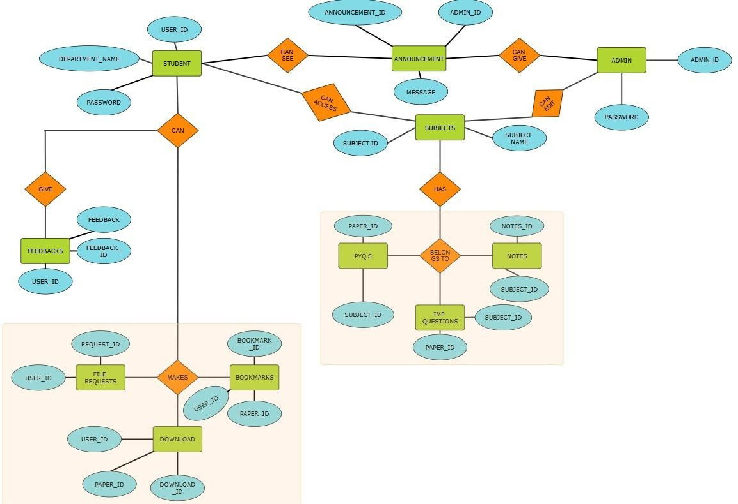

ER DIAGRAM EXPLANATION:

Entities, Attributes, and Relationships in the ER Diagram:

- Entities represent real-world objects in the Online Notes Sharing System. Each entity has attributes and Relationship that describe it.

Entities and Their Attributes, Relationship

- Student

  - Attributes: User ID (PK), Password, Department_name(FK)
  - Relationships:
    - Student can give feedbacks.
    - Student can makes file requests,bookmarks,downloads.

Subjects

  - Attributes: Subject ID (PK),Subject Name.
  - Relationships:
    - A subject belongs to a department (M:1).
    - A subject has multiple notes (1:M with Notes).
    - A subject has multiple CT papers, semester papers, and important papers (1:M)

Notes

  - Attributes: Notes ID (PK), Subject ID (FK)
  - Relationships:
    - A note belongs to a subject (M:1).

PYQ’S

  - Attributes: Paper ID (PK), Subject ID (FK)
- Relationships:
  - A pyq’s paper belongs to a subject (M:1).

Important questions

  - Attributes: Paper ID (PK), Subject ID (FK)

  - Relationships:
    - An Important paper belongs to a subject (M:1).

Admin

  - Attributes: Admin ID (PK), password
  - Relationships:
    - An admin can give announcements, can exit subjects.

Downloads

  - Attributes: Download ID (PK), User ID (FK), Paper ID (FK)
  - Relationships:
    - A user downloads multiple files M:N

Announcements

  - Attributes: Announcement ID (PK), AdminID (FK),
  - Relationships:
    - An admin posts multiple announcements (1:M).

Bookmarks

  - Attributes: Bookmark ID (PK), User ID (FK), File ID (FK)
  - Relationships:
    - A user bookmarks multiple files ( M:N )

Feedback

  - Attributes: Feedback ID (PK), User ID (FK), Feedback.
  - Relationships:
    - A user can submit multiple feedback messages (1:M).

File Requests

  - Attributes: Request ID (PK), User ID (FK), Subject ID (FK)
  - Relationships:
    - A user requests files for a subject (M:1).

CREATING AND INSERTING

STUDENT

Create database review; use review;
CREATE TABLE student (

userid INT auto_increment PRIMARY KEY, name VARCHAR(50)NOT NULL, password VARCHAR(10)NOT NULL,
mail VARCHAR(255) UNIQUE);

INSERT INTO student ( name, password, mail)VALUES ( 'Kaki Nikhilesh', 'pass123', 'nikhilesh@gmail.com'),
( 'Bharath', 'pass456', 'bharath@gmail.com'), ('Harsha','pass897','shampoo@gmail.com’); SELECT * FROM student;

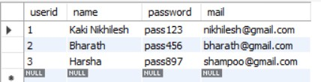

ADMIN

CREATE TABLE admin (

admin_id INT PRIMARY KEY, name VARCHAR(50)NOT NULL,
password VARCHAR(10)NOT NULL, mail VARCHAR(255) UNIQUE);
INSERT INTO admin (admin_id, name, password, mail) VALUES (1, 'Admin A', 'adminpass', 'admina@gmail.com’),
(2, 'Admin B', 'admin567', 'adminb@gmail.com’),

(3, 'Admin C', 'admin999', 'adminc@gmail.com’); SELECT * FROM admin;
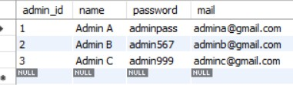

SUBJECTS

CREATE TABLE subjects (

subjectid INT AUTO_INCREMENT PRIMARY KEY,

subjectname VARCHAR(255) UNIQUE); INSERT INTO subjects (subjectname) VALUES ('Database Management Systems'),
('Computer Networks'), ('Probability And Statistics'), ('Social Engineering’);
SELECT * FROM subjects; 8

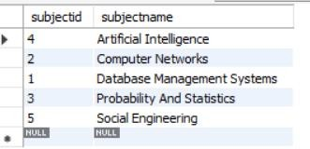

PYQ’S

CREATE TABLE pyqs (

fileid INT AUTO_INCREMENT PRIMARY KEY,

subjectid INT,

FOREIGN KEY (subjectid) REFERENCES subjects(subjectid)); INSERT INTO pyqs (subjectid)
VALUES (1),

(3);

SELECT * FROM pyqs;

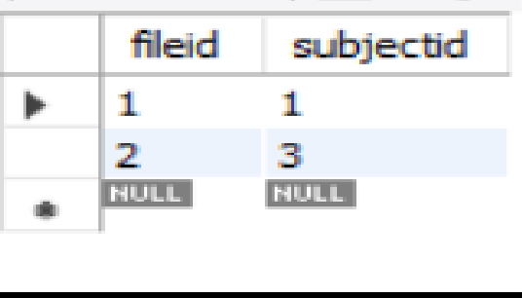

9

IMPORTANT QUESTIONS

CREATE TABLE impquestions (

fileid INT AUTO_INCREMENT PRIMARY KEY,

subjectid INT,

FOREIGN KEY (subjectid) REFERENCES subjects(subjectid)

);

- INSERT INTO impquestions (subjectid) VALUES (2),
(4);

SELECT * FROM impquestions;

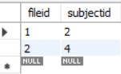

NOTES

CREATE TABLE notes (

fileid INT AUTO_INCREMENT PRIMARY KEY,

subjectid INT,

FOREIGN KEY (subjectid) REFERENCES subjects(subjectid)

);

INSERT INTO notes (subjectid) VALUES (5),
(1);
SELECT * FROM notes; 10

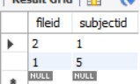

DOWNLOADS

CREATE TABLE downloads (

downloadid INT AUTO_INCREMENT PRIMARY KEY,

fileid INT, userid INT,
file_type ENUM('notes', 'pyq', 'impquestions'), subjectid INT,
FOREIGN KEY (userid) REFERENCES student(userid), FOREIGN KEY (subjectid) REFERENCES subjects(subjectid)
);

INSERT INTO downloads ( fileid, userid, file_type,subjectid) VALUES ( 1, 1, 'notes',1),
( 2, 2, 'pyq',4),

( 1, 1, 'impquestions',5); SELECT * FROM downloads;

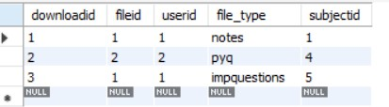

BOOKMARK

CREATE TABLE bookmark (

bookmarkid INT AUTO_INCREMENT PRIMARY KEY,

userid INT, fileid INT,
file_type ENUM('notes', 'pyq', 'impquestions'), subjectid INT,
FOREIGN KEY (userid) REFERENCES student(userid), FOREIGN KEY (subjectid) REFERENCES subjects(subjectid)
);

INSERT INTO bookmark (userid, fileid, file_type, subjectid) VALUES (1, 1, 'notes', 1),
(2, 2, 'pyq', 2),

(3,3,'impquestions',3); SELECT * FROM bookmark;
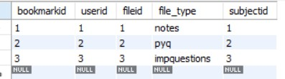

FILE REQUESTS

CREATE TABLE filerequests (

requestid INT auto_increment PRIMARY KEY, userid INT,
request_message TEXT NOT NULL,

FOREIGN KEY (userid) REFERENCES student(userid)

);

INSERT INTO filerequests ( userid,request_message) VALUES ( 1,'Need DBMS CT-2 Papers'),
( 2,'Need End Sem Papers For DBMS’); SELECT * FROM filerequests;
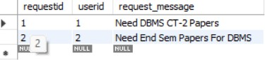

ANNOUNCEMENT

CREATE TABLE announcement (

announcementid INT AUTO_INCREMENT PRIMARY KEY, adminid INT,
message TEXT,

FOREIGN KEY (adminid) REFERENCES admin(admin_id)

);

INSERT INTO announcement ( adminid, message) VALUES ( 1, 'New notes uploaded!'),
( 2, 'Exam schedule released.'), ( 3, 'Results Are Out’);
SELECT * FROM announcement; 13

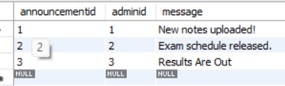

FEEDBACKS

CREATE TABLE feedbacks (

feedbackid INT PRIMARY KEY AUTO_INCREMENT,

userid_sender INT, feedbackmessage TEXT,
FOREIGN KEY (userid_sender) REFERENCES student(userid)

);

INSERT INTO feedbacks (userid_sender, feedbackmessage) VALUES (1, 'Great notes!’),
(2, 'Helpful content!'),

(3,'Good ‘);

SELECT * FROM feedbacks;

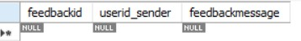

LOGS,TRIGGERS AND CURSORS:

- LOGS
CREATE TABLE logs (
logid INT AUTO_INCREMENT PRIMARY KEY,
action TEXT
);

CREATE TRIGGER after_student_insert AFTER INSERT ON student
FOR EACH ROW
INSERT INTO logs (action) VALUES (CONCAT('New student registered: ', NEW.name));

CREATE TRIGGER after_announcement AFTER INSERT ON announcement FOR EACH ROW
INSERT INTO logs (action) VALUES (CONCAT('Admin ID ', NEW.adminid, ' made an announcement.'));

CREATE TRIGGER after_file_insert AFTER INSERT ON pyqs
FOR EACH ROW
INSERT INTO logs (action) VALUES (CONCAT('New PYQ added for subject ID: ', NEW.subjectid));
;
CREATE TRIGGER after_feedback_insert AFTER INSERT ON feedbacks
FOR EACH ROW
INSERT INTO logs (action) VALUES (CONCAT('Feedback received from User ID: ', NEW.userid_sender));

CREATE TRIGGER after_download_insert AFTER INSERT ON downloads
FOR EACH ROW
INSERT INTO logs (action) VALUES (CONCAT('User ID ', NEW.userid, ' downloaded file ID ', NEW.fileid));

CREATE TRIGGER after_bookmark_insert AFTER INSERT ON bookmark
FOR EACH ROW
INSERT INTO logs (action) VALUES (CONCAT('User ID ', NEW.userid, ' bookmarked file ID ', NEW.fileid));

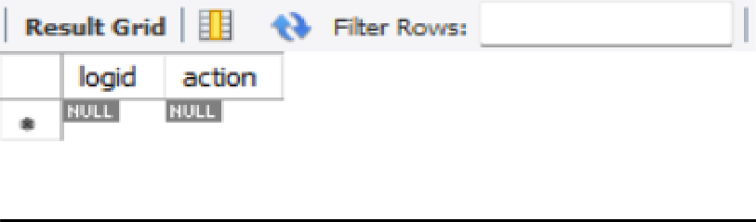

TRIGGER
CREATE VIEW feedback_view AS
SELECT f.feedbackid, s.name AS student_name, f.feedbackmessage FROM feedbacks f
INNER JOIN student s ON f.userid_sender = s.userid;

CREATE VIEW subjects_with_files AS
SELECT s.subjectid, s.subjectname, COUNT(n.fileid) AS total_notes FROM subjects s
LEFT JOIN notes n ON s.subjectid = n.subjectid GROUP BY s.subjectid;

CREATE VIEW file_requests_view AS
SELECT fr.requestid, s.name AS student_name, fr.request_message FROM filerequests fr
INNER JOIN student s ON fr.userid = s.userid;

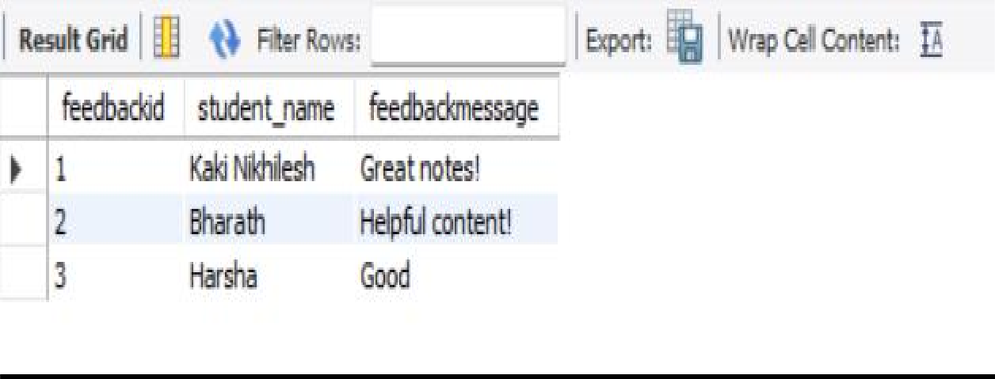

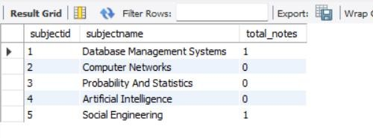
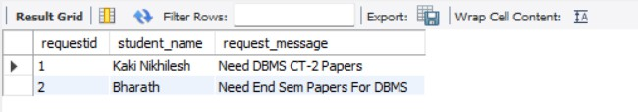

CURSORS
file_requests_viewfile_requests_view DELIMITER //
CREATE PROCEDURE show_students() BEGIN
DECLARE done INT DEFAULT FALSE;
DECLARE student_name VARCHAR(50);
DECLARE cur CURSOR FOR SELECT name FROM student;
DECLARE CONTINUE HANDLER FOR NOT FOUND SET done = TRUE;

OPEN cur; read_loop: LOOP
FETCH cur INTO student_name; IF done THEN
LEAVE read_loop;
END IF;
SELECT student_name; END LOOP;

CLOSE cur; END // DELIMITER ;

DELIMITER //
CREATE PROCEDURE show_subjects() BEGIN
DECLARE done INT DEFAULT FALSE;
DECLARE subj_name VARCHAR(255);
DECLARE cur CURSOR FOR SELECT subjectname FROM subjects; DECLARE CONTINUE HANDLER FOR NOT FOUND SET done = TRUE;

OPEN cur; read_loop: LOOP
FETCH cur INTO subj_name; IF done THEN
LEAVE read_loop;
END IF;
SELECT subj_name;
END LOOP;

CLOSE cur; END // DELIMITER ;

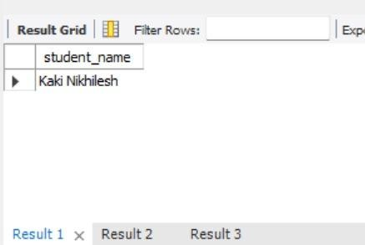

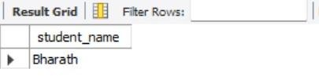

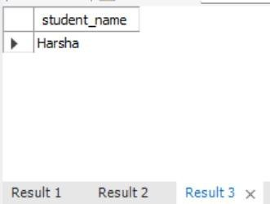

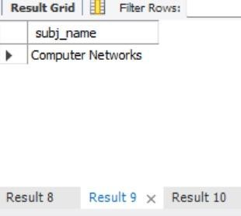

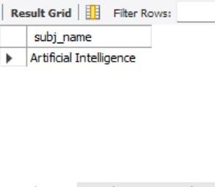

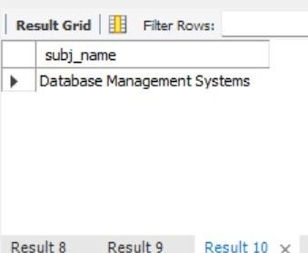

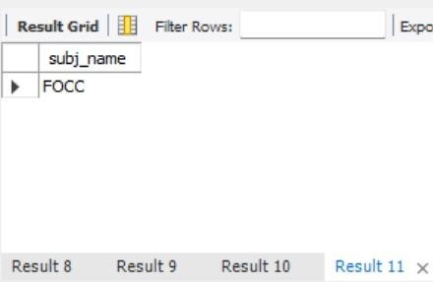

NORMALIZATION:
CREATE TABLE subjects (

subjectid INT AUTO_INCREMENT PRIMARY KEY,

subjectname VARCHAR(255) UNIQUE

);

CREATE TABLE pyqs (

fileid INT AUTO_INCREMENT PRIMARY KEY,

subjectid INT,

FOREIGN KEY (subjectid) REFERENCES subjects(subjectid)

);

CREATE TABLE impquestions (

fileid INT AUTO_INCREMENT PRIMARY KEY,

subjectid INT,

FOREIGN KEY (subjectid) REFERENCES subjects(subjectid)

);

CREATE TABLE notes (

fileid INT AUTO_INCREMENT PRIMARY KEY,

subjectid INT,

FOREIGN KEY (subjectid) REFERENCES subjects(subjectid));

CREATE TABLE files (

fileid INT AUTO_INCREMENT PRIMARY KEY,

subjectid INT, file_type_id INT,
FOREIGN KEY (subjectid) REFERENCES subjects(subjectid),

FOREIGN KEY (file_type_id) REFERENCES file_type_reference(file_type_id)

);
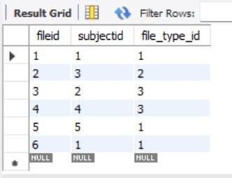

CONCURRENCY CONTROL AND RECOVERY MECHANISMS

START TRANSACTION;
INSERT INTO student (name, password, mail)
VALUES ('Kaki Nikhilesh', 'pass123', 'nikhilesh@gmail.com'), ('Bharath', 'pass456', 'bharath@gmail.com'),
('Harsha', 'pass897', 'shampoo@gmail.com'); COMMIT;
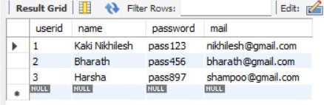

START TRANSACTION;

INSERT INTO admin (admin_id, name, password, mail) VALUES (1, 'Admin A', 'adminpass', 'admina@gmail.com'),
(2, 'Admin B', 'admin567', 'adminb@gmail.com'),
(3, 'Admin C', 'admin999', 'adminc@gmail.com');

COMMIT;
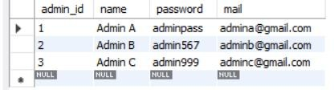

START TRANSACTION;

INSERT INTO subjects (subjectname) VALUES ('Database Management Systems'),
('Computer Networks'), ('Probability And Statistics'), ('Artificial Intelligence'), ('Social Engineering');

COMMIT;
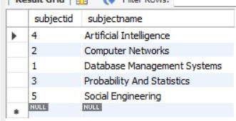

START TRANSACTION;
INSERT INTO file_type_reference (file_type_name) VALUES ('notes'), ('pyq'), ('impquestions'); COMMIT;

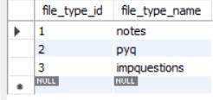

START TRANSACTION;

INSERT INTO files (subjectid, file_type_id) VALUES (1, 1), (3, 2), (2, 3), (4, 3), (5, 1), (1, 1); COMMIT;

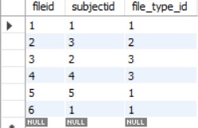

START TRANSACTION;
INSERT INTO feedbacks (userid_sender, feedbackmessage) VALUES (1, 'Great notes!'),
(2, 'Helpful content!'),
(3, 'Good'); COMMIT;

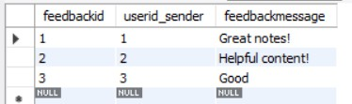

START TRANSACTION;
INSERT INTO downloads (fileid, userid) 26

VALUES (1, 1), (2, 2), (3, 1); COMMIT;

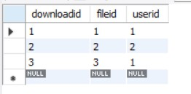

START TRANSACTION;
INSERT INTO bookmark (userid, fileid) VALUES (1, 1), (2, 2), (3, 3); COMMIT;

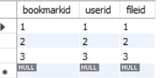

START TRANSACTION;

INSERT INTO filerequests (userid, request_message) VALUES (1, 'Need DBMS CT-2 Papers'),
(2, 'Need End Sem Papers For DBMS'); COMMIT; 27

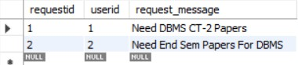

START TRANSACTION;
INSERT INTO announcement (adminid, message) VALUES (1, 'New notes uploaded!'),
(2, 'Exam schedule released.'), (3, 'Results Are Out');

COMMIT;

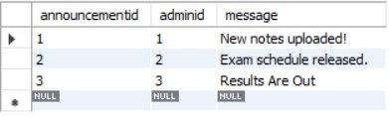

28

CODE FOR THE PROJECT:

CREATE DATABASE review4;
USE review4;

CREATE TABLE student (
userid INT AUTO_INCREMENT PRIMARY KEY, name VARCHAR(50) NOT NULL,
password VARCHAR(10) NOT NULL CHECK (LENGTH(password) >= 6), mail VARCHAR(255) UNIQUE
);

CREATE TABLE admin (
admin_id INT PRIMARY KEY, name VARCHAR(50) NOT NULL,
password VARCHAR(10) NOT NULL, mail VARCHAR(255) UNIQUE
);

CREATE TABLE subjects (
subjectid INT AUTO_INCREMENT PRIMARY KEY,
subjectname VARCHAR(255) UNIQUE

);
CREATE TABLE file_type_reference ( 29

file_type_id INT AUTO_INCREMENT PRIMARY KEY,
file_type_name ENUM('notes', 'pyq', 'impquestions') UNIQUE NOT NULL
);

CREATE TABLE files (
fileid INT AUTO_INCREMENT PRIMARY KEY,
subjectid INT, file_type_id INT,
FOREIGN KEY (subjectid) REFERENCES subjects(subjectid),
FOREIGN KEY (file_type_id) REFERENCES file_type_reference(file_type_id)
);

CREATE TABLE feedbacks (
feedbackid INT AUTO_INCREMENT PRIMARY KEY,

userid_sender INT, feedbackmessage TEXT,
FOREIGN KEY (userid_sender) REFERENCES student(userid)
);

CREATE TABLE downloads (
downloadid INT AUTO_INCREMENT PRIMARY KEY,
fileid INT, userid INT,
FOREIGN KEY (fileid) REFERENCES files(fileid), 30

FOREIGN KEY (userid) REFERENCES student(userid)

);
CREATE TABLE bookmark (
bookmarkid INT AUTO_INCREMENT PRIMARY KEY,
userid INT, fileid INT,
FOREIGN KEY (userid) REFERENCES student(userid), FOREIGN KEY (fileid) REFERENCES files(fileid)
);
CREATE TABLE filerequests (
requestid INT AUTO_INCREMENT PRIMARY KEY,
userid INT,
request_message TEXT NOT NULL,

FOREIGN KEY (userid) REFERENCES student(userid)
);
CREATE TABLE announcement (
announcementid INT AUTO_INCREMENT PRIMARY KEY, adminid INT,
message TEXT,
FOREIGN KEY (adminid) REFERENCES admin(admin_id)

);

CREATE TABLE logs (
logid INT AUTO_INCREMENT PRIMARY KEY, 31

action TEXT

);

START TRANSACTION;
INSERT INTO student (name, password, mail)
VALUES ('Kaki Nikhilesh', 'pass123', 'nikhilesh@gmail.com'), ('Bharath', 'pass456', 'bharath@gmail.com'),
('Harsha', 'pass897', 'shampoo@gmail.com'); COMMIT;

START TRANSACTION;
INSERT INTO admin (admin_id, name, password, mail) VALUES (1, 'Admin A', 'adminpass', 'admina@gmail.com'),
(2, 'Admin B', 'admin567', 'adminb@gmail.com'),
(3, 'Admin C', 'admin999', 'adminc@gmail.com'); COMMIT;

START TRANSACTION;
INSERT INTO subjects (subjectname) VALUES ('Database Management Systems'),
('Computer Networks'), ('Probability And Statistics'), ('Artificial Intelligence'),
('Social Engineering'); 32

COMMIT;

START TRANSACTION;
INSERT INTO file_type_reference (file_type_name) VALUES ('notes'), ('pyq'), ('impquestions'); COMMIT;

START TRANSACTION;

INSERT INTO files (subjectid, file_type_id) VALUES (1, 1), (3, 2), (2, 3), (4, 3), (5, 1), (1, 1); COMMIT;

START TRANSACTION;
INSERT INTO feedbacks (userid_sender, feedbackmessage) VALUES (1, 'Great notes!'),
(2, 'Helpful content!'),
(3, 'Good'); COMMIT;

START TRANSACTION;
INSERT INTO downloads (fileid, userid) VALUES (1, 1), (2, 2), (3, 1);

COMMIT;
33

START TRANSACTION;

INSERT INTO bookmark (userid, fileid) VALUES (1, 1), (2, 2), (3, 3); COMMIT;

START TRANSACTION;
INSERT INTO filerequests (userid, request_message) VALUES (1, 'Need DBMS CT-2 Papers'),
(2, 'Need End Sem Papers For DBMS'); COMMIT;

START TRANSACTION;
INSERT INTO announcement (adminid, message) VALUES (1, 'New notes uploaded!'),
(2, 'Exam schedule released.'), (3, 'Results Are Out');

COMMIT;

CREATE VIEW feedback_view AS
SELECT f.feedbackid, s.name AS student_name, f.feedbackmessage FROM feedbacks f
JOIN student s ON f.userid_sender = s.userid;
CREATE VIEW file_requests_view AS 34

SELECT fr.requestid, s.name AS student_name, fr.request_message FROM filerequests fr
JOIN student s ON fr.userid = s.userid;

CREATE TRIGGER after_student_insert AFTER INSERT ON student

FOR EACH ROW
INSERT INTO logs (action) VALUES (CONCAT('New student registered: ', NEW.name));

CREATE TRIGGER after_announcement AFTER INSERT ON announcement FOR EACH ROW
INSERT INTO logs (action) VALUES (CONCAT('Admin ID ', NEW.adminid, ' made an announcement.'));

CREATE TRIGGER after_file_insert AFTER INSERT ON files

FOR EACH ROW

INSERT INTO logs (action) VALUES (CONCAT('New file added for subject ID: ', NEW.subjectid));

CREATE TRIGGER after_feedback_insert AFTER INSERT ON feedbacks

FOR EACH ROW 35

INSERT INTO logs (action) VALUES (CONCAT('Feedback received from User ID: ', NEW.userid_sender));

CREATE TRIGGER after_download_insert AFTER INSERT ON downloads

FOR EACH ROW
INSERT INTO logs (action) VALUES (CONCAT('User ID ', NEW.userid, ' downloaded file ID ', NEW.fileid));

CREATE TRIGGER after_bookmark_insert AFTER INSERT ON bookmark

FOR EACH ROW
INSERT INTO logs (action) VALUES (CONCAT('User ID ', NEW.userid, ' bookmarked file ID ', NEW.fileid));

DELIMITER //
CREATE PROCEDURE show_students() BEGIN
DECLARE done INT DEFAULT FALSE;
DECLARE student_name VARCHAR(50);
DECLARE cur CURSOR FOR SELECT name FROM student;
DECLARE CONTINUE HANDLER FOR NOT FOUND SET done = TRUE;
OPEN cur; 36

read_loop: LOOP

FETCH cur INTO student_name; IF done THEN
LEAVE read_loop; END IF;
SELECT student_name; END LOOP;
CLOSE cur; END // DELIMITER ;

DELIMITER //
CREATE PROCEDURE show_subjects() BEGIN
DECLARE done INT DEFAULT FALSE;
DECLARE subj_name VARCHAR(255);
DECLARE cur CURSOR FOR SELECT subjectname FROM subjects; DECLARE CONTINUE HANDLER FOR NOT FOUND SET done = TRUE;

OPEN cur; read_loop: LOOP
FETCH cur INTO subj_name; IF done THEN
LEAVE read_loop; 37

END IF;

SELECT subj_name; END LOOP;
CLOSE cur; END // DELIMITER ;

SELECT * FROM student; SELECT * FROM admin; SELECT * FROM subjects;
SELECT * FROM file_type_reference; SELECT * FROM files;
SELECT * FROM downloads; SELECT * FROM bookmark; SELECT * FROM feedbacks; SELECT * FROM filerequests; SELECT * FROM announcement; SELECT * FROM logs;
SELECT * FROM feedback_view; SELECT * FROM file_requests_view; CALL show_students();
CALL show_subjects();

Frontend Outputs:

