* **MODULE – 4 Automation Core Testing**

**(Load Runner Up and Selenium IDE)**

1. **Which components have you used in Load Runner?**

* Ans: **Load Generator** generates the load against the application by following scripts
* **VuGen**  (Virtual User Generator) for generating and editing scripts
* **Controller** controls, launches and sequences instances of Load Generator - specifying which script to use, for how long etc. During runs the Controller receives real-time monitoring data and displays status.
* **Agent process** manages connection between Controller and Load Generator instances.
* **Analysis** assembles logs from various load generators and formats reports for visualization of run result data and monitoring data.

**2. How can you set the number of Vusers in Load Runner?**

* Ans: Edit the .lrp file that corresponds to the protocol you use to create VuGen Script. Paste MaxThreadPerProcess=10 after [Vugen]. Or edit this variable if it already exists.
* You can set the number of Vusers in the controller section while creating your scenarios. Many other advanced options like ramp-up, ramp-down of Vusers are also available in the Controller section.

**3.What is Correlation?**

* Correlation refers to the statistical relationship between two entities. In other words, it's how two variables move in relation to one another. Correlation can be used for various data sets, as well. In some cases, you might have predicted how things will correlate, while in others, the relationship will be a surprise to you. It's important to understand that correlation does not mean the relationship is causal.

**4.What is the process for developing a Vuser Script?**

**Ans:**

There are 5 steps for developing a vuser script.

1- Recording the vuser script.

2- Edit the vuser script.

3- Runtime setting.

4- Run the vuser script in stand-alone mode.

5- Incorporate the vuser script into a load runner scenario.

**5. How Load Runner interacts with the application?**

* Load Runner simulates user activity by generating messages between application components or by simulating interactions with the user interface such as key presses or mouse movements. The messages and interactions to be generated are stored in scripts.
* There are two types of a content check which can be used in LoadRunner: Text Check: This checks for a text/string on the web page. Image Check: This checks for an image on a web page

**6 How many V Users are required for load testing?**

**Ans**:

* If your only goal is to simulate a certain number of transactions in a certain time period, you can do that with quite few virtual users in the test.
* If your average transaction time for 7 transactions is 16 seconds it means you can do 7/16 transactions per second, using a single virtual user.
* To get 10,000 transactions in an hour you would have to use multiple concurrent virtual users.

**7. What is the relationship between Response Time and Throughput?**

**Ans**:

* Response time and throughput are related. The response time for an average transaction tends to decrease as you increase overall throughput. However, you can decrease the response time for a specific query, at the expense of overall throughput, by allocating a disproportionate amount of resources to that query.

**8.What is the difference between hits/second and requests/second?**

**Ans**

* Hits/second are the numbers of HTTP requests made by VUsers0 to the Web Server in a scenario or session step run on a per second basis. Requests/second are the numbers of requests completed during each second of scenario run.

**9. create a normal script of above website with correlate using hp default website**

**Ans**:

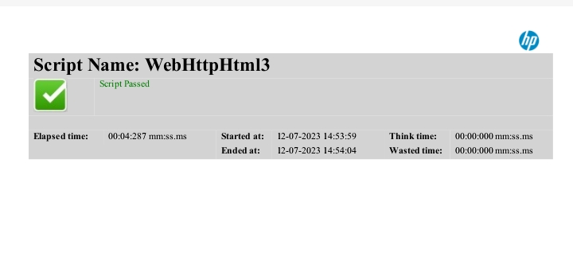

**10.What is Automation Testing?**

**Answer**:

* Automation Testing is a software testing technique that performs using special automated testing software tools to execute a test case suite. On the contrary, Manual Testing is performed by a human sitting in front of a computer carefully executing the test steps.

**11. Which Are The Browsers Supported By Selenium Ide?**

**Ans**:

* Different Browsers Supported By Selenium Ide

e.g.- Firefox, chrome

**12.** **What are the benefits of Automation Testing?**

**Answer**:

* Hear are the key benefit

1. 70% faster than the manual testing
2. Wider test coverage of application features
3. Reliable in results
4. Ensure Consistency
5. Saves Time and Cost
6. Improves accuracy
7. Human Intervention is not required while execution
8. Increases Efficiency
9. Better speed in executing tests

10. Re-usable test scripts

11. Test frequently and thoroughly

12. More cycle of execution can be achieved through aut

13. Early time to mark

13. **What are the advantages of Selenium?**

**Answer**:

* Advantage of Selenium

1. Very easy to use and install.
2. No programming experience is required, through knowledge of HTML and DOM are needed.
3. Can export tests to formats usable in Selenium RC and WebDriver.
4. Have built-in help and test results reporting module.
5. Provides support for extensions.

**14. Why testers should opt for Selenium and not QTP?**

**Ans**:

* Selenium, however, supports a wide range of programming languages. QTP/UFT test scripts run only on the Windows environment. They cannot be run across all browsers. On the other hand, Selenium is OS independent and allows test scripts to run across all browsers.

**15. Java script**

**Ans:** <https://github.com/krishnamadhad09/krishna_tops_testing/blob/main/java%20script.txt>