Project 4: Measure Energy Consumption

**Development Part 2:**

* In this part you will continue building your project.
* Continue the development by:
* Analyzing the energy consumption data
* Creating visualizations.
* We training our Measure Energy Consumption with help of the below dataset link

[**https://www.kaggle.com/datasets/robikscube/hourly-energy-consumption**](https://www.kaggle.com/datasets/robikscube/hourly-energy-consumption)

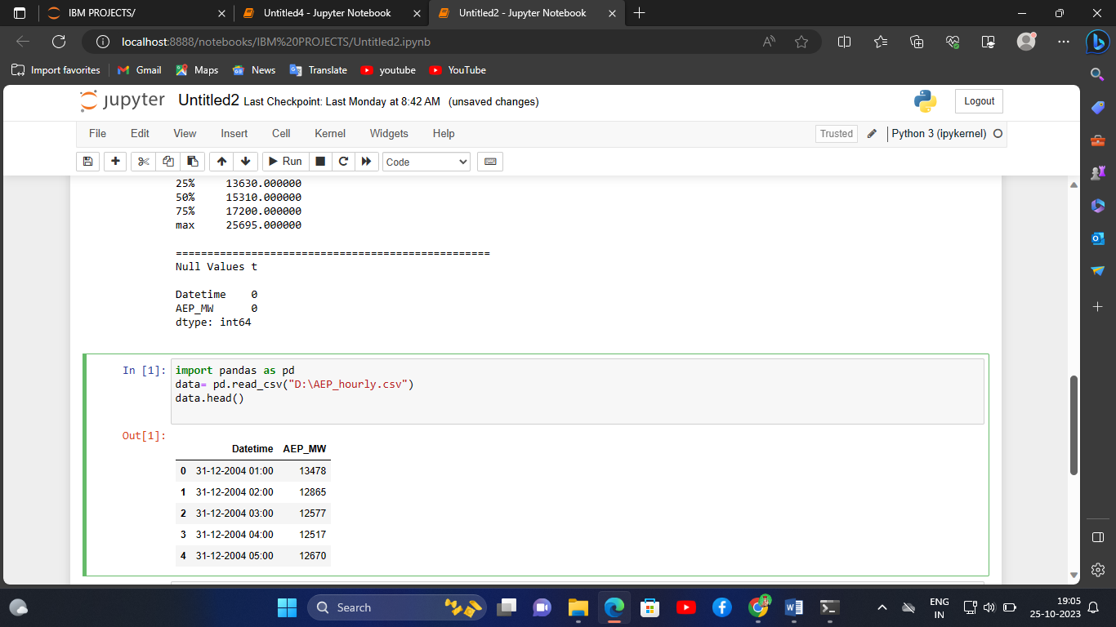

**PROGRAM CODE:**

import pandas as pd

import numpy as np

import matplotlib.pyplot as plt

import seaborn as sns

import pprint

df = pd.read_csv("D:\AEP_hourly.csv")

print("="*50)

print("First Five Rows ","\n")

print(df.head(2),"\n")

print("="*50)

print("Information About Dataset","\n")

print(df.info(),"\n")

print("="*50)

print("Describe the Dataset ","\n")

print(df.describe(),"\n")

print("="*50)

print("Null Values t ","\n")

print(df.isnull().sum(),"\n")

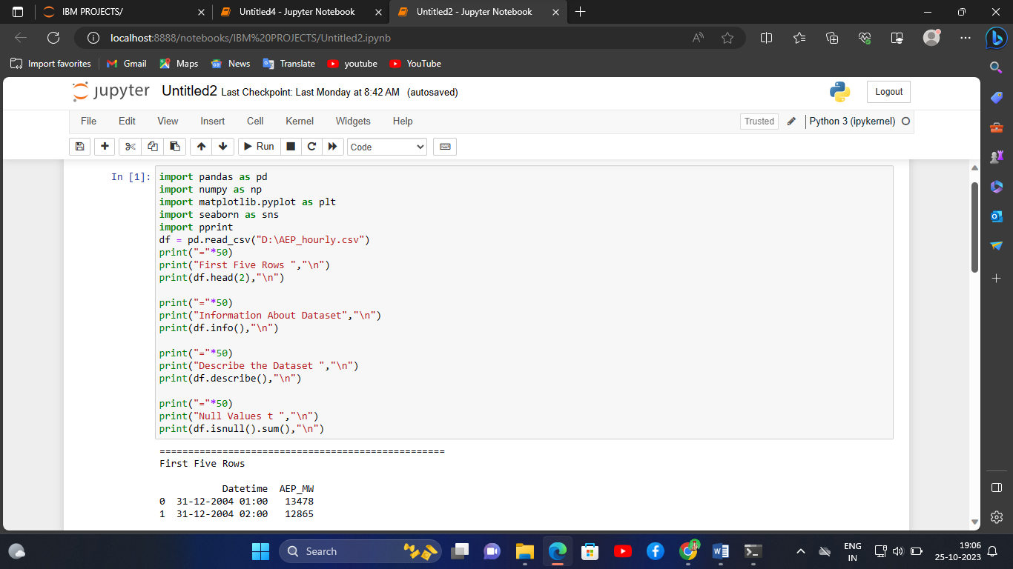

**OUTPUT:**

==================================================

First Five Rows

Datetime AEP_MW

0 31-12-2004 01:00 13478

1 31-12-2004 02:00 12865

==================================================

Information About Dataset

<class 'pandas.core.frame.DataFrame'>

RangeIndex: 121273 entries, 0 to 121272

Data columns (total 2 columns):

# Column Non-Null Count Dtype

--- ------ -------------- -----

0 Datetime 121273 non-null object

1 AEP_MW 121273 non-null int64

dtypes: int64(1), object(1)

memory usage: 1.9+ MB

None

==================================================

Describe the Dataset

AEP_MW

count 121273.000000

mean 15499.513717

std 2591.399065

min 9581.000000

25% 13630.000000

50% 15310.000000

75% 17200.000000

max 25695.000000

==================================================

Null Values t

Datetime 0

AEP_MW 0

dtype: int64

