**PROJECT 4: MEASURE ENERGY CONSUMPUTION**

**Phase 3: Development Part 1**

In this part you will begin building your project by loading and preprocessing the dataset.

We provide a code to implement the dataset and preprocessing the data. Then, we cleaned the data in the dataset.

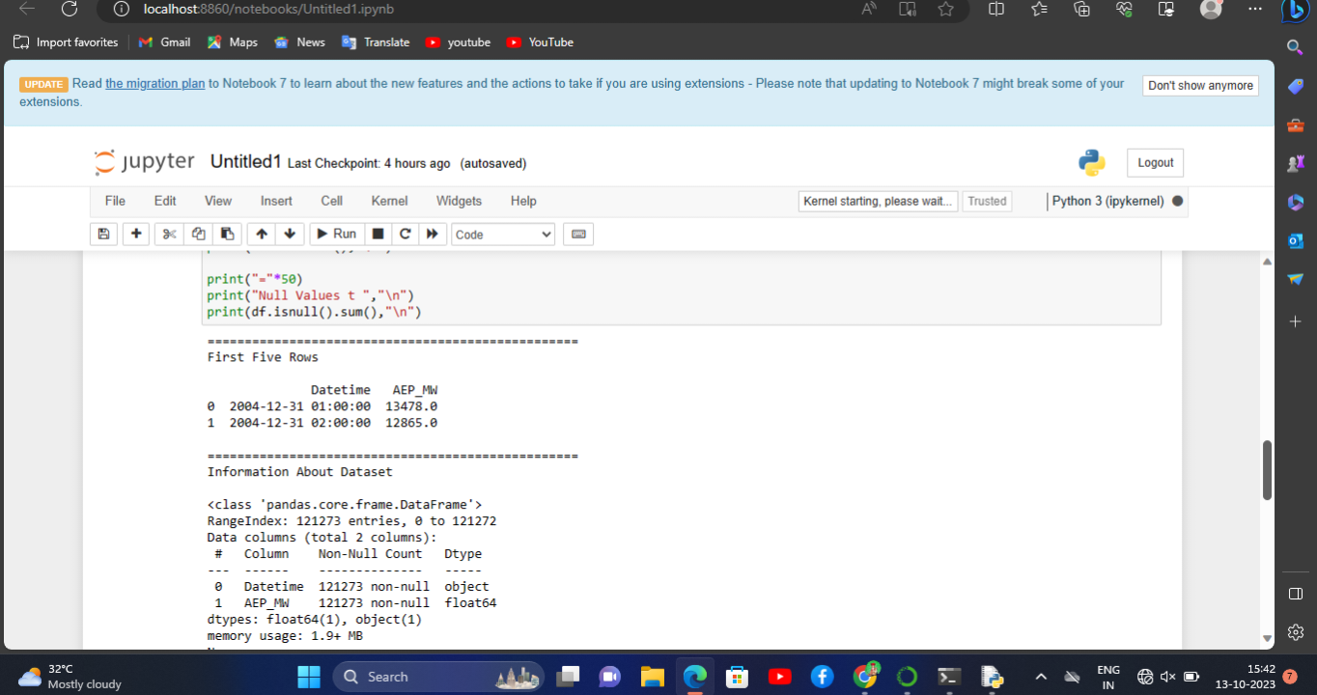

We process the code and import the dataset. Then, we get the output from the dataset.

We got the data easily.