# 0.Assumption

input files will have valid values

# 1.reading input file

I followed object-oriented design for represent object. created Mission<class> with properties that will hold Mission details. So I am reading input files and holding data List<Mission> object

Its given int value in problem statement for value. But It might be float also so I am assuming it float and did computation.

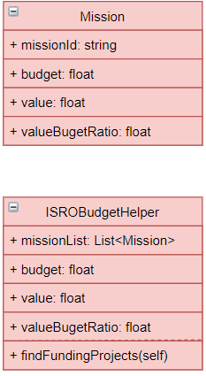

# 2.Analysis

I need to select the missions to be funded having maximize value. I am calculating value to budget ratio, selecting mission having higher ratio will maximize value.

I am using merge sort algorithm to sort list of mission by valueBudgetRatio descending order. So highest value mission will come at first place ,2nd on second place and so on.

Time complexity of this process is : **O(nlogn)**

And iterating mission list ,adding if sum of added mission budget is less than total budget cost.Time complexity to iterate mission : **O(n)**

**total time complexity = O(n) + O(nlogn) =O(nlogn)**