Bugzilla is an open-source issue/bug tracking system that allows developers to keep track of outstanding problems with their product.
Bugzilla is a Defect tracking tool, however, it can be used as a test management tool as such it can be easily linked with other Test Case management tools like Quality Center, Testlink etc.

Key features of Bugzilla includes
- Advanced search capabilities
- E-mail Notifications
- Modify/file Bugs by e-mail
- Time tracking
- Strong security
- Customization
- Localization
Step 1) Use the following link for your hands-on. To create an account in Bugzilla tool or to login into the existing account go to New Account or Log in option in the main menu.
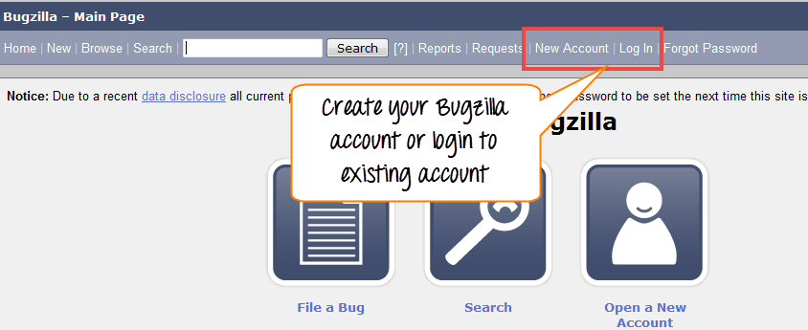
Step 2) Now, enter your personal details to log into Bugzilla
- User ID
- Password
- And then click on “Log in”
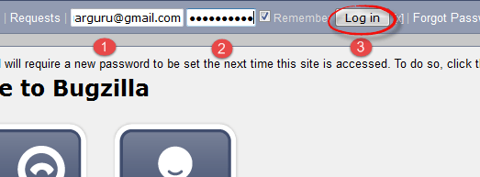
Step 3) You are successfully logged into Bugzilla system
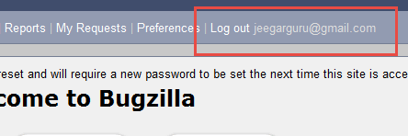
With an account, the most common task is filing a new defect.
Creating a Bug-report in Bugzilla
Step 1) To create a new bug in Bugzilla, visit the home-page of Bugzilla and click on NEW tab from the main menu
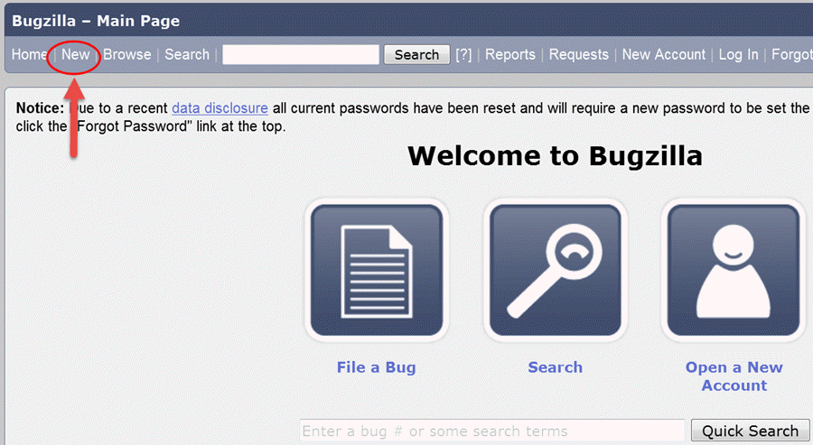
Step 2) In the next window
- Enter Product
- Enter Component
- Give Component description
- Select version,
- Select severity
- Select Hardware
- Select OS
- Enter Summary
- Enter Description
- Attach Attachment
- Submit
NOTE: The above fields will vary as per your customization of Bugzilla
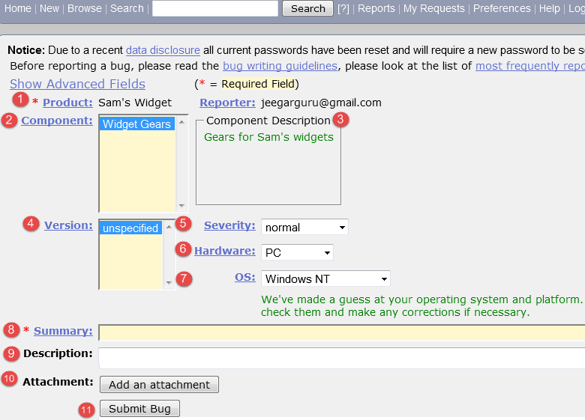
NOTE: The mandatory fields are marked with *.
In our case field’s
- Summary
- Description
Are mandatory
If you do not fill them you will get a screen like below
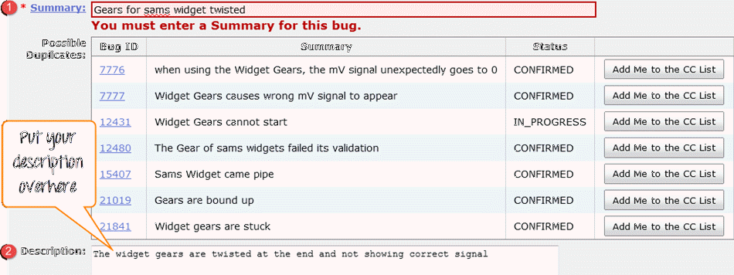
Step 4) Bug is created ID# 26320 is assigned to our Bug. You can also add additional information to the assigned bug like URL, keywords, whiteboard, tags, etc. This extra-information is helpful to give more detail about the Bug you have created.
- Large text box
- URL
- Whiteboard
- Keywords
- Tags
- Depends on
- Blocks
- Attachments
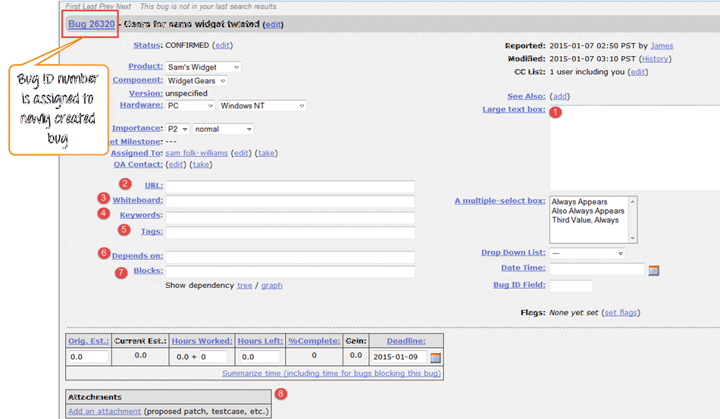
Step 5) In the same window if you scroll down further. You can select deadline date and also status of the bug. Deadline in Bugzilla usually gives the time-limit to resolve the bug in given time frame.
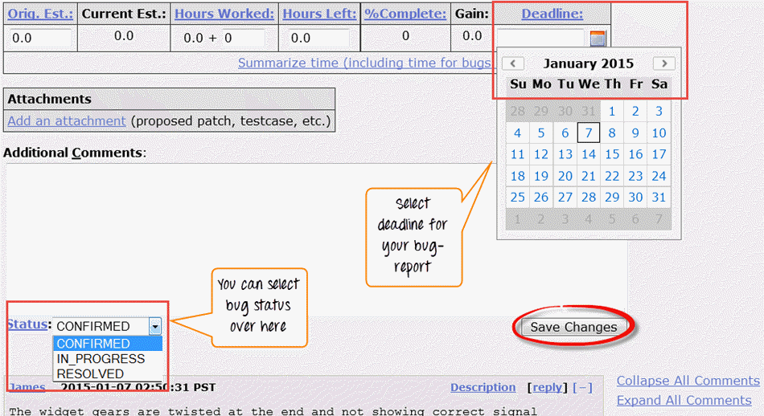

Create Graphical Reports
Graphical reports are one way to view the current state of the bug database. You can run reports either through an HTML table or graphical line/pie/bar-chart-based one. The idea behind graphical report in Bugzilla is to define a set of bugs using the standard search interface and then choosing some aspect of that set to plot on the horizontal and vertical axes. You can also get a 3-dimensional report by choosing the option of “Multiple Pages”.
Reports are helpful in many ways, for instance, if you want to know which component has the largest number of bad bugs reported against it. In order to represent that in the graph, you can select severity on X-axis and component on Y-axis, and then click on generate a report. It will generate a report with crucial information.
