## Description / Documentation

This document provides an overview and detailed explanation of the Power BI dashboard components, including visualizations, data sources, and key metrics.

## 1. Overview

The Power BI dashboard is designed to provide real-time insights into various aspects of the business, including sales performance, customer demographics, and operational efficiency.

Figure 1: Energy Consumption Insights Dashboard

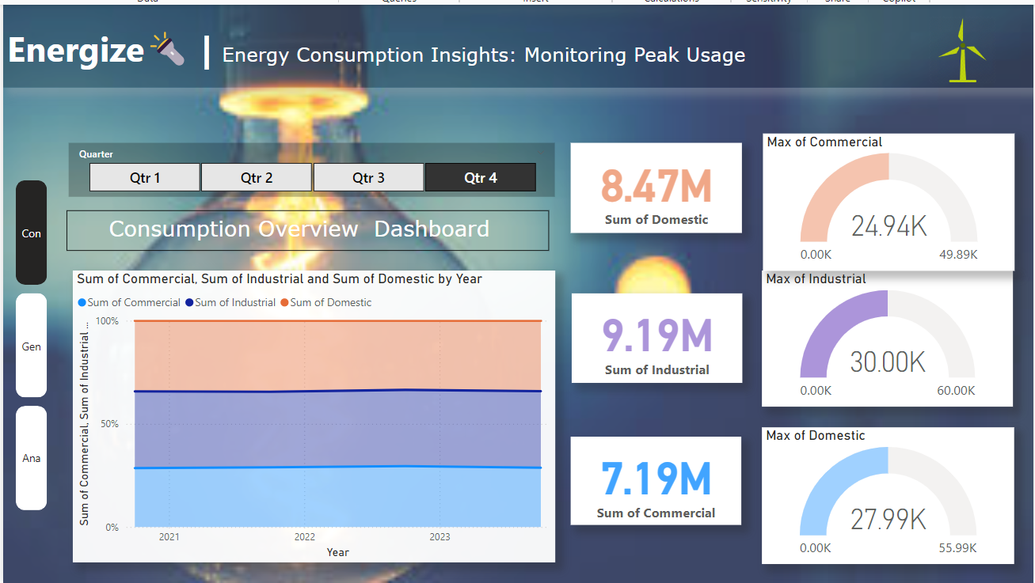

## 2. WindStream: Energy Metrics and Analysis

This section covers the analysis of renewable energy metrics over the years with a focus on wind energy production and its correlation with wind speed.

Figure 2: WindStream Dashboard

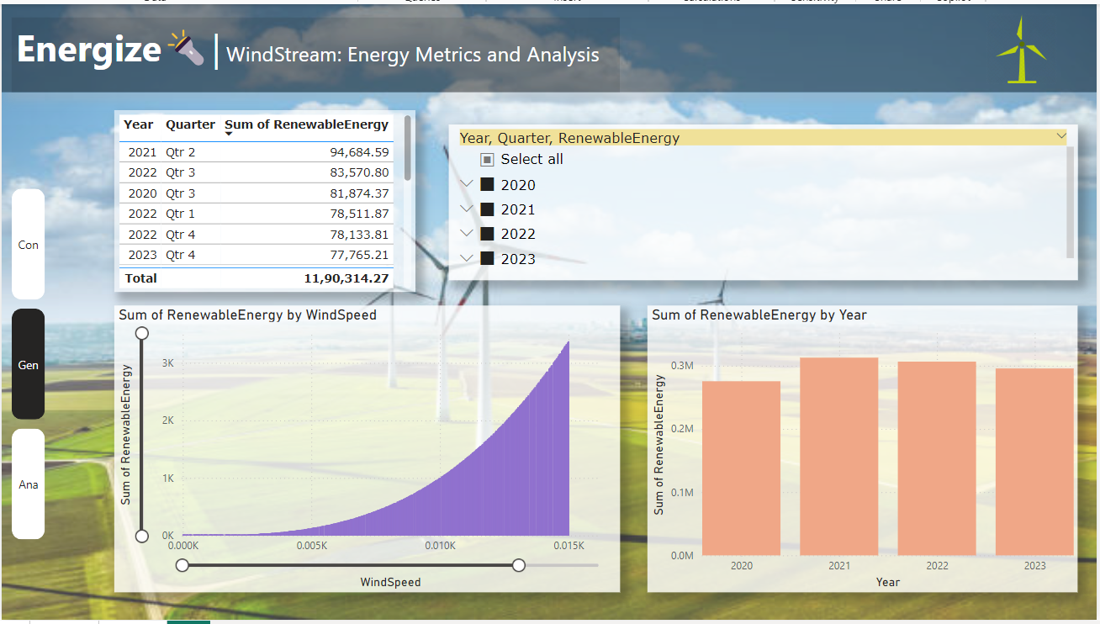

## 3. Environmental Influence on Energy Use

This section demonstrates the impact of environmental factors on energy consumption, emphasizing the importance of expanding renewable energy sources.

Figure 3: Environmental Influence on Energy Dashboard

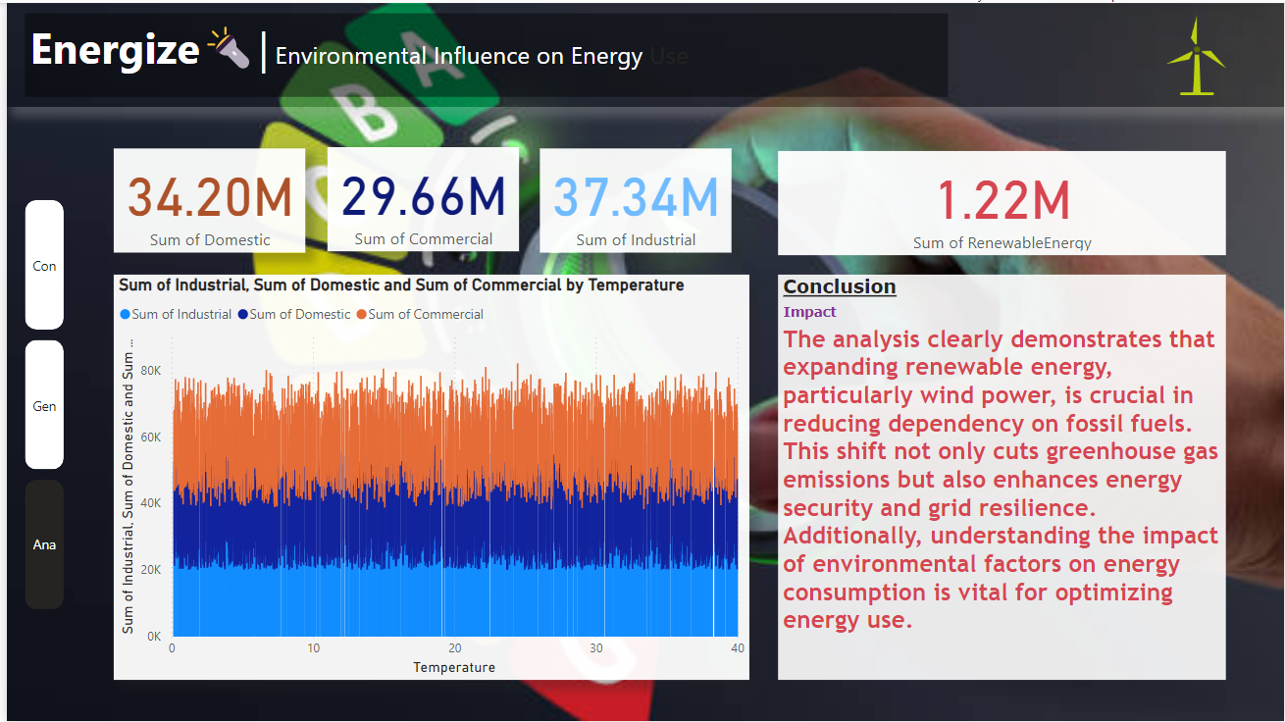

## 4. Conclusion

The Power BI dashboard serves as a powerful tool for decision-making, providing stakeholders with the information needed to drive business growth and improve operational efficiency.