Handling Data Using Data Base Management System

**1: Create a schema and table in MySQL**

**Code:**

create database edunetfoundation;

show databases;

use edunetfoundation;

CREATE TABLE Persona (PersonID int,LastName varchar(255),FirstName varchar(255),Address varchar(255),City varchar(255));

**OUTPUT:**

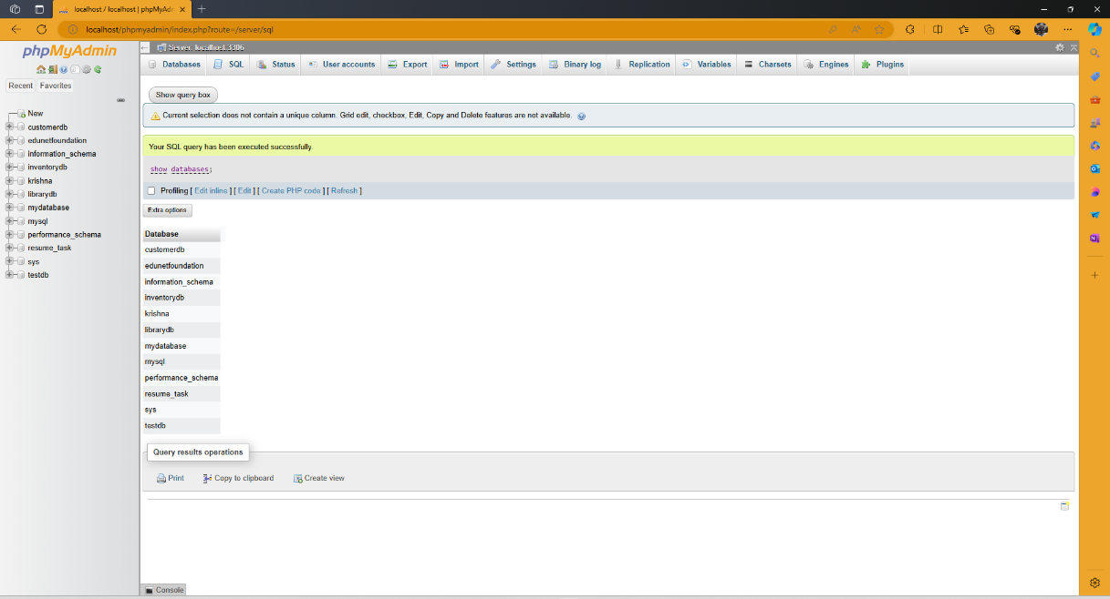

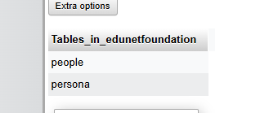

**2: Perform insert query on the table .**

**3: Perform several select queries to retrieve the data from table**

**Code:**

CREATE TABLE People(

    id int NOT NULL AUTO_INCREMENT,

    name varchar(45) NOT NULL,

    occupation varchar(35) NOT NULL,

    age int,

    PRIMARY KEY (id)

);

INSERT INTO People VALUES

(1, 'krishna', 'Developer', 22),

(2, 'Harilal', 'Leader', 26),

(3, 'Pawan', 'Scientist', 26);

**Output:**

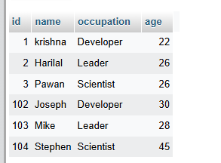

**4: Perform Alter table query**

**code:**

alter table people add location varchar(40) not null;

**Output:**

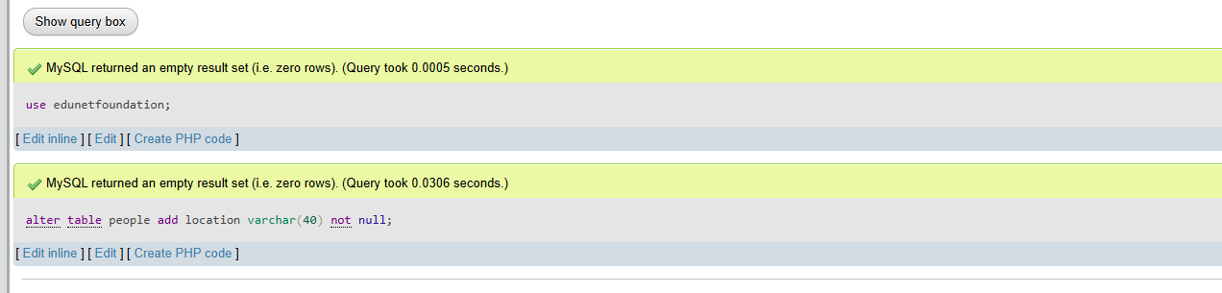

**5: Perform update query on table to modify the data**

**Code:**

update people set location='telegana' where id='102';

update people set location='newdelhi' where id='103';

update people set location='Tamilnadu' where id='104';

**output:**

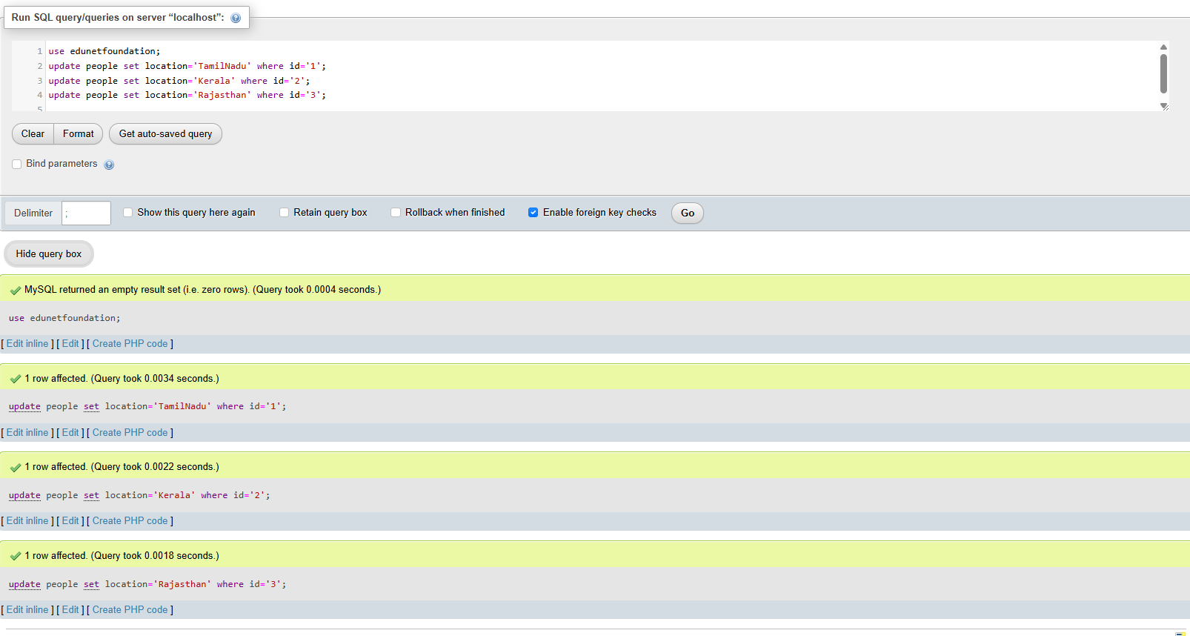

**6: Use of max(), min(), avg(), total() methods**

**Code:**

alter table people add Salary varchar(40) not null;

update people set Salary='50,000,00' where id='1';

update people set Salary ='100,000' where id='2';

update people set Salary ='50,000' where id='3';

select max(age) as "maximum Age" from people;

select min(age) as "minimum Age" from people;

select avg(salary) as "Avg_salary" from people;

select sum(salary) as "Totalsum" from people;

**Output:**

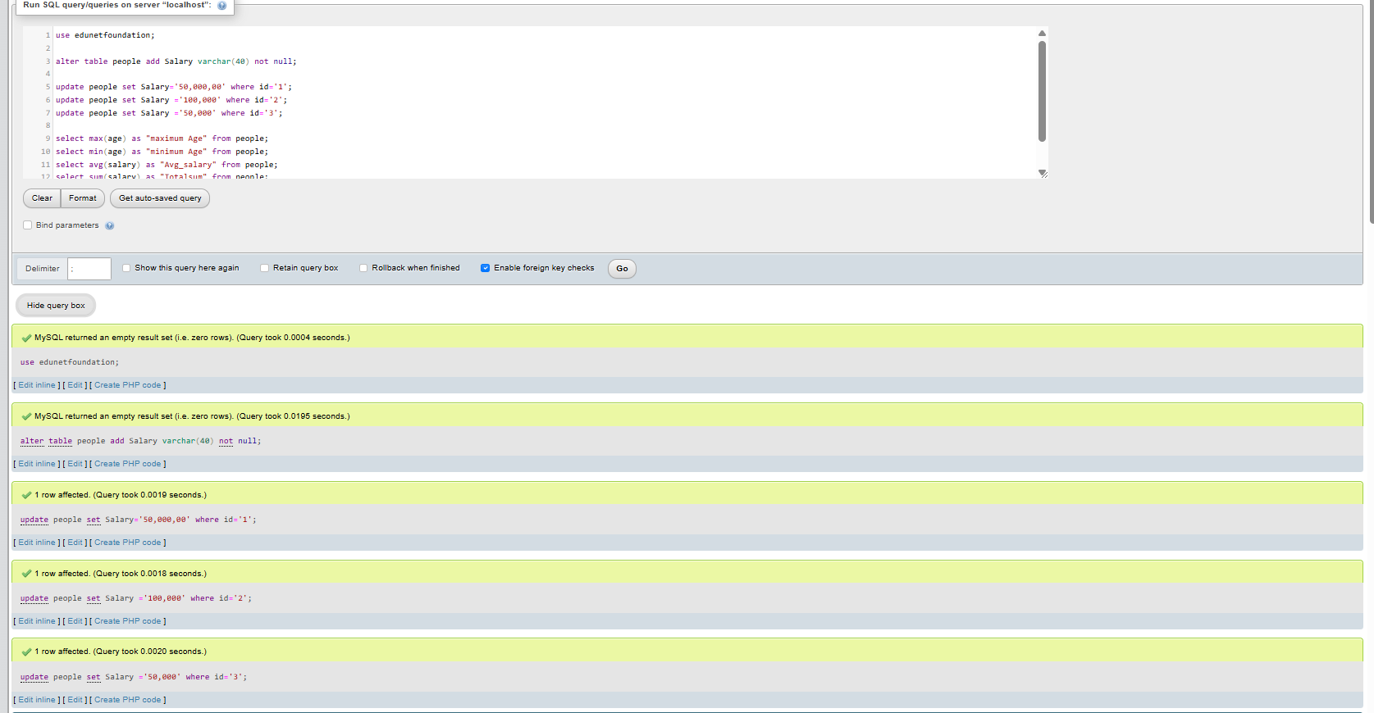

maximum Age:

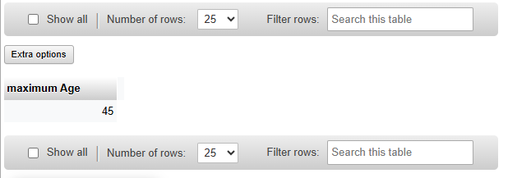

minimum Age:

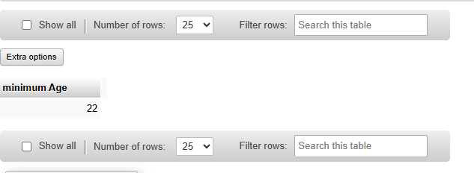

**Avg_salary:**

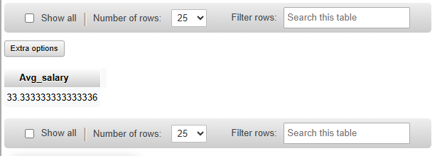

**Totalsum:/**

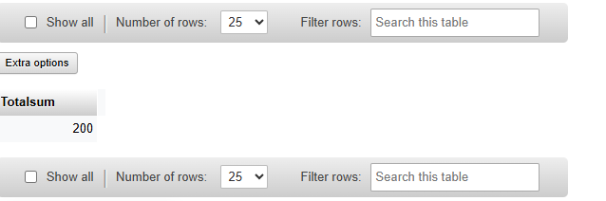

**7: Use of check constraints**

**Code:**

CREATE TABLE employee(ID int NOT NULL,Name varchar(45) NOT NULL,Age int CHECK (Age>=18));

INSERT INTO employee(Id, Name, Age) VALUES (1,'Robert', 28), (2, 'Joseph', 35), (3, 'Peter', 40);

INSERT INTO employee(Id, Name, Age) VALUES (1,'Robert', 15);

**Output:**

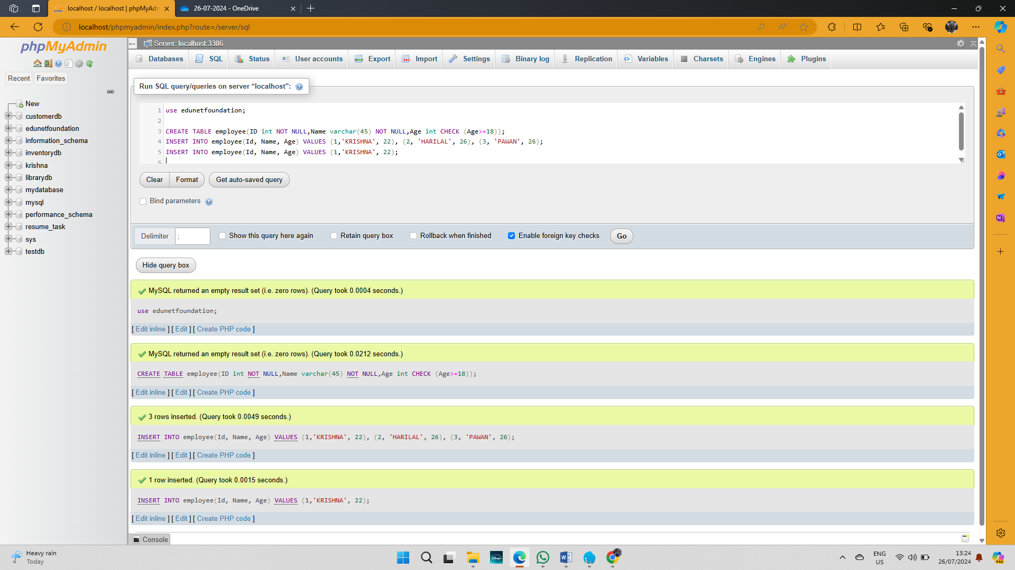

**8: Use of case, as, like operators**

**Code:**

CREATE TABLE Officers(Officer_ID int NOT NULL, Officer_Name varchar(45) NOT NULL, Address varchar(255);

INSERT INTO employee(Id, Name, Age) VALUES (1,'Robert', 28), (2, 'Joseph', 35), (3, 'Peter', 40);

SELECT officer_name

FROM officers

WHERE address LIKE 'Luck%';

SELECT CASE 1 WHEN 1 THEN 'one' WHEN 2 THEN 'two' ELSE 'more' END;

SELECT CASE 2 WHEN 1 THEN 'one' WHEN 2 THEN 'two' ELSE 'more' END;

SELECT CASE 3 WHEN 1 THEN 'one' WHEN 2 THEN 'two' ELSE 'more' END;

select name as "employee name" from employee;

**Output:**

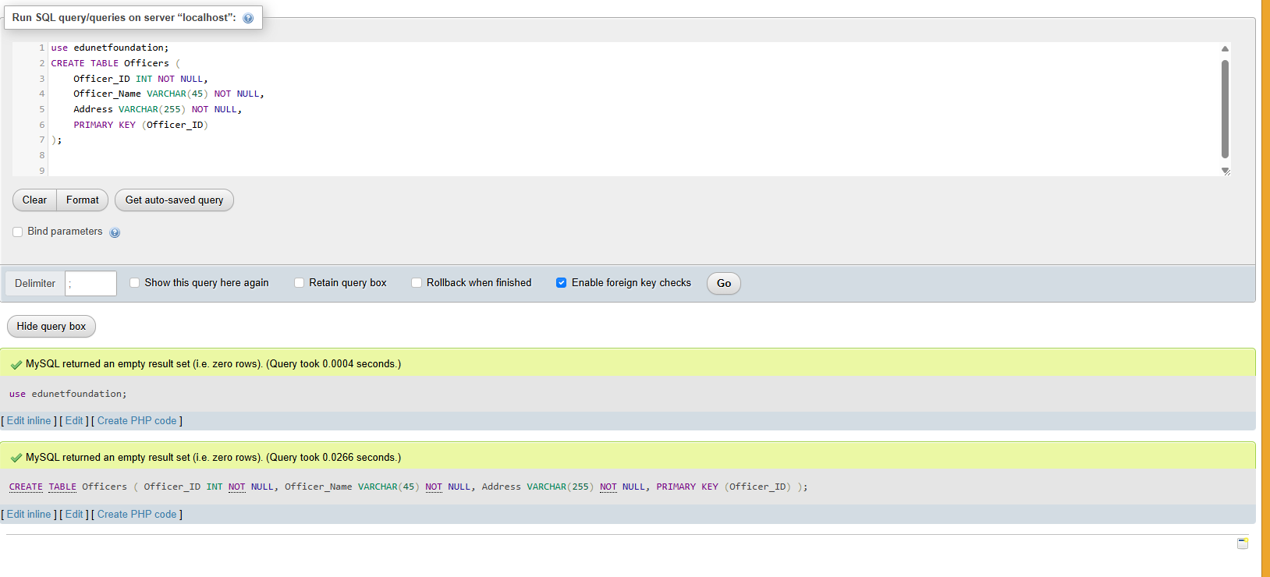

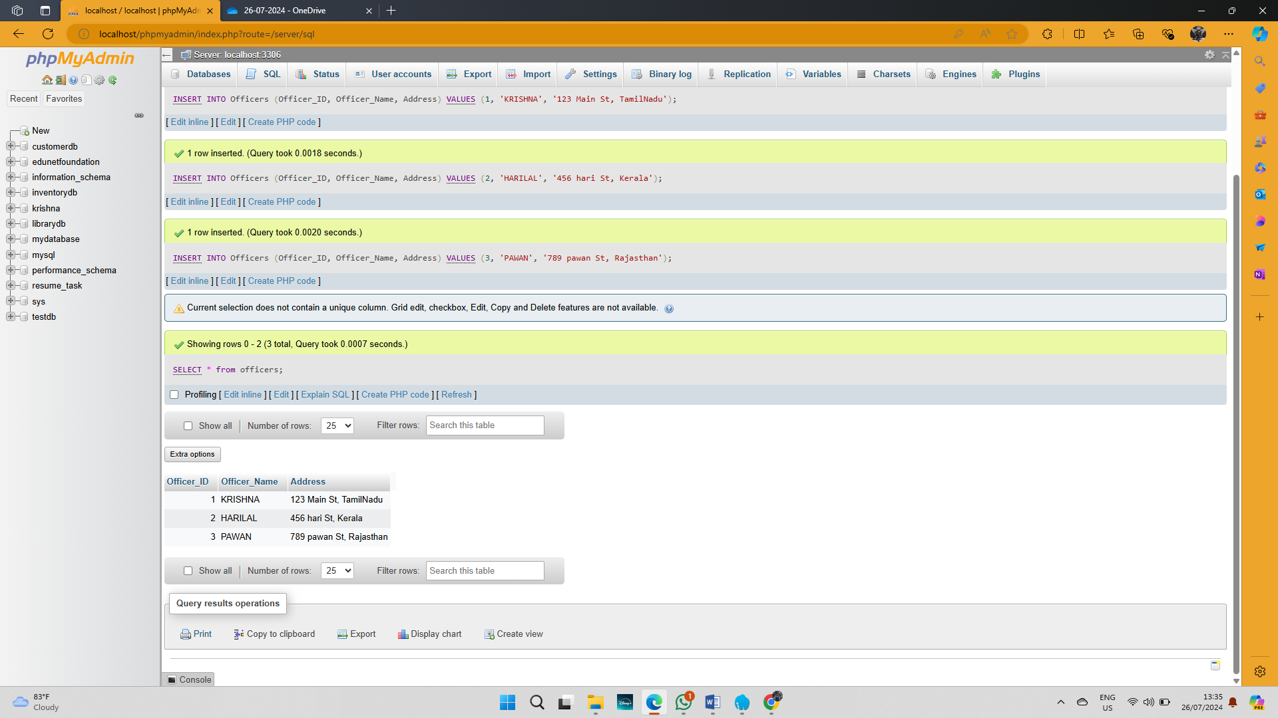

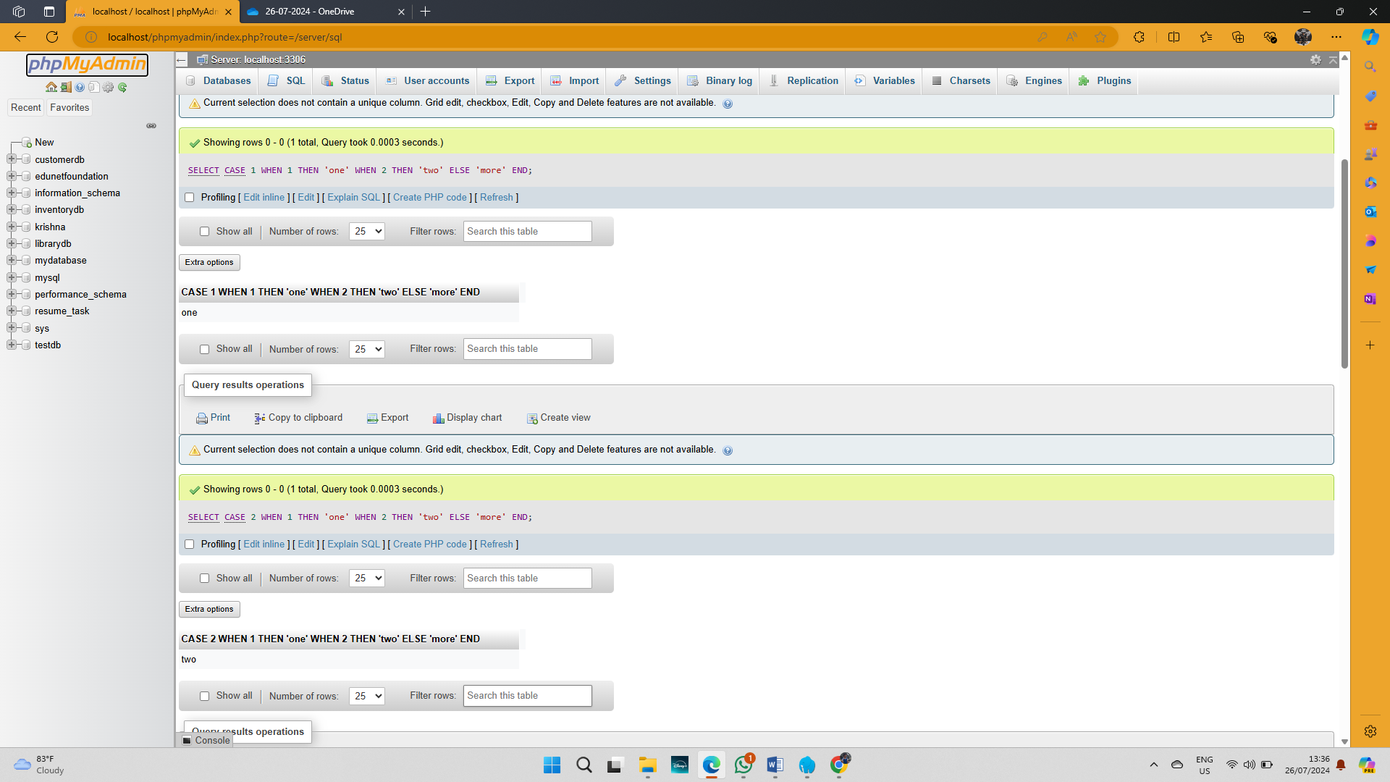

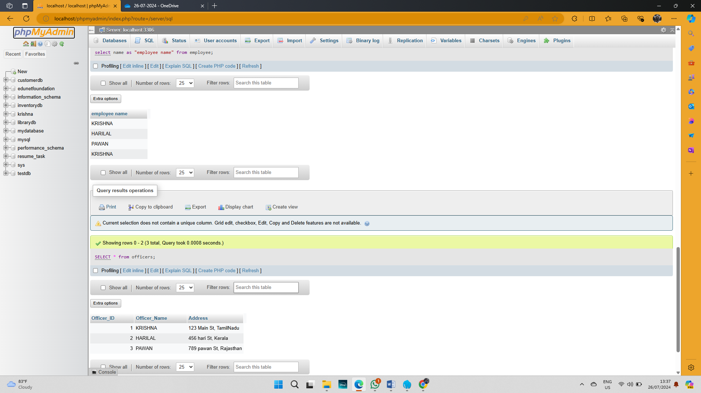

**9: Perform various join operations on tables**

**Code:**

**CREATE TABLE Students (**

**student_id INT NOT NULL,**

**student_name VARCHAR(45) NOT NULL,**

**course_name VARCHAR(45) NOT NULL,**

**PRIMARY KEY (student_id)**

**);**

**INSERT INTO Students (student_id, student_name, course_name) VALUES (1, 'PAWAN', 'Mathematics');**

**INSERT INTO Students (student_id, student_name, course_name) VALUES (2, 'HARILAL', 'Physics');**

**INSERT INTO Students (student_id, student_name, course_name) VALUES (3, 'KRISHNA', 'Chemistry');**

SELECT officers.officer_name, officers.address, students.course_name

FROM officers

INNER JOIN students

ON officers.officer_id = students.student_id;

**Output:**

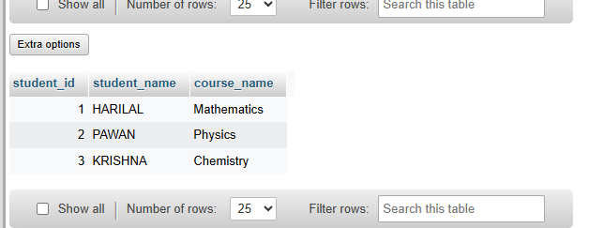

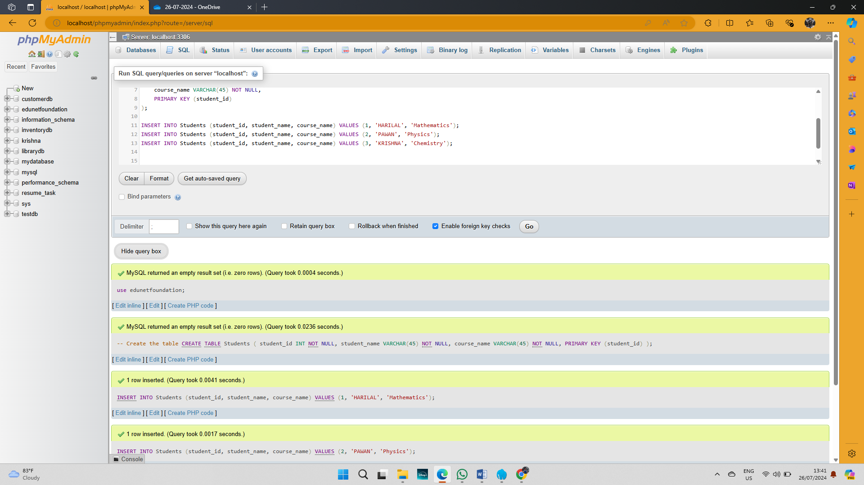

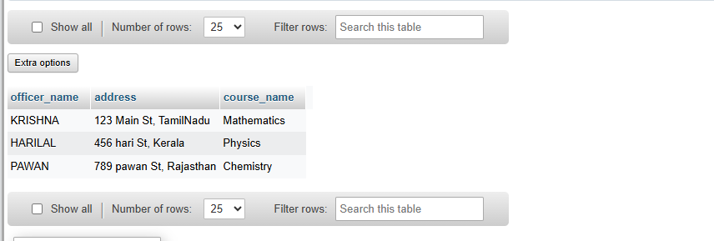

**10: Perform delete and drop query**

**Code:**

**CREATE TABLE Test (**

**id INT AUTO_INCREMENT PRIMARY KEY,**

**name VARCHAR(45) NOT NULL,**

**branch VARCHAR(45),**

**mob_num VARCHAR(15),**

**email VARCHAR(100),**

**city VARCHAR(45)**

**);**

**INSERT INTO Test (name, branch, mob_num, email, city) VALUES ('hai', 'Engineering', '7598579472', 'hai@example.com', 'Springfield');**

**INSERT INTO Test (name, branch, mob_num, email, city) VALUES ('krishna', 'Science', '9037502150', 'krishna@example.com', 'Shelbyville');**

**select * from Test;**

Select * from Employee;

ALTER TABLE Test DROP COLUMN Branch;

DELETE FROM Employees WHERE emp_id=107;

**Output:**

