Smart Library Request Workflow in ServiceNow

TEAM MEMBERS: R.KRISHNAMOORTHY
C.KUMARAN
B.KATHIRVEL
M.MATHAN RAJ

Introduction

  - A role-based Library Management System developed using ServiceNow platform.
  - Automates book borrowing, approval, and tracking process.
  - Improves efficiency and transparency in academic libraries.

Problem Statement

  - Manual tracking of books causes delays and errors.
  - No real-time visibility of book availability.
  - Difficult approval and reporting process.

Objectives

  - Automate borrow request lifecycle.
  - Implement role-based access (Student & Librarian).
  - Enable real-time book status updates.
  - Generate analytical reports for management.

Roles and Responsibilities

  - Student: Create and track borrow requests.
  - Librarian: Manage catalog and approve/reject requests.
  - Admin: Configure system and maintain secu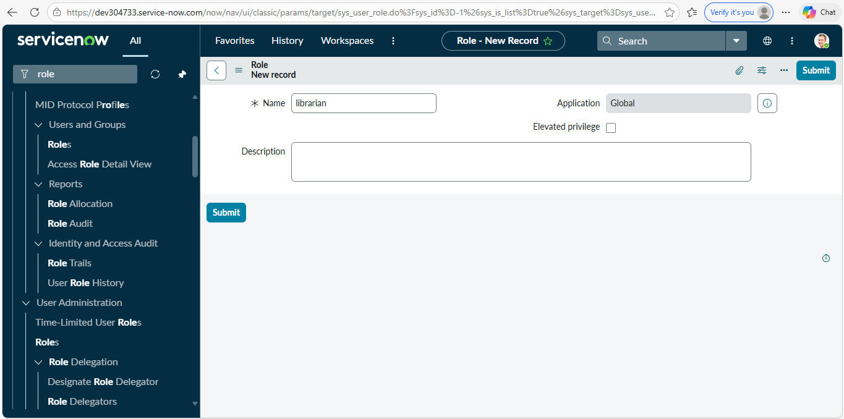
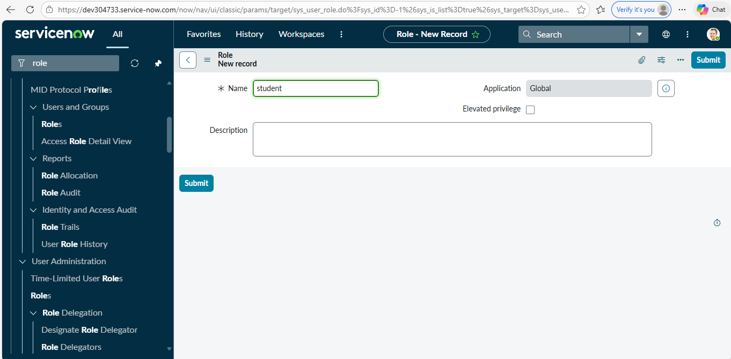
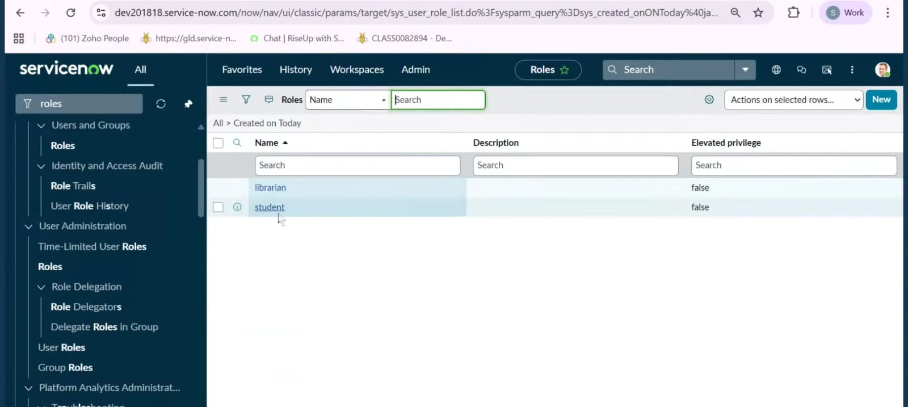

Tables Created

  - Book Table (u_book): Title, Author, ISBN, Status.
  - Borrow Request Table (u_borrow_request): Requested By, Book, Date, Status.

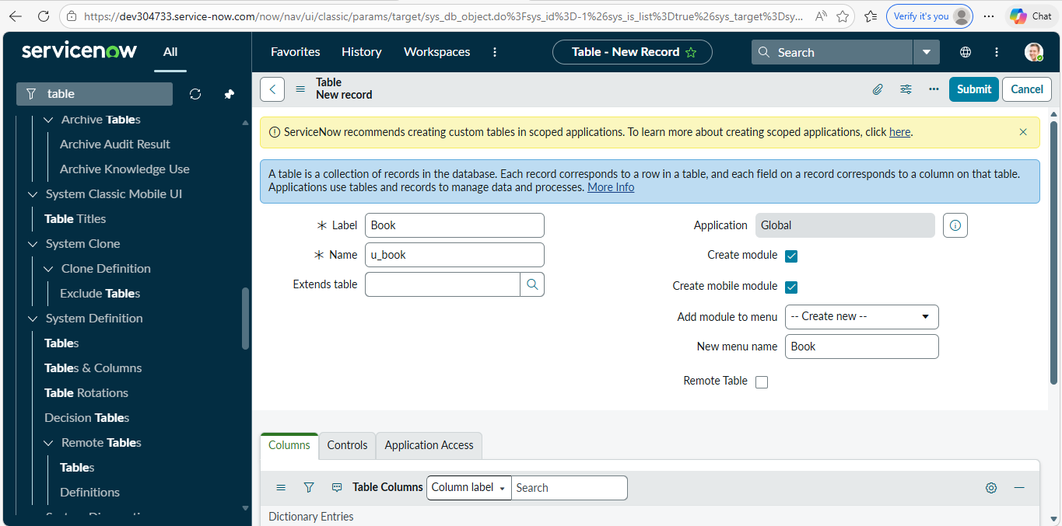
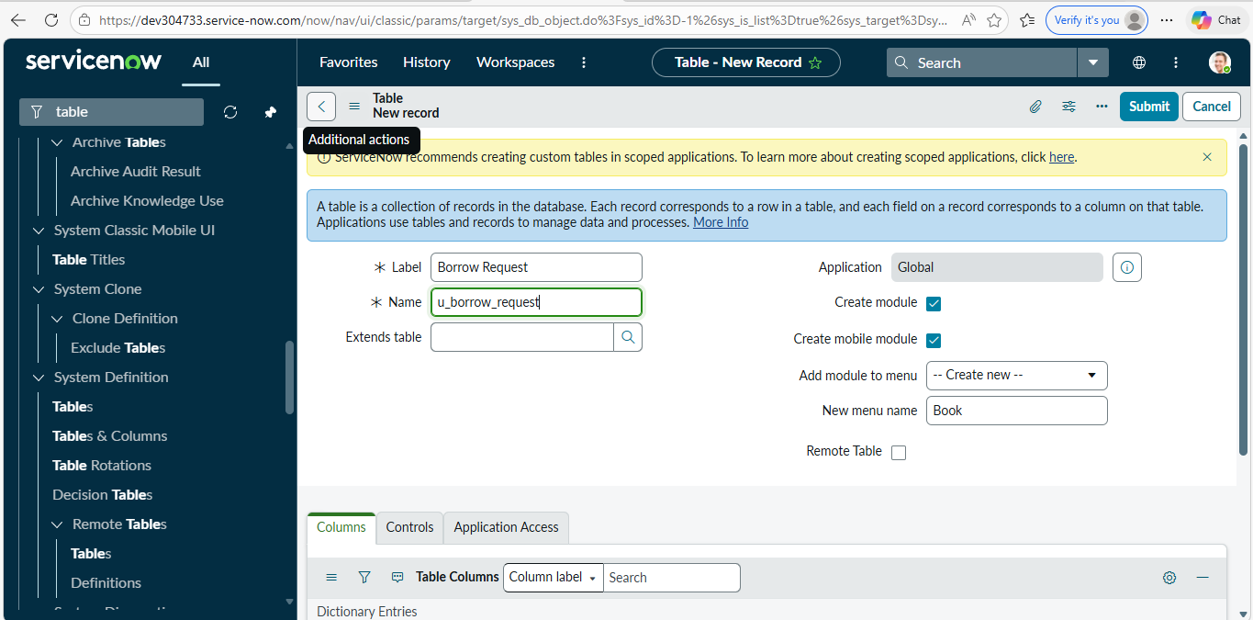

Key Features

  - Reference Qualifier to show only available books.
  - Flow Designer automation for approval and issuance.
  - UI Policy for dynamic field control.
  - Access Control Lists (ACL) for security. 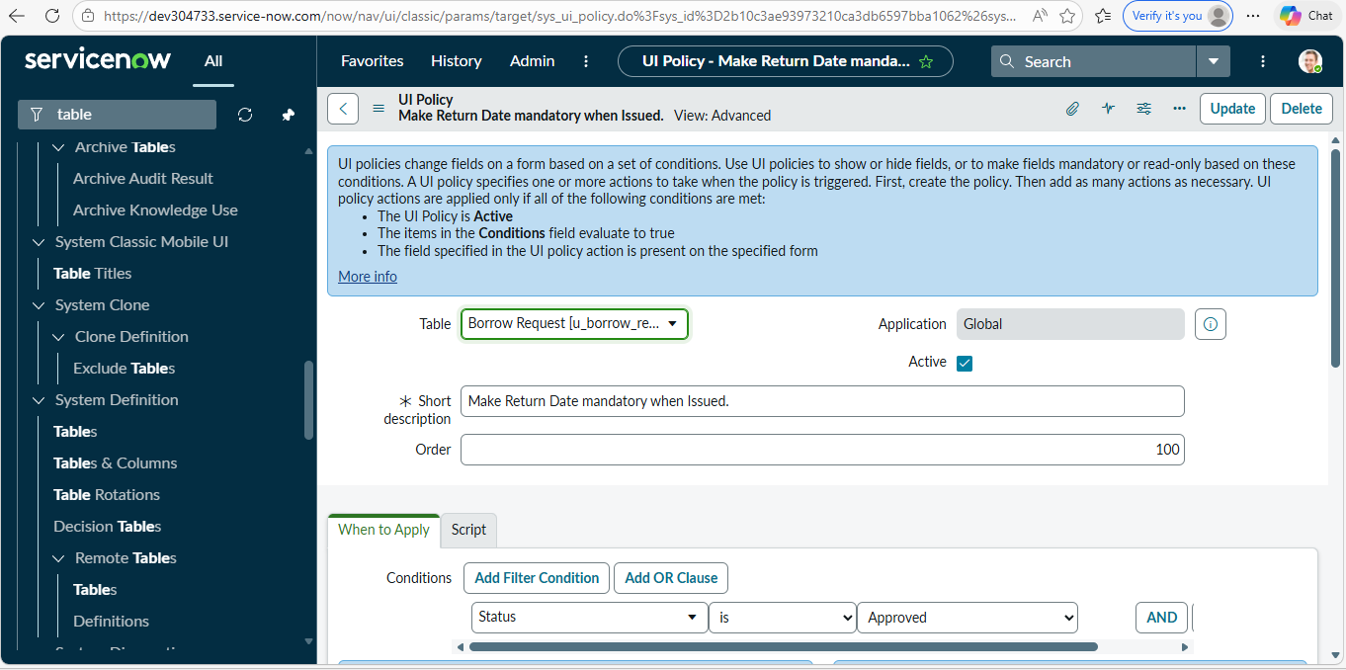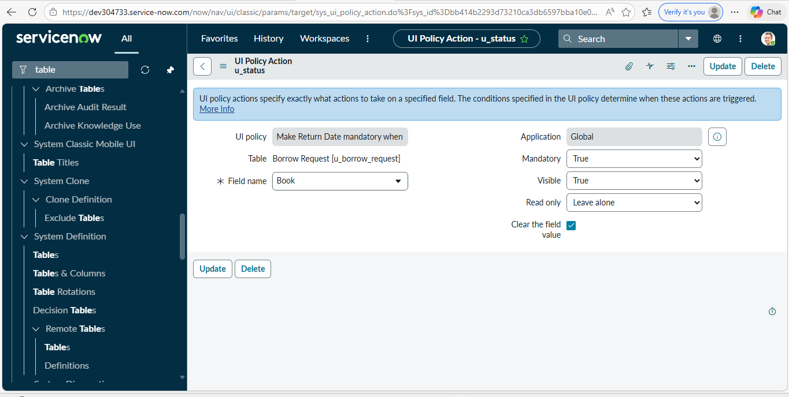
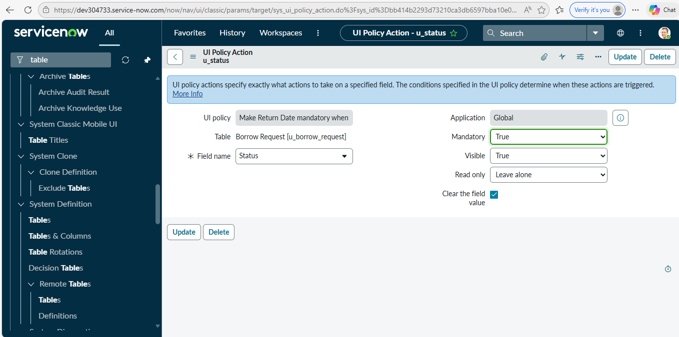

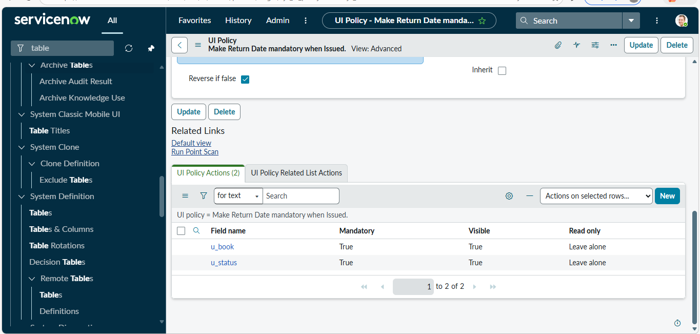

Workflow Process

  - Student submits request.
  - Librarian receives approval notification.
  - On approval, Book status changes to Issued.
  - Email notification sent to student.
  - Book returned and status updated.

Reporting

  - Most Borrowed Books report.
  - Grouped by Book and counted by Approved status.
  - Helps management decision-making.
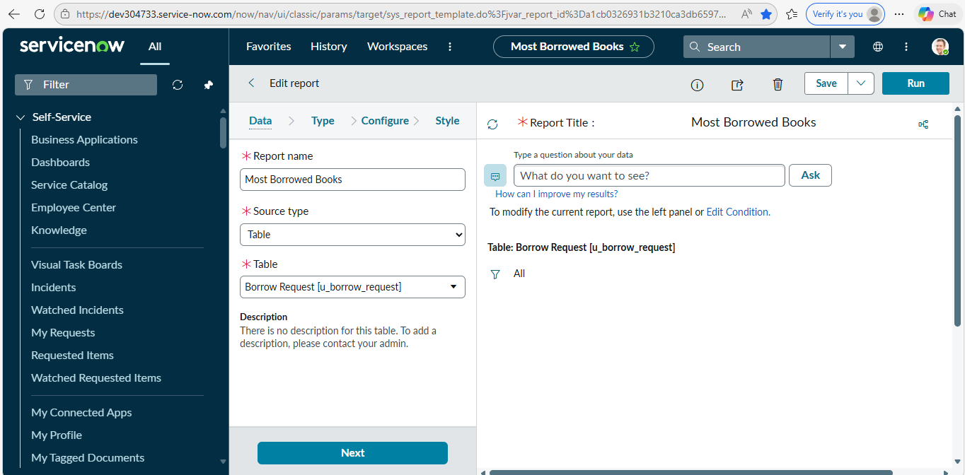
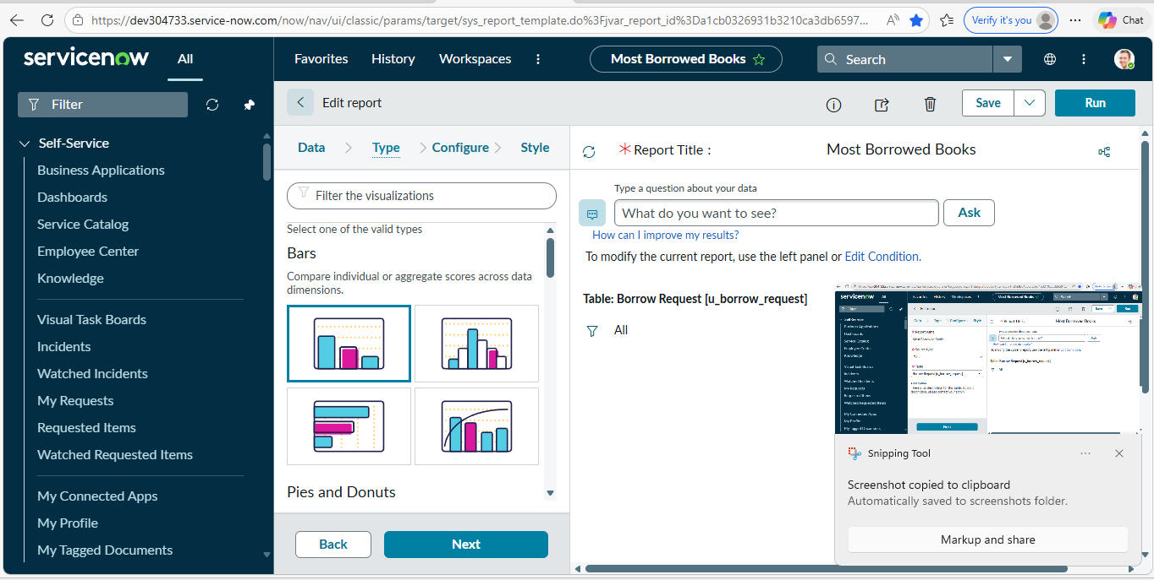
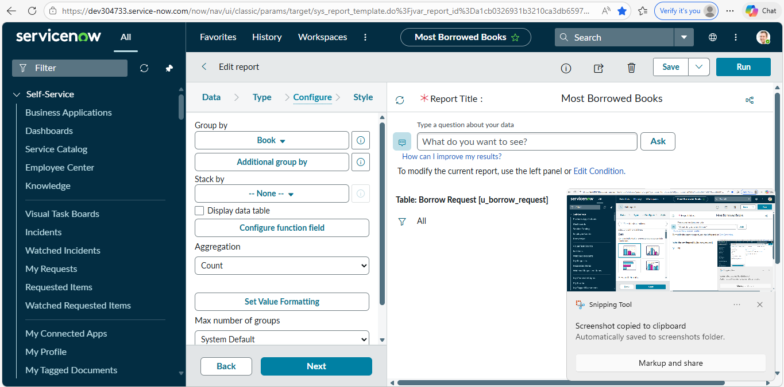
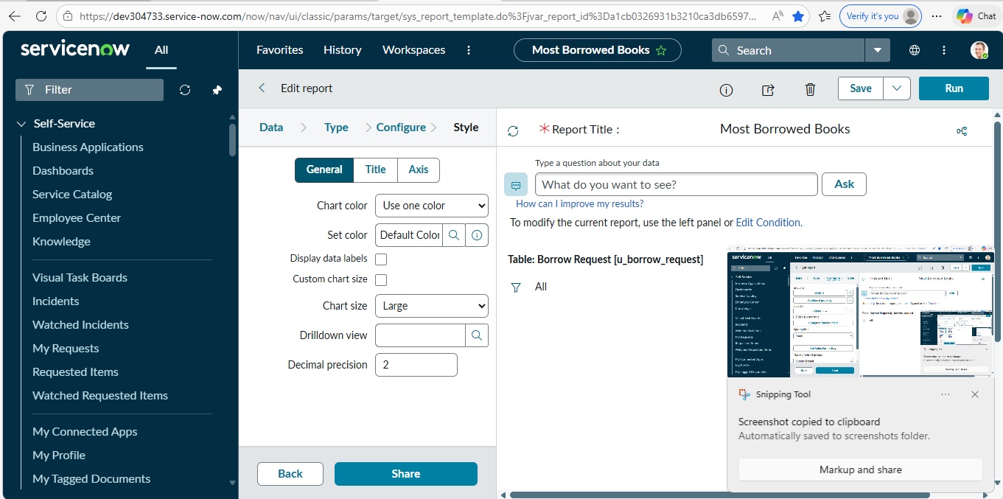
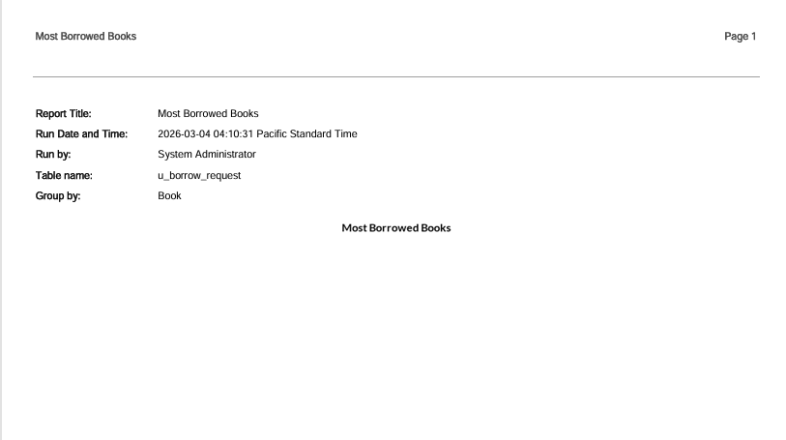

Innovation

  - End-to-end automation.
  - Role-based security implementation.
  - User-friendly dynamic forms.
  - Scalable architecture.

Future Enhancements

  - Overdue reminders via Email/SMS.
  - Advanced dashboards and analytics.
  - Integration with digital library

11.Conclusion

  - The project successfully digitalizes and automates library operations.
  - Improves efficiency, accuracy, and user experience.
  - Provides a scalable solution for academic institutions.

