Need to create subscription like free tail

Need to create subscription for pay and use –

Azure DevOps

Initial setup:

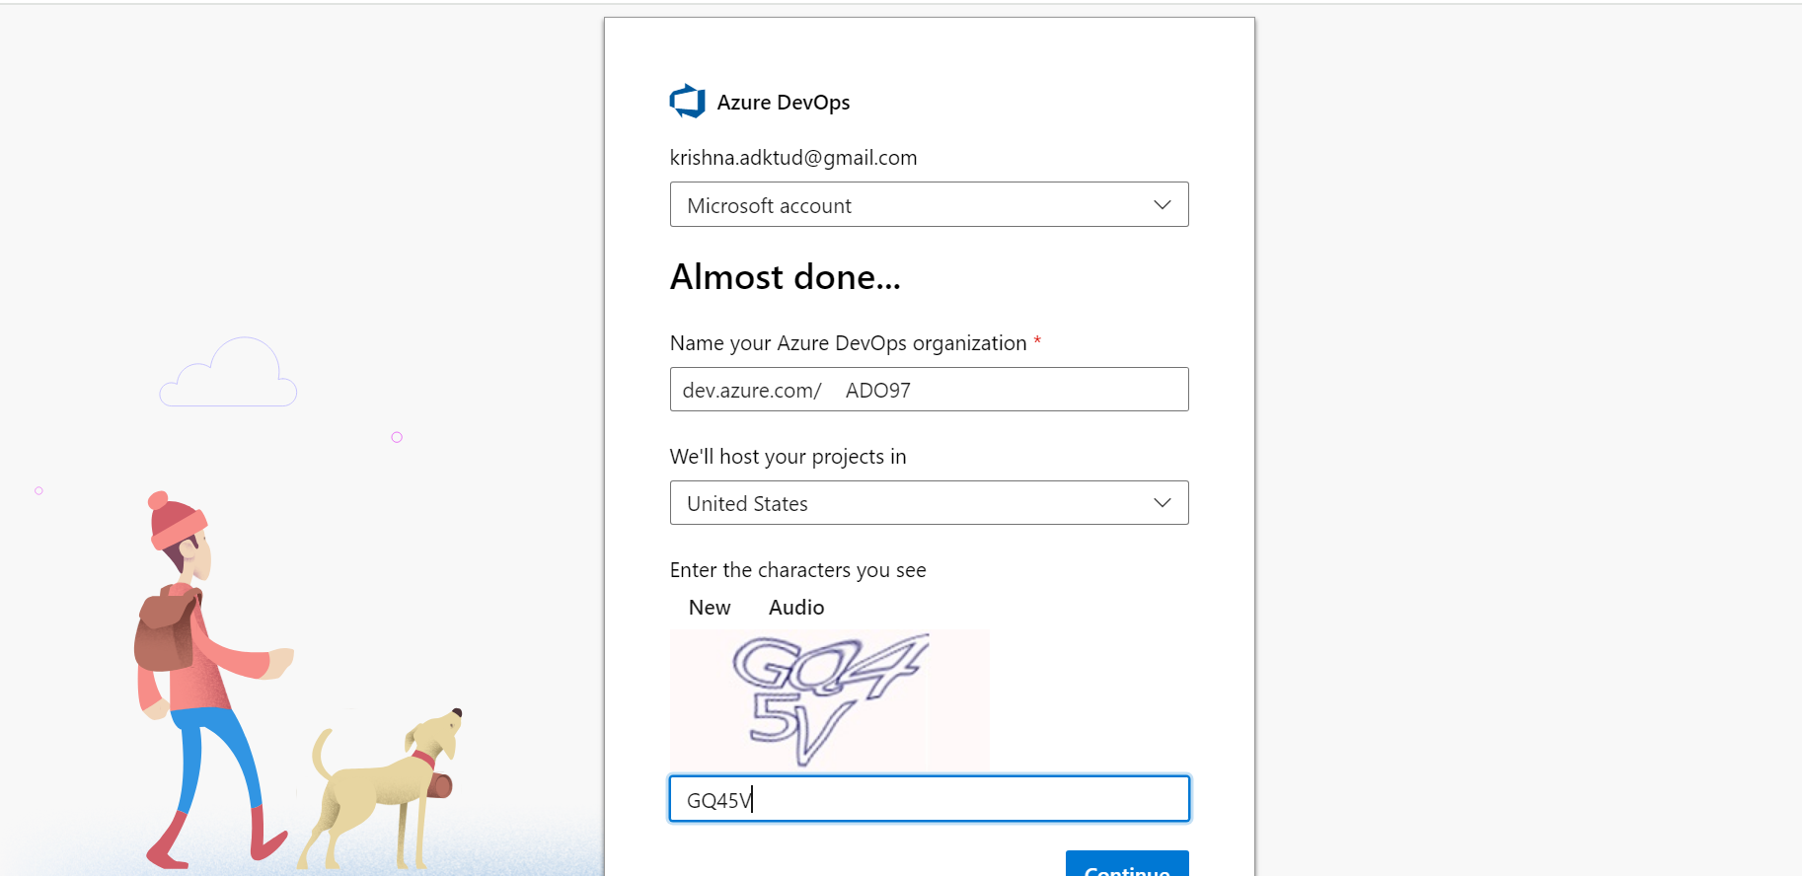

Create project name and select private or public then click will be lunch azure Devops browser

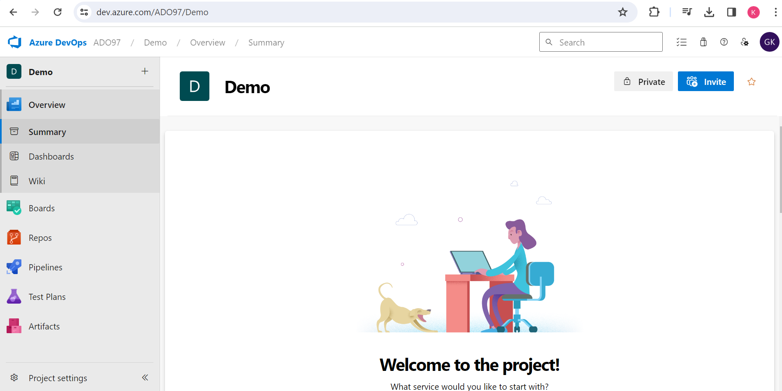

Create repo and added files for project related files

Repo will show look like below.

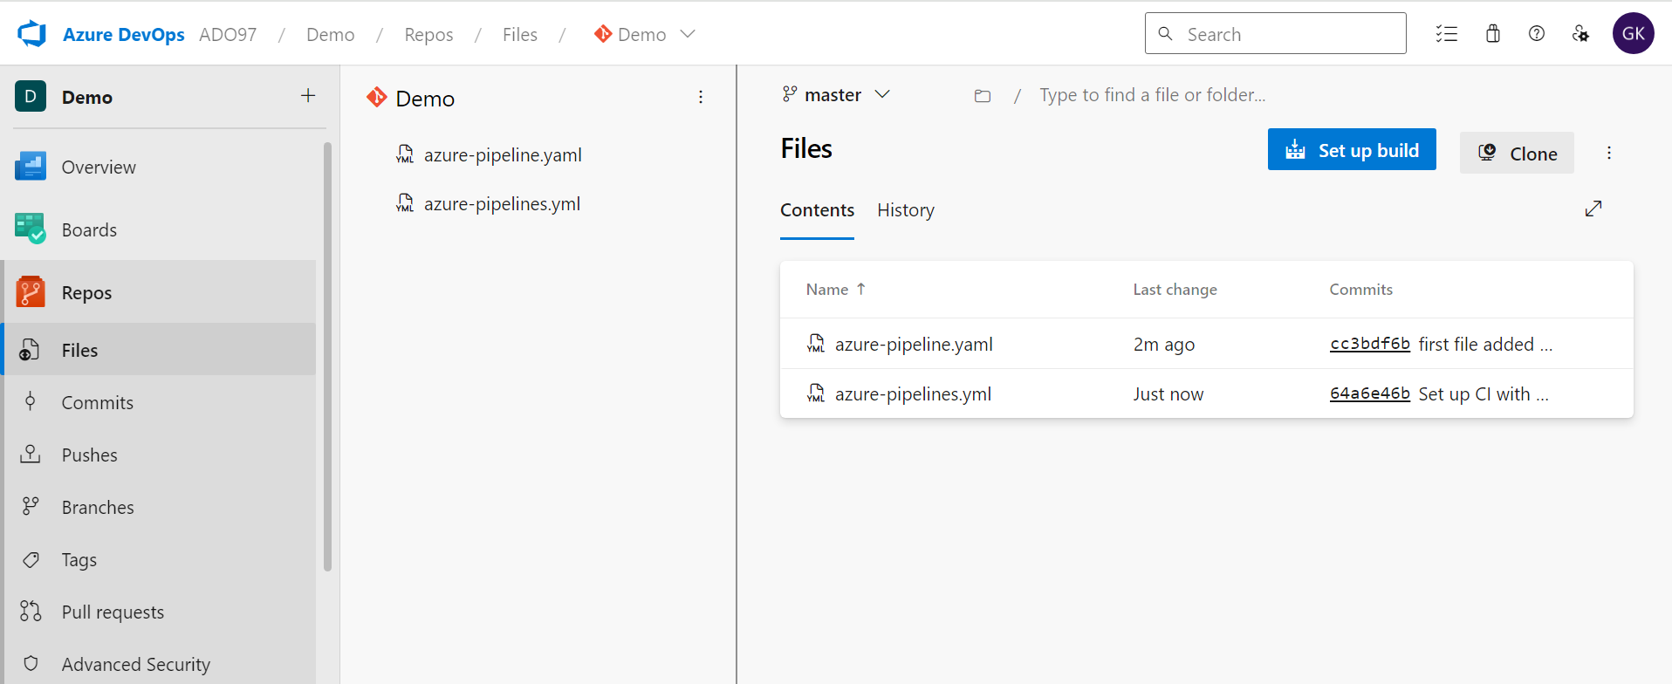

Then create pipeline

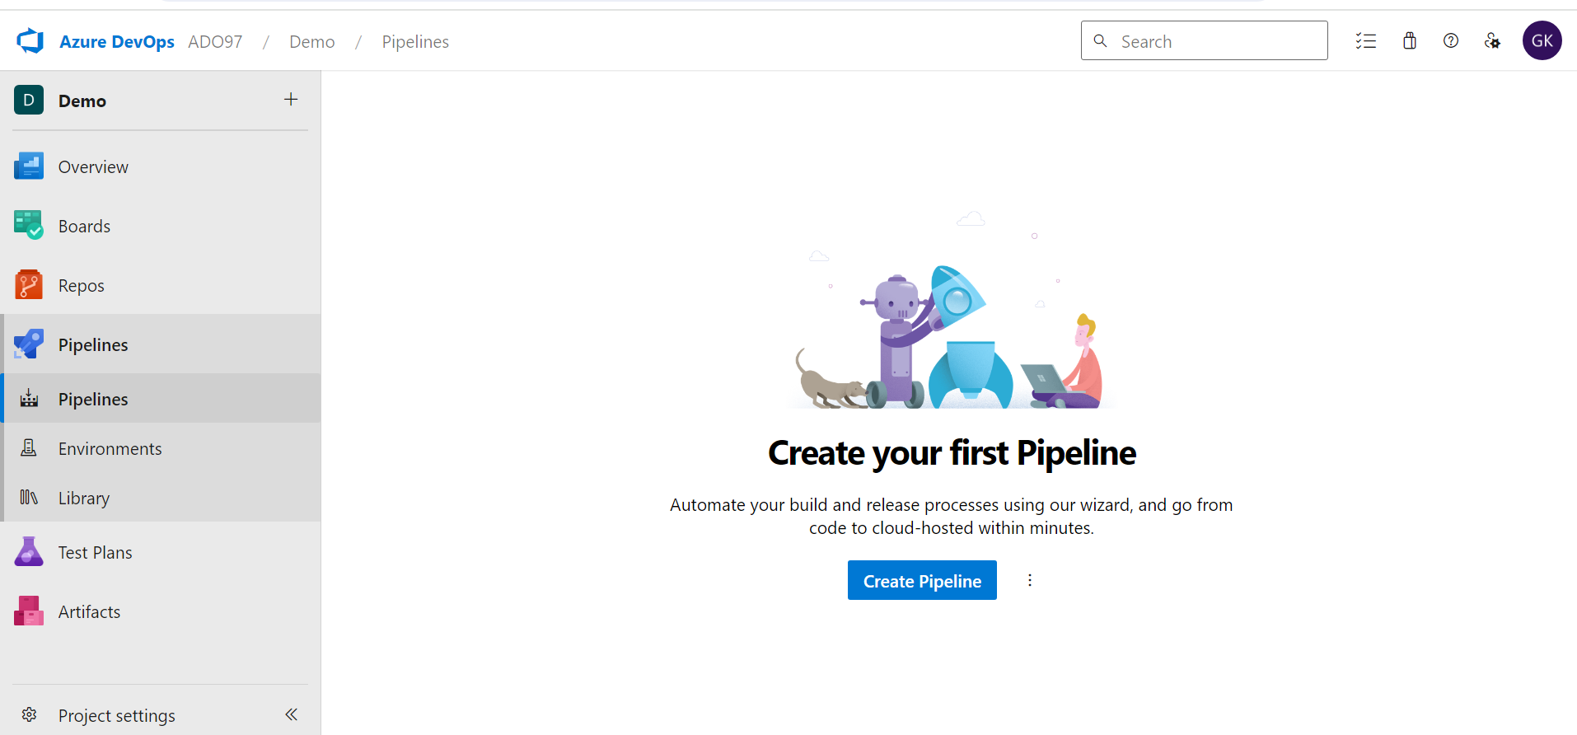

Just click on Create pipeline

Asking where is your code like below screshot:

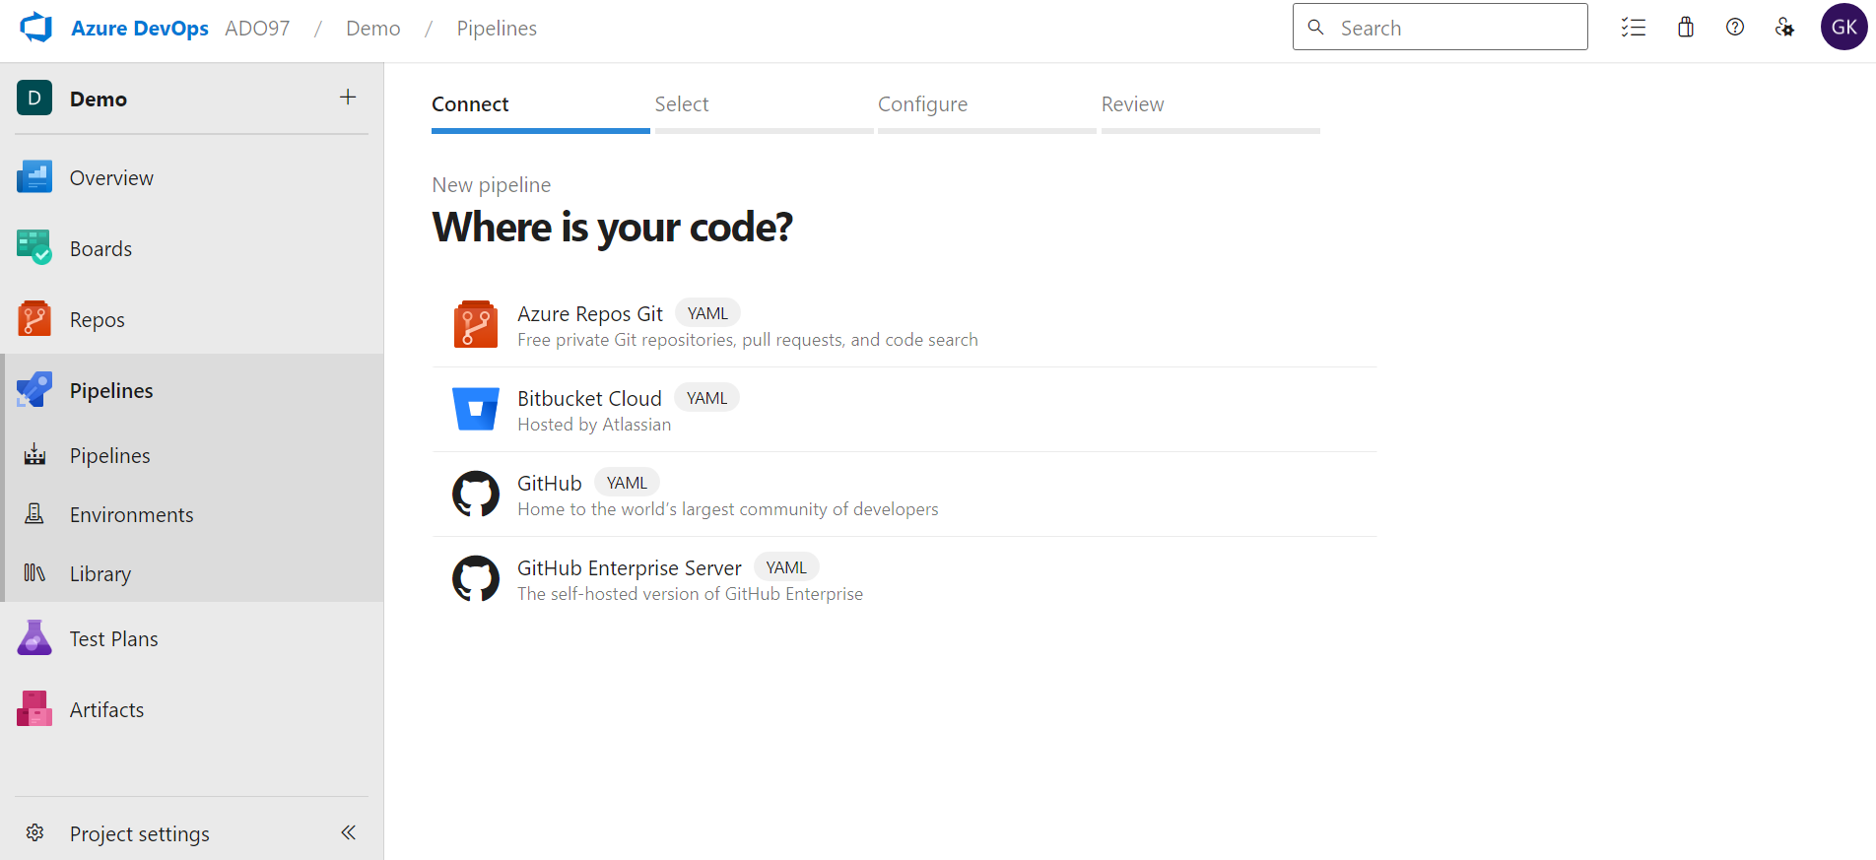

Just click azure Repos Git or related your version controller