A: Multiple Choice

1. Which command is used to display the current working directory in Ubuntu Linux?
2. Pwd

2.What is the purpose of ‘chmod’ command in Ubuntu Linux?

(b) Change file permissions

3. Which command is use to list all the running process in Ubuntu Linux?

(c) top

4. Which directory is contains system configuration files in Ubuntu Linux?

(b)/etc

5. What does SSH stand for in Ubuntu Linux?

(a) Secure shell

6. Which command is used to install a package in Ubuntu Linux?

(b) apt-get

7. Which command is used to create a new directory ?

(a) mkdir

8. Which is the default text editor in Ubuntu Linux?

(d) Gedit

9. Which command is used to search for files or directory in Ubuntu Linux?

(a) find

10. What does the command ‘sudo apt update’ do in Ubuntu Linux?

(b) Updates package list

11. Explain the difference between absolute and relative path in Ubuntu Linux?

* An absolute path is defined as specifying the location of a file or directory from the root directory (/).
* We can also say that an absolute path is a complete path from start of actual file system or directory .
* Relative is defined as the path related to the working directory
* It always starts at your current directory and never starts with a (/) starts with (..).

12. Describe the purpose of ‘grep’ command and provide an example of how it can be used.

* The grep command is used for searching things in a particular patterns.
* Example: grep -n abc filename :- this shows the line number that the word ‘abc’ is present.

13. Briefly explain the significance of the /’etc/passwd’ file in Ubuntu Linux.

* The /etc/passwd file is used to keep track of every registered user that has access to a system.
* It contains the information about user name, encrypted password, user id number(UID) user’s group id number(GID), full name of the user(GECOS), user home directory, login shell.

14. What is the purpose of ‘ping ‘ command in Ubuntu Linux.

* It is used to check the connection between the host server and url.
* Example : ping [www.google.com](http://www.google.com)

15. Explain the difference between the apt-get and apt commands in Ubuntu Linux package management.

* **apt** is a CLI (command line interface) package manager tool which after the apt-get and apt-cache but this tool is much more structured and advance
* apt-get is a CLI package management tool. This tool is Debian based and used in different Debian based operating systems like Ubuntu, Kali Linux, etc

16. Create a new directory named “test” in your home directory.

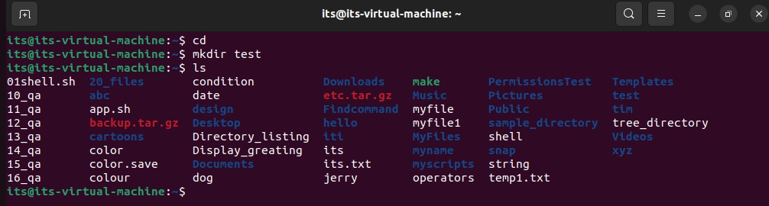

cd

mkdir test

17. Change the permission of a file named “file .txt ” to allow read , write and execute permission for the owner and read -only permission foe group and others.

chmod 744 file.txt

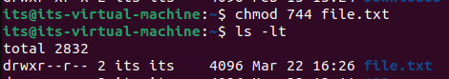

18. List all files in the ‘/etc’ directory and redirect the output to a file named “etc_file.txt”. the “/etc” directory.

ls / etc >etc_file.txt

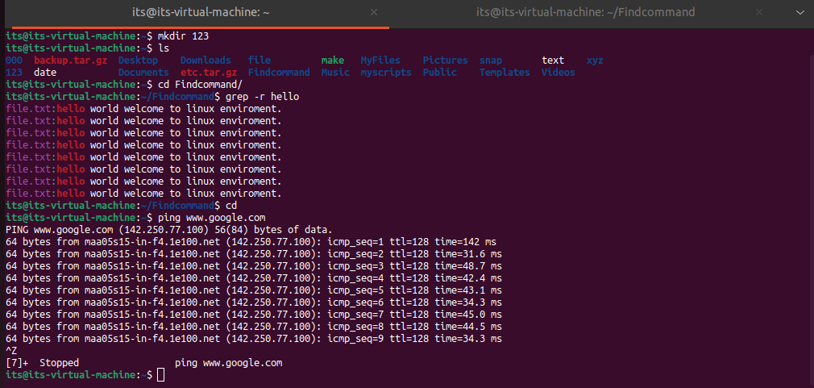

20. Create a new directory named “data” in the root directory (“/”) and set its permission to allow read, write, and execute permission for owner and read permissions for group and other.

