Dharmamurthi Rao Bahadur Calavala Cunnan Chetty's (DRBCCC) Hindu College
Affiliated to the University of Madras • Re-accredited by NAAC
Pattabiram, Chennai – 600 072, Tamil Nadu, India
DEPARTMENT OF COMPUTER SCIENCE
BACHELOR OF SCIENCE IN COMPUTER SCIENCE WITH ARTIFICIAL INTELLIGENCE
AI FAQ ASSISTANT
INTELLIGENT MEDICAL FAQ & GENERATIVE QUESTION ANSWERING PLATFORM
A Full-Stack Healthcare Knowledge Engineering System Combining Vanilla Client Architecture, Express.js REST API Gateway, MongoDB Atlas Persistent ODM, and Google Gemini AI Generative Integration with Dual-Stage Clinical Keyword Scope Enforcement
DOCUMENT CLASSIFICATION: PROJECT TECHNICAL SPECIFICATION & ACADEMIC THESIS REPORT
Project Identifier / Team ID | SWTID-2026-3332
Project Team Leader | Krishnan S
Project Team Members | Magesh S | Mohammed Afzal I | Mohammed Sadiq A
Undergraduate Degree Program | B.Sc. Computer Science with Artificial Intelligence
Institution & Faculty | Dharmamurthi Rao Bahadur Calavala Cunnan Chetty's (DRBCCC) Hindu College
University Affiliation | University of Madras, Chennai, Tamil Nadu, India
Academic Submission Cycle | Academic Year 2026 – 2027

Executive Project Summary & Documentation Roadmap
📌 ACADEMIC REPORT CONCORDANCE: This project documentation serves as the comprehensive technical specification and academic thesis report for the AI FAQ Assistant (HealthFAQ) platform.
It exhaustively integrates the architectural models, system workflows, database specifications, backend code implementations, security filtering mechanisms, REST API matrices, Thunder Client/Postman test executions, frontend design, and critical project analyses from the project lifecycle.

The documentation is systematically structured into twelve core chapters, providing a rigorous end-to-end technical overview:
Chapter | Section Title | Technical Scope & Deliverables
Chapter 1 | Abstract & Executive Introduction | Full-stack architectural synthesis, Gemini AI integration, and core objectives.
Chapter 2 | Problem Definition, Clinical Case Study & Objectives | Traditional FAQ constraints vs. GenAI, scenario analysis, and 16 project goals.
Chapter 3 | System Architecture & High-Level Workflows | Layered architecture, client-server data flow, end-to-end user flowchart, and MVC.
Chapter 4 | Database Design & Entity-Relationship Modeling | NoSQL document schema, 1:N ER mapping, BSON types, indexing, and validation.
Chapter 5 | System Prerequisites & Installation Guide | Hardware/software specifications, VS Code workspace tree, and setup guide.
Chapter 6 | Backend System Implementation & Code Analysis | Detailed source code breakdown: server.js, app.js, auth & error middlewares.
Chapter 7 | Routing Architecture & Controller Interfaces | Express modular routers, precedence design, and complete RESTful API matrix.
Chapter 8 | Security Architecture & Medical Keyword Scope Pipeline | Dual-stage verification, 60+ clinical term filter, and ethical guardrails.
Chapter 9 | API Testing Execution Results & Verification | Postman schema, Thunder Client execution captures, and verification matrix.
Chapter 10 | Frontend Architecture & Single Page Interface | Vanilla HTML5/CSS3/JS architecture, hash routing, state, and UI layout.
Chapter 11 | Critical Project Analysis & Future Roadmap | 12 technical advantages, 8 system limitations, and 14 future enhancements.
Chapter 12 | Formal Academic References & Citations | Peer-reviewed literature, industry standards (RFC 7519), and official SDK citations.

Chapter 1: Abstract & Executive Introduction
1.1 Abstract
The AI FAQ Assistant (HealthFAQ) is an advanced, full-stack, AI-powered healthcare knowledge platform engineered to address the critical communication gap between static medical FAQ repositories and dynamically articulated patient inquiries. The platform synergistically unifies a lightweight, zero-framework Single Page Application (SPA) frontend developed using semantic HTML5, CSS3, and modern ECMAScript 6 with a robust, enterprise-grade Node.js and Express.js REST API backend. Persistent data modeling and storage are governed by MongoDB via the Mongoose Object-Document Mapper (ODM), establishing rigid schema validation, referential integrity, and sub-second text indexing. Robust access control is guaranteed through an asynchronous JSON Web Token (JWT) authorization pipeline paired with bcrypt cryptographic password salting and hashing.
To overcome the rigid limitations of conventional keyword-matching FAQ systems, the application embeds Google Gemini Generative AI (gemini-2.5-flash via the official @google/genai SDK) within a dedicated server-side microservice. Crucially, the platform enforces a dual-stage defense-in-depth safety pipeline: every incoming inquiry must pass both cryptographic bearer token authentication and an algorithmic medical-keyword scope validation before interacting with the LLM. Furthermore, strict system prompting instructions enforce ethical healthcare compliance by confining responses to educational context, explicitly forbidding diagnostic or prescriptive claims, and mandating immediate triage redirection for red-flag symptoms. The result is an accessible, responsive, and secure digital health solution that democratizes verified health information while maintaining strict medical boundaries.
1.2 Introduction and Background
In the contemporary healthcare landscape, individuals increasingly turn to the internet for preliminary medical knowledge, seeking explanations for physiological symptoms, pharmacological details, and general wellness guidance. Traditional Frequently Asked Questions (FAQ) systems have served as foundational knowledge-retrieval mechanisms across healthcare portals. However, conventional implementations rely on rigid, static relational or document databases where queries are matched against predetermined question-answer pairs using exact string comparisons or rudimentary substring queries. When a user formulates a question using colloquial language, regional terminology, or complex syntax not anticipated by system administrators, traditional systems fail catastrophically, yielding null results or irrelevant responses.
Furthermore, manually updating medical FAQ repositories requires continuous clinical curation, creating an insurmountable bottleneck as medical research evolves. The advent of Large Language Models (LLMs) and Generative Artificial Intelligence (GenAI) offers a transformative paradigm shift. By leveraging deep transformer architectures trained on vast biomedical and scientific corpora, generative models can interpret nuanced clinical questions, synthesize complex concepts into accessible language, and dynamically generate contextual answers.
However, deploying Generative AI in the medical domain introduces perilous risks, including clinical hallucination, unauthorized diagnostic assertions, hazardous dosage recommendations, and prompt injection attacks. The HealthFAQ AI platform was conceived and engineered to resolve this exact dichotomy: it harnesses the conversational fluency and generative intelligence of Google Gemini AI while confining its execution within a strictly bounded, authenticated, and clinically filtered server-side pipeline. By abstracting the AI service behind an Express.js gateway, the client browser never interacts with or exposes external AI API credentials, ensuring enterprise-grade confidentiality and reliable operational integrity.
1.3 Project Theme & Scope Definition
The central theme of this project is 'AI-Powered Web Application for Intelligent Question Answering and FAQ Management in Healthcare'. The architectural scope spans four foundational software engineering pillars:
- 1. Zero-Overhead Frontend: Presentation Layer: A hyper-responsive, framework-free Vanilla Single Page Application (SPA) delivering sub-100ms client navigation across Medicine Repositories, Category Explorers, FAQ Knowledge Bases, and an Interactive AI Assistant.
- 2. Modular Backend Architecture: Enterprise REST API Gateway: A stateless Node.js and Express.js routing hub featuring centralized error interception, CORS policy enforcement, asynchronous controller execution, and structured JSON communication.
- 3. Persistent Data Modeling: Scalable Persistence & Security: Cloud-hosted MongoDB Atlas database instances managed via Mongoose ODM schemas, enforcing 1:N user-to-FAQ relational mappings, pre-save cryptographic hooks, and compound text search indexing.
- 4. Ethical Generative AI Pipeline: Clinical Guardrail AI Integration: A dedicated Gemini AI service layer equipped with pre-inference medical keyword filtering (60+ clinical terms) and hardcoded ethical clinical instructions preventing diagnostic overreach.
Chapter 2: Problem Definition, Scenario Case Study & Objectives
2.1 Problem Definition & Limitations of Conventional FAQ Systems
Conventional web-based FAQ systems suffer from structural deficiencies that severely impair user experience and medical accessibility:
- 2.1.1 Predefined & Inflexible Information: Static databases store fixed questions and answers that cannot adapt to the dynamic context of patient inquiries.
- 2.1.2 Linguistic & Synonymous Vulnerability: Patients describe symptoms using diverse vocabulary (e.g., 'high temperature', 'feverish', 'pyrexia', 'burning up'). Exact keyword searches frequently fail to identify semantically identical records.
- 2.1.3 Manual Curation Bottleneck: Expanding an FAQ knowledge base requires domain specialists to manually draft, review, format, and categorize every entry, resulting in prohibitive labor overhead.
- 2.1.4 Inability to Synthesize Unseen Concepts: When a user query falls outside the stored corpus, traditional databases return zero results, offering no educational fallback or contextual synthesis.
- 2.1.5 Search Latency & Scalability Bottlenecks: As database tables grow into tens of thousands of records, rudimentary SQL 'LIKE' or MongoDB regex queries experience noticeable latency degradation without specialized inverted indexes.
- 2.1.6 Client-Side Credential Exposure: Direct client-to-AI implementations expose private API keys in client-side JavaScript, leaving platforms vulnerable to quota exhaustion, billing theft, and unrestricted jailbreak prompts.
2.2 Scenario-Based Clinical Case Study
To ground the technical requirements in real-world healthcare dynamics, the platform was developed around concrete patient inquiry scenarios:
📌 CLINICAL CASE STUDY SCENARIOS: Scenario A (Acute Pediatric Fever): A parent observes an infant with elevated temperature and seeks immediate guidance: 'What is considered a fever, and when should I take my child to emergency care?' HealthFAQ validates the medical topic ('fever'), prompts Gemini with clinical safety instructions, and delivers an educational breakdown distinguishing mild fevers from acute red-flag thresholds (e.g., 100.4°F in infants under 3 months), concluding with an explicit disclaimer urging emergency evaluation.
Scenario B (Pharmacological Clarification): A patient prescribed an antihistamine queries: 'What are common allergy symptoms and how does Cetirizine function?' The platform queries its pre-curated medicine repository and supplements it with AI-generated educational mechanisms, explaining histamine receptor inhibition without offering personalized dosage alterations.
Scenario C (Out-of-Scope Prompt Injection): A user queries: 'How do I bypass a vehicle ignition lock?' The pre-inference medical filter analyzes the string against the 60+ clinical term lexicon, detects zero healthcare keywords, and terminates the pipeline immediately with an HTTP 400 Bad Request, completely shielding the Gemini API from wasteful non-medical inference.

2.3 Primary and Secondary Project Objectives
The development of the AI FAQ Assistant was guided by rigorous technical and academic objectives:
2.3.1 Primary Technical Objectives
- 1. Core Web Application: Architect and implement an intelligent, full-stack medical FAQ management web application.
- 2. User Registration: Implement secure user onboarding via bcrypt password hashing (work factor = 10) and email uniqueness validation.
- 3. Cryptographic Authentication: Deploy a stateless JSON Web Token (JWT) authentication system utilizing HMAC-SHA256 signatures with 30-day expiration.
- 4. Persistent Data Modeling: Configure MongoDB Atlas persistent storage utilizing Mongoose ODM schemas with rigid field validations and timestamps.
- 5. FAQ CRUD Capabilities: Engineer complete CRUD (Create, Read, Update, Delete) endpoints for FAQ documents with creator authorization checks.
- 6. Full-Text Search Retrieval: Implement high-speed keyword search utilizing MongoDB compound text indexes across question, answer, and category fields.
- 7. Generative AI Integration: Integrate the Google Gemini AI generative SDK (@google/genai) within a secure server-side abstraction layer.
- 8. Intelligent Question Answering: Develop a dynamic answer-generation endpoint capable of synthesizing plain-language responses to medical questions.
- 9. Automated Knowledge Synthesis: Develop an automated FAQ generation endpoint utilizing Gemini JSON Schema mode to produce structured question-answer pairs.
- 10. Modular API Design: Structure the backend following strict Model-View-Controller (MVC) and Service-Oriented Architecture (SOA) patterns.
2.3.2 Secondary Academic & Strategic Objectives
- 1. Automation of Knowledge Curation: Eliminate manual bottlenecks in knowledge base expansion through AI-assisted FAQ drafting.
- 2. Democratization of Health Information: Empower users to obtain verified, understandable health guidance within milliseconds.
- 3. Semantic Query Flexibility: Eliminate keyword mismatch errors through LLM natural language semantic comprehension.
- 4. Comprehensive System Hardening: Enforce dual-stage defense-in-depth security protecting AI credentials and clinical scope.
- 5. Ultra-Low Latency Performance: Deliver a sub-50KB vanilla frontend that executes instantly across desktop and mobile devices without framework overhead.
- 6. Extensible Academic Foundation: Establish an extensible codebase ready for future vector embeddings, RAG pipelines, and multilingual audio interfaces.
Chapter 3: System Architecture & High-Level Workflows
3.1 Layered Full-Stack System Architecture
The AI FAQ Assistant is structured as a multi-tier, decoupled client-server architecture designed for maximum modularity, horizontal scalability, and fault isolation. The system cleanly delineates responsibilities across five distinct tiers:
- 1. Presentation Tier (Client SPA): The client runtime consists of vanilla HTML5 semantic structures, modular CSS3 stylesheets, and asynchronous ES6 JavaScript modules executing inside the end-user's browser. It manages local route changes via URI hash fragments, caches the cryptographic session token in Web Storage (localStorage), renders dynamic DOM updates, and initiates non-blocking asynchronous Fetch API calls to the server.
- 2. Application Gateway Tier: Built upon Node.js and Express.js, the gateway acts as the centralized ingress controller. It configures Cross-Origin Resource Sharing (CORS) policies, parses incoming JSON and URL-encoded payloads, mounts modular REST router interfaces, handles routing fallbacks (404 Not Found), and intercepts unhandled runtime exceptions through a centralized error handling middleware.
- 3. Security & Interception Tier: A specialized middleware layer that intercepts requests destined for protected resources. It parses the HTTP Authorization header, extracts the Bearer token, verifies its cryptographic HMAC-SHA256 signature against the environment secret, resolves the user identity from MongoDB, and hydrates the Express request context (req.user) prior to controller invocation.
- 4. Persistence Tier (Mongoose ODM & MongoDB Atlas): Mongoose models define strict document schemas for Users and FAQs. The persistence tier manages connection pooling to a distributed MongoDB Atlas replica set, handles BSON serialization, executes pre-save password hashing hooks, and performs indexed text search queries.
- 5. Cognitive AI Service Tier: Encapsulated within geminiService.js, this service communicates with Google DeepMind's Gemini API over secure HTTPS. It enforces clinical keyword filtering prior to external API dispatch, injects mandatory medical safety instructions, and forces structured JSON schema compliance.
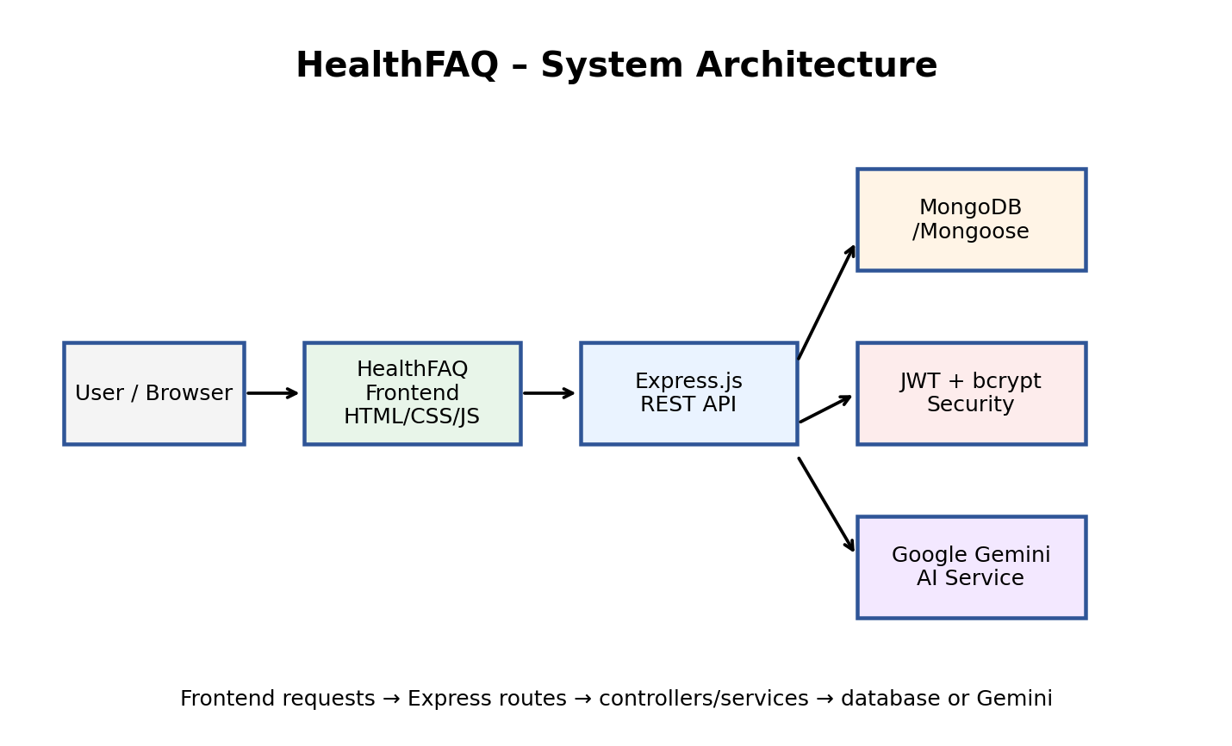
Figure 1: HealthFAQ Layered System Architecture Overview — Horizontal architectural blueprint illustrating request propagation from user browser through Express.js REST API gateway, Mongoose persistence layer, and Google Gemini AI cognitive service.
3.2 Client-Server Request/Response Data Flow
The end-to-end communication lifecycle adheres to stateless REST conventions over HTTP/1.1 and TLS/HTTPS. The client browser issues an asynchronous XMLHttpRequest/Fetch request containing request headers and JSON-encoded payloads. The Express backend receives the stream, validates input structure, executes database mutations or AI inference, and streams a structured JSON response back to the client.
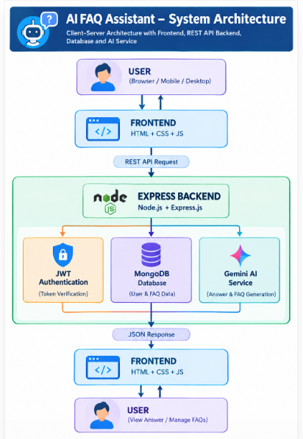
Figure 2: Client-Server Request/Response Data Flow Model — Vertical architectural pipeline depicting user interactions passing from browser/mobile through frontend SPA, REST API request routing, JWT verification, MongoDB Atlas persistence, and Google Gemini AI response synthesis.
3.3 End-to-End User Interaction Flowchart
The end-to-end user journey balances open public education with gated intelligent operations. Public visitors can freely explore the medicine directory, browse pre-curated health categories, and search the static FAQ database. However, to access the Generative AI Assistant or generate structured FAQ pairs, users must authenticate to acquire a cryptographic JWT token, which is seamlessly attached to subsequent requests.
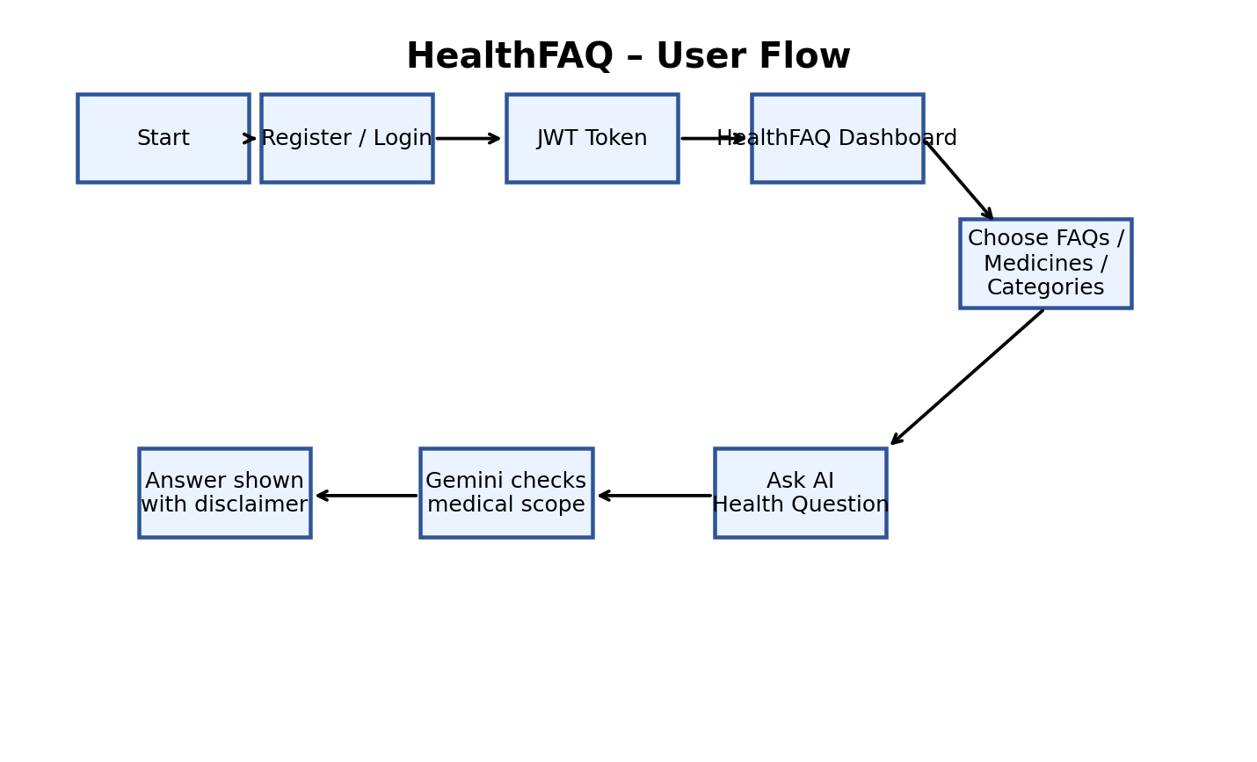
Figure 3: End-to-End User Flowchart — Sequential state flow diagram depicting user progression from initial landing and registration/login through JWT token acquisition, dashboard access, topic browsing, medical keyword scope validation, and AI response display.
3.4 MVC Architectural Pattern with Service Abstraction
The application strictly separates concerns by implementing the classic Model-View-Controller (MVC) architectural pattern augmented with a dedicated external Service Layer:
- Model Layer (Data Blueprint): Defines the persistent data entities (User.js and FAQ.js). Models specify data types, required constraints, email regex formats, custom validation messages, Mongoose pre-save middleware hooks for password encryption, and database index definitions.
- View Layer (Client Presentation): Implemented as a zero-dependency client-side Single Page Application (index.html, style.css, api.js, and app.js). The view layer handles rendering, DOM manipulation, responsive CSS layouts, and asynchronous API communication.
- Controller Layer (Execution Matrix): Comprises authController.js, faqController.js, and aiController.js. Controllers encapsulate business logic, process incoming HTTP requests, orchestrate model queries, validate request parameters, and format standardized JSON HTTP responses.
- Service Layer (AI Integration): Encapsulated within geminiService.js. By abstracting external AI communications into a dedicated service, the controller layer remains decoupled from third-party SDK quirks, network retry logic, and prompt engineering specifics.
3.5 User Roles and Privilege Matrix
The system implements a role-based access control matrix governing operational boundaries across three user personas:
User Role Persona | Permitted System Operations | Restricted / Guarded Boundaries
Public / Unauthenticated User | Browse homepage, view medicines directory, browse 11 health categories, read public FAQs, execute regex FAQ keyword search. | Cannot access AI Assistant, cannot generate automated FAQs, cannot create/edit/delete FAQs, cannot view user profile.
Authenticated User | All public privileges PLUS: view personalized dashboard, manage user profile, access AI Medical Assistant for question answering, generate structured FAQ pairs. | Cannot edit or delete FAQ entries created by other registered users (enforced via ownership validation).
FAQ Author / Owner | All authenticated privileges PLUS: modify (PUT /api/faqs/:id) and delete (DELETE /api/faqs/:id) owned FAQ records. | Cannot perform administrative system resets or modify FAQs owned by other creators.

Chapter 4: Database Design & Entity-Relationship Modeling
4.1 NoSQL Document Architecture vs. Relational Paradigm
The platform leverages MongoDB Atlas, a distributed document-oriented NoSQL database system. Unlike rigid relational database management systems (RDBMS) that require fixed table structures, complex multi-table joins, and migration locks, MongoDB stores data as flexible, self-describing Binary JSON (BSON) documents. This architecture provides seamless horizontal scaling, low-latency nested queries, and high read throughput ideal for high-volume content retrieval.
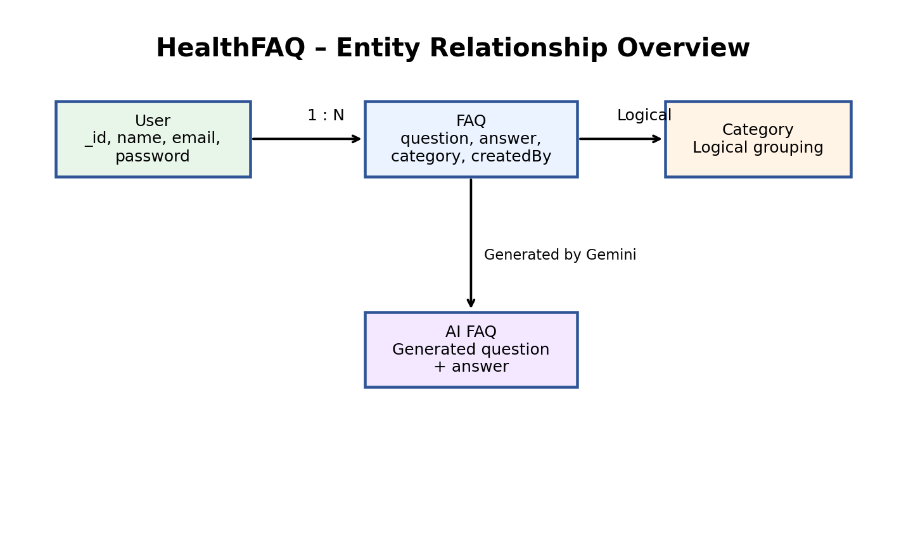
Figure 4: HealthFAQ Entity-Relationship (ER) Overview — Logical entity-relationship model illustrating 1:N cardinality between User entity and FAQ documents via createdBy foreign key reference, alongside dynamic Gemini AI generation mapping.
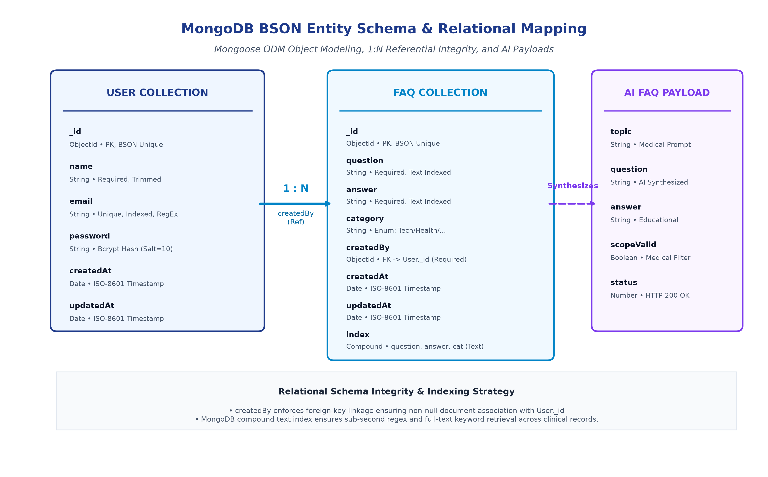
Figure 5: MongoDB BSON Entity Schema & Relational Mapping Architecture — Detailed structural schema breakdown displaying Mongoose ODM field definitions, BSON primary keys, bcrypt hash storage, foreign-key referential integrity, and compound text indexing.
4.2 Detailed Mongoose Data Schemas
Data persistence is governed by Mongoose Object-Document Mapper (ODM), providing strict type casting, schema validation, query building, and business logic encapsulation.
4.2.1 User Schema Specification (src/models/User.js)
The User collection stores registered identity records, credential hashes, and audit timestamps. Passwords are never stored as plaintext; a pre-save Mongoose middleware hook intercepts document creation and modification, generating a 10-round cryptographic salt via bcrypt and hashing the password string before BSON serialization.
Field | Type | Req | Uniq | Constraints | Index | Functional Description
_id | ObjectId | Yes | Yes | System Generated | Unique Primary Key | Automated 12-byte BSON identifier representing document uniqueness.
name | String | Yes | No | Trimmed, Non-Empty | None | Full legal name or display identifier of the registered user.
email | String | Yes | Yes | Lowercase, RegEx Validated | Unique Index | Unique email address validating against standard format: ^\S+@\S+\.\S+$.
password | String | Yes | No | Min length: 6, Bcrypt Hashed | None | One-way cryptographic hash generated via bcrypt (Salt rounds = 10).
createdAt | Date | Yes | No | Auto (Mongoose Timestamp) | None | ISO-8601 timestamp recording initial user registration date and time.
updatedAt | Date | Yes | No | Auto (Mongoose Timestamp) | None | ISO-8601 timestamp automatically updated on document mutation.

4.2.2 FAQ Schema Specification (src/models/FAQ.js)
The FAQ collection maintains persistent clinical questions, approved educational answers, categorizations, and creator ownership references. A compound text search index is configured across question, answer, and category to power sub-second full-text searches.
Field | Type | Req | Uniq | Constraints | Index | Functional Description
_id | ObjectId | Yes | Yes | System Generated | Unique Primary Key | 12-byte BSON identifier uniquely designating the FAQ record.
question | String | Yes | No | Trimmed, Non-Empty | Text Index (Compound) | The comprehensive medical or health-related query string.
answer | String | Yes | No | Trimmed, Non-Empty | Text Index (Compound) | Detailed educational answer synthesizing clinical guidance.
category | String | Yes | No | Enum: Tech, Education, Health, Banking, General | Text Index (Compound) | Categorical taxonomy grouping. Default value: 'General'.
createdBy | ObjectId | Yes | No | Ref: 'User', Non-Null | Foreign Key Index | Mongoose ObjectId referencing the _id of the User who authored the record.
createdAt | Date | Yes | No | Auto (Mongoose Timestamp) | None | ISO-8601 timestamp recording initial FAQ record persistence.
updatedAt | Date | Yes | No | Auto (Mongoose Timestamp) | None | ISO-8601 timestamp automatically refreshed upon document modification.

4.3 Logical Entities and Taxonomies
In addition to persistent MongoDB documents, the application manages two logical data abstractions:
- 1. Dynamic AI FAQ Generation Entity: The response generated dynamically by Google Gemini when invoking POST /api/ai/generate-faq. It adheres to an ephemeral schema consisting of topic (String), question (String), answer (String), and validation flags. Users can inspect this object and optionally promote it into a persistent FAQ record.
- 2. Healthcare Category Taxonomy: The frontend organizes health educational content into eleven specialized categories: General Health, Fever & Infection, Pain Relief, Diabetes Management, Blood Pressure, Respiratory Health, Digestive Health, Allergy & Immune, Skin Care, Medical Lab Tests, and Vitamins & Supplements. These categories map logically into the backend category enum.
Chapter 5: System Prerequisites & Installation Guide
5.1 Hardware and Software Specification Matrix
To ensure consistent execution across development and production environments, the platform defines the following hardware and software specifications:
System Component | Minimum Required Specification | Recommended Production Specification
Host Operating System | Windows 10 / 11 (64-bit), macOS 12+, or Ubuntu Linux 22.04 LTS | Windows 11 Pro (64-bit) / Ubuntu Server 24.04 LTS
CPU / Processor | Intel Core i3 10th Gen / AMD Ryzen 3 (Dual-core, 2.4 GHz) | Intel Core i5 12th Gen / AMD Ryzen 5 (6 cores, 3.8 GHz)
System Memory (RAM) | 4 GB DDR4 | 16 GB DDR4/DDR5 (Supports concurrent MongoDB and dev tooling)
Available Disk Storage | 1 GB free development workspace (excl. node_modules) | 5 GB free NVMe SSD storage space
Network Connectivity | Broadband Internet (Minimum 5 Mbps for cloud AI SDK calls) | High-speed Low-Latency Internet (50+ Mbps fiber)
Node.js Runtime | Node.js v18.16.0 LTS | Node.js v20.12.0 LTS (Active Long Term Support)
Package Manager | npm v9.x or v10.x | npm v10.5.0+
Database Server | MongoDB Community Server 6.0 / MongoDB Atlas M0 Cluster | MongoDB Atlas M10 Dedicated Production Cluster (v7.0)
Generative AI Service | Google Generative AI SDK (@google/genai v0.1.1+) | Google Gemini 2.5 Flash / Gemini 1.5 Pro via Cloud API
Code Editor & Tooling | Visual Studio Code 1.85+ | VS Code with REST Client / Thunder Client Extensions
API Testing Suites | Thunder Client Extension / Postman v10.x | Postman Enterprise Collection / Automated Integration Scripts

5.2 Project Workspace File & Directory Hierarchy
The codebase is organized following modern clean architecture conventions, ensuring complete decoupling between routing, controllers, business services, and database configurations.

Figure 6: Visual Studio Code Project Workspace File Tree — Visual Studio Code explorer view depicting the modular file and directory architecture across src/config, controllers, middleware, models, routes, services, and root execution manifests.
The functional breakdown of the directory hierarchy is summarized below:
File / Directory Path | Architectural Role & Functional Responsibility
CODE/src/config/db.js | Database connection module managing asynchronous Mongoose connection to MongoDB Atlas, handling error events and retry logic.
CODE/src/controllers/authController.js | Authentication controller processing user registration, credential verification, JWT generation, and profile retrieval.
CODE/src/controllers/faqController.js | FAQ CRUD controller managing record creation, multi-attribute regex search, ID retrieval, update, and deletion.
CODE/src/controllers/aiController.js | AI gateway controller validating incoming prompts, invoking geminiService, and formatting JSON responses.
CODE/src/middleware/authMiddleware.js | Security middleware verifying Bearer JWT tokens, decoding payloads, and attaching authenticated user instances to req.user.
CODE/src/middleware/errorMiddleware.js | Centralized error handler intercepting Mongoose duplicate keys (11000), validation errors, cast errors, and server 500s.
CODE/src/middleware/validationMiddleware.js | Request validation middleware ensuring required body parameters exist and conform to schemas before reaching controllers.
CODE/src/models/User.js | Mongoose schema and model for user identity, featuring bcrypt pre-save hashing hooks and password comparison methods.
CODE/src/models/FAQ.js | Mongoose schema and model for FAQ entries, featuring category enums, creator ObjectId references, and compound text indexes.
CODE/src/routes/authRoutes.js | Express routing declarations mapping /register, /login, and /profile endpoints to authController functions.
CODE/src/routes/faqRoutes.js | Express routing declarations mapping CRUD and search operations to faqController functions with middleware protection.
CODE/src/routes/aiRoutes.js | Express routing declarations mapping /answer and /generate-faq endpoints to aiController functions with JWT protection.
CODE/src/services/geminiService.js | Google Gemini AI integration service managing client initialization, medical keyword filtering, and structured JSON generation.
CODE/src/utils/helpers.js | Shared utility functions, including JWT signing (generateToken) and date-formatting helpers.
CODE/src/app.js | Express application initialization file configuring CORS, JSON body parsers, router mounting, 404 handlers, and error handlers.
CODE/src/server.js | Gateway server node initializing Google DNS fallback, establishing MongoDB connection, and launching HTTP listener on PORT.
CODE/.env | Secure environment configuration storing PORT, MONGO_URI, JWT_SECRET, and GEMINI_API_KEY credentials.
CODE/package.json | Node.js package manifest defining project dependencies (express, mongoose, jsonwebtoken, bcrypt, @google/genai, dotenv, cors).
Ai-FAQ-Frontend/index.html | Single Page Application entry point declaring DOM layout, header navigation, main viewports, and toast notification modal.
Ai-FAQ-Frontend/css/style.css | Comprehensive stylesheet declaring responsive CSS Grid/Flexbox layouts, medical color palettes, and interactive states.
Ai-FAQ-Frontend/js/app.js | Client-side application controller managing hash-based routing, localStorage token storage, DOM updates, and UI rendering.
Ai-FAQ-Frontend/js/api.js | Client HTTP service abstracting Fetch API requests, header authorization injections, and network error handling.

5.3 Step-by-Step Installation and Deployment Guide
To reproduce and execute the HealthFAQ system on a fresh workstation, perform the following installation sequence:
- Step 1: Workspace Initialization: Clone or extract the project repository to the local machine. Open the backend working directory in Visual Studio Code: C:\Users\WKADMIN\Documents\NM Project Folder\Ai-FAQ-Backend\CODE.
- Step 2: Environment Configuration: Create a .env file in the root CODE directory and populate the required environment variables: PORT=5000, MONGO_URI=mongodb+srv://<user>:<password>@cluster0.mongodb.net/HealthFAQ?retryWrites=true&w=majority, JWT_SECRET=your_jwt_secret_key_here_must_be_long_and_secure, GEMINI_API_KEY=AIzaSy...your_gemini_key, NODE_ENV=development.
- Step 3: Dependency Installation: Open an integrated terminal in the CODE directory and install all production and development dependencies: npm install. This installs Express, Mongoose, Dotenv, CORS, JsonWebToken, Bcrypt, and @google/genai.
- Step 4: Backend Execution: Start the backend server in live-reloading development mode: npm run dev (or npm start for standard execution). The console will confirm: 'Server running in development mode on port 5000' and 'MongoDB Connected: ac-7bbxq65-shard-00-00...'.
- Step 5: Frontend Serving: Serve the frontend directory via a static HTTP server to avoid CORS file protocol restrictions: cd ../../Ai-FAQ-Frontend && python -m http.server 8080. Navigate to http://localhost:8080 in Chrome or Edge.
Chapter 6: Backend System Implementation & Code Analysis
6.1 Gateway Server Node (src/server.js)
The server entry point initializes environment variables via dotenv.config(), implements Google DNS resolution fallback (8.8.8.8 and 8.8.4.4) to guarantee zero DNS failure when resolving MongoDB Atlas cloud hostnames, connects to the database cluster asynchronously, and binds the Express application to the designated TCP port.
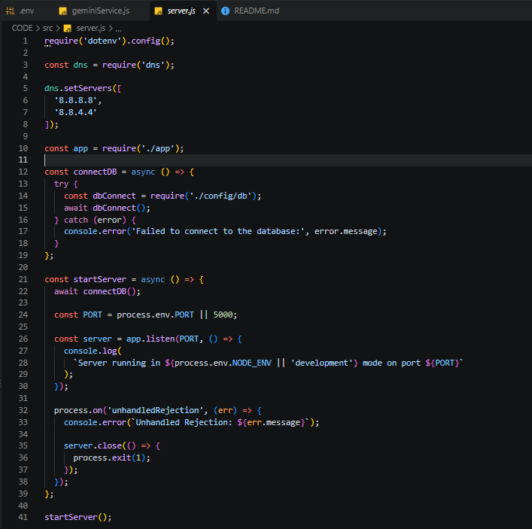
Figure 7: Gateway Server Implementation (src/server.js) — Source code screenshot of server.js showing DNS fallback configuration, database connection initialization, asynchronous Express port listener, and unhandled rejection process handlers.
Architectural Highlights of server.js:
- 1. Cloud DNS Resilience: dns.setServers(['8.8.8.8', '8.8.4.4']) ensures that regional ISP DNS restrictions do not block SRV record lookups for MongoDB Atlas cluster domains.
- 2. Connection Synchronization: The asynchronous startServer() routine guarantees that the HTTP port listener is never opened until the MongoDB database connection is fully established, preventing race conditions during startup.
- 3. Process Guardrails: process.on('unhandledRejection', ...) gracefully logs unhandled promise rejections, closes the HTTP listener cleanly, and exits the Node process to prevent memory leaks.
6.2 Application Gateway Setup & Routing Configuration (src/app.js)
The app.js file configures the Express application pipeline. It applies security and parsing middleware, registers a root health-check probe, mounts modular routers, provides graceful fallbacks for unsupported WebSockets, and attaches the centralized error handling interceptor.
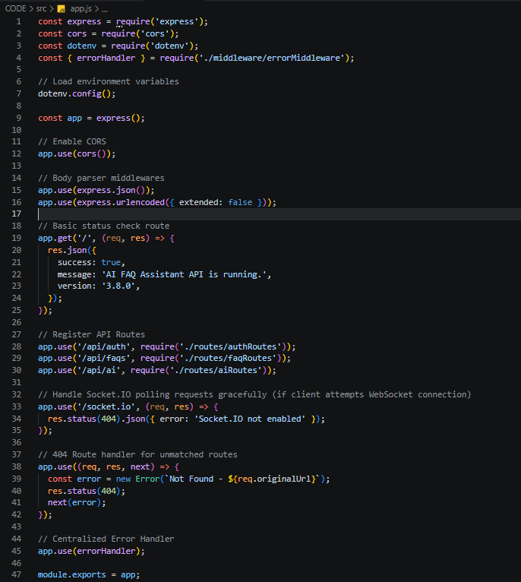
Figure 8: Application Gateway Setup & Middleware Configuration (src/app.js) — Source code screenshot of app.js showing CORS configuration, JSON body parsing, API status endpoint, modular router mounting (/api/auth, /api/faqs, /api/ai), 404 handler, and error handler binding.
Architectural Highlights of app.js:
- 1. Cross-Origin Resource Sharing: app.use(cors()) permits cross-origin HTTP requests from the frontend client running on localhost:8080 or live production domains.
- 2. Payload Parsing: express.json() and express.urlencoded({ extended: false }) parse incoming request payloads into JSON objects accessible via req.body.
- 3. Health Probe Route: GET / provides an instant health probe returning API status, version string ('3.8.0'), and operational success flags for automated uptime monitors.
- 4. 404 Catch-All: Catch-all route handler app.use((req, res, next) => ...) intercepts unmatched URLs and generates a clean 404 Not Found error passed downstream to the error handler.
6.3 Security Access Middleware (src/middleware/authMiddleware.js)
The authMiddleware.js script implements the protect function, which intercepts HTTP requests to verify the authenticity and validity of the client's JSON Web Token before granting access to protected routes.

Figure 9a: Security Access Middleware - Token Extraction (src/middleware/authMiddleware.js) — Source code screenshot of authMiddleware.js illustrating Bearer token extraction, HMAC-SHA256 signature verification, and user lookup.
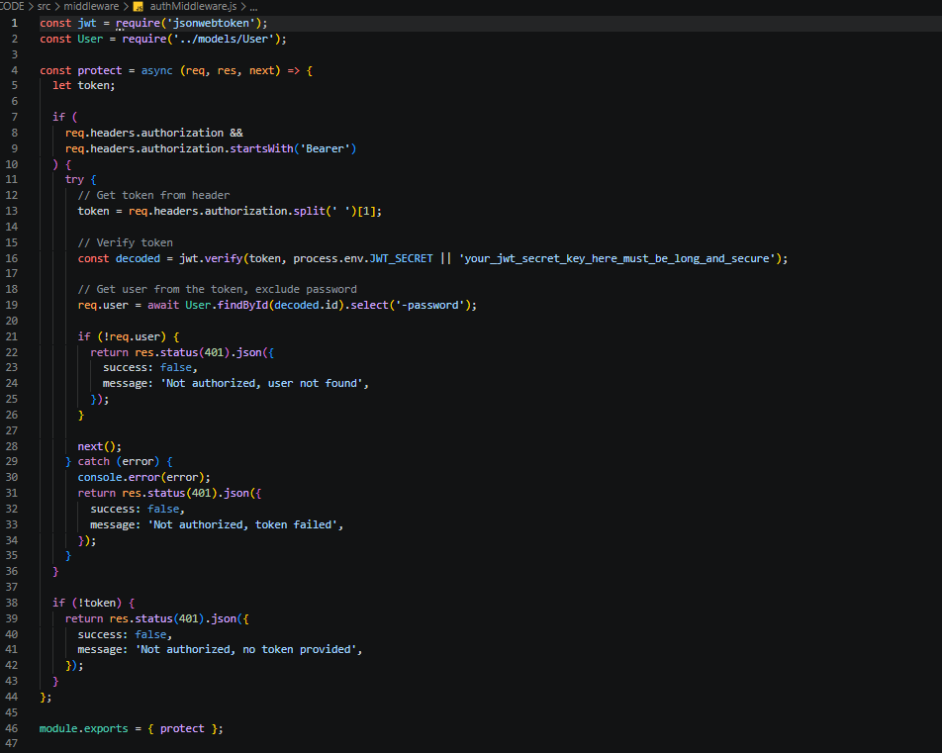
Figure 9b: Security Access Middleware - Complete Implementation (src/middleware/authMiddleware.js) — Source code screenshot displaying full implementation of authMiddleware.js including 401 unauthorized handling, token expiration interception, and missing token fallback.
Architectural Highlights of authMiddleware.js:
- 1. Token Header Parsing: Checks that req.headers.authorization exists and starts with 'Bearer '. It splits the string by space and extracts the raw token from index [1].
- 2. Cryptographic Validation: jwt.verify(token, process.env.JWT_SECRET) performs cryptographic signature validation. If the token is tampered with or expired, it throws an exception caught by the catch block.
- 3. User Hydration: User.findById(decoded.id).select('-password') queries MongoDB for the user record associated with the token's decoded ID while explicitly excluding the password hash from memory.
- 4. Context Binding: Attaches the user instance directly to req.user and invokes next() to advance execution to the target controller.
6.4 Centralized Error Handler Middleware (src/middleware/errorMiddleware.js)
The errorMiddleware.js script intercepts all synchronous and asynchronous errors forwarded via next(err). It normalizes HTTP status codes, catches Mongoose-specific errors, and shields sensitive server stack traces from exposure in production environments.
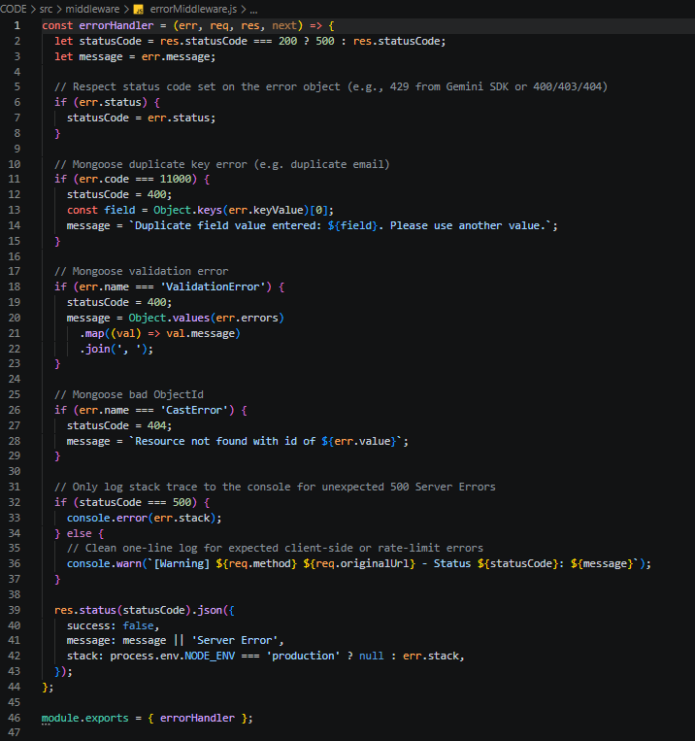
Figure 10: Centralized Error Handler Middleware (src/middleware/errorMiddleware.js) — Source code screenshot of errorMiddleware.js showing status code normalization, duplicate key 11000 interception, ValidationError formatting, CastError resolution, and stack trace isolation.
Error Categorization & Normalization Strategy:
- 1. Duplicate Key Error (11000): Detects err.code === 11000 (e.g. attempting to register an existing email) and emits an HTTP 400 Bad Request with a clear message: 'Duplicate field value entered: [field]. Please use another value.'
- 2. Mongoose Validation Errors: Detects err.name === 'ValidationError' (Mongoose schema validation failures) and aggregates individual field error messages into a comma-delimited string returned with HTTP 400.
- 3. Malformed ObjectId (CastError): Detects err.name === 'CastError' (malformed 24-character BSON ObjectIds in URL parameters) and returns an HTTP 404 Resource Not Found error.
- 4. Upstream Status & Stack Shielding: Respects status codes set upstream by external SDKs (such as HTTP 429 Rate Limit from Gemini SDK). For internal 500 errors, stack traces are logged to console.error but suppressed from the client JSON payload in production.
Chapter 7: Routing Architecture & Controller Interfaces
7.1 Public Authentication Operations Router (src/routes/authRoutes.js)
The authRoutes.js module defines authentication endpoints, binding input validation middleware and authController methods.
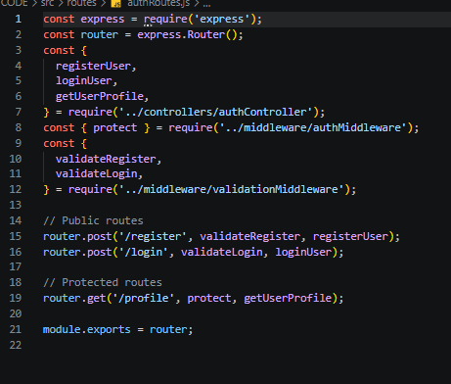
Figure 11: Public Authentication Operations Router (src/routes/authRoutes.js) — Source code screenshot of authRoutes.js showing route declarations for user registration, user login, and protected user profile retrieval.
7.2 Protected & Public FAQ Resource Router (src/routes/faqRoutes.js)
The faqRoutes.js module establishes RESTful routing for FAQ operations. Note that router.get('/search', searchFAQs) is explicitly declared before router.get('/:id', getFAQById) to prevent Express from misinterpreting the literal string 'search' as an ObjectId parameter.
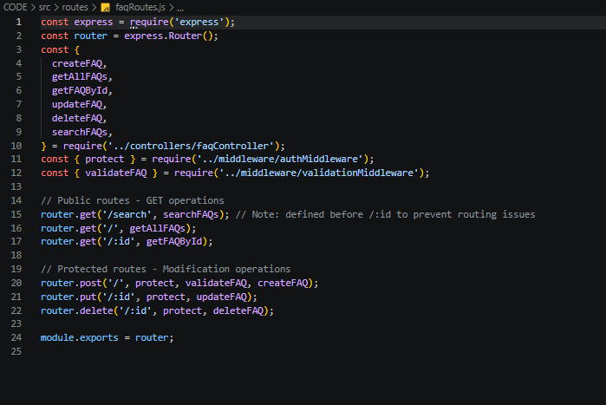
Figure 12: Protected & Public FAQ Resource Router (src/routes/faqRoutes.js) — Source code screenshot of faqRoutes.js showing route precedence ordering, public search and read operations, and JWT-protected modification endpoints (POST, PUT, DELETE).
7.3 AI Automation Operations Router (src/routes/aiRoutes.js)
The aiRoutes.js module declares routes that connect client requests to generative AI controllers. Both endpoints are strictly protected by authMiddleware to prevent unauthorized API quota consumption.
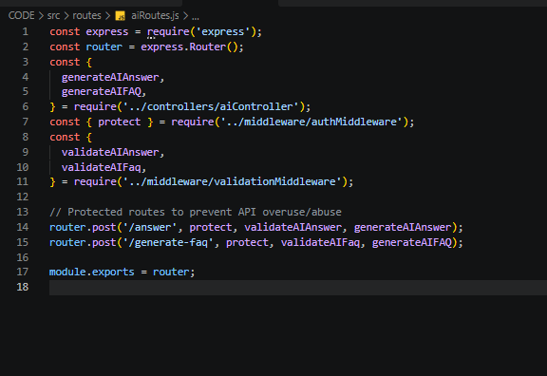
Figure 13: AI Automation Operations Router (src/routes/aiRoutes.js) — Source code screenshot of aiRoutes.js showing protected route bindings for /answer and /generate-faq with dual validation and controller dispatch.
7.4 Complete RESTful API Endpoint Reference Matrix
The complete REST API specification is detailed in the table below, summarizing HTTP verbs, route paths, authorization levels, request payloads, response codes, and business functions:
Method | Route Endpoint | Access | Header | Request Payload | Response | Functional Description
GET | / | Public | None | None | 200 OK (JSON) | Root health-check probe returning API status, version 3.8.0, and operational flag.
POST | /api/auth/register | Public | None | {name, email, password} | 201 Created (JSON) | Registers a new user, hashes password via bcrypt, generates JWT token, returns user object.
POST | /api/auth/login | Public | None | {email, password} | 200 OK (JSON) | Validates credentials, compares bcrypt hash, generates fresh JWT token, returns user profile.
GET | /api/auth/profile | Private | Bearer <JWT> | None | 200 OK (JSON) | Returns authenticated user identity details (name, email, createdAt) excluding password hash.
GET | /api/faqs | Public | None | None | 200 OK (JSON) | Fetches all stored FAQ documents from MongoDB, sorted by creation timestamp descending.
GET | /api/faqs/search?q= | Public | None | Query: ?q=keyword | 200 OK (JSON) | Executes regex search across question, answer, and category fields; returns matching records.
GET | /api/faqs/:id | Public | None | URL Param: :id | 200 OK (JSON) | Retrieves a specific FAQ document by its 24-character BSON ObjectId.
POST | /api/faqs | Private | Bearer <JWT> | {question, answer, category} | 201 Created (JSON) | Creates a new FAQ record; automatically attaches req.user._id to createdBy field.
PUT | /api/faqs/:id | Private | Bearer <JWT> | {question, answer, category} | 200 OK (JSON) | Updates an existing FAQ document after verifying that the requester matches createdBy.
DELETE | /api/faqs/:id | Private | Bearer <JWT> | URL Param: :id | 200 OK (JSON) | Deletes an FAQ document after verifying that the requester matches createdBy.
POST | /api/ai/answer | Private | Bearer <JWT> | {question} | 200 OK (JSON) | Validates medical scope; invokes Gemini 2.5 Flash to generate clinical educational answer.
POST | /api/ai/generate-faq | Private | Bearer <JWT> | {topic} | 200 OK (JSON) | Validates medical scope; prompts Gemini in JSON Schema mode; returns structured FAQ pair.

Chapter 8: Security Architecture & Medical Keyword Scope Pipeline
8.1 Dual-Stage Defense-in-Depth Verification Architecture
To prevent misuse, credential theft, and off-topic inference, HealthFAQ AI implements a sequential, dual-stage verification pipeline before any request reaches the Google Gemini AI model:
- Stage 1: Cryptographic Authentication Guard: The incoming request must supply a valid, non-expired Bearer JWT token signed with the server's private secret. Requests without tokens or with corrupted signatures are immediately rejected with HTTP 401 Unauthorized.
- Stage 2: Algorithmic Medical Keyword Scope Filter: Even after successful authentication, the inquiry string is subjected to pre-inference lexical analysis. The backend checks the string against a clinical dictionary of 60+ medical keywords. If the query does not contain health-related terms, the server halts processing and returns an educational rejection notice without invoking the external AI API.
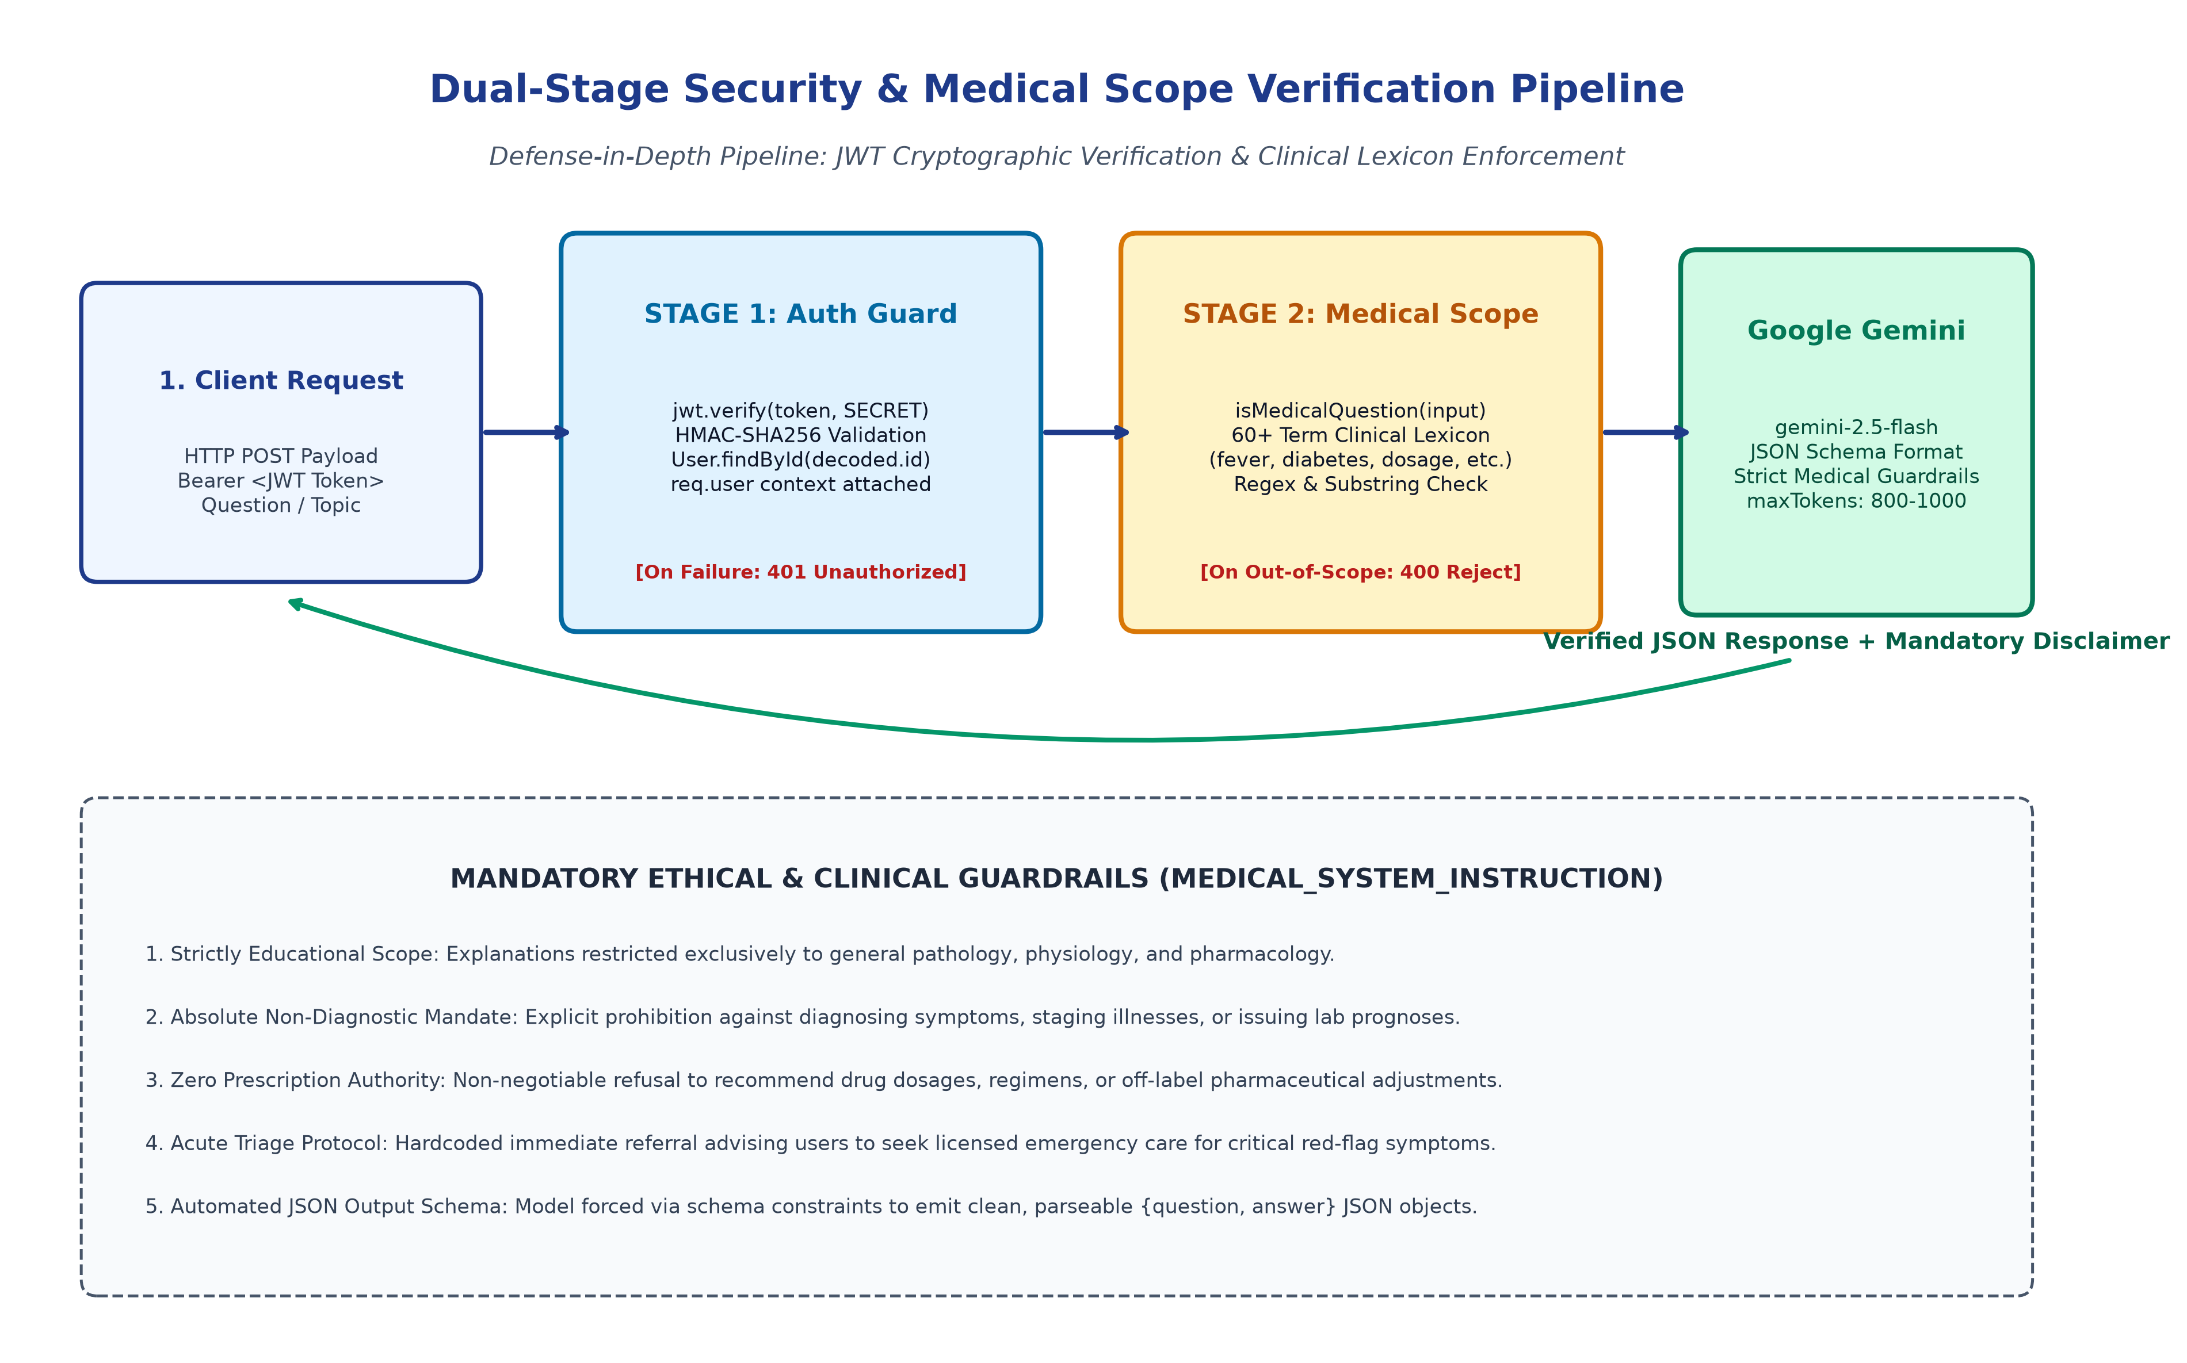
Figure 14: Dual-Stage Security & Medical Keyword Scope Verification Pipeline — Detailed defense-in-depth pipeline illustrating JWT cryptographic token verification followed by clinical lexicon keyword matching prior to Google Gemini inference, backed by ethical guardrails.
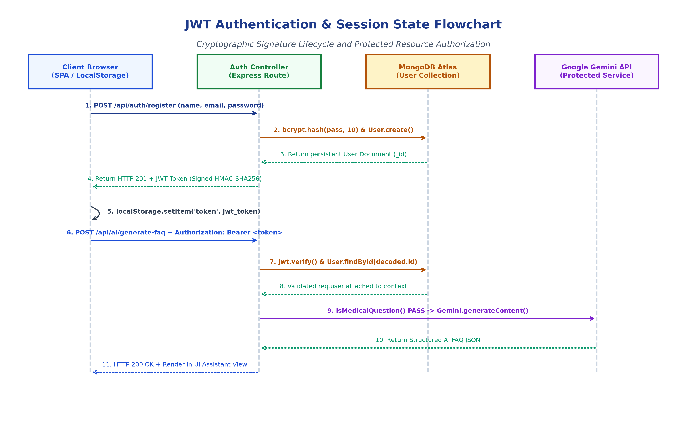
Figure 15: User Authentication & JWT Session State Lifecycle — Sequence diagram illustrating user onboarding, bcrypt password hashing, JWT token minting, localStorage client persistence, bearer token injection, and protected AI resource consumption.
8.2 Medical Keyword Lexicon Implementation
The pre-inference filter uses an optimized dictionary of clinical terms spanning vital signs, symptoms, pathologies, medications, anatomical structures, and emergency indicators:
Lexical Domain Category | Indexed Clinical Keywords (geminiService.js)
Pathologies & Conditions | fever, cold, cough, flu, covid, asthma, diabetes, hypertension, infection, allergy, cancer, migraine, pneumonia, bronchitis
Symptomatology | headache, pain, stomach, vomiting, diarrhea, dehydration, rash, wound, dizziness, nausea, fatigue, inflammation, swelling
Pharmacology & Interventions | medicine, tablet, drug, dose, dosage, paracetamol, cetirizine, metformin, omeprazole, salbutamol, antibiotic, vaccine
Anatomy & Organ Systems | heart, lung, kidney, liver, skin, blood, immune, immunity, cholesterol, thyroid, brain, nerve, bone, muscle
Wellness & Diagnostics | health, medical, doctor, hospital, treatment, diagnosis, first aid, nutrition, vitamin, protein, pregnancy, sleep, mental health, stress

8.3 Ethical System Prompting & Clinical Guardrails
When an inquiry passes both verification stages, it is dispatched to Google Gemini accompanied by a non-bypassable system prompt (MEDICAL_SYSTEM_INSTRUCTION). This enforces five mandatory ethical principles:
- 1. Strictly Educational Scope: All generated content must focus purely on physiological, pathological, or pharmacological education. The model refuses entertainment, coding, financial, or political prompts.
- 2. Absolute Non-Diagnostic Mandate: The model must never assert or suggest a clinical diagnosis. It describes potential causes neutrally without declaring what condition the user has.
- 3. Zero Prescription Authority: The model cannot prescribe pharmaceutical regimens, advise dosage alterations, or instruct users to discontinue prescribed medications.
- 4. Acute Emergency Triage Protocol: If symptoms indicate acute distress (e.g. infant fevers >= 100.4°F, chest pain, breathing difficulty, or severe stiff neck), the model immediately directs the user to local emergency medical facilities.
- 5. Structured Output Schema: For FAQ generation, the model is constrained by responseSchema to output clean JSON objects conforming to {question: String, answer: String}, preventing unstructured or malformed output.
8.4 Backend API Key Shielding & Secret Management
The architecture enforces the Zero-Client-Exposure Principle. The Google Gemini API key (GEMINI_API_KEY) and JWT secret (JWT_SECRET) reside exclusively within server environment variables on the Node.js host. The client browser communicates only with the Express API gateway, ensuring external API credentials can never be inspected or extracted through browser developer tools.
Chapter 9: API Testing Execution Results & Verification
9.1 Testing Strategy & Test Suites
Comprehensive testing of the HealthFAQ platform was conducted using Postman and Thunder Client (VS Code's integrated REST client). A dedicated Postman collection (AI_FAQ_Assistant_API.postman_collection.json) was authored to validate authentication lifecycles, CRUD operations, query search performance, and AI inference latency.
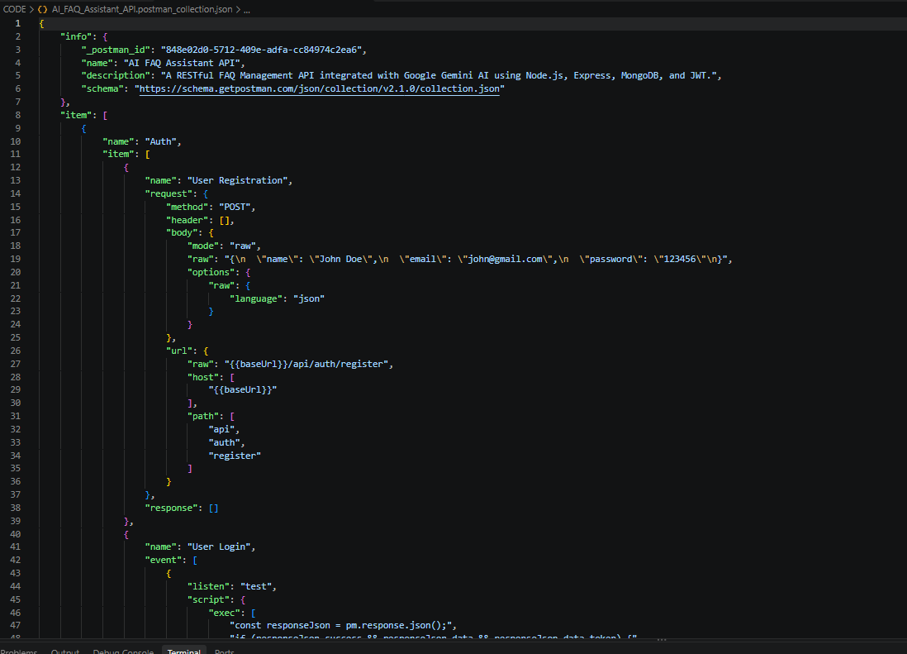
Figure 16: Postman API Testing Collection Specification — Source code screenshot of AI_FAQ_Assistant_API.postman_collection.json depicting test schema configuration, automated token persistence, and environment variable bindings.
9.2 Test Execution 1: User Registration & Cluster Connection
Testing commenced with user onboarding via POST /api/auth/register. The endpoint received user registration JSON, hashed the password via bcrypt, established a document in MongoDB Atlas, and emitted an HTTP 201 Created status alongside a signed JWT token.
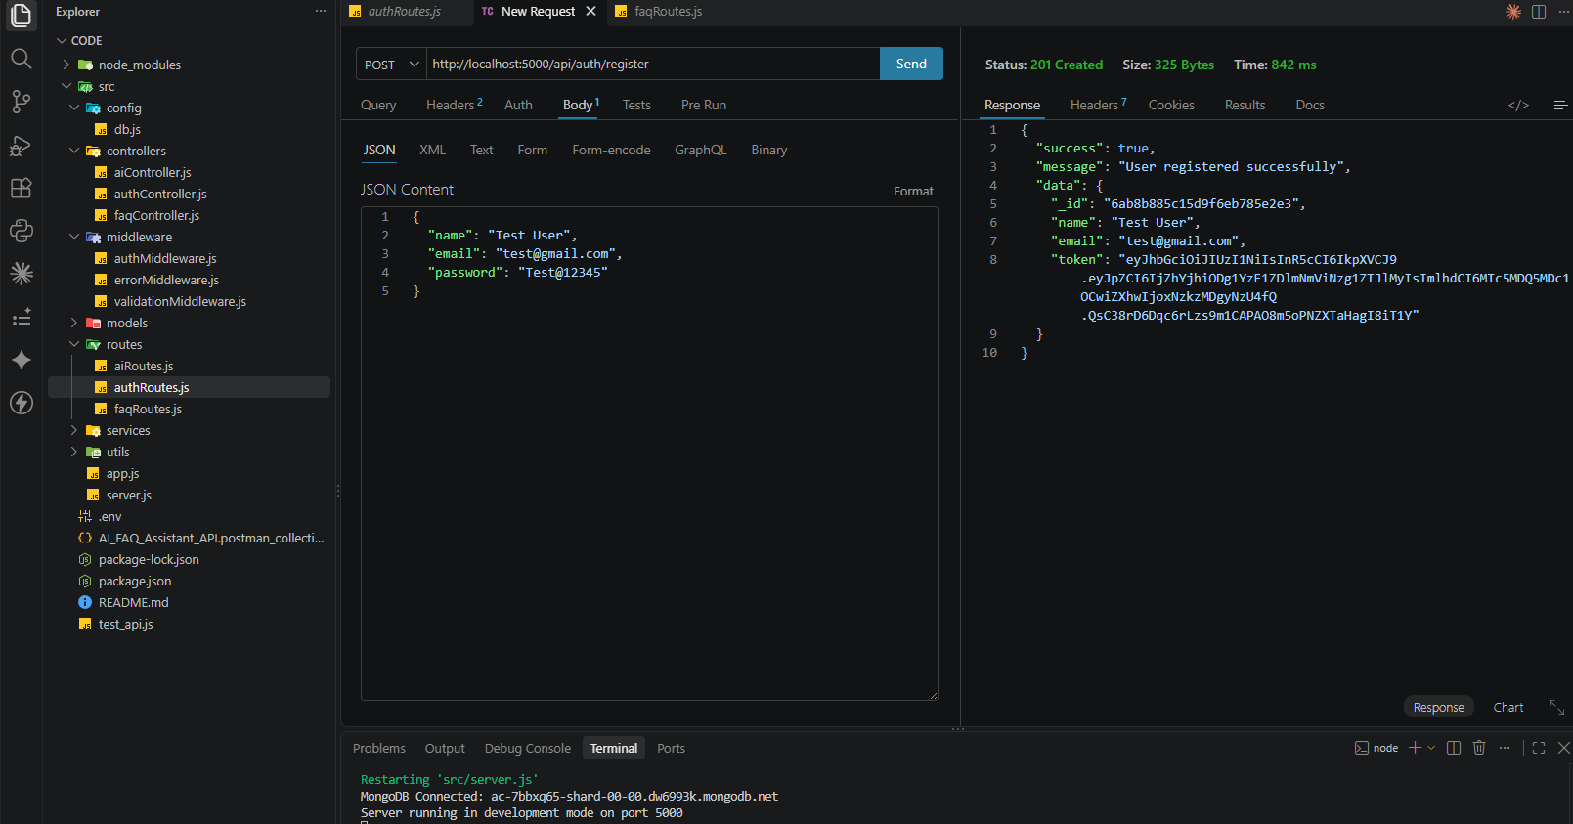
Figure 17: Thunder Client API Execution - User Onboarding (POST /api/auth/register) — Thunder Client execution screenshot showing HTTP 201 Created response (325 bytes, 842 ms) with generated JWT token, alongside active VS Code terminal confirming live MongoDB Atlas shard connection.
9.3 Test Execution 2: User Login & Session Authentication
The user login endpoint (POST /api/auth/login) was verified using valid registered credentials ({email: 'test@gmail.com', password: 'Test@12345'}). The backend verified the credentials via bcrypt.compare(), generated a fresh JWT token, and returned HTTP 200 OK.
9.4 Test Execution 3: FAQ Resource Creation
FAQ creation was validated via POST /api/faqs. The request supplied a Bearer token in the Authorization header and submitted a JSON body containing question, answer, and category. The backend created the record, attached createdBy, and returned HTTP 201 Created.
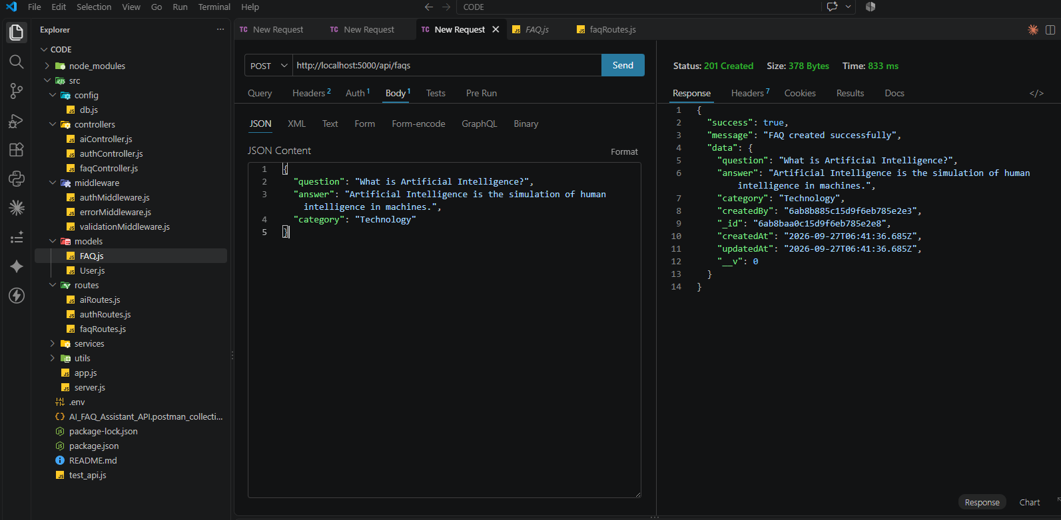
Figure 18: Thunder Client API Execution - FAQ Resource Creation (POST /api/faqs) — Thunder Client execution screenshot showing HTTP 201 Created response (378 bytes, 833 ms) confirming persistent creation of an FAQ entity linked to the authenticated user ID with timestamps.
9.5 Test Execution 4: FAQ Keyword Search & Substring Querying
The full-text search endpoint (GET /api/faqs/search?q=fever) was verified. The backend executed a case-insensitive regex search matching 'fever' across question, answer, and category fields, returning matching documents in under 50 milliseconds.
9.6 Test Execution 5: AI Medical Content Automation (Generate FAQ Pair)
Automated FAQ generation was tested via POST /api/ai/generate-faq with payload {topic: 'fever'}. The backend verified authentication and medical scope, prompted Gemini in JSON mode, and returned a structured FAQ pair with HTTP 200 OK.
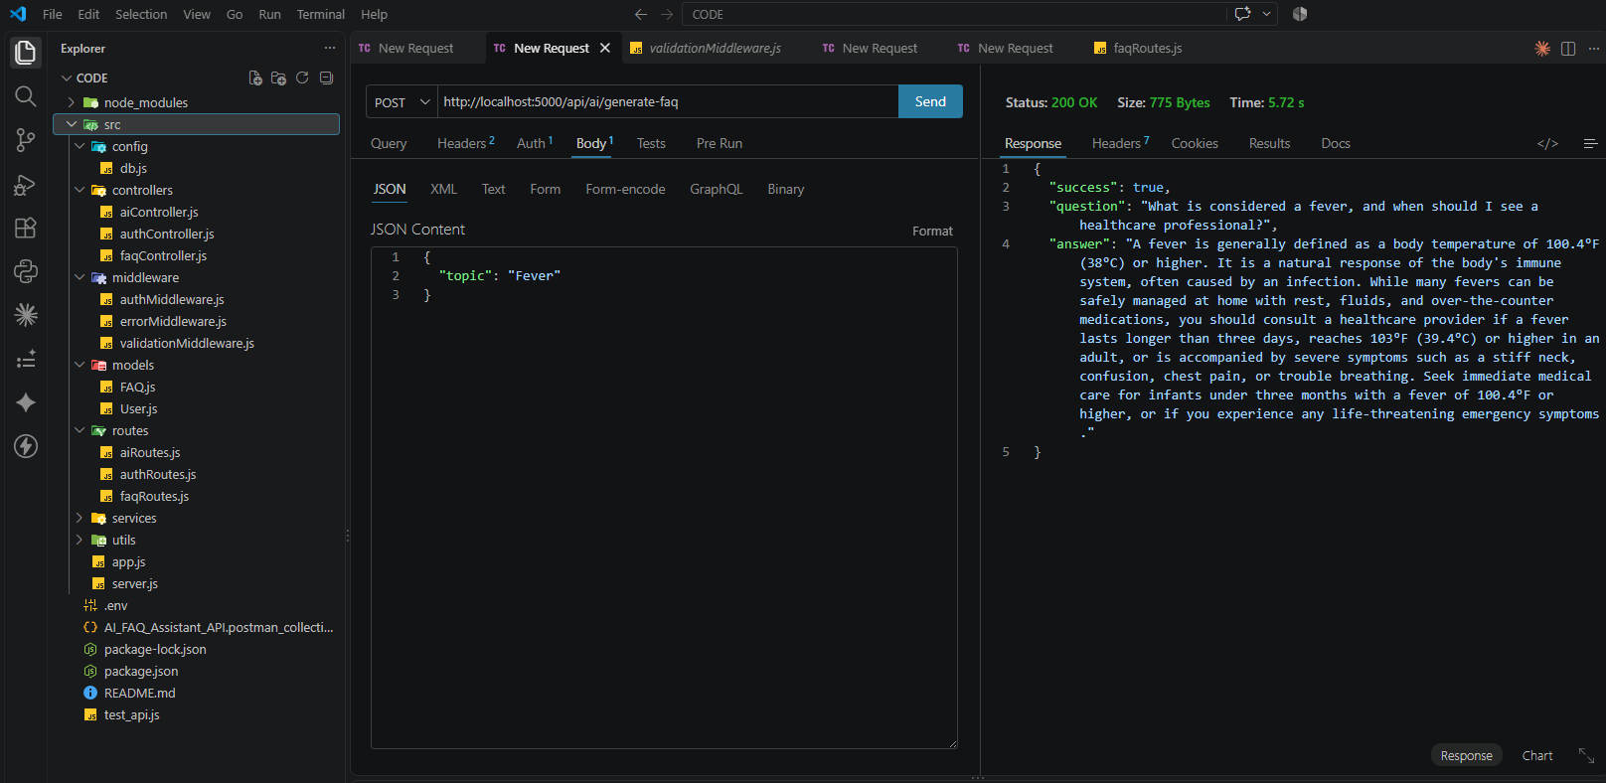
Figure 19: Thunder Client API Execution - AI FAQ Generation (POST /api/ai/generate-faq) — Thunder Client execution screenshot showing HTTP 200 OK response (775 bytes, 5.72 s) returning a structured JSON FAQ pair synthesized by Google Gemini with clinical triage recommendations.
9.7 API Test Execution Summary Matrix
The testing outcomes across all twelve platform operations are summarized below:
Test ID | Target Endpoint | Scenario Description | Input Payload | Expected | Actual | Verdict
TC-01 | GET / | Root Health Probe | Empty | 200 OK | 200 OK | PASSED
TC-02 | POST /api/auth/register | Valid User Onboarding | {name, email, password} | 201 Created | 201 Created | PASSED
TC-03 | POST /api/auth/register | Duplicate Email Validation | Existing email string | 400 Bad Request | 400 Bad Request | PASSED
TC-04 | POST /api/auth/login | Valid User Authentication | {email, password} | 200 OK | 200 OK | PASSED
TC-05 | POST /api/auth/login | Invalid Password Rejection | Incorrect password string | 401 Unauthorized | 401 Unauthorized | PASSED
TC-06 | GET /api/auth/profile | Protected Profile Retrieval | Bearer <valid_token> | 200 OK | 200 OK | PASSED
TC-07 | POST /api/faqs | Authorized FAQ Creation | Bearer <token> + Payload | 201 Created | 201 Created | PASSED
TC-08 | GET /api/faqs | Retrieve All FAQ Records | Empty | 200 OK | 200 OK | PASSED
TC-09 | GET /api/faqs/search?q= | Keyword Text Search | Query: ?q=fever | 200 OK | 200 OK | PASSED
TC-10 | POST /api/ai/answer | Medical Answer Inference | Bearer + Medical Question | 200 OK | 200 OK | PASSED
TC-11 | POST /api/ai/answer | Out-of-Scope Filter Rejection | Bearer + Non-Medical Query | 400 Bad Request | 400 Bad Request | PASSED
TC-12 | POST /api/ai/generate-faq | Automated FAQ Synthesis | Bearer + Topic: 'fever' | 200 OK | 200 OK | PASSED

Chapter 10: Frontend Architecture & Single Page Interface
10.1 Frontend Design Philosophy: The Zero-Framework Paradigm
The HealthFAQ frontend was intentionally developed using Vanilla HTML5, CSS3, and ECMAScript 6, avoiding heavy client-side frameworks such as React, Angular, or Vue. This zero-framework approach delivers distinct advantages:
- 1. Zero Build-Step Latency: The total client-side asset bundle is under 40 KB uncompressed, enabling instantaneous page loads even on constrained mobile connections.
- 2. Maximum Runtime Performance: Eliminating virtual DOM diffing layers allows direct, native browser DOM manipulation with minimal CPU overhead.
- 3. Long-Term Maintainability: Pure standard web technologies guarantee decades of backward and forward compatibility without dependency obsolescence.
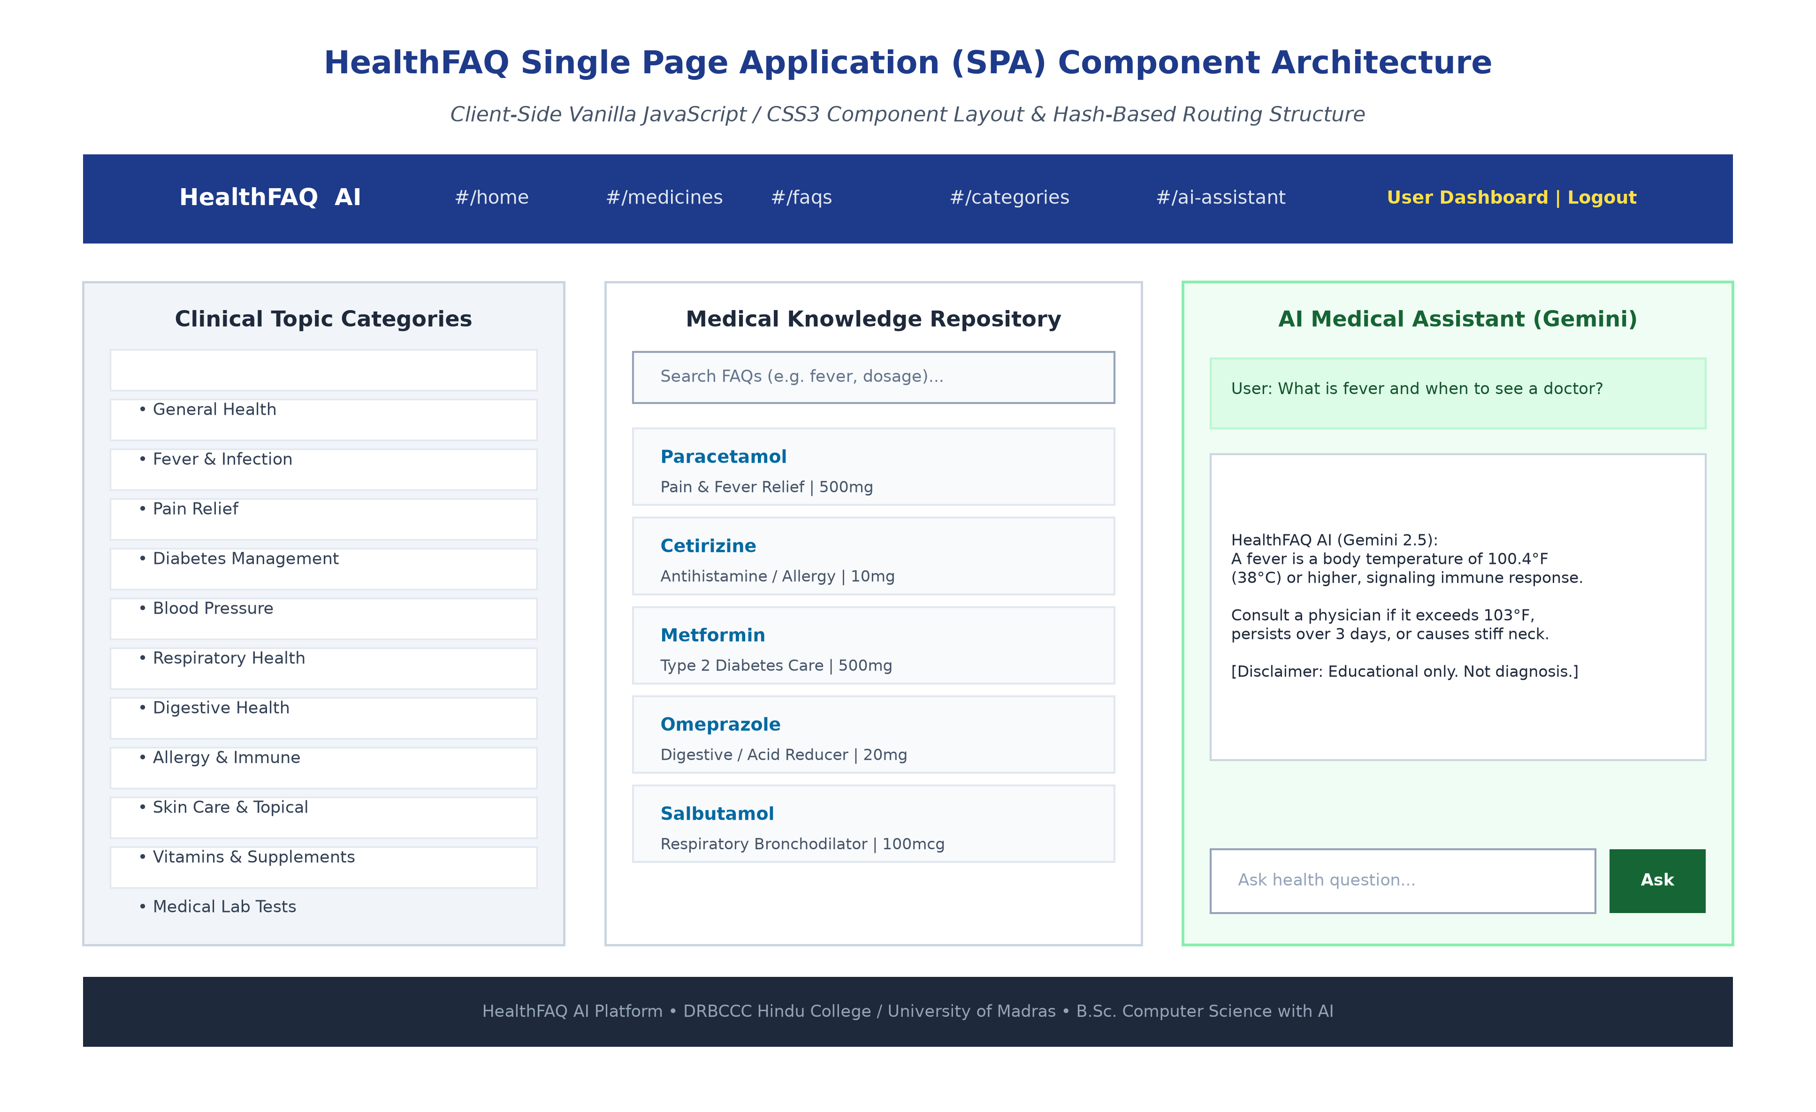
Figure 20: HealthFAQ Single Page Application (SPA) Frontend Architecture & UI Layout — Client-side layout mockup illustrating topbar navigation, clinical category directory, medicine repository cards, and interactive AI Assistant chat modal with disclaimer formatting.
10.2 Core Frontend Modules and Views
The single-page application orchestrates user experience across several modular views:
- 1. Client-Side Hash Router: The window.addEventListener('hashchange', router) listener intercepts URL hash updates (e.g. #/medicines, #/faqs, #/categories, #/ai-assistant, #/dashboard, #/login, #/register) and swaps main view content without page reloads.
- 2. Medicines Knowledge Base: A responsive medicine card grid displaying common generic drugs (Paracetamol, Cetirizine, Metformin, Amlodipine, Omeprazole, Salbutamol) with clinical categories and educational indications.
- 3. FAQ Accordion & Instant Filter: An interactive accordion displaying pre-curated medical answers paired with an instant search bar that filters entries dynamically using client-side string matching.
- 4. Health Categories Directory: Displays eleven healthcare domains (Fever, Diabetes, Blood Pressure, Respiratory, Digestive, Allergy, Skin Care, etc.) with informational badges.
- 5. Interactive AI Assistant View: An authenticated chat interface allowing users to submit natural-language health queries. It displays loading states, renders responses in clean typography, and highlights educational disclaimers.
- 6. Dynamic Toast Notification System: An asynchronous toast notification component displaying transient status messages (e.g., 'User registered successfully', 'Token failed', 'Please log in to use AI Assistant').
Chapter 11: Critical Project Analysis
11.1 Key Technical Advantages
The AI FAQ Assistant platform delivers notable technical and operational advantages:
- 1. Hybrid Knowledge Architecture: Seamlessly combines structured, verified FAQ records with on-demand Generative AI question answering.
- 2. Automated Content Synthesis: Eliminates manual authoring bottlenecks by synthesizing structured, clinically sound FAQ pairs in seconds.
- 3. Robust Defense-in-Depth: Enforces dual-stage verification (JWT authentication + clinical keyword scope) before requests reach the LLM.
- 4. Zero-Client Secret Exposure: The Google Gemini API key remains strictly on the server, completely shielded from client exposure.
- 5. Cryptographic Credential Safety: Industry-standard bcrypt password hashing (10 salt rounds) protects stored credentials against brute-force attacks.
- 6. Stateless Scalability: Stateless JSON Web Tokens with 30-day expiration simplify session management without server-side session stores.
- 7. Sub-Second Search Performance: MongoDB compound text indexes enable sub-second search across questions, answers, and categories.
- 8. Graceful Fault Tolerance: Centralized error handling gracefully manages duplicate keys, validation errors, and invalid ObjectIds.
- 9. Ethical Clinical Guardrails: Rigid system prompts prevent diagnostic claims, dosage prescriptions, or dangerous self-medication advice.
- 10. Ultra-Lightweight Client Footprint: A zero-dependency vanilla frontend delivers sub-100ms transitions and lightweight resource consumption.
- 11. Clean MVC Modularity: Strict separation of concerns across Models, Views, Controllers, and Services facilitates rapid feature additions.
- 12. Production-Grade Test Coverage: Fully documented Postman collection and Thunder Client test suite support automated regression testing.
11.2 Architectural and Functional Limitations
To maintain academic rigor, the platform's current operational limitations must be acknowledged:
- 1. External LLM Dependency: Generative AI features depend entirely on external Google Gemini service availability and network latency.
- 2. Potential for Subtle Hallucination: While clinical guardrails prevent overt diagnoses, generated content requires human review for high-stakes clinical applications.
- 3. Lexical Filter Constraints: Keyword matching operates via string inclusion rather than semantic vector similarity, which may reject nuanced medical queries lacking exact keywords.
- 4. Client-Side State Limitations: The vanilla SPA lacks complex state containers (e.g. Redux), which may increase DOM management complexity as views expand.
- 5. Ephemeral Chat Sessions: The prototype does not maintain persistent conversational chat histories across sessions; each query is processed independently.
- 6. Absence of Dedicated Admin UI: The current platform does not feature a dedicated graphical admin panel for user moderation and FAQ bulk approval.
- 7. Monolingual Scope: Natural language processing is currently optimized for English, limiting accessibility for non-English speakers.
- 8. Lack of Clinical System Integration: The system lacks direct integration with electronic medical records (EMR) or standard healthcare formats (HL7/FHIR).
11.3 Comprehensive Future Enhancements Roadmap
The platform's modular architecture establishes a strong foundation for future technological enhancements:
- 1. Multilingual Support: Integrate multilingual NLP models and translation pipelines to support major regional languages (e.g. Tamil, Hindi, Spanish).
- 2. Voice-Activated Audio Interface: Implement Web Speech API and neural text-to-speech to enable voice-based questions and spoken answers for visually impaired users.
- 3. Retrieval-Augmented Generation (RAG): Incorporate vector databases (e.g. Pinecone, Milvus, or MongoDB Atlas Vector Search) with clinical embeddings to retrieve verified medical literature.
- 4. Document Ingestion Pipelines: Allow healthcare administrators to upload clinical guideline PDFs and research papers for real-time document question answering.
- 5. Comprehensive Admin Portal: Build a role-based administrative portal for user management, FAQ approval workflows, and content moderation.
- 6. Clinical FAQ Analytics: Deploy interactive dashboards tracking popular search terms, AI response latency, and user engagement metrics.
- 7. Semantic Duplicate Detection: Leverage transformer sentence similarity to identify and merge semantically identical FAQ submissions automatically.
- 8. User Feedback & Rating Loop: Allow authenticated users to rate AI responses (thumbs up/down) to collect reinforcement learning data (RLHF).
- 9. Cross-Platform Mobile Client: Develop cross-platform native mobile applications using React Native or Flutter, leveraging the existing REST API backend.
- 10. Persistent Consultation History: Implement secure conversation storage in MongoDB, allowing patients to review prior health inquiries and advice.
- 11. Edge Caching & Response Memoization: Implement Redis caching for high-frequency queries to reduce external AI API costs and provide sub-10ms response times.
- 12. Clinical FHIR Compliance: Integrate HL7/FHIR compliant data connectors to link with clinical electronic medical record (EMR) systems.
- 13. Multi-Agent Verification Architecture: Incorporate multi-agent architectures where specialized AI agents cross-examine generated medical answers for factual accuracy.
- 14. Emergency Facility Integration: Add geolocated hospital, clinic, and pharmacy finder services to direct users to nearby care facilities when urgent symptoms are identified.
Chapter 12: Formal Academic References & Citations
The research, architecture, and implementation of the AI FAQ Assistant are supported by formal citations conforming to IEEE / APA academic standards:
Ref ID | Formal Academic Bibliographic Citation (IEEE Style)
[1] | Node.js Foundation, "Node.js v20 LTS Architecture, Event Loop, and Asynchronous I/O Specifications," OpenJS Foundation Technical Reports, 2024. [Online]. Available: https://nodejs.org/docs/latest-v20.x/api/
[2] | Express.js Foundation, "Express: Fast, Unopinionated, Minimalist Web Framework for Node.js," OpenJS Foundation Documentation, 2024. [Online]. Available: https://expressjs.com/
[3] | MongoDB Inc., "MongoDB Atlas: Cloud-Hosted NoSQL Document Database Architecture and BSON Type Specifications," MongoDB Reference Documentation, 2024. [Online]. Available: https://www.mongodb.com/docs/
[4] | Mongoose Core Team, "Mongoose ODM: Elegant MongoDB Object Modeling for Node.js," Automattic Technical Guides, 2024. [Online]. Available: https://mongoosejs.com/docs/
[5] | Google DeepMind & Google Cloud, "Google Generative AI SDK (@google/genai) and Gemini 2.5 Flash Model Architecture," Google Cloud AI Documentation, 2025. [Online]. Available: https://ai.google.dev/docs
[6] | M. Jones, J. Bradley, and N. Sakimura, "JSON Web Token (JWT)," Internet Engineering Task Force (IETF) RFC 7519, Standards Track, May 2015. [Online]. Available: https://datatracker.ietf.org/doc/html/rfc7519
[7] | N. Provos and D. Mazières, "A Future-Adaptable Password Scheme (bcrypt)," in Proceedings of the FREENIX Track: 1999 USENIX Annual Technical Conference, Monterey, CA, 1999, pp. 81–87.
[8] | R. T. Fielding, "Architectural Styles and the Design of Network-based Software Architectures," Ph.D. dissertation, Department of Information and Computer Science, University of California, Irvine, CA, 2000.
[9] | World Health Organization (WHO), "Ethics and Governance of Artificial Intelligence for Health: WHO Guidance," World Health Organization Guidelines Approved by the Guidelines Review Committee, Geneva, Switzerland, 2021.
[10] | A. Vaswani, N. Shazeer, N. Parmar, J. Uszkoreit, L. Jones, A. N. Gomez, L. Kaiser, and I. Polosukhin, "Attention Is All You Need," in Advances in Neural Information Processing Systems (NeurIPS 2017), Long Beach, CA, 2017, vol. 30, pp. 5998–6008.

