**K-Cloud**

### **A SEM END PROJECT REPORT**

**Submitted by**

## **KRISHNANAND A**

## **MASTER OF COMPUTER APPLICATIONS**



**Department of Computer Applications**

**SAINTGITS COLLEGE OF ENGINEERING(AUTONOMOUS)**

**Kottukulam Hills, Pathamuttom P.O., Kottayam 686 532**

### **December, 2022**

### **ABSTRACT**

K-Drive Which is short for Krishnanand-Drive is a personal website with public access to all the project works done by Krishnanand A. This platform showcases all the works, the users get access to the repositories, inspect codes, and download the repositories from this website. This website also consists of a comment form where users can share their comments and suggestions for each repository. The whole website is designed accordingly for user friendly interactions and better user experience.

**INTRODUCTION**

K-Drive Which is short for Krishnanand-Drive is a personal website with public access to all the project works done by Krishnanand A. This platform showcases all the works, the users get access to the repositories, inspect codes, and download the repositories from this website. This website also consists of a comment form where users can share their comments and suggestions for each repository. The whole website is designed accordingly for user friendly interactions and better user experience.

**SAMPLE SCREENSHOTS**

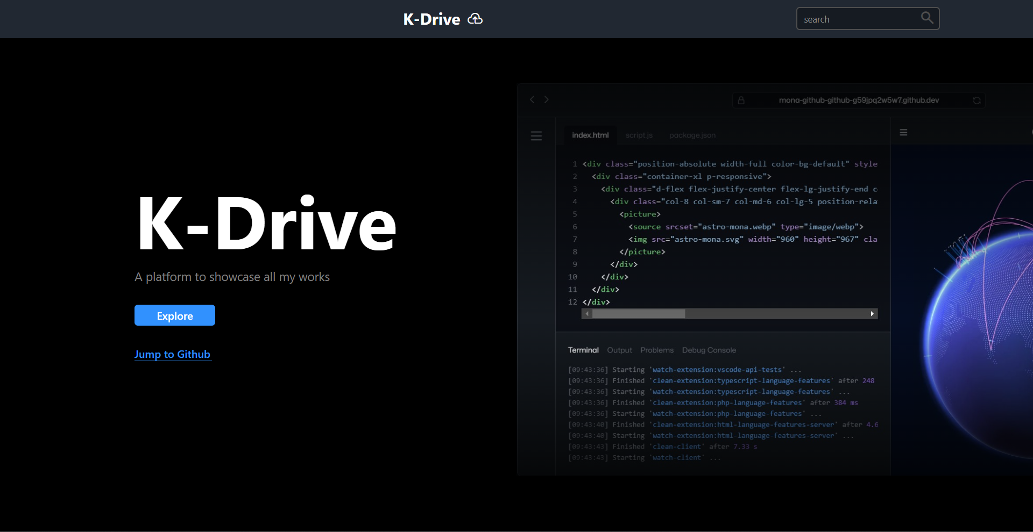

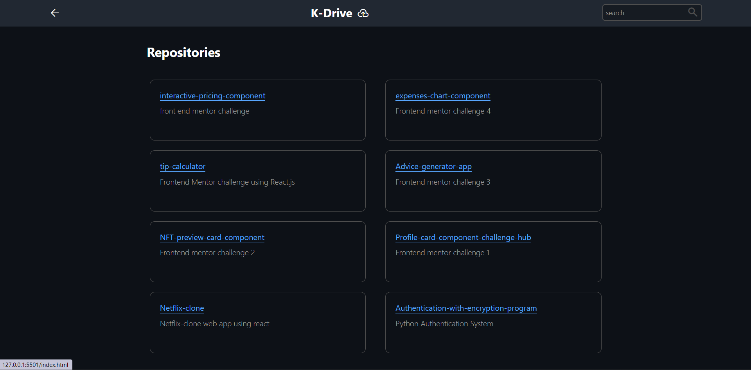

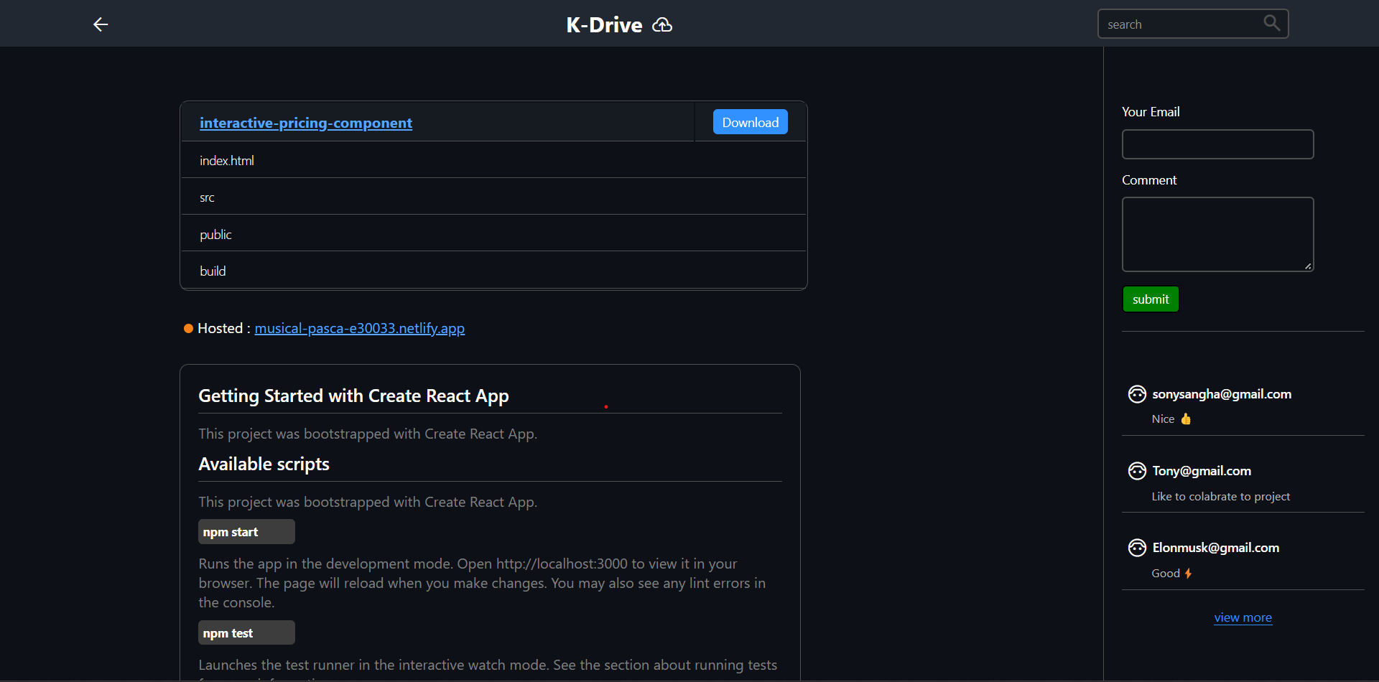

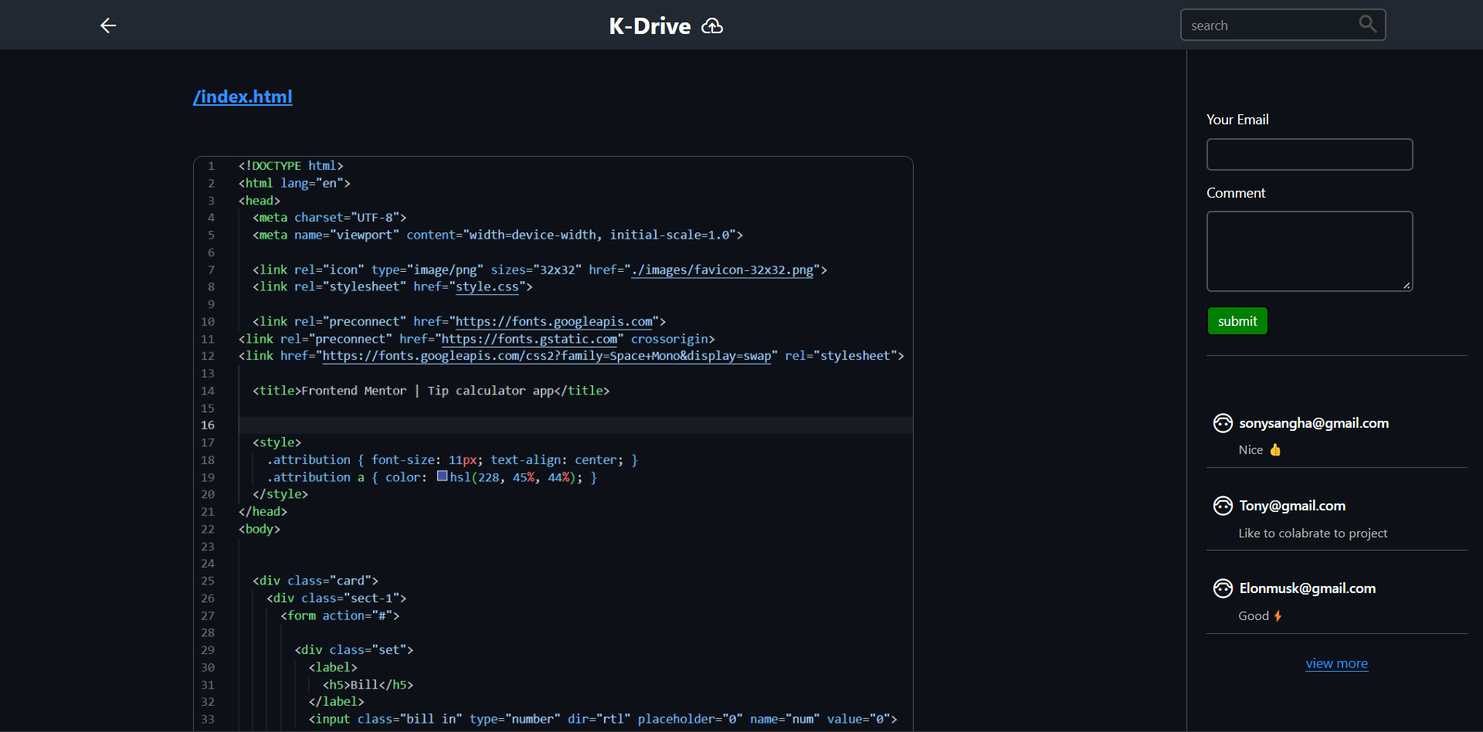

**SAMPLE CODE**

**Index.html**

<!DOCTYPE html>

<html lang="en">

  <head>

    <meta charset="UTF-8" />

    <meta http-equiv="X-UA-Compatible" content="IE=edge" />

    <meta name="viewport" content="width=device-width, initial-scale=1.0" />

    <title>Document</title>

    <link

      rel="stylesheet"

      href="https://fonts.googleapis.com/css2?family=Material+Symbols+Outlined:opsz,wght,FILL,GRAD@48,400,0,0"

    />

    <link rel="stylesheet" href="styles\style.css" />

  </head>

  <body

    class="land"

    style="

      background-image: linear-gradient(

          0deg,

          rgb(0, 0, 0),

          rgba(255, 255, 255, 0) 40%,

          rgb(0, 0, 0)

        ),

        url(assets/ss.jpg);

      background-size: 65%;

      background-position: 48rem;

      background-position-y: 60%;

      background-repeat: no-repeat;

    "

  >

    <nav>

      <div class="nav-bar">

        <h1></h1>

        <h1>

          K-Drive

          <span

            style="position: absolute; top: 16px; padding: 0 10px 0"

            class="material-symbols-outlined cloud"

          >

            cloud_upload

          </span>

        </h1>

        <div>

          <input

            class="search"

            placeholder="search"

            type="text"

            style="color: white; padding: 0 5px 0"

          />

          <span class="material-symbols-outlined search-btn"> search </span>

        </div>

      </div>

    </nav>

    <div class="land-head">

      <h1>K-Drive</h1>

      <p>A platform to showcase all my works</p>

      <a href="repo.html" class="btn3">Explore</a>

</div>

  </body>

</html>

**Form.html**

<!DOCTYPE html>

<html lang="en">

  <head>

    <meta charset="UTF-8" />

    <meta http-equiv="X-UA-Compatible" content="IE=edge" />

    <meta name="viewport" content="width=device-width, initial-scale=1.0" />

    <title>Document</title>

    <link rel="stylesheet" href="styles\style.css" />

    <link

      rel="stylesheet"

      href="https://fonts.googleapis.com/css2?family=Material+Symbols+Outlined:opsz,wght,FILL,GRAD@48,400,0,0"

    />

  </head>

  <body>

    <div class="section3">

      <div class="form">

        <form>

          <div class="lab">

            <label>Your Email</label>

            <div>

              <input type="text" name="subject" required/>

            </div>

          </div>

          <div class="lab">

            <label>Comment</label>

            <div>

              <textarea type="text" name="comment"></textarea>

            </div>

          </div>

          <div>

            <button type="submit" class="btn">submit</button>

          </div>

        </form>

        <div>

        <div class="noti-ctn">

          <div class="noti">

            <h4>

              <span class="material-symbols-outlined face"> face_6 </span>Abhinav@gmail.com

            </h4>

            <p>Nice 👍</p>

          </div>

          <div class="noti">

            <h4>

              <span class="material-symbols-outlined face"> face_6 </span>Jishnu@gmail.com

            </h4>

            <p>Like to colabrate to project</p>

          </div>

          <div class="noti">

            <h4>

              <div class="status"></div>

              <span class="material-symbols-outlined face"> face_6 </span>Alin@gmail.com

            </h4>

            <p>Good⚡</p>

          </div>

          <div class="btn-ctn">

          <div class="btn6">view more</div>

        </div>

        </div>

      </div>

    </div>

  </body>

</html>

**repo.html**

<!DOCTYPE html>

<html lang="en">

  <head>

    <meta charset="UTF-8" />

    <meta http-equiv="X-UA-Compatible" content="IE=edge" />

    <meta name="viewport" content="width=device-width, initial-scale=1.0" />

    <title>Document</title>

    <link

      rel="stylesheet"

      href="https://fonts.googleapis.com/css2?family=Material+Symbols+Outlined:opsz,wght,FILL,GRAD@48,400,0,0"

    />

    <link rel="stylesheet" href="styles\style.css" />

  </head>

  <body>

    <nav>

      <div class="nav-bar">

        <a class="back" target="_parent" href="index.html"

          ><span class="material-symbols-outlined"> arrow_back </span></a

        >

        <h1>

          K-Drive<span

            style="position: absolute; top: 16px; padding: 0 10px 0"

            class="material-symbols-outlined cloud"

          >

            cloud_upload

          </span>

        </h1>

        <div>

          <input class="search" placeholder="search" type="text" />

          <span class="material-symbols-outlined search-btn"> search </span>

        </div>

      </div>

    </nav>

    <section class="section4">

      <div>

        <h3>Repositories</h3>

      </div>

      <div class="repo-flex">

        <div class="repo">

          <h4><a href="frame\frame.html">interactive-pricing-component </a></h4>

          <p>front end mentor challenge</p>

        </div>

        <div class="repo">

          <h4>

            <a href="frame\frame2.html">expenses-chart-component</a>

          </h4>

          <p>Frontend mentor challenge 4</p>

        </div>

        <div class="repo">

          <h4><a href="frame\frame3.html">tip-calculator</a></h4>

          <p>Frontend Mentor challenge using React.js</p>

        </div>

        <div class="repo">

          <h4><a href="frame\frame3.html">Advice-generator-app </a></h4>

          <p>Frontend mentor challenge 3</p>

        </div>

        <div class="repo">

          <h4><a href="frame\frame3.html">NFT-preview-card-component </a></h4>

          <p>Frontend mentor challenge 2</p>

        </div>

        <div class="repo">

          <h4>

            <a href="frame\frame3.html"

              >Profile-card-component-challenge-hub

            </a>

          </h4>

          <p>Frontend mentor challenge 1</p>

        </div>

        <div class="repo">

          <h4><a href="frame\frame3.html">Netflix-clone </a></h4>

          <p>Netflix-clone web app using react</p>

        </div>

        <div class="repo">

          <h4>

            <a href="frame\frame3.html"

              >Authentication-with-encryption-program

            </a>

          </h4>

          <p>Python Authentication System</p>

        </div>

      </div>

    </section>

  </body>

</html>