1)Create java program to find total mark and percentage using class and object constructer

ans:

package student;

/**
*
* @author sjcet
*/
public class Student {
int m1,m2,m3;
Student()
{
m1=20;
m2=30;
m3=40;

}
public void sum()
{
int sum;
sum=m1+m2+m3;
System.out.println("sum is="+sum);
}
public void percentage()
{
float percentage;
percentage=((m1+m2+m3)*100)/300;
System.out.println("percentage is="+percentage);
}
public static void main(String[] args) {
Student s=new Student();
s.sum();
s.percentage();

}

}

output:

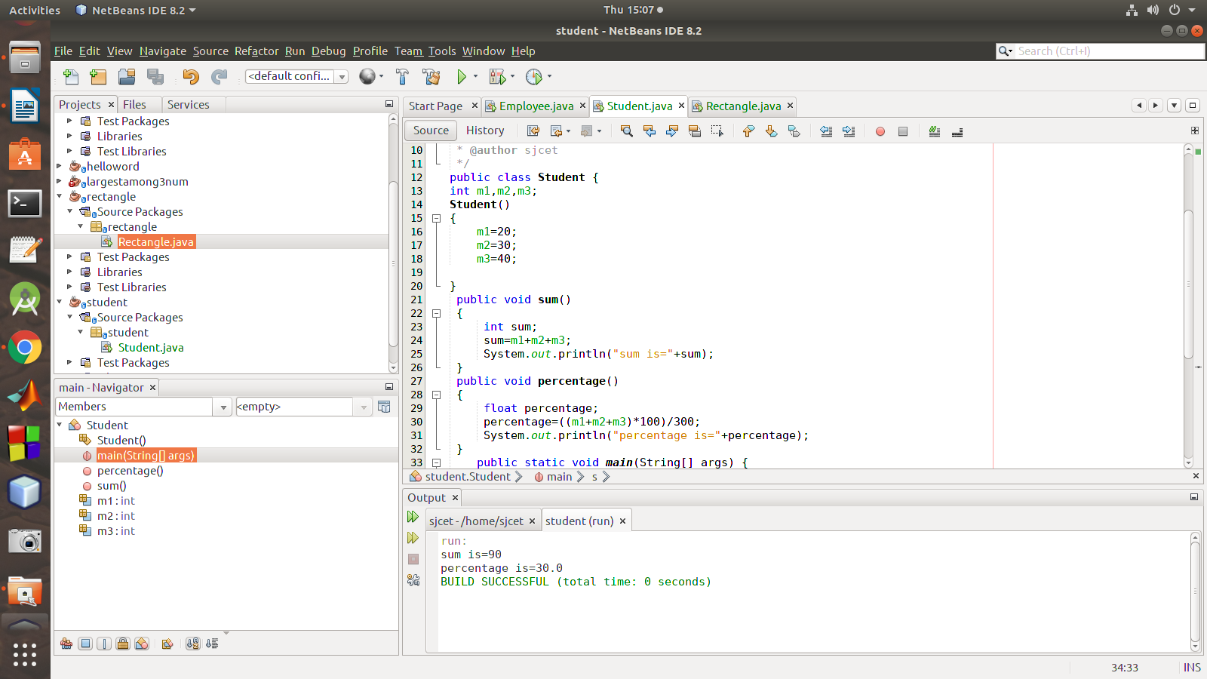

2) create a class employee ask data members empid,empname,salary.calculate total salary with DA 20%.

ans:
package employee;

/**
*
* @author sjcet
*/
public class Employee {
int emp_id;
String emp_name;
float salary;
Employee(int a,String b,float c)
{
emp_id=a;
emp_name=b;
salary=c;
}
public void disp()
{
System.out.println("emp_id="+emp_id);
System.out.println("emp_name="+emp_name);
System.out.println("salary="+(salary+(salary*20)/100));

}
public static void main(String[] args) {
Employee e1 = new Employee(101, "krishna", 100);
e1.disp();
Employee e2 = new Employee(102,"nanda", 200);
e2.disp();
}

}

output:

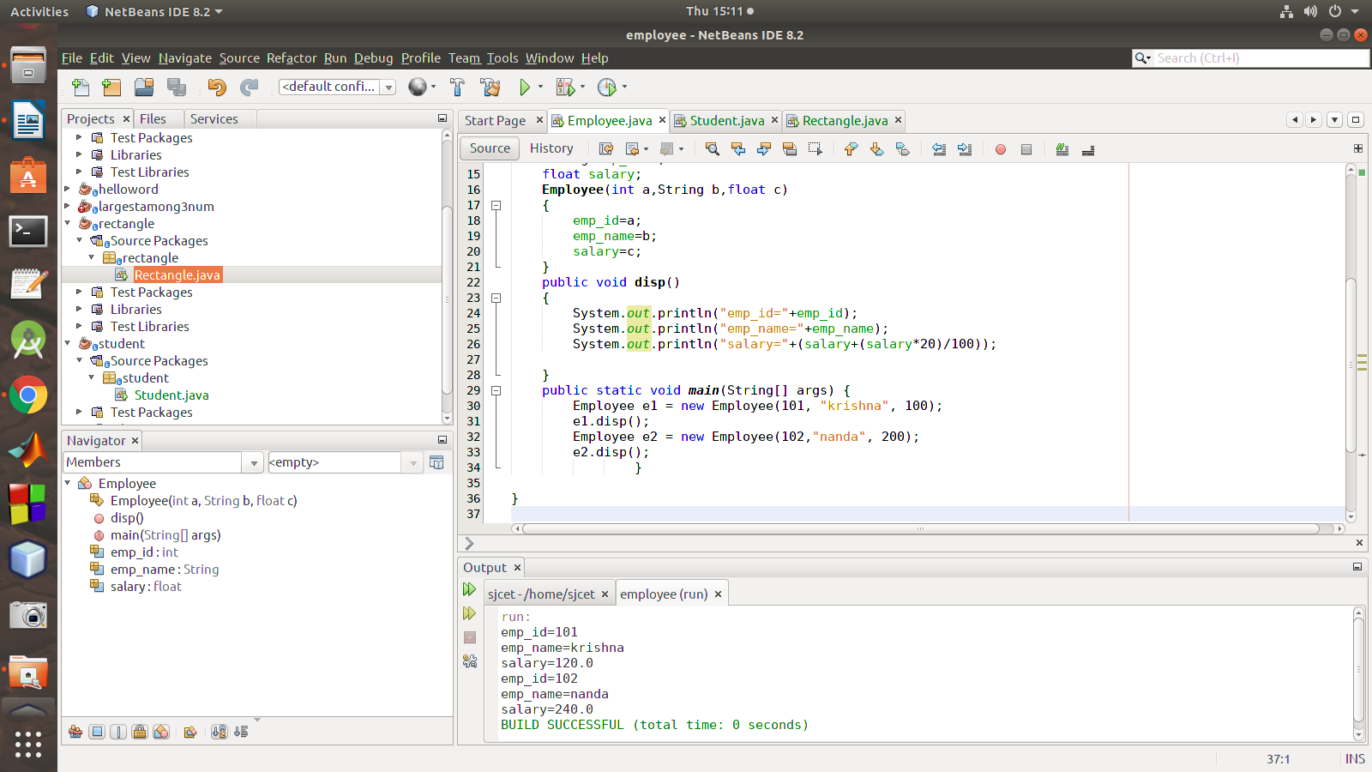

3) create a class rectangle with data members l and b and member functions perimeter and area
ans:
package rectangle;

/**
*
* @author sjcet
*/
public class Rectangle {

int l,b;
public Rectangle(int a,int c){
l=a;
b=c;
}
public void area(){
System.out.println("area is="+l*b);
}
public void perimeter(){
System.out.println("perimeter is="+(2*l+b));

}

public static void main(String[] args) {
Rectangle s1=new Rectangle(20, 10);
s1.area();
s1.perimeter();

}

}

output:

