UML Diagram

Team No:35 (Freight Forwarding System)

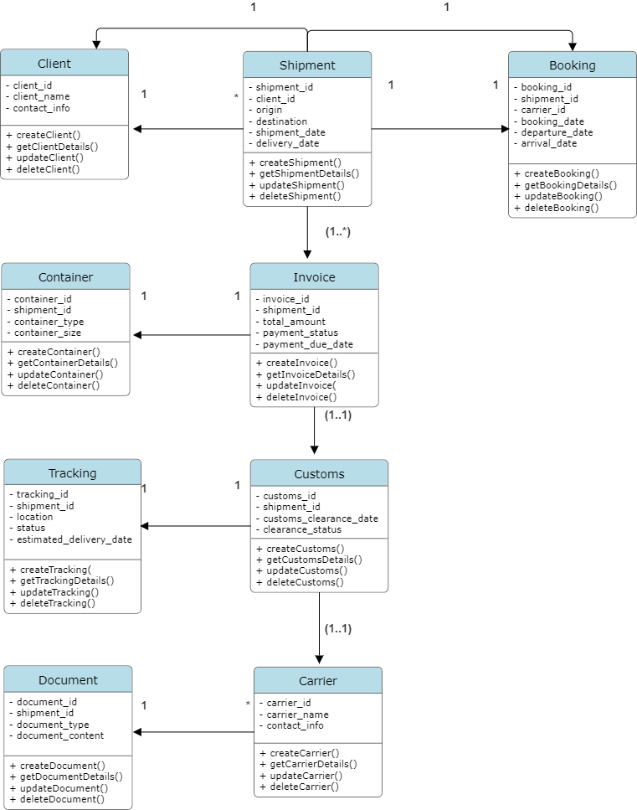

Classes, Attributes, and Relationships

Client
Attributes:
client_id: Integer
client_name: String
contact_info: String

Methods:
+ createClient()
+ getClientDetails()
+ updateClient()
+ deleteClient()

Shipment
Attributes:
shipment_id: Integer
client_id: Integer
origin: String
destination: String
shipment_date: Date
delivery_date: Date

Methods:
+ createShipment()
+ getShipmentDetails()
+ updateShipment()
+ deleteShipment()

Container
Attributes:
container_id: Integer
shipment_id: Integer
container_type: String
container_size: String

Methods:
+ createContainer()
+ getContainerDetails()
+ updateContainer()
+ deleteContainer()

Carrier
Attributes:
carrier_id: Integer
carrier_name: String
contact_info: String

Methods:
+ createCarrier()
+ getCarrierDetails()
+ updateCarrier()
+ deleteCarrier()

Booking
Attributes:
booking_id: Integer
shipment_id: Integer
carrier_id: Integer
booking_date: Date
departure_date: Date
arrival_date: Date

Methods:
+ createBooking()
+ getBookingDetails()
+ updateBooking()
+ deleteBooking()

Route
Attributes:
route_id: Integer
booking_id: Integer
origin: String
destination: String
transit_points: String

Methods:
+ createRoute()
+ getRouteDetails()
+ updateRoute()
+ deleteRoute()

Invoice
Attributes:
invoice_id: Integer
shipment_id: Integer
total_amount: Float
payment_status: String
payment_due_date: Date

Methods:
+ createInvoice()
+ getInvoiceDetails()
+ updateInvoice()
+ deleteInvoice()

Tracking
Attributes:
tracking_id: Integer
shipment_id: Integer
location: String
status: String
estimated_delivery_date: Date

Methods:
+ createTracking()
+ getTrackingDetails()
+ updateTracking()
+ deleteTracking()

Customs
Attributes:
customs_id: Integer
shipment_id: Integer
customs_clearance_date: Date
clearance_status: String

Methods:
+ createCustoms()
+ getCustomsDetails()
+ updateCustoms()
+ deleteCustoms()

Document
Attributes:
document_id: Integer
shipment_id: Integer
document_type: String
document_content: String

Methods:
+ createDocument()
+ getDocumentDetails()
+ updateDocument()
+ deleteDocument()

Relationships
Client to Shipment: One-to-many (1 to *)
- A client can have multiple shipments, but each shipment is associated with only one client.
Shipment to Booking: One-to-one (1 to 1)
- Each shipment can have one booking, and each booking is associated with one shipment.
Shipment to Container: One-to-many (1 to *)
- Each shipment can have multiple containers, but each container is associated with only one shipment.
Shipment to Invoice: One-to-one (1 to 1)
- Each shipment has one invoice, and each invoice is associated with one shipment.
Shipment to Tracking: One-to-one (1 to 1)
- Each shipment has one tracking record, and each tracking record is associated with one shipment.
Shipment to Customs: One-to-one (1 to 1)
- Each shipment has one customs clearance record, and each customs clearance record is associated with one shipment.
Shipment to Document: One-to-many (1 to *)
- Each shipment can have multiple documents, but each document is associated with only one shipment.
Carrier to Booking: One-to-many (1 to *)
- A carrier can have multiple bookings, but each booking is associated with only one carrier.

