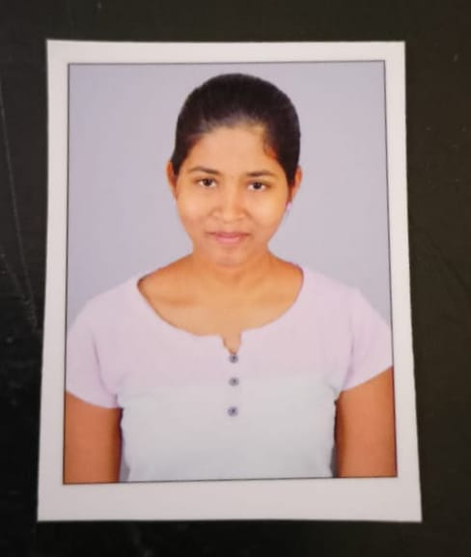
PHOTO

NAME : Kuppireddy Nikitha
H.No : 9-1/143, Bhavani Nagar colony,
dammaiguda , nagaram.
Phone : 9652083981
E-mail : nikithakuppi@gmail.com

CAREER OBJECTIVE
To obtain a challenging position as a Software Engineer in a leading multi-national organization where I can use my qualifications and skills to prove my abilities to lead the team as team leader.

EDUCATIONAL QUALIFICATIONS
S.  No. | Examination Passed | Name  of Institute/ University | Discipline/ Subject | Month & Year of Passing | Percen- tage of Marks | Division
1. | B. Tech | Ace Engineering College | Computer Science Engineering -AIML. | 2025 | 8.5 | First
2. | Intermediate | Narayana junior college-ECIL | Maths, Physics, Chemistry. | March  2019-21 | 89 | First
3. | S.S.C | Board of Secondary Education, TS., Hyderabad. | Maths , Science, Social Studies | March 1  2019 | 9.3 | First
TECHNICAL PROFILE
- Languages : C, PYTHON

ACHIEVEMENT:

BEC certification

Cisco PCAP - Programming Essentials in Python

Cisco CLA - Programming Essentials in C

Salesforce Developer virtual intership

Uipath Automation Explorer for Students

STRENGTHS
- Patience
- Determination
- Positivity

WEAKNESSES

Hesitating to say No

HOBBIES
- Dancing
- Listening to music
PERSONAL PROFILE
- Date of Birth : 30th October 2003
- Languages known : English ,Telugu, Hindi.
- Father's Name : Mr. Kuppireddy Ashokreddy
- Mother’s Name : Mrs. Kuppireddy Chandrakala

DECLARATION :

It is hereby acknowledged that the information furnished above is true to my knowledge.


Place : Hyderabad Signature

Date : 11/11/2023

* * *

