UML Diagram

Team No:35 (Freight Forwarding System)

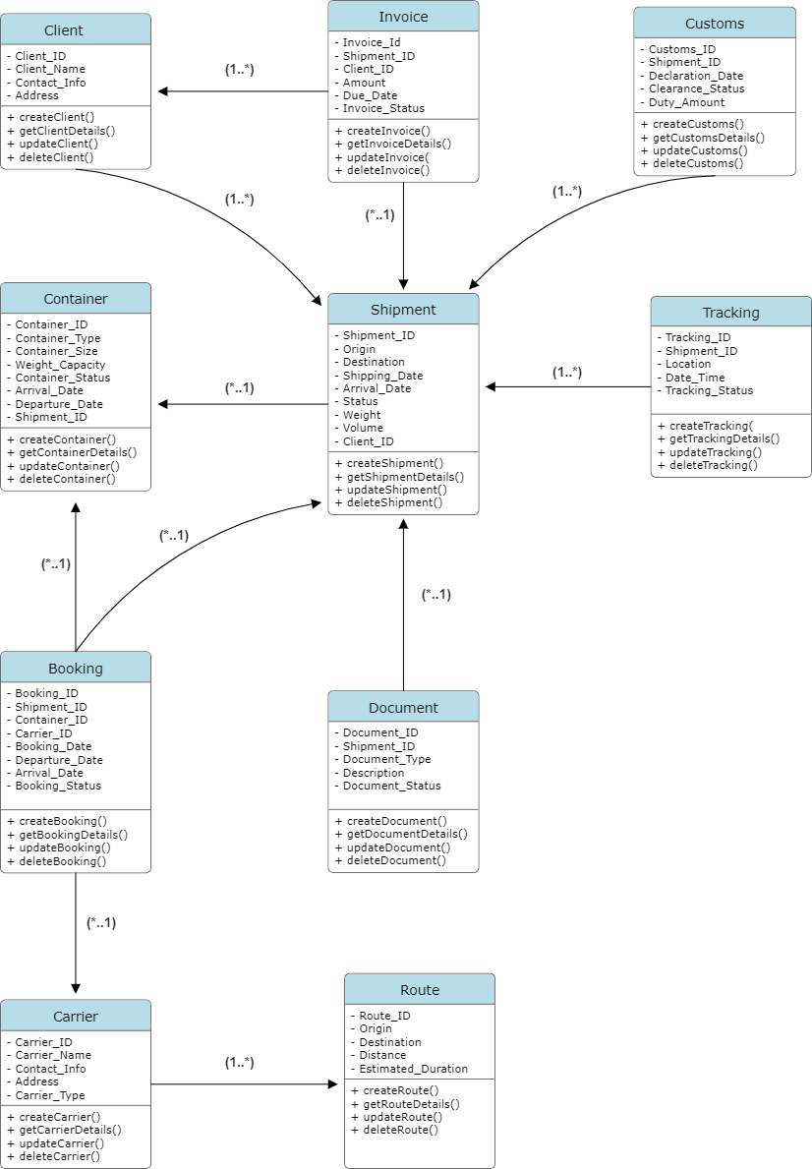

Classes, Attributes, and Relationships

Attributes: Methods: Shipment_ID: Integer + createsShipment()
Origin: String + getShipmentDetails()
Destination: String + updateShipment()
Shipping_Date: Date + deleteShipment()
Arrival_Date: Date
Shipment_Status:String
Weight:Double
Volume:Double
Client_ID: Integer

Container
Attributes: Methods:
Container_ID: Integer + createContainer()
Container_Type:String + getContainerDetails()
Container_Size:String + updateContainer()
Weight_Capacity:Double + deleteContainer()
Container_Status:String
Arrival_Date:date
Departure_Date:date
Shipment_ID: Integer

Carrier
Attributes: Methods:
Carrier_ID: Integer + createCarrier()
Carrier_Name: String + getCarrierDetails()
Contact_Info: String + updateCarrier()
Address:String + deleteCarrier()
Carrier_Type:String

Booking
Attributes: Methods:
Booking_ID: Integer + createBooking()
Shipment_ID: Integer + getBookingDetails()
Container_ID:Integer + updateBooking()
Carrier_ID: Integer + deleteBooking()
Booking_Date: Date
Departure_Date: Date
Arrival_Date: Date
Booking_Status:String

Route
Attributes: Methods:
Route_ID: Integer + createRoute()
Origin: String + getRouteDetails()
Destination:Double + updateRoute()
Distance:Double + deleteRoute()
Estimated_Duration:Time

Invoice
Attributes: Methods:
Invoice_ID: Integer + createInvoice()
Shipment_ID: Integer + getInvoiceDetails()
Client_ID:Integer + updateInvoice()
Amount: Float + deleteInvoice()
Due_Date: Date
Invoice_Status: String

Tracking
Attributes: Methods:
Tracking_ID: Integer + createTracking()
Shipment_ID: Integer + getTrackingDetails()
Location: String + updateTracking()
Date_Lime:DateTime + deleteTracking()
Tracking_Status: String

Customs
Attributes: Methods:
Customs_ID: Integer + createCustoms()
Shipment_ID: Integer + getCustomsDetails()
Declaration_Date: Date + updateCustoms()
Clearance_Status: String + deleteCustoms()
Duty_Amount:Double

Document
Attributes: Methods:
Document_ID: Integer + createDocument()
Shipment_ID: Integer + getDocumentDetails()
Document_Type: String + updateDocument()
Description:String + deleteDocument()
Document_status:String

Client
Attributes: Methods:
Client_ID: Integer + createClient()
Client_Name: String + getClientDetails()
Contact_Info: String + updateClient()
Address:String + deleteClient()

Relationships:
Client and Shipment: One client can have multiple shipments (one-to-many).
Shipment and Container: One shipment can be associated with multiple containers (one-to-many).
Booking and Shipment: Each booking is linked to a single shipment (many-to-one).
Booking and Container: Each booking is linked to a single container (many-to-one).
Booking and Carrier: Each booking is linked to a single carrier (many-to-one).
Invoice and Shipment: Each invoice is linked to a single shipment (many-to-one).
Invoice and Client: Each invoice is linked to a single client (many-to-one).
Tracking and Shipment: Each tracking record is linked to a single shipment (many-to-one).
Customs and Shipment: Each customs record is linked to a single shipment (many-to-one).
Document and Shipment: Each document is linked to a single shipment (many-to-one).
Carrier and Route: Each carrier record is linked to a single route(many to one).

